**REVIEW OF 2017 COMMERCIAL CLUB ALBURY AUSTRALIAN OPEN RACQUETBALL CHAMPIONSHIPS**

The 34th edition of Racquetball’s pinnacle event, superbly hosted by the Commercial Club Albury-Squash and Racquetball Section, and held at the magnificent Commercial Club Albury, the Wodonga Squash & Racquetball Centre, plus the Albury Club, was a resounding success, securing a massive total of 229 entries, including 33 junior players, who spent two and half days jousting for the sixteen national titles on offer.

Although the KING and QUEEN of Australian Racquetball Cam White and Sarah Fitz-Gerald, once again snared the lion’s share of the $10,000 booty on offer, it was the junior brigade who stole the show capturing five of the ten singles titles on offer.

The President’s Choice Commercial Club Junior Scholarship Award sponsored by Andrew Sobolewski and all of the Grand Prix tournament hosts was won by Alexander Brigden and he received $200 to put towards his coaching and training expenses, plus free entry into every Grand Prix racquetball event held in Australia in 2018.

The Heidi Tugend E Grade Championship, now named after one of South Australia’s most popular Squash and Racquetball players, was won by fourteen year old Alexander Brigden.

The inaugural John Broadway D Grade Singles Championship, which was established in honour of one of our great ambassadors for the sports of racquetball and squash, who sadly passed away in January this year, was won by thirteen year old Justin Chu.

This event’s Perpetual Shield in honour of John will be permanently housed on display at the Wangaratta Squash and Racquetball club’s courts which are located at the Wangaratta Indoor Sports and Aquatic Centre.

The Australian Open Teams Challenge comprised participants from 23 clubs, with the host clubs fighting it out for top honours, with eventually the Commercial Club annexing the first prize of $250, Wodonga received $150 for second place and SS&A taking out third place and winning $100.

SINGLES RESULTS

MEN’S OPEN

The Men’s Open attracted another stellar field which included fifteen times national champion Cam White, National and Victorian Grand Prix Circuit leader Steve Andrewartha, plus top Australian squash player Rex Hedrick, who has two major squash events ahead of him, the 2017 World Men’s Teams Championships and next year’s Commonwealth Games on the Gold Coast.

The Men’s Open final was an absolute corker, commencing at a frenetic pace with the flamboyant White exposing his full repertoire of shots, whilst the speed and remarkable returning of Hedrick ensured a long day at the office for the Champion.

Although White comfortably held control throughout the first game claiming it 21/8, the second game was played in two halves. Once again White hit his straps early and maintained a handy four to five point advantage until the score reached 16/11 when Hedrick commenced making serious inroads into the deficit, and at 18/16 the immense crowd sensed anything was possible.

Hedrick moved into overdrive and claimed five of the next six points to extend the match into a third and final game decider, which was very unfamiliar territory for White, the last time being the Lakes Classic Final in November 2015, when Peter French took the second game 22/21.

A champion has many defining features, and White has three compelling one’s; the ability to apply unswerving pressure to his opponents, remarkable concentration, plus the ability to move into overdrive when the heat is on at the ‘pointy end’ of a game or match.

In the end it was the preciseness of White’s short game and his impeccable width and length that proved the difference taking the enthralling match against the very talented Hedrick, 21/8, 19/21, 21/11, and capture his sixteenth National title and extend his unbeaten run to a remarkable seventeen years.

In the semi finals, White overcame Geelong LTC stable mate Garry Pedersen, 21/7, 21/14, with Hedrick surviving an enthralling first game over Andrewartha, 22/21, then outgunning him in the second 21/8.

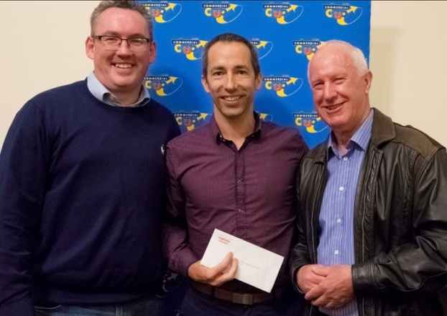 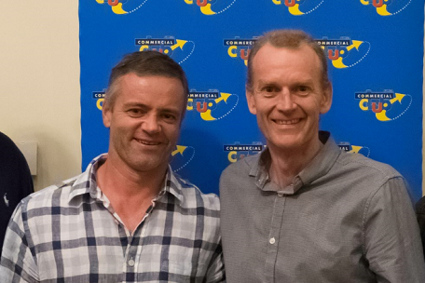

*Sam Abishara, Cam White & Ross Falconer Steve Andrewartha & Gary Pedersen*

WOMEN’S OPEN

Although initially this event looked on paper a one horse affair, the large crowd were well and truly entertained by the rest of the field’s endeavours to secure a final’s berth against the five times world open squash champion and eight times national racquetball champion Sarah Fitz-Gerald.

Second seeded and National Grand Prix leader Kristel Proctor, eventually ended up with that honour after nailing South Australia’s third seeded Corinne Yallup-Cross, 21/10, 22/20 in their lengthy semi final.

Meanwhile, Fitz-Gerald had overcome fourth seeded Sally White, 21/6, 21/5 in their semi final, to set up an entertaining final.

From the outset Proctor clearly showed that in no way was she going to be intimidated by the title holder, displaying remarkable agility and recovery, but when the judge finally called a halt to proceedings, Fitz-Gerald utilising her brilliant front court game to great advantage, had claimed another title over the courageous Proctor, 21/6, 21/8, and her ninth national crown in a row.

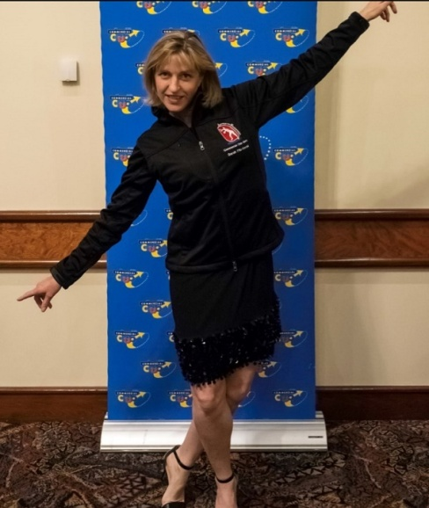 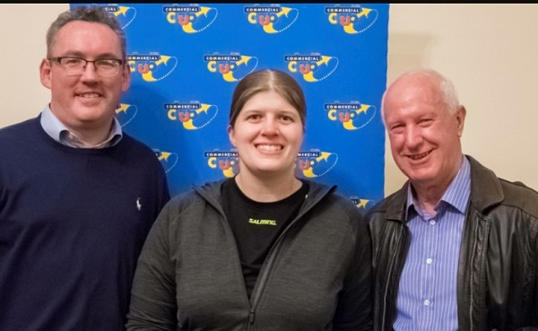

*Sarah Fitz-Gerald Sam, Kristel Proctor & Ross*

A GRADE

The high quality field that the A Grade event attracted guaranteed a plethora of close matches, with some likely upsets, which was the eventual outcome.

In his semi final, Victoria’s top seeded Anthony Hain, took out local hope Carl Chant, 21/16, 21/9, whilst Albury’s sixth seeded Scott Petts was cutting a swathe through the bottom half of the draw, dispatching third seeded South Aussie Dean Cross, in a tough quarter final encounter, 21/14, 21/18, then overcoming sixteen year old local Daniel Chu, in their semi final, 21/16, 21/13. Chu had earlier taken out second seeded Chris Rollauer 21/8, 9/21, 21/10.

The final stanza was a dour struggle with Hain holding sway for most of the match, eventually claiming the A Grade crown 21/16, 21/17, and in the process taking out his fourth successive A Grade title.

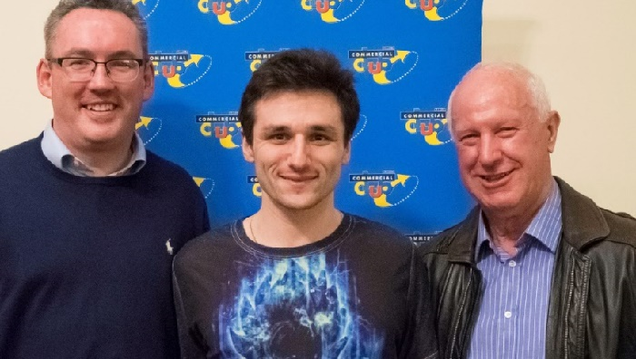

*Sam, Anthony Hain & Ross*

B GRADE

In recent times if you are going to win a National or for that matter a Victorian B Grade title in 2017 the two players most likely that you would have to take out at some stage have been Victoria’s Matt Bayley and South Aussie Dave Whan, and on this occasion no one was capable of stopping either player from reaching the final stanza.

After surviving a match point against him in his first round encounter with another very talented local junior, Casey Macpherson, Bayley then accounted for Wangaratta’s Paul Trinick and SS&A’s Cory Sutcliffe in straight games to reach the final.

Waiting for him was the top seeded Whan, who had only three days earlier returned to OZ from Nepal as his quest to conquer Mt. Everest was terminated when he contracted altitude sickness at just under 19,000 feet, a herculean performance at his first attempt.

On his way to the final Whan recovered from a game down in the quarters against Wangaratta’s Jason Hawkins, then ousted Wodonga’s Sean Darcy in their semi final, 21/11, 21/12.

Whan is one of the true warhorses of the sport, but Bayley was relentless taking the first 21/14, then the second game 21/13, to secure his first Australian crown, although Whan still took out the National B Grade Grand Prix Circuit title for 2017.

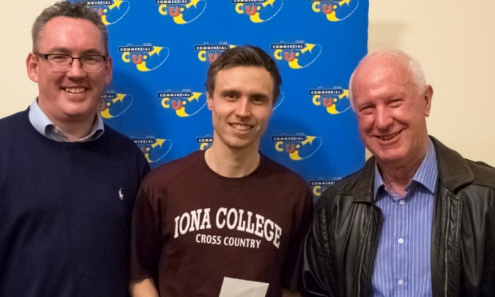 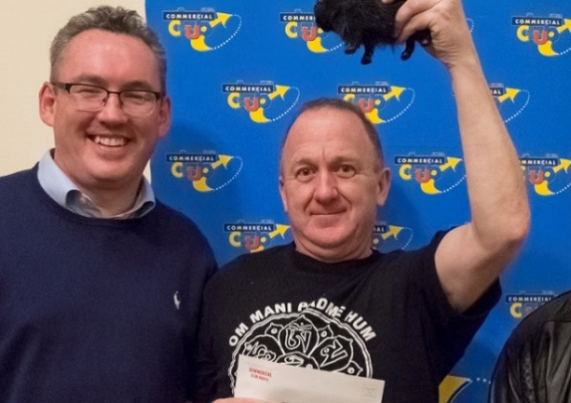

*Sam, Matthew Bayley & Ross Sam & Dave Whan*

C GRADE

A Melbourne Cup field of twenty two starters entered the barrier stalls for this event and after thirty nine very competitive matches Ballarat’s top seeded Blake Caspersz, who had already won four Grand Prix events this year, plus was runner up to Daniel Chu in last year’s event, took out a gruelling finale over the Commercial Club’s “Marathon Man” David Parkinson, 16/21, 21/18, 21/5, to keep his unbeaten record for the year intact.

In their penultimate matches, Caspersz came back from a game down to overcome Commercial Club’s Darcy Macpherson, 18/21, 21/12, 21/12, with Parkinson ousting fellow team mate Tim Darmody, 21/17, 21/17, the only straight games encounter he had in the four matches he played.

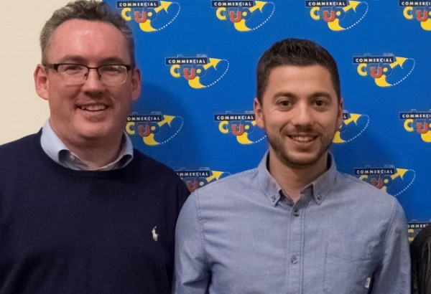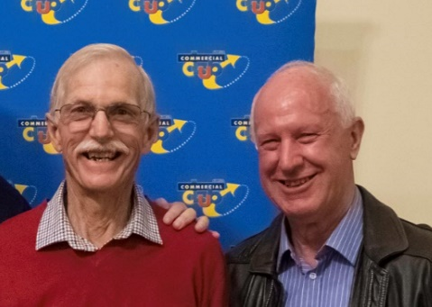

*Sam & Blake Caspersz David Parkinson & Ross*

FOOTNOTE

This writer has for some time now been lauding the work of the clubs around the North East region of Victoria, in particular for their implementation of highly successful junior development programs, which has led to an enormous increase in player numbers, and the production of several highly talented junior players.

A number of those highly talented youngsters performed extremely well in the grades listed above, and the results for the next five events highlights that this regions talent pool is showing no signs of eroding, but in fact rapidly increasing.

This region is a remarkable role model for Racquetball and Squash for not only in Victoria, but nationally as well, and it all has all been done by a network of very passionate, dedicated and skilful volunteers.

JOHN BROADWAY D GRADE

The Wodonga duo of now fourteen year old Nicola Baines, who stole the show in last year’s E Grade event, and now thirteen year old Justin Chu, who took out the 2016 Junior Boy’s title, were chasing ‘back to back’ OZ Open titles and that opportunity well and truly presented itself when both players came through to the final stanza without losing a game in three earlier round matches.

Chu ended up victorious on this occasion, 21/10, 21/15, with both players displaying a skill level well above their age level.

In their penultimate matches, Baines fell over the line against Wodonga’s Liam Tippett 22/21, 21/17, and Chu accounted for Commercial Club’s second seeded Nick Driver, 21/9, 21/13.

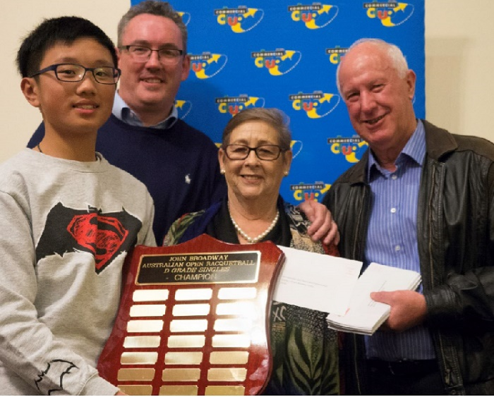

*Justin Chu, Sam, Elaine Broadway & Ross*

HEIDI TUGEND E GRADE

This event contained an enormous variance in player’s ages, including seven juniors, but in the end it was two of the younger brigade who reached the final, two Commercial Club fourteen year olds, Alexander Brigden, plus Joey Rees, who put paid to a fairytale final when he held on gamely to defeat Alexander’s mother Cheryl in a very entertaining semi final, 17/21, 22/20, 21/15.

To reach the final Alexander ousted Wodonga’s Jordan Tamburini, 21/18, 21/13.

In the final Brigden came back from a game down to claim the title, 18/21, 21/7, 21/10, the first of a unique trifecta for the Championships, as he also won the E Grade Doubles with his mother, and was presented with the Presidents Scholarship award.

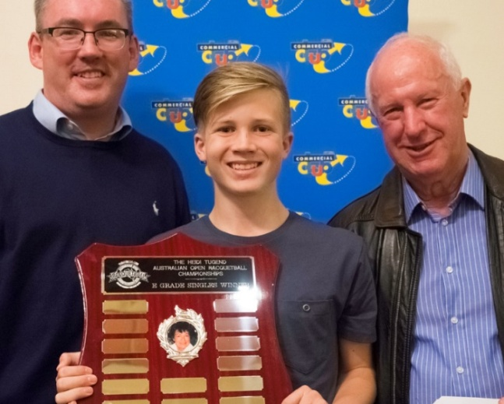 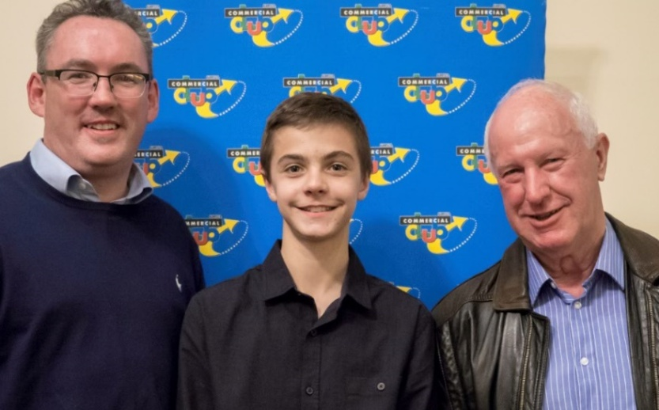

*Sam, Alexander Brigden & Ross Sam, Joey Rees & Ross*

F GRADE

This event also included three local youngsters, who put on a great show for the other players and spectators, with Wodonga junior Zach Tamburini eventually triumphing over SS&A’s Kai Braddy-Nelson, 21/13, 21/16.

In their respective semi finals Tamburini came out on top against Commercial Club’s Lillian Brigden, 21/8, 21/11, with Braddy-Nelson holding on against the Commercial Club’s singing sensation Sandy Lindsay, 21/9, 19/21, 21/9.

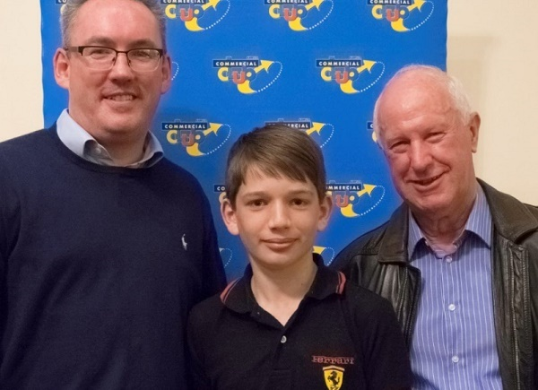

*Sam, Zach Tamburini & Ross*

JUNIOR BOY’S UNDER 13 YEARS

A very strong pool of five locals participated in this event and after each had completed four matches, SS&A’s undefeated Blake Sutcliffe was declared the victor, with the Commercial Club’s Xavier Brigden finishing in second place with three wins.

In their unbelievable decider, Sutcliffe won the 117th point and the contest, 18/21, 21/17, 21/19.

The playoff for third/fourth was between the Parmesan brothers with Tye coming back from a game down to win 20/22, 21/9, 21/7, and claim bragging rights for a little while in their household.

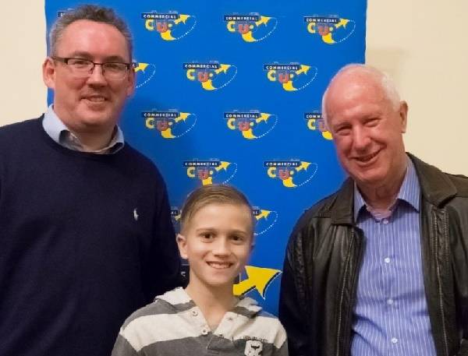

*Sam, Xavier Brigden & Ross*

JUNIOR GIRL’S UNDER 13 YEARS

Wodonga’s pocket dynamo twelve year old Gabby Baines won her second Australian Junior Girl’s event defeating Corio’s Ella Partington in the decider, 21/5, 21/7, and in so doing registering the fifth singles title at these championships for the junior brigade.

Third placing in this event went to the Commercial Club’s Taf Mutape who overcame nine years old Amelia Brigden, 21/13, 21/7.

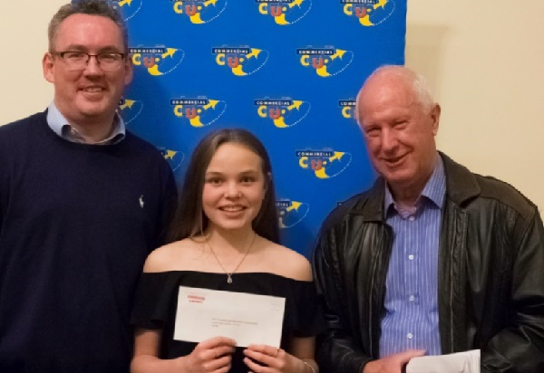

*Sam, Gabby Baines & Ross*

|  |  |  |
| --- | --- | --- |
| SINGLES | | |
| Grade | **Winner** | **Runner-Up** |
| Men’s Open | Cam White (VIC) | Rex Hedrick (VIC) |
| Women’s Open | Sarah Fitz-Gerald (VIC) | Kristel Proctor (VIC) |
| A | Anthony Hain (VIC) | Scott Petts (NSW) |
| B | Matthew Bayley (VIC) | Dave Whan (SA) |
| C | Blake Caspersz (VIC) | David Parkinson (NSW) |
| D | Justin Chu (NSW) | Nicola Baines (VIC) |
| Heidi Tugend E Grade | Alexander Brigden (NSW) | Joey Rees (NSW) |
| John Broadway F Grade | Zach Tamburini (VIC) | Kai Braddy-Nelson (NSW) |
| Junior Boys | Blake Sutcliffe (NSW) | Xavier Brigden (NSW) |
| Junior Girls | Gabby Baines (VIC) | Ella Partington (VIC) |

|  |
| --- |
| DOUBLES |
| Grade Winners Runners-Up |
| Open Andrewartha/England (VIC) White(VIC)/Paramore (NSW) |
| A Abishara/Andrew (SA) Sobolewski/Petts(NSW) |
| B Bayley/Cooper(VIC) Worthington/Kamber (NSW) |
| C Hanckel/Bartlett (NSW) Parkinson/Westman(NSW) |
| D Richards(SA)/Gerontzos(VIC) O’Connell/Baines(VIC) |
| E A & C Brigden(NSW) Mulloy/Shaw (NSW) |

Author: Paul Vear

Photos courtesy of Steve Daniel

Special Presenters: Sam Abishara & Ross Falconer