Graph Number 1

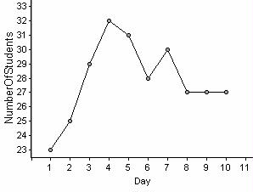

1. What relationship do you notice on this graph between the independent variable (the day) and dependent variable (the number of students)?

2. What might explain this relationship? For example: Why might the number of students steadily increased days 1-4? Why might it have dropped on day 6?

3. What patterns (if any) do you notice in this graph?

4. If possible, try to predict where the next amount would fall on the graph (Day 11)

Graph Number 2

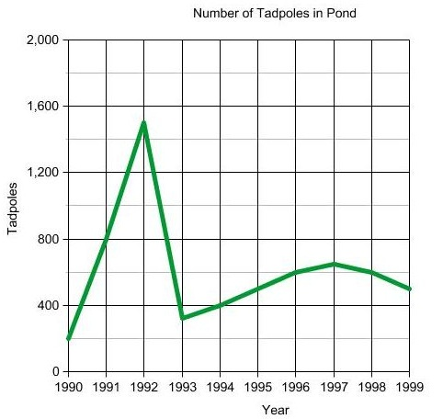

1. What is the independent variable in this graph?
2. What is the dependent variable in this graph?
3. In 1994, approximately how many tadpoles were there?

1. What do you think might have caused the sharp drop in tadpoles from 1992-1993?

Graph Number 3

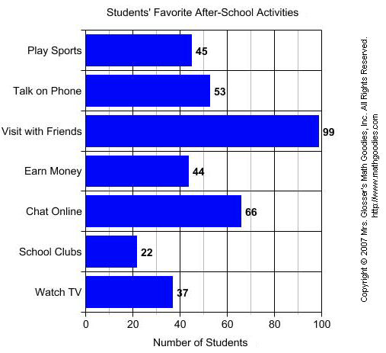

1. What do students enjoy doing the most after school?
2. What do students seem to enjoy doing the least?
3. How many more students prefer talking on the phone to watching TV?

Graph Number 4

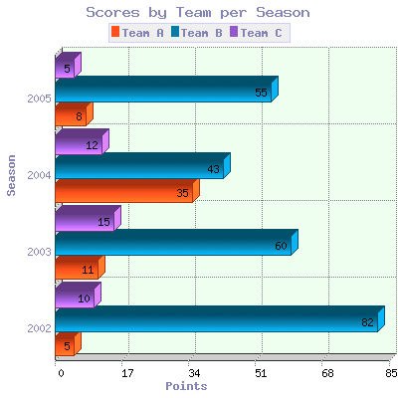

1. What is this graph comparing?
2. Did any team’s points steadily increase over the years?
3. What team scored the best in 2004?
4. How many points did Team B score in 2003?
5. What might have happened to team A from 2004 to 2005?

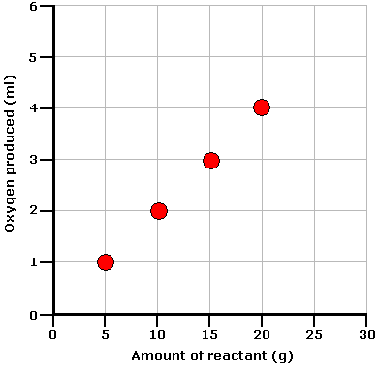Graph Number 5

1. If the trend continues, how much oxygen will be produced when 25 g of the reactant is consumed?
2. What is the independent variable?
3. What is the dependent variable?
4. Do you notice a pattern in this graph? What is it?

Graph Number 6

|  |  |
| --- | --- |
| Day # | Volume of Water Left in Beaker (mL) |
| 1 | 20 |
| 2 | 16 |
| 3 | 12 |
| 4 | 8 |
| 5 | ? |

1. What pattern do you notice in this graph?
2. How much water in mL leaves the beaker each day?
3. What volume of water do you expect to be left on day 5?

Graph Number 7

**Average Annual Snowfall**

|  |  |
| --- | --- |
| **City** | **Snowfall (inches)** |
| Green Bay | 47.7 |
| Bristol | 46.8 |
| Buffalo | 93.6 |
| Kalamazoo | 68.8 |

1. What is a conclusion that we can make from this graph?
2. Do we have enough information to predict what next year’s snowfall in Bristol will be?
3. Which type of graph would be the best way to visually represent the information in this table? Line graph, bar graph, or circle graph?

Graph Number 8

A patient suffering from a bacterial infection was given antibiotics to take by her doctor. The patient took the antibiotics for 6 days out of a 10 day period. The percentage of bacteria surviving during each day of this period is shown in the table below.

|  |  |  |
| --- | --- | --- |
| **Antibiotic Treatment** | | |
| **Day** | **Dosage** | **% of Bacteria Surviving** |
| 1 | 300 mg | 85% |
| 2 | 300 mg | 45% |
| 3 | 300 mg | 25% |
| 4 | 300 mg | 5% |
| 5 | 0 mg | 10% |
| 6 | 0 mg | 20% |
| 7 | 0 mg | 45% |
| 8 | 0 mg | 55% |
| 9 | 300 mg | 65% |
| 10 | 300 mg | 70% |

Which of the following conclusions is most likely correct?

|  |  |  |
| --- | --- | --- |
|  | A. | The bacteria developed resistance to the antibiotics. |

|  |  |  |
| --- | --- | --- |
|  | B. | The patient should have not taken the antibiotics again after day 5. |

|  |  |  |
| --- | --- | --- |
|  | C. | The bacteria will be completely killed off if the antibiotics dosage is increased. |

|  |  |  |
| --- | --- | --- |
|  | D. | The patient has become immune to the bacteria by day 10. |

Graph Number 9

Average Annual Rainfall

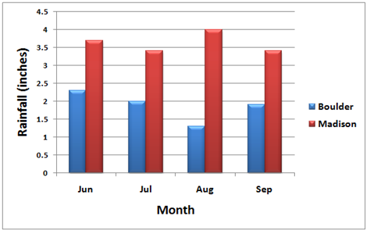

1. What is one conclusion that we can draw from this graph?
2. How much rain (in inches) was there in Boulder during the month of August?
3. In June, how much more did it rain in Madison than in Boulder?
4. How much more did it rain in Madison in August than in June?

Graph Number 10  
  
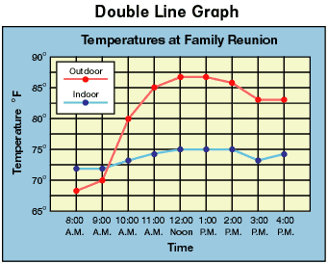

1. What is the relationship between the time and temperature outdoors?
2. At what time was the indoor and outdoor temperature closest?
3. At what time was the outdoor temperature highest?
4. What temperature was it indoors at 2:00 PM?
5. Based on the graph, what temperature do you predict it will be outdoors at 5:00 PM?

Graph Number 11

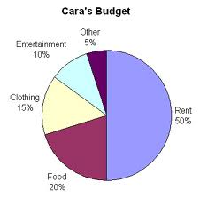

1. Why do you think a circle/pie graph is the best way to represent this data?
2. What percent of Cara’s budget is spent on clothing and food combined?
3. What does Cara spend the most money on each month?
4. What do you think would happen if Cara suddenly lost her job? What areas of this pie chart might change?
5. What do you think would happen if Cara suddenly got a huge bonus at work? What areas of this pie chart might change?

Graph Number 12

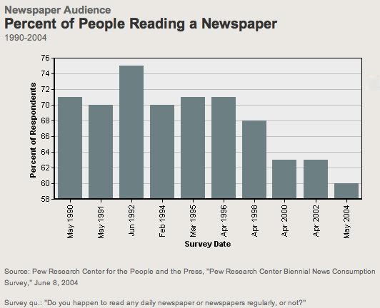

1. What conclusion can we make from looking at this graph?
2. How many more people read a newspaper in 1992 than 2002?
3. What is the independent variable?
4. What is the dependent variable?
5. Look at the dependent variable (percent of respondents). We know the percentage of people that said they read a newspaper, but we don’t know how many people were surveyed. Would this graph be reliable if they surveyed 10 people? Would it be reliable if they surveyed 100,000 people?
6. Why might the number of people reading newspapers be declining?

Graph Number 13  
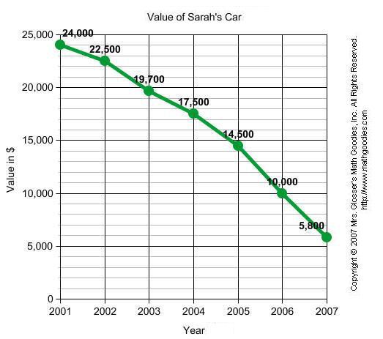

1. What is the relationship between the independent variable (year) and the dependent variable (value in $)?
2. If Sarah decided to sell her car in 2006, what value could she expect to get for it?
3. Based on this graph, how much do you think Sarah’s car would be worth in 2008?

Graph Number 14

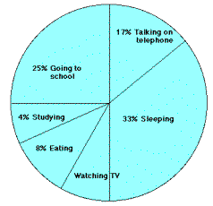

1. What percent of the day is spent Sleeping?
2. What activity takes up the least amount of time?
3. What activity takes up a quarter of the day?
4. Watching TV is not labeled with a percent. What percent of time is spent watching tv? Remember that Pie Charts add up to 100%

Graph Number 15

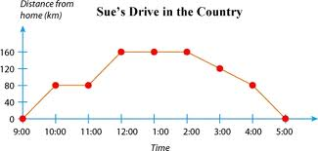

1. What is the independent variable on this graph?
2. What might have happened from 12:00-2:00?
3. What time did Sue arrive back at home after her drive?
4. What was the furthest distance Sue was from home?
5. Someone suggests that Sue’s car may have broken down at 10:00 and was fixed by 11:00. Based on the graph, could this be a valid explanation? Why or why not?

Graph Number 16

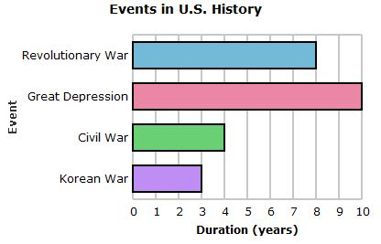

1. What event took approximately 8 years?
2. If we added just these 3 wars, how many years has the US spent at war?
3. How much longer did the Civil War last than the Korean?

Graph Number 17

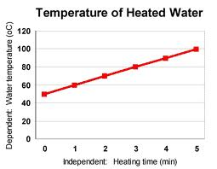

1. What relationship is there between the independent and dependent variable?
2. What conclusion can we make from this graph?
3. After 6 minutes, at what temperature to you expect the water to be at?
4. After how many minutes will the water be approximately 120 degrees Celsius?
5. Your friend made a hypothesis that said “The longer water is heated the hotter water will be.” Is her hypothesis supported by this data?

Graph Number 18

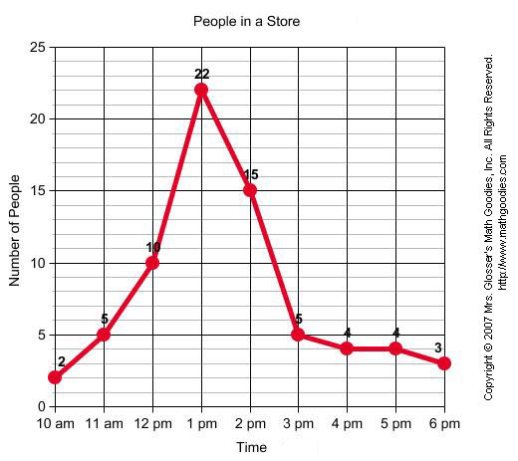

1. What is the independent variable?
2. What is the dependent variable?
3. How many people do you think will be in the store at 7 pm?
4. Why do you think 1 pm was such a popular time for people to be at the store?
5. How many more people were at the store at 2 pm than at 3 pm?

Graph Number 19

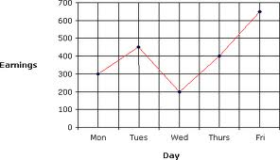

1. Is there a relationship between the day of the week and earnings?
2. What days seem to be the best for earnings?
3. What day was the worst for earnings?
4. How much total was earned throughout the entire work week?

Graph Number 20

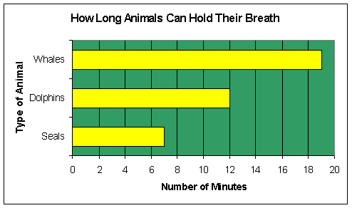

1. Your hypothesis was “I believe seals can hold their breath the longest.” Is your hypothesis supported by this data?
2. What is the independent variable?
3. What animal can hold their breath the longest?
4. Do you think that the size of the animal relates to how long they can hold their breath? Why or why not?

Graph Number 21

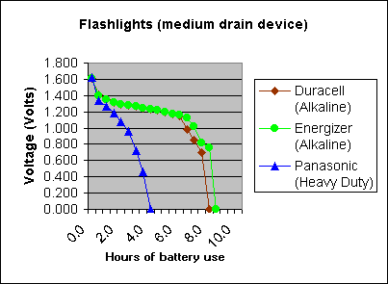

1. Which battery brand died the quickest?
2. Which battery brand lasted the longest?
3. My hypothesis was “If Duracell batteries are the best, they will last the longest.” Is my hypothesis supported?
4. How many hours did the Panasonic battery last?
5. What can we conclude about heavy duty batteries vs. alkaline batteries based on this graph?

Graph Number 22

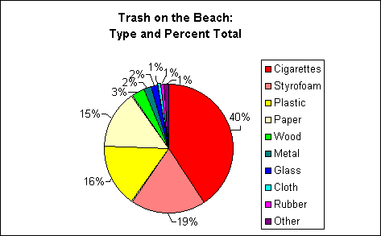

1. Why is a pie chart a good way to represent this data?
2. What percentage of the trash found were cigarettes?
3. What would happen if plastic was no longer produced?
4. My hypothesis was “Over 50% of trash found on the beach is from cigarettes.” Is my hypothesis supported by this data?

Graph Number 23

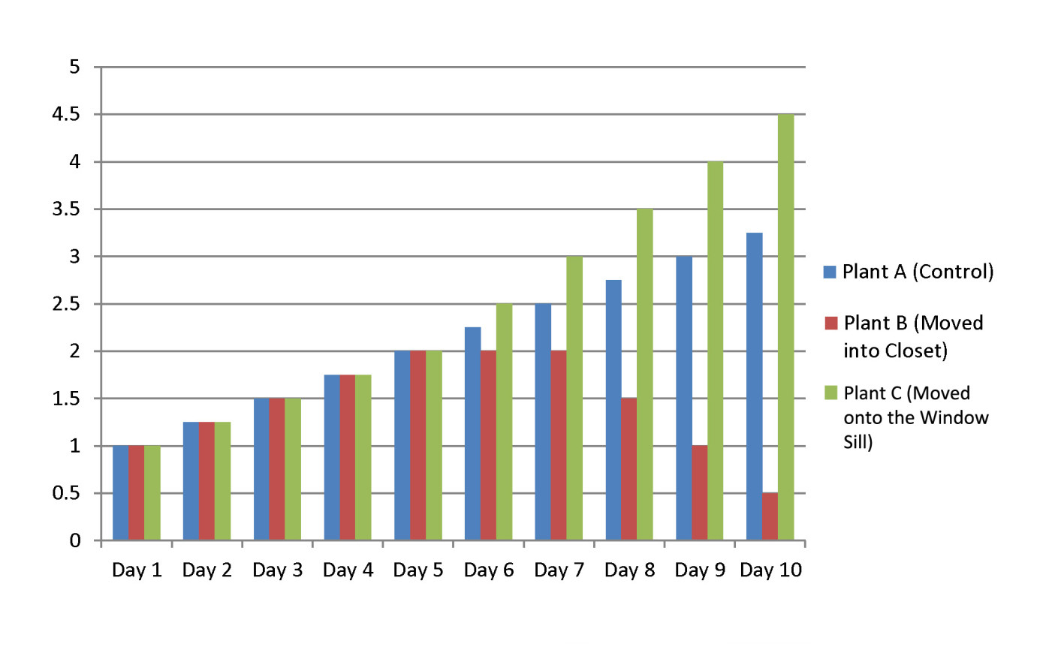

Length of Plant

1. What was the effect of moving the plant into the closet?
2. What was the effect of moving the plant to the window sill?
3. My hypothesis was “If I move a plant to the closet, it will not grow as tall as my control plant.” Is this hypothesis supported?
4. What is the independent variable?
5. What is the dependent variable?

Graph Number 24

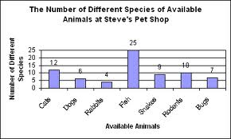

1. Your friend looks at this data and automatically assumes that fish must have more species than dogs or cats. Why could this assumption be incorrect? (Hint: Think about what Steve’s Pet Shop might have more of)
2. How many more species of cats are represented than snakes?
3. What animal has the fewest species represented?

Graph Number 25

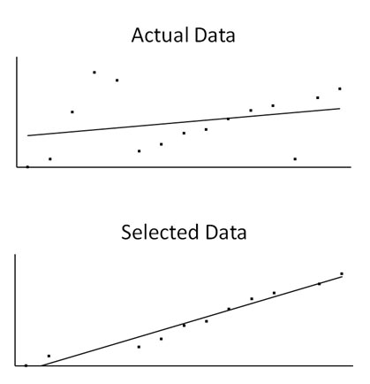

1. Is the graph that is represented on the bottom a good representation of the actual data? Why or why not?
2. What would a better graph look like?

Graph Number 26

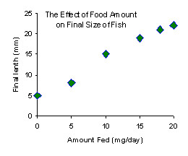

1. Is there a relationship between how much fish are fed and how long they are? If so, what is the relationship?
2. How long are fish that get fed 10 mg/day?
3. How long would you expect a fish that is fed 25 mg/day to be?
4. What is the independent variable?

Graph Number 27

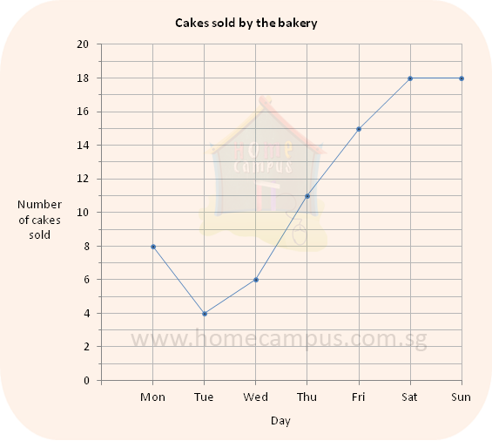

1. Describe the relationship between the day of the week and the number of cakes sold by the bakery.
2. How many more cakes were sold on Saturday than on Tuesday?
3. What is the dependent variable here?
4. How many cakes were sold on Thursday?