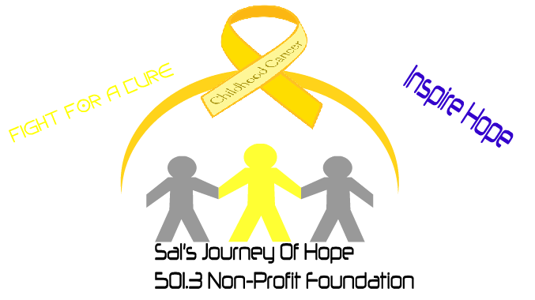**Sal’s Race for a Cure**

**1st Annual Childhood Cancer Awareness 5k Run**

**September 3rd, 2016**

**Anderson Park**

**8.00 a.m-10:30 a.m.**

On -Site registration at 7a.m at Anderson Park

Registration fee $25 which will include a shirt * *to receive a shirt you must register by 8/24** If you are registering by check, please make check payable to ACCO with Sal’s Journey on the memo line.

Medals for all age group categories 1st, 2nd, 3rd place

Sign up at: Get A Grip, GNC, Fit24 Gym, give.acco.org/sals5k or contact Elena at 361-396-7605 for more information.