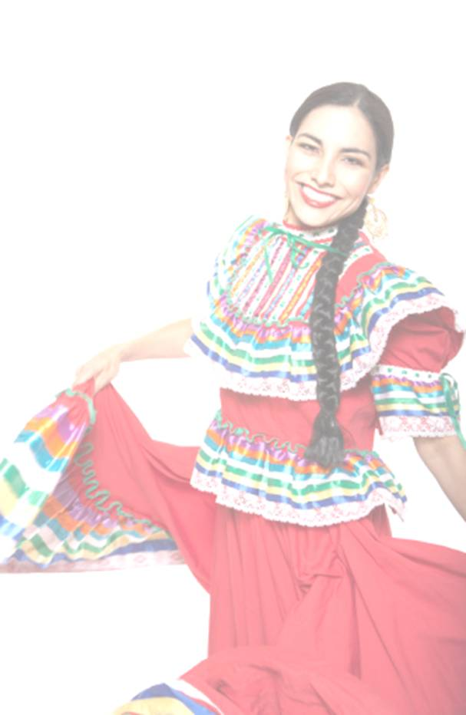
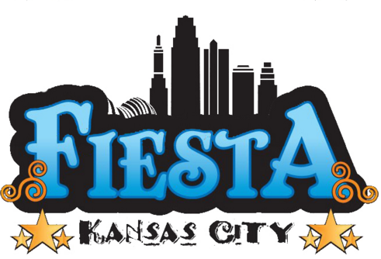

June 17th, 18th & 19th, 2016

Crown Center, Kansas City, Missouri

FIESTA KANSAS CITY SPONSORSHIPS

Presenting Sponsor - $25,000 (2 Available)
- Corporate booth on main stage level
- Company name and logo listed as Presenting Fiesta Sponsor
- Company logo on all television, radio and print Media
- Company logo on Fiesta Poster
- 30 Fiesta passes to be used all weekend
- 30 VIP passes to The View area (Includes food & drinks)
- Banner placements on both sides of main stage and street stage
- Stage mentions throughout the event
- 10 Minute presentation on main stage before main act
- Saturday Stage Night as Sponsor

Main Stage Sponsor - $10,000 (3 Available)
- Corporate booth on main stage level
- Company logo on Poster
- Company logo on all print and radio media
- Stage mentions on sponsoring day
- 5 Minute presentation on main stage before main act
- 25 Fiesta passes to be used all weekend
- 25 VIP passes to The View area (Includes food & drinks)
- Banner placement at Main Stage

Street Stage Sponsor (All 3 nights) - $5,000 (1 Available)
- Vendor booth
- Company logo on all print and radio media
- Stage mentions throughout the event
- 1 Minute presentation on street stage before main acts
- 10 Fiesta passes to be used all weekend
- 2 Banner placements at both sides of the Street Stage

FAMILY FUN ZONE (CHILDREN’S CORNER)
Family Fun Zone is an array of children’s activities that encompass face painting, hands crafts, large inflatables and other activities.

Family Fun Zone Sponsorship - $5,000 (1 Available)
- Company logo listed as the Family Fun Zone Sponsor on Fiesta Program
- Company logo listed as the Family Fun Zone Sponsor on Fiesta Website
- Company logo on all television, radio and print media
- Company logo on Fiesta Poster
- 10 Fiesta passes to be used all weekend
- 2 Banner placements – One on the Family Fun Zone area and one near the Main Stage (Banners must be provided by sponsor)
- Stage mentions throughout the event
- 1 Minute stage presentation on main stage

Family Fun Zone “Amigo” Sponsor – $500 (6 Available)
- Company logo listed as the Family Fun Zone Sponsor on Fiesta Program
- Company logo listed as the Family Fun Zone Sponsor on Fiesta Website
- 4 Fiesta passes to be used all weekend
- Banner placement on Family Fun Zone area (Banner must be provided by sponsor)
- Stage mentions throughout the event

“THE VIEW” (VIP AREA)

.

The View Sponsor - $3,000 (1 Available)
- Company logo listed as The View Fiesta Sponsor on Fiesta Program
- Company logo listed as The View Fiesta Sponsor on Fiesta Website
- Company logo on all television, radio and print media
- Company logo on Fiesta Poster
- 10 Fiesta passes to be used all weekend
- 10 VIP passes to The View (Includes food & drinks)
- 2 Banner placements - One on The View area and one to the side of the main stage (3x5 Banners must be provided by sponsor)
- Stage mentions throughout the event

The View “Amigo” Sponsor – $500 (6 Available)
- Company logo listed as The View Fiesta Sponsor on Fiesta Program
- Company logo listed as The View Fiesta Sponsor on Fiesta Website
- 2 Fiesta passes to be used all weekend
- 2 VIP passes to The View (Includes food & drinks)
- 2 Banner placements - One on The View area and one to the side of the main stage (3x5 Banners must be provided by sponsor)
- Stage mentions throughout the event

BELLAS ARTES (ARTISAN VILLAGE)

This area will showcase Kansas City’s Best Latino Art!

Art Demonstrations with youth participation will also be taking place throughout the Fiesta Weekend

Bellas Artes Sponsorship - $5,000 (2 Available)
- Vendor booth
- Company logo on Poster
- 10 Fiesta passes to be used all weekend
- Banner placement at Artisan Village

Bellas Artes Amigo Sponsorship - $500 (6 Available)
- Company logo on Poster
- 2 Fiesta passes to be used all weekend
- Banner placement at Artisan Village

MARGARITA COVE
This area will host Chamber Day event on Friday night.
The tent will feature 6 flavors of margaritas the entire weekend.

Margarita Cove Sponsorship - $5,000 (3 Available)
- Vendor booth
- Company banner placed Margarita Cove
- Company logo on all print and radio media
- 10 Fiesta passes to be used all weekend
- Stage mention throughout event

Margarita Cove Amigo Sponsorship - $500 (6 Available)
- 1 Banner displayed on Margarita Cove grounds (3x5 Banner provided by Sponsor)
- 4 Fiesta passes to be used all weekend

FIESTA KC CONTESTS

Jalapeño Contest $1,500 (1 Available)
This is the 13th year for this popular Contest at Fiesta Kansas City. 10 Contestants will compete to eat the most jalapeños in 1 minute. Contest entails 30 to 40 minutes of Stage Time.

- Company Representatives presented on Stage
- Banner Placement on Stage during Contest
- Company Representatives award prizes to Winners, 1st, 2nd, & 3rd.
- Company name listed as Sponsor in Entertainment Schedule
- 4 Fiesta passes to be used all weekend

Grito Contest $1,500 (1 Available)
This is the 5th year for this popular Contest at Fiesta Kansas City. 10 Contestants will compete for the best Grito (yell) judged by the audience. Contest entails 30 to 40 minutes of Stage time.

- Company Representatives brought up on Stage
- Banner Placement on Stage during Contest
- Company Representatives award prizes to Winners, 1st, 2nd, & 3rd
- Company name listed as Sponsor in Entertainment Schedule
- 4 Fiesta passes to be used all weekend

The Tortilla Fling $1,500 (1 Available)
10 Contestants compete to the best throw of three tortillas inside a Hula Hoop 30 foot away from stage. Contest encompasses 30 minutes of Stage time.

- Company Representatives brought up on Stage
- Banner Placement on Stage during Contest
- Company Representatives award prizes to Winners 1st, 2nd, & 3rd
- Company name listed as Sponsor in Entertainment Schedule
- 4 Fiesta passes to be used all weekend

FIESTA KANSAS CITY SPONSORSHIPS

T-Shirt Sponsor - $3,500 (1 Available)
- Company Logo (2 color) on Fiesta Volunteer T-shirts (T-Shirts for volunteers)
- Banner placement at Volunteer Tent.
- 6 Fiesta passes to be used all weekend

Ice Sponsor - $1,500 (1 Available)
- Sign with Company Logo on Ice Carts (Carts carry ice for all beverage and beer booths)
- Banner Placements at Pop and Beer Stands (2x4 Banners must be provided by Sponsor)
- 4 Fiesta passes to be used all weekend

Fiesta Padrino Sponsor - $1,000
- 2 Banners displayed on Fiesta grounds (3x5 Banners provided by Sponsor)
- 6 Fiesta passes to be used all weekend

Fiesta Amigo Sponsor $500
- 1 Banner displayed on Fiesta grounds (3x5 Banner provided by Sponsor)
- 4 Fiesta passes to be used all weekend

FIESTA KANSAS CITY DEALERSHIP SPONSOR PACKAGES

Elite Level Dealership Sponsor Package - $3,000 (All 3 nights)
- Company logo listed as The Elite Level Dealership Fiesta Sponsor on Fiesta Program
- Company logo listed as The Elite Level Dealership Sponsor on Fiesta Website
- Company logo on all television, radio and print media as The Elite Level Dealership Sponsor
- Company logo on Fiesta Poster
- Dealership tent within the Low Rider show room all weekend
- 10 Fiesta passes to be used all weekend
- 2 vehicles displayed within the Low Rider show room all weekend
- Security during event operation hours & throughout the night

Gold Level Dealership Sponsor Package - $1,500 (All 3 nights)
- Company logo listed as Gold Level Dealership Fiesta Sponsor on Fiesta Program
- Company logo listed as Gold Level Dealership Fiesta Sponsor on Fiesta Website
- Dealership tent within the Low Rider show room all weekend
- 6 Fiesta passes to be used all weekend
- 2 vehicles displayed within the Low Rider show room all weekend
- Security during event operation hours & throughout the night

Amigo Level Dealership Sponsor Package - $750/vehicle (All 3 nights)
- Company logo listed as Amigo Level Dealership Fiesta Sponsor on Fiesta Program
- Company logo listed as Amigo Level Dealership Fiesta Sponsor on Fiesta Website
- 2 Fiesta passes to be used all weekend
- 1 vehicle displayed within the Low Rider show room all weekend
Security during event operation hours & throughout the night

