IPSWICH, SUFFOLK
BAR/BISTRO OPPORTUNITY
TO LET
TOWN CENTRE LOCATION
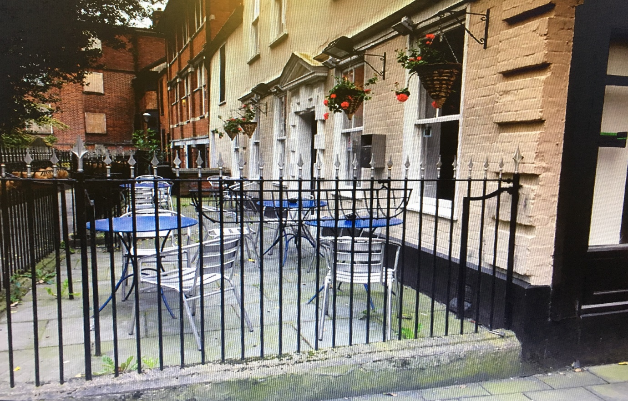
Church’s Bar Bistro
Tower Churchyard
Off Tavern Street
Ipswich
Suffolk IP1 3BW

LOCATION Located in Tower Churchyard, just off Tavern Street which is the main shopping thoroughfare of Ipswich Town Centre, Church’s Bar Bistro nestles within the precincts of Ipswich’s main Civic Church, St Mary-Le-Tower.

A popular venue for Lunch and Dinner, Church’s Bar Bistro’s main ground floor restaurant can accommodate 32 covers, with additional
function rooms on the first and second floors with seating for an additional 50 persons.

The property also benefits from a pleasant front terrace for al-fresco dining during the Summer months.

FLOOR AREAS: (all areas stated are approximate only) SQ.M SQ.FT

Ground floor 63.48 683
First Floor 42.42 456
Kitchen 8.06 86
+ Store & Preparation Rooms
Second Floor 41.33 445
TOTAL: 155.29 1,672
Separate Male & Female WC’s

TERMS: A new full repairing and insuring lease is available for a term of 20 years incorporating 5 yearly rent reviews.

RENT: £40,000 per annum exclusive.

VAT: VAT is chargeable on the rent.

BUSINESS RATES: Rateable Value: £15,750. Rates Payable: £7,764.75

EPC: An Energy Performance certificate is available upon request.

LEGAL COSTS: Ingoing tenant to be responsible for the Lessor’s legal costs.

VIEWING: Strictly by appointment with SOLE LETTING AGENTS:-
HARRIS COMMERCIAL SURVEYORS
(01473) 221222
www.harriscommercial.com

