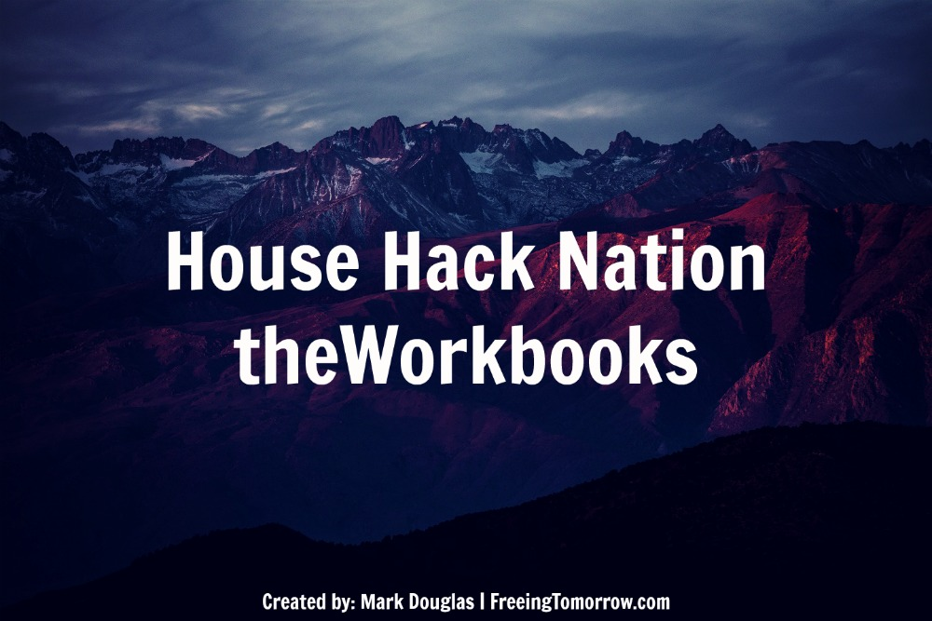
Workbook #1 – Three Things
I want to take a quick pause here, to do a little brainstorming.

Imagine this month, finding $400 between the couch (it could happen!).

After dancing in the street, you’d likely begin thinking of ways to wisely deploy that cache.

(See what I did there?)

These funds can now be used in conjuction with your regular earnings.

If you usually have $235 dollars left at the end of the month, this month you’d have $635 remaining!

This is essentially what house hacking gets you, when done properly.

The difference is, that it isn’t a chance occurrence, like finding a crumpled up $5 bill beneath the seat cushion.

House hacking ensures you have a reliable well, pumping out money each month, just for you.

Think about this: How cool would it be to have some (or all!) of your living expense covered by someone else?

What are three things you could immediately do with the money you’re currently spending on your rent/mortgage?

Here are a few examples to get you thinking:
- Pay down credit card + student loan debt
- Help fund a child's college tuition or wedding
- Save up to launch a food truck business or other lifelong endeavor
- Sponsor children through charitable organizations

Get creative here, these are YOUR dreams!

- I/We could: ___________________________________________________________________________________________________________________________________________________________________________________________________________________________________________________________________________________________________
- I/We could:
___________________________________________________________________________________________________________________________________________________________________________________________________________________________________________________________________________________________________
- I/We could:
___________________________________________________________________________________________________________________________________________________________________________________________________________________________________________________________________________________________________

