Welcome

This journal is designed to accompany the online training and to help you reflect and record your learning.

At the end of many of the lectures you will find a short task to help you relate what we have just covered to your school’s context. We have collated these tasks to create this reflective journal which you can either print out or save to your system to complete as you progress through the course. Don’t worry – the journal is entirely optional and does not form part of the assessment for your CPD certification (there is a test at the end for this).

Introduction

Before we start
Reflect on and answer the following questions:

- What is school for?

- What do pupils need to know – what is the best curriculum for my school?

- What attitudes and dispositions do I want my pupils to develop?

- What qualities do I want my pupils to have by the time they leave my school?

What is SMSC?

Task 1
Look at the word cloud graphic at the top of the page. Are there other words that you think are missing? You can ask your pupils to list the words that they would add to the cloud too. How do you already incorporate spiritual education into your day-to-day teaching? Make notes in your journal to reflect on later. 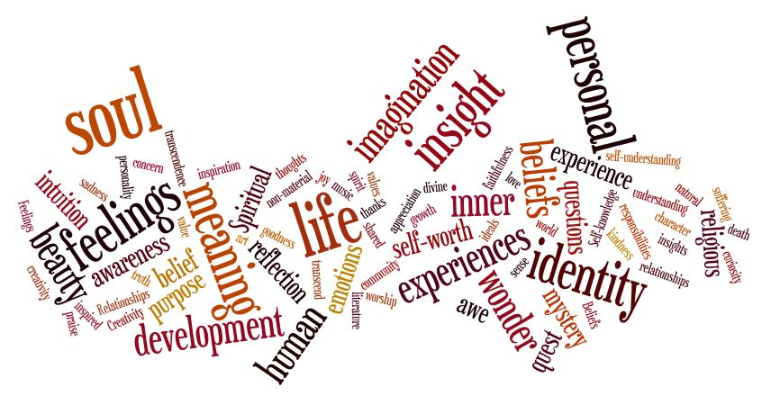

Task 2
Look at the word cloud graphic below. Are there other words that you think are missing? You can ask your pupils to list the words that they would add to the cloud too. How do you already incorporate moral education into your day-to-day teaching? Make notes to refer to again later.

Task 3
Look at the word cloud graphic below. Are there other words that you think are missing? You can ask your pupils to list the words that they would add to the cloud too. How do you already incorporate social education into your day-to-day teaching? Make notes to refer to again later.

Task 4
Look at the word cloud graphic at the top of the page. Are there other words that you think are missing? You can ask your pupils to list the words that they would add to the cloud too. How do you already incorporate cultural education into your day-to-day teaching? Make notes to refer to again later.

The SMSC Umbrella

Task 5
Think of a lesson that you recently delivered. Were there opportunities for pupils to engage with the SMSC development approaches listed below in an age and stage appropriate way? You might also want to revisit your lesson plan and note below where, and how, you can increase opportunities for SMSC development next time.
- Work in teams;

- Discuss, debate and critique ideas respectfully;

- Reflect on their own learning;

- Consider ethical implications and moral dilemmas;

- Explore the wonder of the natural world;

- Be represented and have their voices heard.

Task 6
Go back to the word clouds used in Tasks 1 to 4 where we look at what is meant by spiritual, moral, social and cultural education. Where do you think SMSC and fundamental British values overlap?

Task 7
Choose one of the five foundations of character education and list everything that you currently do within your school within this area. Consider how accessible and inclusive these opportunities are. What are some of the barriers to pupils accessing them and what can you do to overcome them?

Foundation of character education
What we already do
Barriers to access/inclusion
Ways of overcoming these barriers

Task 8
Look at the five ways in which you can improve your pupils' cultural capital mentioned below and consider what you already do, and what more you can do. Are there other things that you do to develop cultural capital with your pupils?
Ways to improve | What I already do | What more I can do
Expand their vocabulary

Address gaps

Encourage aspiration

Enjoy the creative arts

Encourage a sense of wonder

Anything else?

Task 9
Pick an area of the curriculum, or one of the EYFS seven areas of learning and development, and in your journal brainstorm all the ways that you can think of to include, highlight and evidence SMSC learning within it.

Subject
How to include SMSC in the curriculum area
How to highlight SMSC in the curriculum area
How to evidence SMSC in the curriculum area

SMSC Standards

Task 10
What are the next steps you will take to support SMSC in your teaching?
Immediate tasks  (eg this month) | Intermediate tasks  (eg 2-6 months) | Long term tasks  (eg in the year)

Task 11
Write the name of your SMSC coordinator at school. Think of some key things that you would like to talk to them about SMSC and how your school moves forward with it?

Task 12
Look at the Ofsted indicators and consider how well your school is doing in each area. List the ways in which you can improve your school's personal development provision for each of the indicators.

Ofsted indicators | Ways to improve quality | Ways to improve intent | Ways to improve impact
Breadth, quality and take-up of  extra-curricular activities | 1.  2.  3. | 1.  2.  3. | 1.  2.  3.
How subjects such as citizenship and RE, and areas such as PSHE, support pupils’ personal development | 1.  2.  3. | 1.  2.  3. | 1.  2.  3.
How well leaders promote British values through the curriculum and broader activities development | 1.  2.  3. | 1.  2.  3. | 1.  2.  3.
How well leaders develop pupils’ character through education provision | 1.  2.  3. | 1.  2.  3. | 1.  2.  3.
The quality of debate and discussions | 1.  2.  3. | 1.  2.  3. | 1.  2.  3.
Pupils’ understanding of protected characteristics and how equality and diversity are promoted | 1.  2.  3. | 1.  2.  3. | 1.  2.  3.

NOTES

NOTES

