www.robinbooth.co.za  WRITE YOUR SITUATION  UNDERNEATH HERE | 3 good reasons- convince me  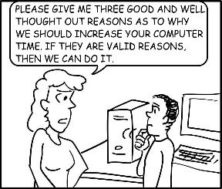 | How can I support your plan  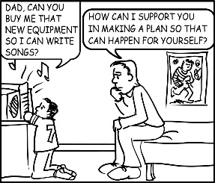 | Finding the CORE NEED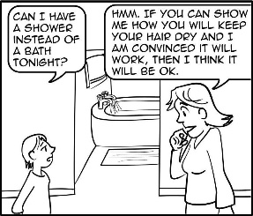 | Acknowledging Emotions  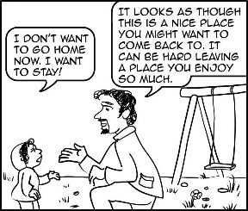
1
2
3
4
5

