Getting Started with CreateSpace

(Note: The Following was written prior to the introduction of Kindle Print. We will be posting a separate lesson about using Kindle Print. However, there are still some advantages to using CreateSpace at the moment. You can obtain extended distribution beyond Amazon and you can order author copies at a discount. So, I’m including this chapter about setting things up on CreateSpace. I do suspect, though, that Amazon is phasing out CreateSpace as a platform and will be migrating everything to Kindle. They already did something similar to their video component by creating Amazon Video Direct.)

Creating a print book using CreateSpace is time-consuming, but easy if you want to commit to the process. There are no "technical skills" necessary. You can do everything just using your word processor and the conversion tools on the CreateSpace site. So, let's start with the process of setting up your first book on the site. As an example, I'm going to upload my novel Death Gets an "F." It has been out as an ebook for more than a year, so I might as well make it a paperback as well.
We are going to assume you have already logged in at http://www.createspace.com with your Amazon credentials or set up a separate account. They will ask for all the basic information including tax information and bank account so you can get paid.

The Member Dashboard

When you log in you get a screen that looks like this:
Royalties
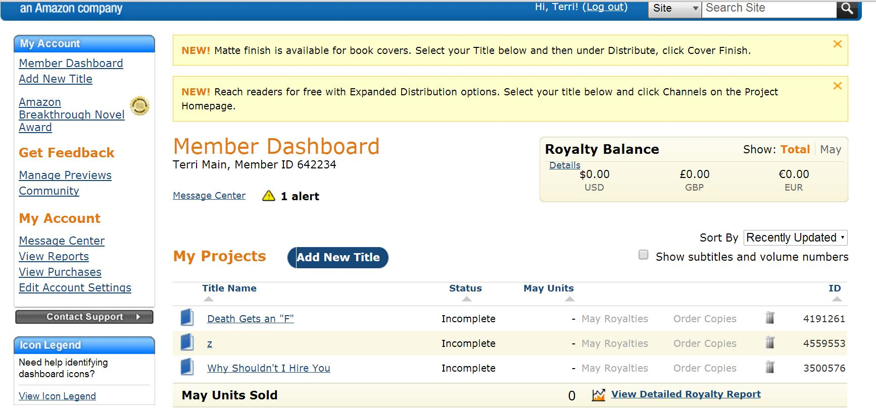
Quick Navigation
Add New Title
Projects
Message Center

This is your dashboard. You have access to all of your books here. You can get accounts of your current royalties, jump to different parts of the site, be notified of messages from CreateSpace and add new projects.
I suggest that you follow along with a project you might want to publish. Even if it is not yet ready, you can do a test and just stop short of actual publication until it is ready.
To get started click on The Add New Title button.

Start Project

When you click the Add New Title button, you get this screen.

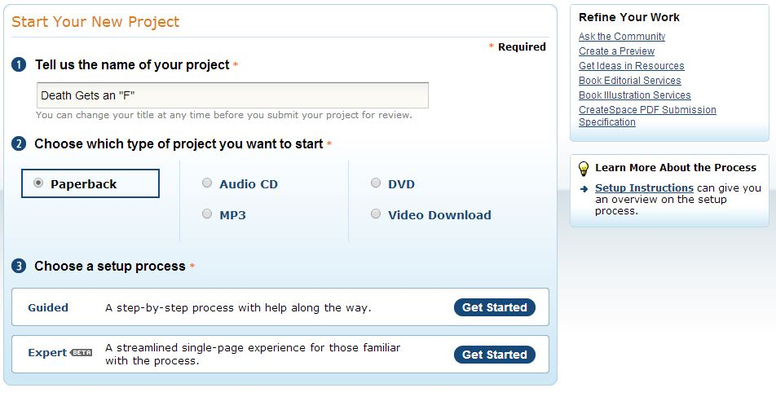
Here you just enter a name for the project and identify the type of project you are doing. We are doing print on demand, but you can also create audio and video projects as well.
You have a choice of how to go through the setup process. We are going to select guided, but once you get used to how CreateSpace works you can click on the "expert" version and streamline the process.

Title Information

At this point, you get a screen that asks for the title of your book. This is the actual title that will be listed on Amazon. You will also add your name and any subtitles and series titles you might have. You can also set a publication date. Think about this section carefully. It is locked in once you publish the book. So give it serious consideration.

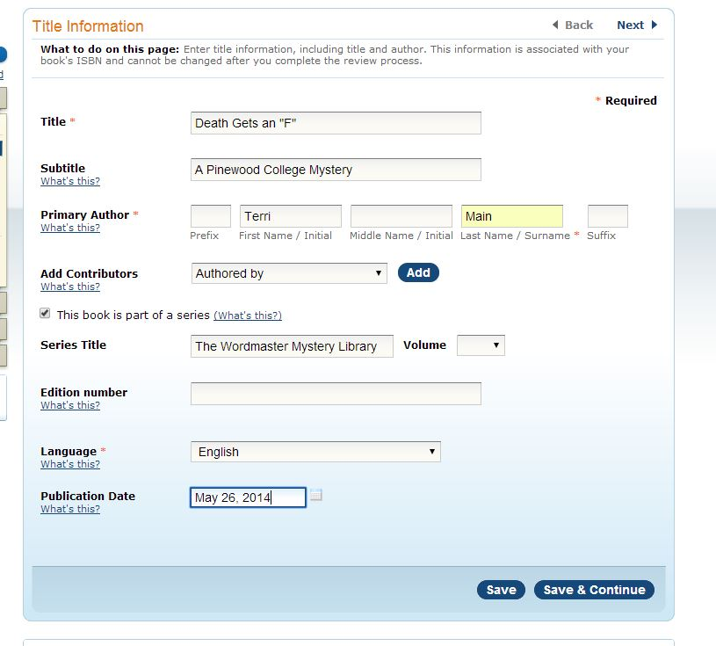

Obtain ISBN

ISBN stands for International Standard Book Number. It's a unique number that identifies your book. If you bought an ISBN for your ebook, you CANNOT use it for your print book. Every edition of a book has a unique ISBN.
Fortunately, CreateSpace has low-cost options.

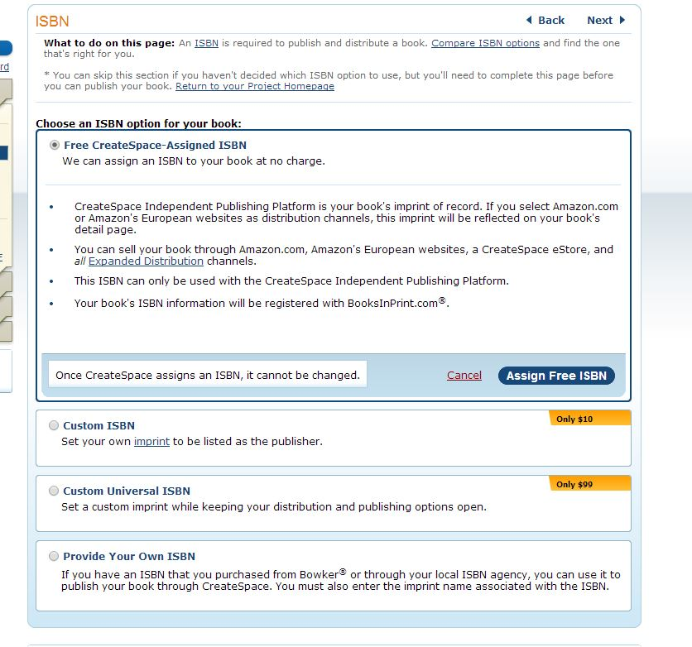

You can get a free ISBN, but your book's imprint of record will be "CreateSpace Independent Publishing Platform." That will be your publisher name. I don't mind for this book, but for others, I like to have a custom name. That cost just $10. If you have your own ISBN, you can use that one. There are different distribution options that go with the ISBNs. There are some advantages of going with the free option and others with the $10 one. There is also a premium option for $99. It provides more distribution options. However, you may not need those options. For most of us, the free or $10 option is enough.

You are now set up to begin working on the interior of your book. We will begin to cover that part of the process in our next lesson.

