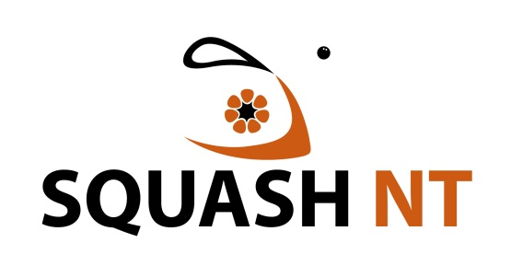
Code of Behaviour

The following outlines the code of behaviour for everyone involved in Squash in the Northern Territory.

• Operate within the rules and spirit of your sport, promoting fair play over winning at any cost.
• Encourage and support opportunities for people to learn appropriate behaviours and skills.
• Support opportunities for participation in all aspects of the sport.
• Treat each person as an individual.
• Display control and courtesy to all involved with the sport.
• Respect the rights and worth of every person regardless of their gender, ability, cultural background or religion.
• Respect the decisions of officials, coaches and administrators in the conduct of the sport.
• Wherever practical, avoid unaccompanied and unobserved one-on-one activity (when in a supervisory capacity or where a power imbalance will exist) with people under the age of 18yrs.
• Adopt appropriate and responsible behaviour in all interactions.
• Adopt responsible behaviour in relation to alcohol and other drugs.
• Act with integrity and objectivity, and accept responsibility for your decisions and actions.
• Ensure your decisions and actions contribute to a safe environment and harassment free environment.
• Do not tolerate harmful or abusive behaviours.

Athletes
• Give your best at all times.
• Participate for your own enjoyment and benefit.

Coaches
• Place the safety and welfare of the athletes above all else.
• Help each person (athletes, officials etc) reach their potential - respect the talent, developmental stage and goals of each person and compliment and encourage with positive and supportive feedback.
• Any physical contact with a person should be appropriate to the situation and necessary for the person’s skill development.
• Be honest and do not allow your qualifications to be misrepresented.

Officials
• Place the safety and welfare of the athletes above all else.
• Be consistent and impartial when making decisions.
• Address unsporting behaviour and promote respect for all people.

Administrators
• Act honestly, in good faith and in the best interests of the sport as a whole.
• Ensure that any information acquired or advantage gained from the position is not used improperly.
• Conduct your responsibilities with due care, competence and diligence.
• Do not allow prejudice, conflict of interest or bias to affect your objectivity.

Parents
• Encourage children to participate and have fun.
• Focus on the child’s effort and performance rather than winning or losing.
• Never ridicule or yell at a child for making a mistake or losing a competition.

Spectators
• Respect the performances and efforts of all people.
• Reject the use of violence in any form, whether it is by spectators, coaches, officials or athletes.

