Insights and Added Information on Mark
INSIGHTS

Identify yourself to yourself as a disciple of Jesus. You are a disciple first, before anything else.

Each day in each situation, think, “I am a disciple of Jesus” — chosen to walk with him, observe him, be taught by him, imitate him, support him, and companion with him. Remember to identify yourself in this way. How can I cast my net today? Watch for opportunities that are natural and easy. Pray for opportunities to fish for men today.
The two sets of brothers (chapter 1) stopped fishing for fish, and started fishing for men as soon as Jesus called. They “left their [fishing] nets” immediately — traded them for the Christ-net of Love. Later, they went back to fishing (after the crucifixion and resurrection), and they “caught nothing.” Jesus appeared and called to them from the shore. He told them to “cast [their] nets on the right side.” After fishing all night in the best conditions, they had empty nets, but now, suddenly, the net was so full of fish that they could barely bring it in.
CAST YOUR NET ON THE RIGHT SIDE
At this moment you may either leave your ordinary net or you can cast it on the right side.
Casting your net on the right side (not the wrong side), means to spiritualize your thought. Think spiritually as Jesus did, then you will “catch” — be successful — in whatever you are doing. If you put Christ first, keep your spiritual eyes and ears open to see and hear, the Spirit will direct your path. Remember that as his disciple/apostle, you have been given power to “heal the sick, cleanse the lepers, raise the dead, cast out devils” (Matthew 10:8). These are the “signs that follow them that believe” (Matthew 16:17). You include these elements of grace in your very being and can exercise this spiritual power anywhere at any time — wherever you are, whatever you are doing — you are first and always a disciple that can heal and save. You are commissioned, “Go into all the world, and preach the gospel to every creature” (Mark 16:15).

REALIZE THAT YOU POSSESS THE GIFT OF SPIRITUAL POWER TO HEAL
Jesus promises, “The works that I do shall ye do also” (John 14:12). It is not personal power; it is innate in your eternal spiritual being. This power of God, Good, is within you.

Jesus has bestowed this healing power on his disciples in a perpetual prayer that rests on all that believe, that spiritually understand Jesus, his teachings, the true nature of the infinite God (Love), and man in His likeness.

Our Master’s powerful prayer rests upon you, “And these signs shall follow them that believe; In my name shall they cast out devils; they shall speak with new tongues; They shall take up serpents; and if they drink any deadly thing, it shall not hurt them; they shall lay hands on the sick, and they shall recover” (Mark 16:17-18).The power of the Christ is realized as you cast your net on the right side, the spiritual side of things, now.

John 16:23. Verily, verily, I say unto you, Whatsoever ye shall ask the Father in my name, he will give it you.

Mark 11:23 For verily I say unto you, That whosoever shall say unto this mountain, Be thou removed, and be thou cast into the sea; and shall not doubt in his heart, but shall believe that those things which he saith shall come to pass; he shall have whatsoever he saith.
ADDED INFORMATION ON MARK

In The Complete Gospels, or Scholar’s Version (SV), every known gospel or fragment of writing that has been found concerning Jesus is translated into English.

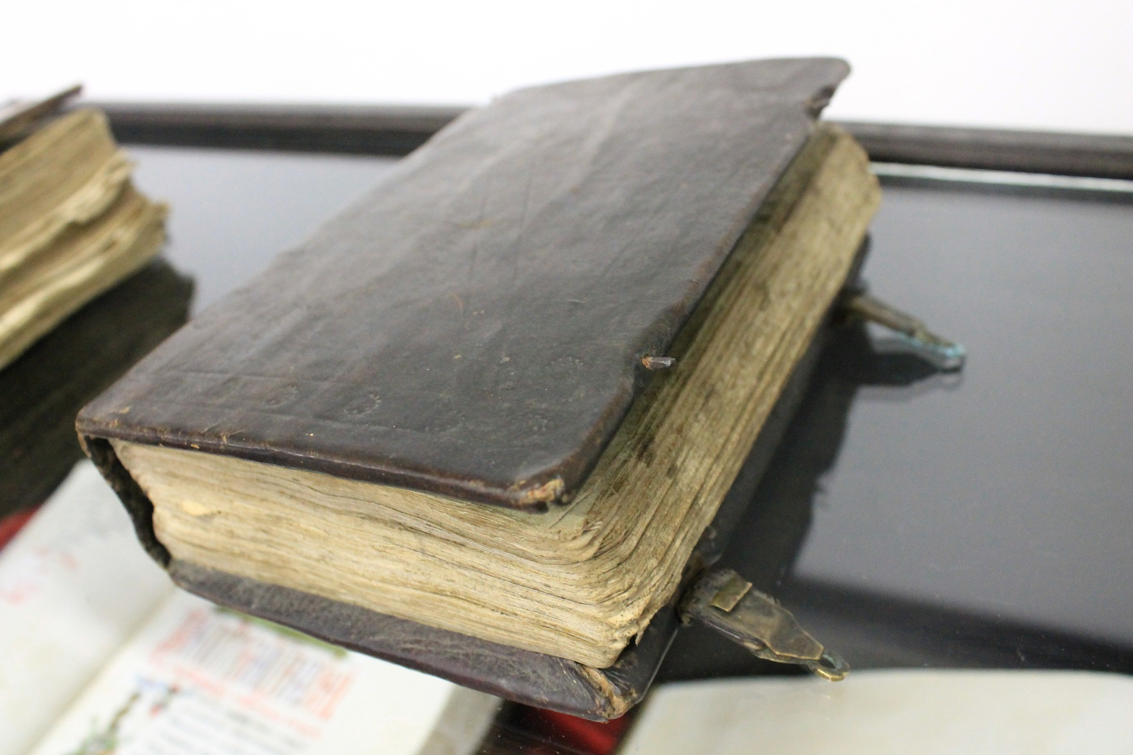
From a letter by early Church father, Clement, second century Alexandrian theologian, (and according to local tradition in Alexandria), it has been discovered that there were two versions of Mark’s Gospel — one for public use written in Rome (canonized), and a “secret” Gospel for “a narrow circle of initiates” written in Alexandria (409). Clement cites two passages from the “Secret Gospel of Mark.” Without these, the entirety would have been unknown.

In the first passage, Jesus raises a man from the grave in response to the man’s sister’s plea. It is placed between verses 34 and 35 in chapter 10. The second passage mentions Salome and is found between 10:46 and 47. These are the only passages left to us, and we have them simply because they were written by Clement to make a point in a letter to his friend.

FRAGMENT 1: Clement to Theodore, Folio 1, verso, line 23 — Folio 2, recto, line 11.

1. “And they come into Bethany, and this woman was there whose brother had died. 2. She knelt down in front of Jesus and says to him, Son of David, have mercy on me.” 3. But the disciples rebuked her. 4. And Jesus got angry and went with her into the garden where the tomb was. 5. Just then a loud voice was heard from inside the tomb. 6. Then Jesus went up and rolled the stone away from the entrance to the tomb. 7. He went right in where the young man was, stuck out his hand, grabbed him by the hand, and raised him up. 8. The young man looked at Jesus, loved him, and began to beg him to be with him. 9. Then they left the tomb and went into the young man’s house. (Incidentally, he was rich.) 10. Six days later Jesus gave him an order; 11. and when evening had come, the young man went to him, dressed only in a linen cloth. 12. He spent that night with him, because Jesus taught him the mystery of God’s domain. 13. From there [Jesus] got up and returned to the other side of the Jordan” (411).

FRAGMENT 2: To be located between 10:46a (“Then they came to Jericho”) and 10:46b (“As he was leaving Jericho…”). Clement to Theodore, Folio 2, recto, lines 14-16

1. “The sister of the young man whom Jesus loved was there, along with his mother and Salome, 2. but Jesus refused to see them.

Footnotes in the SV on these passages say that this young man plays an important role in Mark. The story of his resurrection serves to foreshadow Jesus’ resurrection. “Gave him an order “ means gave him instructions. “… dressed only in a linen cloth” — uses the same wording as Mark 14:51 — scholars believe the young man to be Mark himself. Some believe the “linen cloth” to be baptismal garb. The “young man” was the same as in the first passage (411).

Mark, the young man who saw Jesus for a few moments on the way to the cross, was forever transformed by that brief encounter. Go within consciousness and ask the Christ to come to you. Be transformed in the actuality of that Light, that Life and Love of Spirit that dwells eternal in the center of your being. Ask for and feel after its transforming and purifying power.

