REPORT ON 2018 ESRA OPEN RACQUETBALL CHAMPIONSHIPS
The 2018 edition of the ESRA Open Racquetball Championships, played out at the totally refurbished Westerfolds Bayswater Squash and Racquetball Centre, was highlighted by the Dromana Dynamo Steve Andrewartha’s continued outstanding form from the past two years and claiming ‘back to back’ ESRA Men’s Open titles, and seven times Australian Open Champion Judy Wright annexing her first ESRA Women’s Open Crown after losing out in the final in 2016 & 17 to top guns Sarah Fitz-Gerald and Christine Nunn respectively.
MEN’S OPEN
Although the Men’s Open was missing sixteen times National Open champion Cam White, a stellar field still assembled.
Whilst top seeded Andrewartha was proving impregnable in the top half of the draw, perennial finalist third seeded Garry Pedersen was back to his best form cutting a swathe through the bottom half, including toppling second seeded Geelong stable mate Peter French in the semi final, 22/20, 21/16.
In his penultimate match, Andrewartha overcame local favourite Ryan McCarter, 21/10, 21/12, to advance to the final stanza where he was virtually never headed by Pedersen, through his impeccable driving tightness and length, plus a very accurate short game.
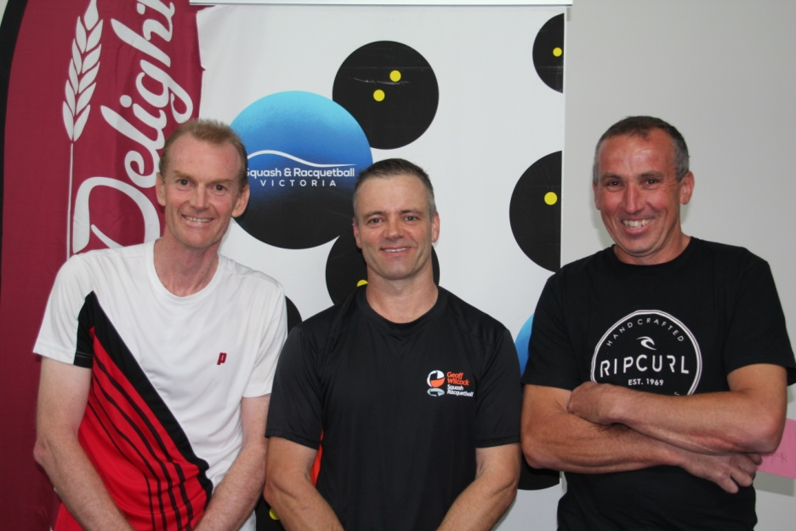
Garry Pedersen, Steve Andrewartha & Peter French
WOMEN’S OPEN
Although 2017 ESRA Open winner Sarah Fitz-Gerald was missing, great anticipation still surrounded this year’s event with seven times Australian Open Women’s champion, and 2016/17 ESRA Open runner-up Judy Wright, seeded to meet National and Victorian Grand Prix champion Kristel Proctor in the final, but this outcome did not eventuate.
Over the past three years it has taken someone very special to deny Wright the winners crown in Women’s Open titles, and it has only happened twice, on both occasions in this event, 2016 by Sarah Fitz-Gerald and last year by Christine Nunn, so was the 2018 edition of this event going to be hers to saviour.
In their respective semi finals, Wright overcame Aeron Skidmore, 21/6, 21/7, whilst Sue Dunlop won a titanic struggle over Proctor, 21/18, 19/21, 21/9, avenging her loss to Proctor in the final of the 2017 Ballarat Open.
In the final, Wright took control early and never relinquished her lead to take out an entertaining final over Dunlop,21/13, 21/16, and claim her first ESRA crown.
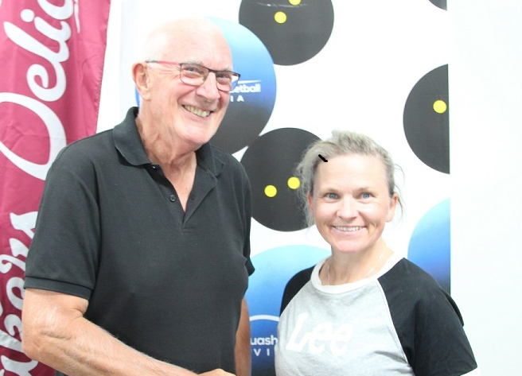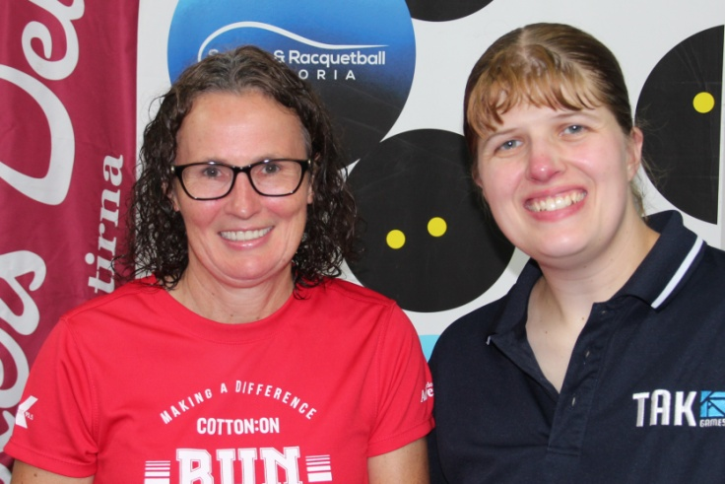
Ian Chalmers & Judy Wright Sue Dunlop & Kristel Proctor
A Grade
Following his domination of A Grade events in 2017, Anthony Hain was kindly escorted into the Men’s Open ranks for this year, leaving what looked on paper a wide open A Grade field, although very little was known of Englishman Daniel Lewis who played Racketball, the English version of our game, in his home country.
Lewis ended up being the event’s wildcard, eliminating third seeded Matt Bayley in the quarters, 21/22, 21/12, 21/12, then second seeded Rob Hay in the semi’s, 21/19, 21/15.

Meanwhile top seeded and 2017 Victorian Open runner up Dean Milligan was putting the blowtorch to Tim Paramore and Craig Royale- Young on his side of the draw, both in straight games to reach the event’s climax.
The first game of the final went point for point until Lewis broke clear right at the end, then established an early lead in the second which he steadily increased to secure the match, 21/19, 21/10.
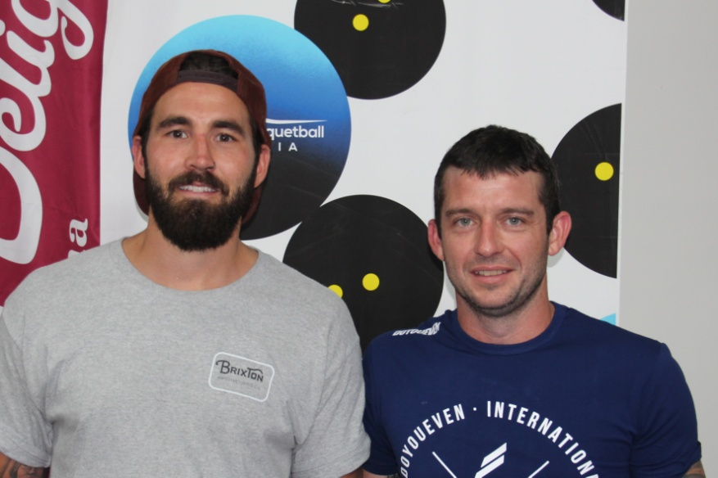
Daniel Lewis & Dean Milligan

B Grade
A very even field of ten faced the starter for this event with most interest focussing on Ballarat’s Blake Caspersz and how he would transition from his dominance of C Grade events in 2017 into B Grade this year.
Well it did not take long for Caspersz to demonstrate that he is going create havoc in B Grade this year, removing second seeded Jason Hawkins in the quarters, and then third seeded Lance Cowan in their semi final, both in three games and after coming back from a game down.
In the top half of the draw the top seed was former world deaf squash champion Peter Walters, who was returning to tournament play after a six month absence due to injury, but after surviving a 117 point marathon, 21/19 in the third game against Marcus Horvat in their quarter final encounter, he succumbed to Lakes Entrance’s Steve Theologou in the semi’s, 21/14, 21/14.
The final was literally a “last man standing affair”, and after nearly seventy five minutes of unbelievable rallies, comebacks and counter punching, Theologou was able to claim the one hundred and sixteenth point and the title, 21/16, 21/22, 21/15.
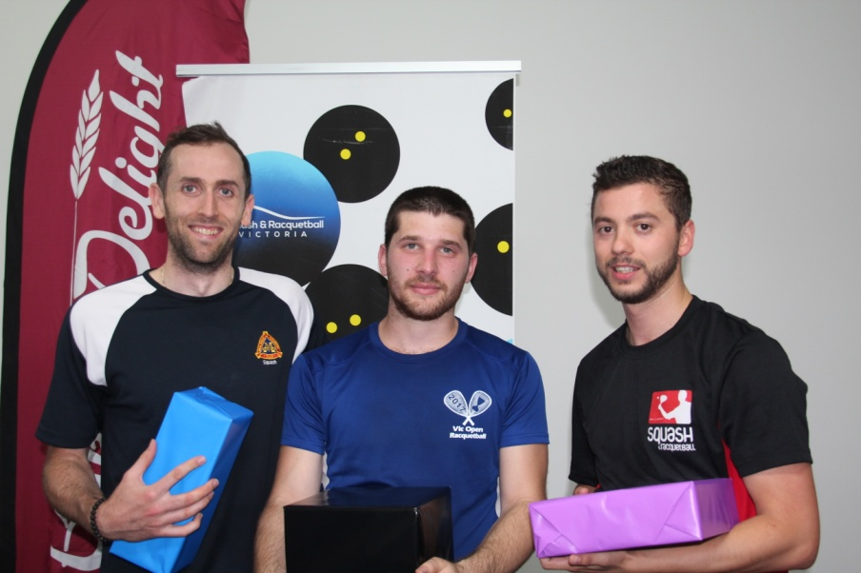
Matthew Tench, Steve Theologou & Blake Caspersz
C GRADE
Anthony Dzioba made his Grand Prix debut in 2017 playing in three C Grade events, but getting some tough draws along the way, although making steady improvement highlighted by his close loss in the Australian Open at the quarter final stage to C Grade GP champion Blake Caspersz.
This time Dzioba went all the way, overcoming sixth seeded Denise Skidmore in the quarters, second seeded Ross Falconer, 21/12, 21/10 at the semi final stage, then Mulgrave’s David Bayley, who was making his GP debut, in the final, 21/14, 14/21, 21/15.
To reach the final climax Bayley had ousted top seeded Rayleen Cooper, and fifth seeded Brandon Morgan, both in straight games.
Co-incidentally, David’s brother Matt made his GP debut in these championships last year in C Grade, also losing in the final with very similar total points scores to David’s this year, 109 points to 106. Matt then moved into B Grade, and in 2018 was elevated into A Grade events. Will a similar path unfold for David?
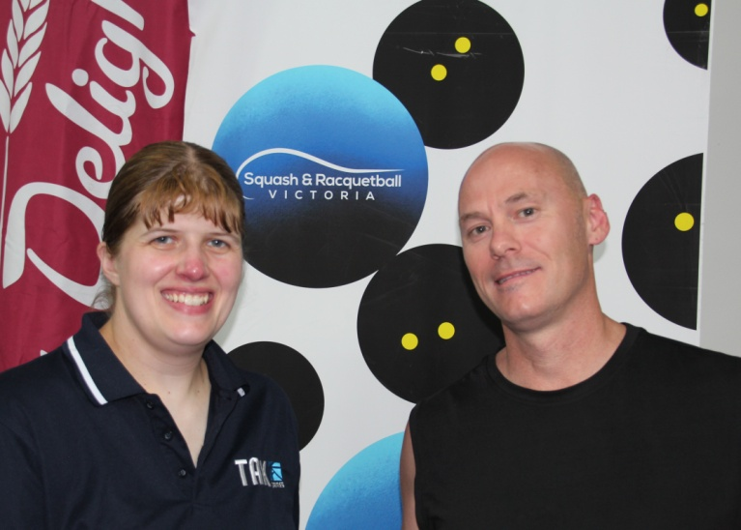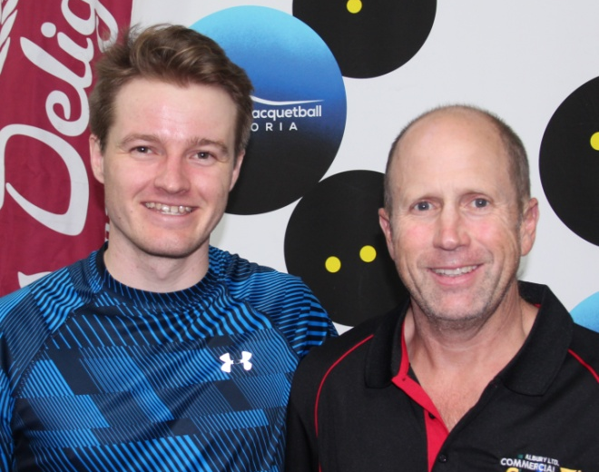
Kristel Proctor & Anthony Dzioba David Bayley & Michael Brigden
D GRADE
This event contained our lovely and indefatigable “Godmother” of the sport, Wangaratta’s Heather Meldrum, plus three young teenagers and a sprinkling of players rising through the ranks, but in the end it was one of the teenagers who went all of the way, Wodonga’s sixteen year old Jordan Tamburini who held out Bairnsdale’s third seeded Chris Kool in the final stanza, 21/15, 21/4.
In their respective semi finals, Tamburini in a marathon literally fell over line against fourteen year old Alex Brigden, 21/11, 17/21, 22/21, whilst Kool put paid to a fairytale ending for second seeded Meldrum, 21/11, 11/21, 21/17.
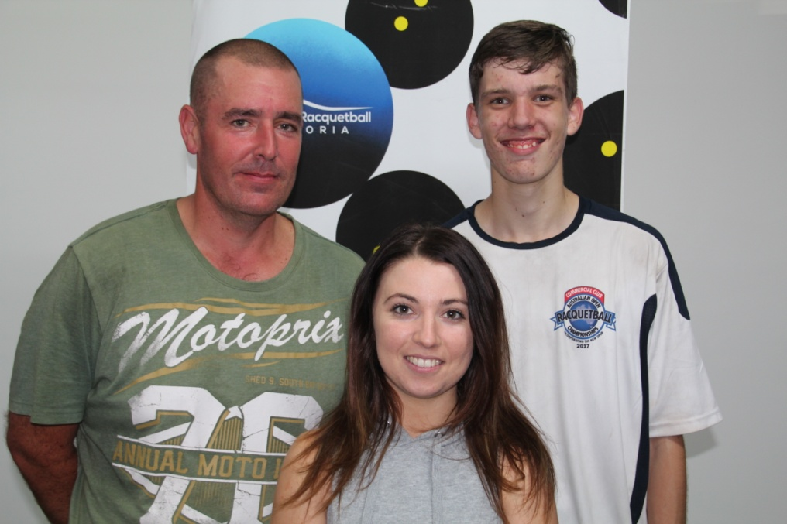
Chris Kool, Janita Theologou & Jordan Tamburini
E GRADE
Three juniors and two local stalwarts faced off in the five player round robin, but In the end it was Mt. District’s Heather Cook who showed both talent and stamina to claim the title winning all four long and exhausting matches, with Wodonga’s thirteen year old Zach Tamburini finishing in second place with three wins, and Commercial Clubs Lillian Brigden filling third place with two wins.
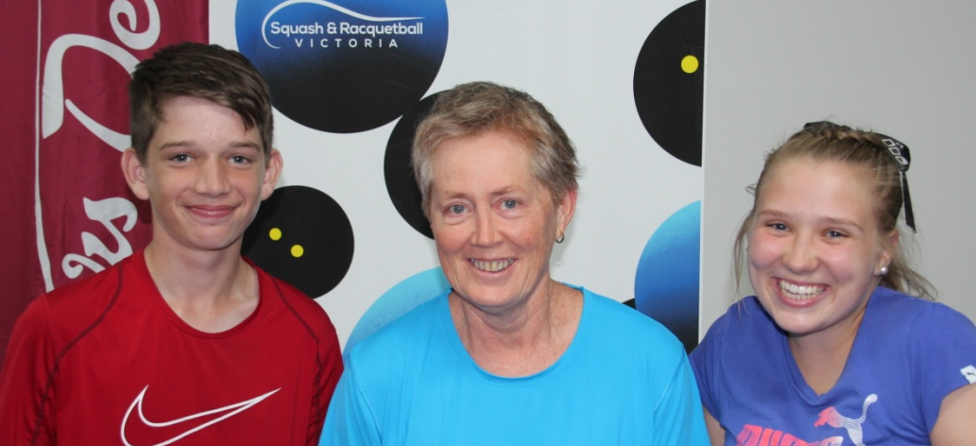
Zach Tamburini, Heather Cook & Lillian Brigden
F Grade
This was a Corio versus Tonic Dromana round robin event with Tonic’s GP debutant Jacqui Wilcock coming out on top winning all three matches, the most important being over her sister Jessica, relegating her to second spot, and claiming bragging rights for the long drive home.
Shane Skidmore & Jacqui Wilcock Shane Skidmore & Jessica Wilcock
Junior Under 13’s
Mt. Districts Jordan Brook defeated Commercial Club’s Amelia Brigden, 21/13, 21/10, to win the junior girls crown, and Commercial Club’s Xavier Brigden overcame Bairnsdale’s Harry Kool, 21/5, 21/9, to record ‘back to back’ ESRA junior boy’s titles.
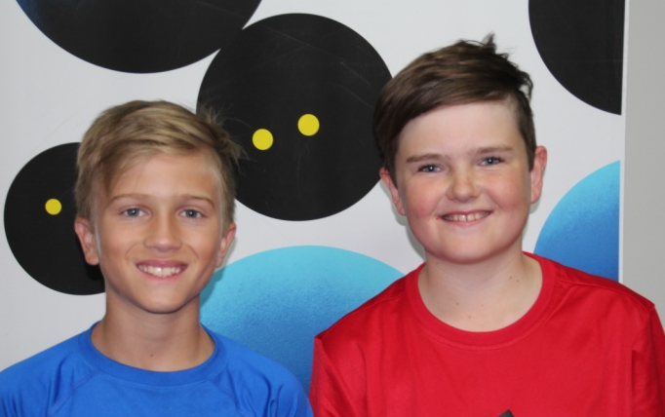
Jordan Brook & Amelia Brigden Xavier Brigden & Harry Kool
DOUBLES EVENTS WINNERS AND RUNNERS UP
OPEN
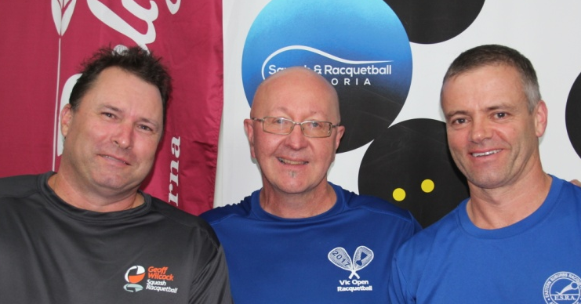
Geoff Wilcock, Shane Skidmore & Steve Andrewartha Cameron Morris, Shane Skidmore & Nathan Patterson
A GRADE
Shane Skidmore, James Long & SimonBinda
B GRADE
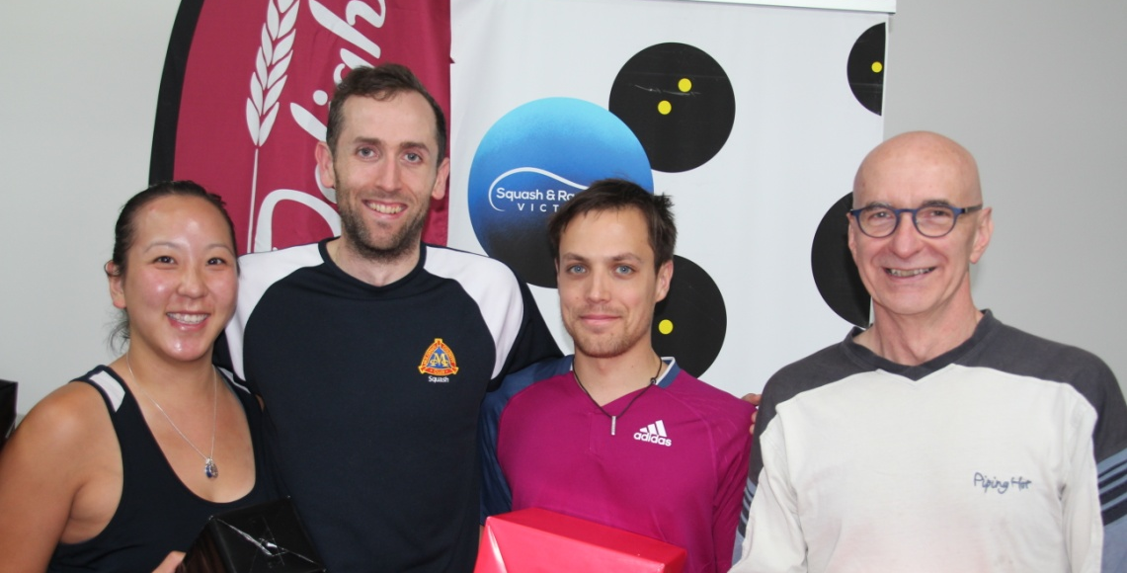
Sylvia Tiet, Matthew Tench, Lance Cowan & Marco Premoselli

C GRADE
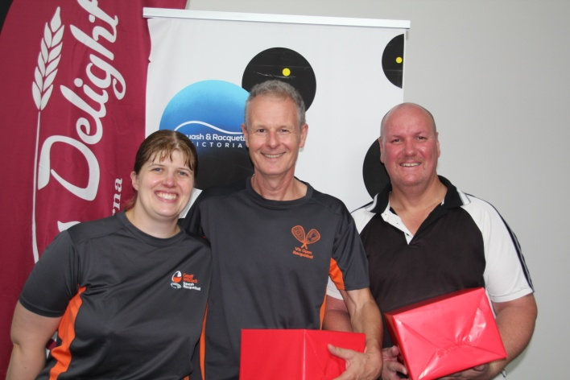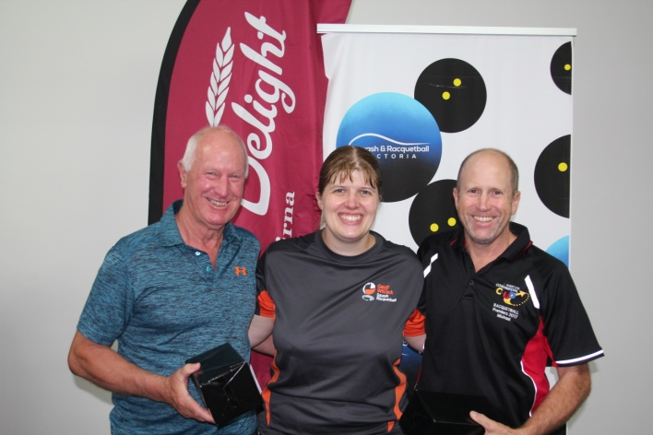
Kristel Proctor, Lao Biesbroek & Kent Beveridge Ross Falconer, Kristel Proctor & Michael Brigden
D GRADE
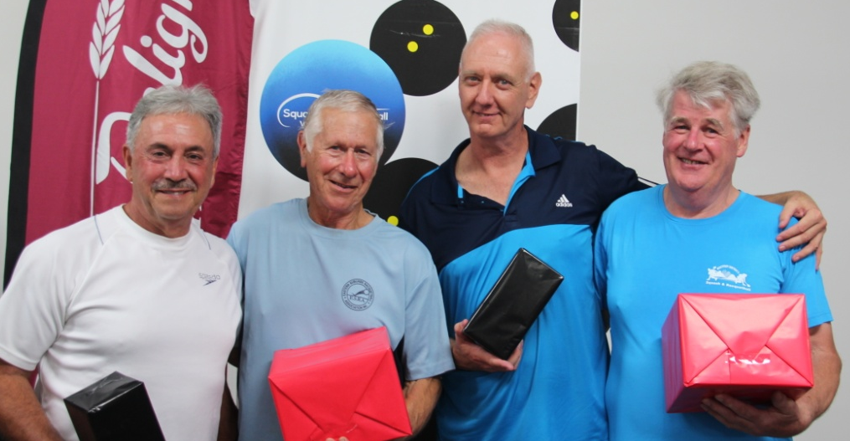
Charles Gargoura, Tim Hill, Phil Alger & Don House,

E GRADE
Kristel Proctor, Amelia & Lillian Brigden Jacqui & Jessica Wilcock

SINGLES
Grade | Winner | Runner-Up
Men’s Open | Steve Andrewartha | Garry Pedersen
Women’s Open | Judy Wright | Sue Dunlop
A | Daniel Lewis | Dean Milligan
B | Steve Theologou | Blake Caspersz
C | Anthony Dzioba | David Bayley
D | Jordan Tamburini | Chris Kool
E | Heather Cook | Zach Tamburini
F | Jacqui Wilcock | Jessica Wilcock
Junior Girls | Jordan Brook | Amelia Brigden
Junior Boys | Xavier Brigden | Harry Kool

DOUBLES
Grade Winner Runner-Up
Open S. Andrewartha/G. Wilcock C.Morris/N. Patterson
A J. Long/S.Binda None
B M.Premoselli/L.Cowan S. Tiet/M.Tench
C L. Biesbroek/K. Beveridge M.Brigden/R.Falconer
D T.Hill/D.House P. Alger/C. Gargoura
E Lillian & Amelia Brigden Jacqui & Jessica Wilcock

Words: Paul Vear
Photos: Courtesy of Jodi Wilkinson
Special Presenters: Kristel Proctor, Shane Skidmore & Ian Chalmers

