Your Personal Ideas Notebook for
The Life You’d Love to Live
Let’s start!
Module 1: What Could the Life You’d Love Include?
By
Heather Powell
www.heatherkpowell.com
Hello and Welcome!
Retirement is a change in daily life with the habits and patterns of activity we knew being put aside. Changing to a different mode can allow us to focus and actively choose a life we want. This short program will start you on your way.
Each module has a video, a notebook and a star template PDF where we will summarize the insights found in our personal notebook. Eventually we will create a 1-page star template for each module so we can see at a glance where we are on our journey.

In this first module of 4, we explore aspects of the life you’d love.
I look forward to sharing the journey with you.
May You and Your life flourish
Heather
Contents
Introduction 2
1.1 WHO is in the Life You Love? 3
1.2 WHERE is the Life You Love? 4
1.3 WHAT is your health like in the Life You Love? 5
1.4 WHAT is Your Abundance Like in the Life You Love? 6
1.5 WHAT are You Doing in the Life You Love? 7
1.6 WHY Are You Doing It in the Life You Love? 8
1.7 Collecting a Vision of the Life You Love 9
1.8 Some Further Thoughts About the Vision of the Life You Love 9
A Sneak Peek at the next steps 9
Appendix 10

Introduction
This notebook is where you collect info to start from.
  - Ideas, thoughts, feelings, brain-storm, brain-dump, rough draft or journal.
These are your own, ‘not-seen-by-anyone-unless-you-show-them’ notes.
- Absolutely as secret as you wish.
- For you to keep, or to tear up when you finish with them.
- To file as precious, or come back to.
So you can record freely, uncensored.
- Write
- Draw
- Create
- Type
- ‘talk and record audio’
- ‘talk-to-text’ it to your device, etc.
Use some way to record any and all stuff that comes up from your subconscious mind as well as your conscious top-of-mind stuff.
How can you most easily let thoughts flow unchecked onto a record? Choose the method which feels easiest for you.
All info is valuable. If something comes to your notice or into your mind, it’s because part of you has this info stored. Put together, all the info from all parts of you supports [or doesn’t!] you to move to the life you’d love.
Let’s find the best way for you now.

1.1 WHO is in the Life You Love?
Start writing/drawing/talking about ONLY those people you REALLY want as this is about the life you’d love.
It may include just yourself, or a significant other, romance, a family, friends, community, work colleagues, inspiring figures, role models, people and/or animals etc.

Qualities they embody:
How I relate with them is important. I look for qualities of support, appreciation, respect and love - for me, and that I can offer them.
What qualities do they represent which are so important to you?

1.2 WHERE is the Life You Love?
Is it in a city, in an apartment, or the suburbs, on a lifestyle block, a farm, village, in the mountains, by the seaside, in a forest, or a traveling home?

1.3 WHAT is your health like in the Life You Love?
Physical, Mental, Emotional, Spiritual, your heart?

What level of personal growth or excitement, of challenge, gives you the thrill of being alive?

1.4 WHAT is Your Abundance Like in the Life You Love?
Financial wealth,
The flow of money in and out; and what stays in the bank?

Your Surroundings: material wealth, possessions, the vibrant natural world around you? Anything else you treasure – people, memories, knowledge?

1.5 WHAT are You Doing in the Life You Love?
How do you occupy your days?
In paid employment you love, your own thriving business, service-oriented working for your community or society, learning, creating; hobbies, interests or passions?

What stretches and challenges you?

What do you reflect on?

What relaxes you?

1.6 WHY Are You Doing It in the Life You Love?
Your driving forces:
How do they reflect your values, your purpose, your beliefs?
What’s it like for you as you do these actions in a life you love?

What is especially important for you out of all of them?

1.7 Collecting a Vision of the Life You Love
Looking back over these notes, what are the highlights for you?
For each part, now transfer the main highlights to the star template page to give you an interesting snapshot picture of the life you’d love. [The template is also included here as an appendix]

Take as long as you wish to add/change/remove parts from your 1-page vision of the life you’d love to live.

1.8 Some Further Thoughts About the Vision of the Life You Love
This vision can be a dream, a fantasy, unlike current reality, unrealistic if you like. It is a time to let your imagination flow unchecked. These are thoughts already held in your mind – it’s time to let them flow out into your record.
If you have a desire for something, yet no idea how it could arrive in your life, a key part is to somehow allow the possibility. Using phrases like ‘I wonder…’ or ‘I wonder how…’ keep allowing possibilities.
Notice how that phrase feels about something you don’t yet have, and wish to. Compare the feeling with one when you think about something you see as impossible.
Viewing life ahead with curiosity can be learnt.
I see my future life as an interesting experiment, and curiosity about things I’d like which aren’t yet in my life [such as this program being available to you!] is an important part.
How could you view your future life with curiosity?

A Sneak Peek at the next steps
In Module 2 we explore resources you already have to support your journey to living the life you’d love. We all have an amazing collection of strengths, abilities and developed skills which we can draw upon. It can be surprising what strengths we ignore because they are so easy for us. Stay tuned to find strengths you never realised you possessed!

In Module 3 we will see where we are for each aspect of the life we’d love, and in Module 4 we will craft a path from the reality of ‘now’ to the life you would really love.

See you in the next module!

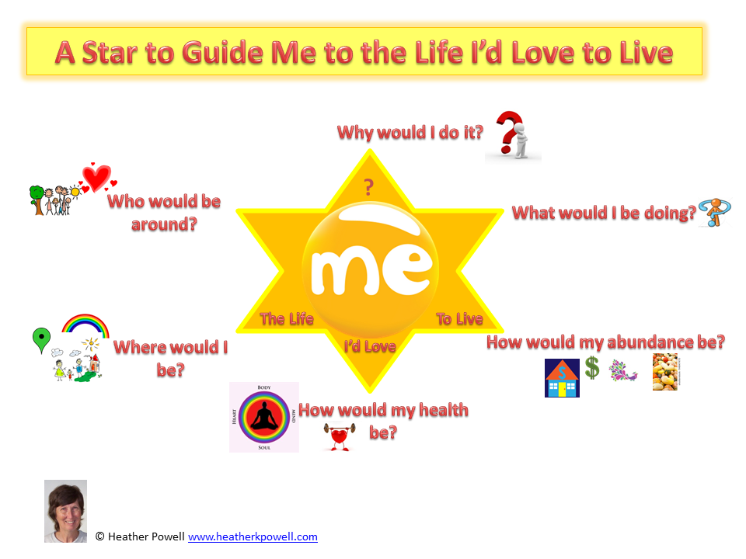
Appendix

