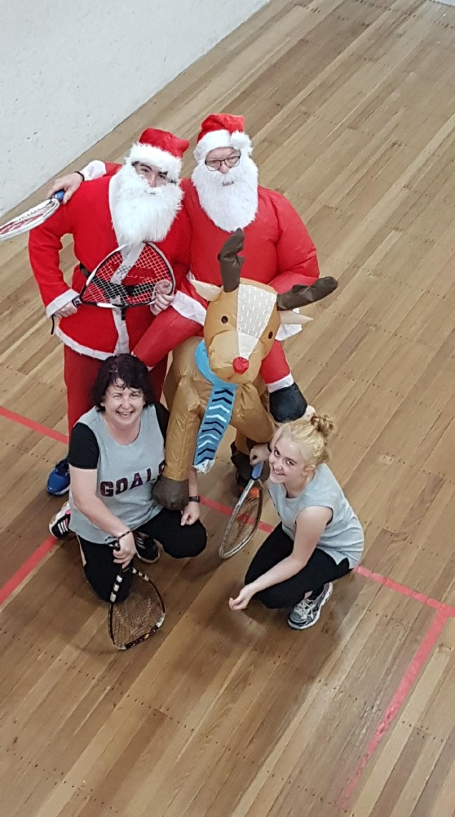**REPORT ON 2017 BIG4 WHITERS LAKES CLASSIC OPEN RACQUETBALL CHAMPIONSHIPS**

The 25th Anniversary of the BIG4 WHITERSLakes Classic, was played out at the Lakes Squash & Movie Theatre, and was highlighted by the magnificent Men’s Open Final, in particular the first game, between Cam White and Steve Andrewartha, which saw White win his eighth Lakes Classic and extend his unbeaten record in tournament play to a remarkable seventeen years, Albury’s Brigden families’ pillaging of the trophy presentations escaping with no less than nine awards, plus the performances of our latest convert to Racquetball, Santa Claus in the C Grade doubles partnered by his trusty elf LG, before succumbing to the Grinch’s Ross Falconer and Michael Brigden 15/13 in the third and deciding game of their semi final encounter.

The Rob McFadzean Memorial Award for the best performance by a junior was won by fourteen year old Alex Brigden who plays for the Commercial Club Albury, one of six family members who regularly LG,Santa,Denise&Aeron Skidmore

play racquetball, who was runner up in the D Grade singles event and

won the D Grade Doubles Plate event with his Mother, Cheryl.

The tournament attracted a capacity field of 131 entries with no fewer than eight Grand Prix Tournament Circuit debutants.

MEN’S OPEN

For the past sixteen years this event has virtually been owned by Cam White with seven titles and Steve Andrewartha winning it on six occasions as well as being runner-up four times, so it was no surprise to see these goliaths of the sport come together for the event’s climax.

Over the past two years if you are going to defeat Andrewartha you know you will have a long day at the office trying to reach that goal, including numerous gut busting rallies, and with White you have a total understanding that you will be regularly extended to the four corners of the court, so a great match up was assured.

The match commenced at a hectic pace with both players unrelenting in their pursuit of claiming every point available which went unabated for the entire contest of seventy two points, with the first game being the most enthralling with White eventually taking it out 22/20, but with both players nearly out on their feet.

The second game also opened at a frenetic pace, but the remarkable parts of White’s game is his great recovery, pin point accuracy with both his short game and length, plus his impeccable width which always has his opponents doing far more stretching than any other player in the sport, which led to him taking total control of the second game against a formidable opponent, and claiming his eighth Lakes Classic, 22/20, 21/9.

In his penultimate match, Andrewartha overcame third seeded Garry Pedersen, 21/11, 21/17, with White ousting fourth seeded Peter French, 21/16, 21/4.

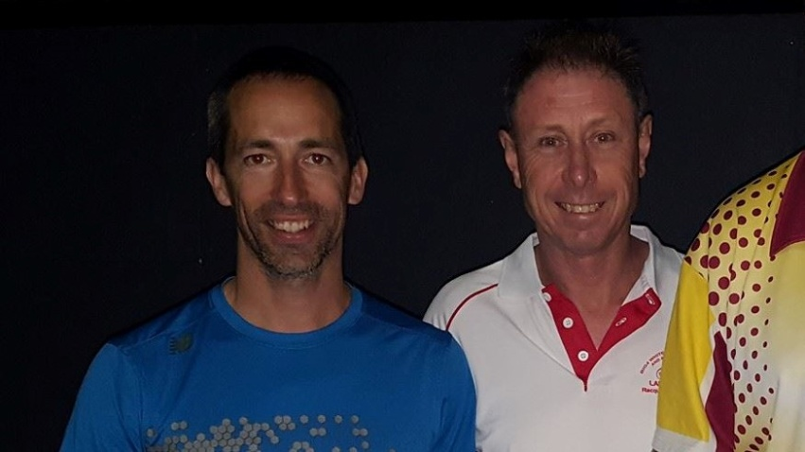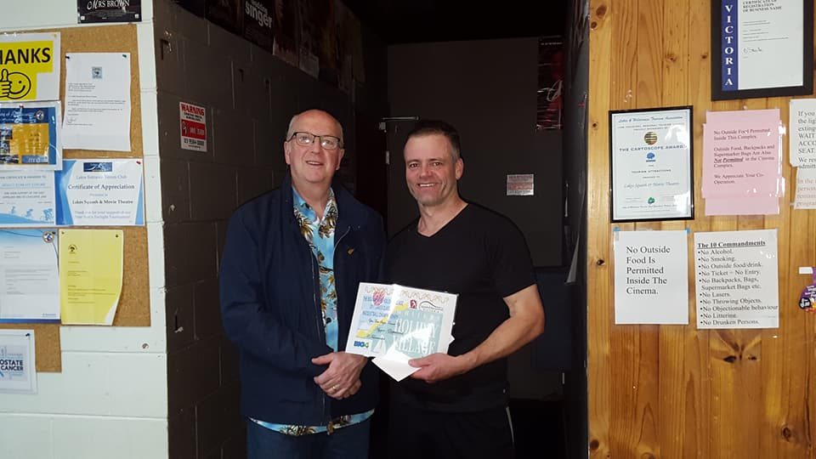

*Cam White & Michael Smits Chris Fuhrmeister & Steve Andrewartha*

WOMEN’S OPEN

This event boasted seven times Australian Open and seven times Victorian Open Champion Judy Wright, 2017 Australian and Victorian Open runner-up Kristel Proctor, plus Sue Dunlop who was in second place on the Victorian GP rankings and in third placed on the National GP rankings.

In the end it was the 2016 Victorian GP champion Judy Wright who prevailed over second seeded Proctor in the final 21/11, 21/9, after Proctor had come from a game down to overcome Dunlop in their entertaining semi final, 16/21, 21/16, 21/9.

To reach the final stanza Wright put paid to Westerfolds Bayswater’s Aeron Skidmore, 21/2, 21/3.

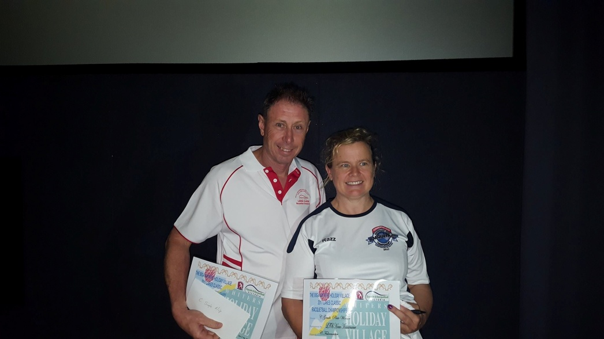 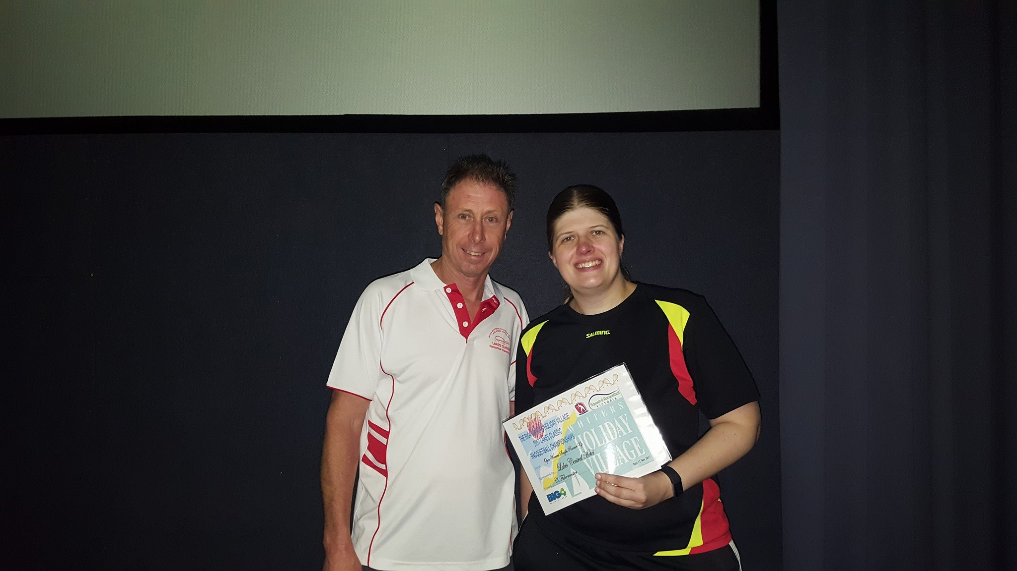

*Michael & Judy Wright Michael & Kristel Proctor*

A GRADE

Corio’s Adam Lander is one of the great warriors of the Grand Prix Circuits and in 2017 he moved up into A Grade following his annexing of the 2016 National and Victorian B Grade GP Champions titles, with his goal being to claim at least one A Grade crown in 2017.

Mulgrave’s Matt Bayley played his first ever GP event in the ESRA C Grade championships in February this year where he finished in second place, and since then has played in five B Grade events where he captured the Australian and Victorian titles, which influenced him to have a crack at A Grade for the year’s final event.

Both Lander and Bayley managed to reach the final stanza but not before escaping tough three game semi final encounters; Bayley overcoming top seeded Chris Rollauer, 21/18, 20/22, 21/16, with Lander overpowering the indefatigable Tim Paramore, 21/8, 19/21, 21/9.

The final had everything and it took 104 points to decide the outcome with Lander prevailing, after coming from a game down to win 17/21, 21/7, 21/17.

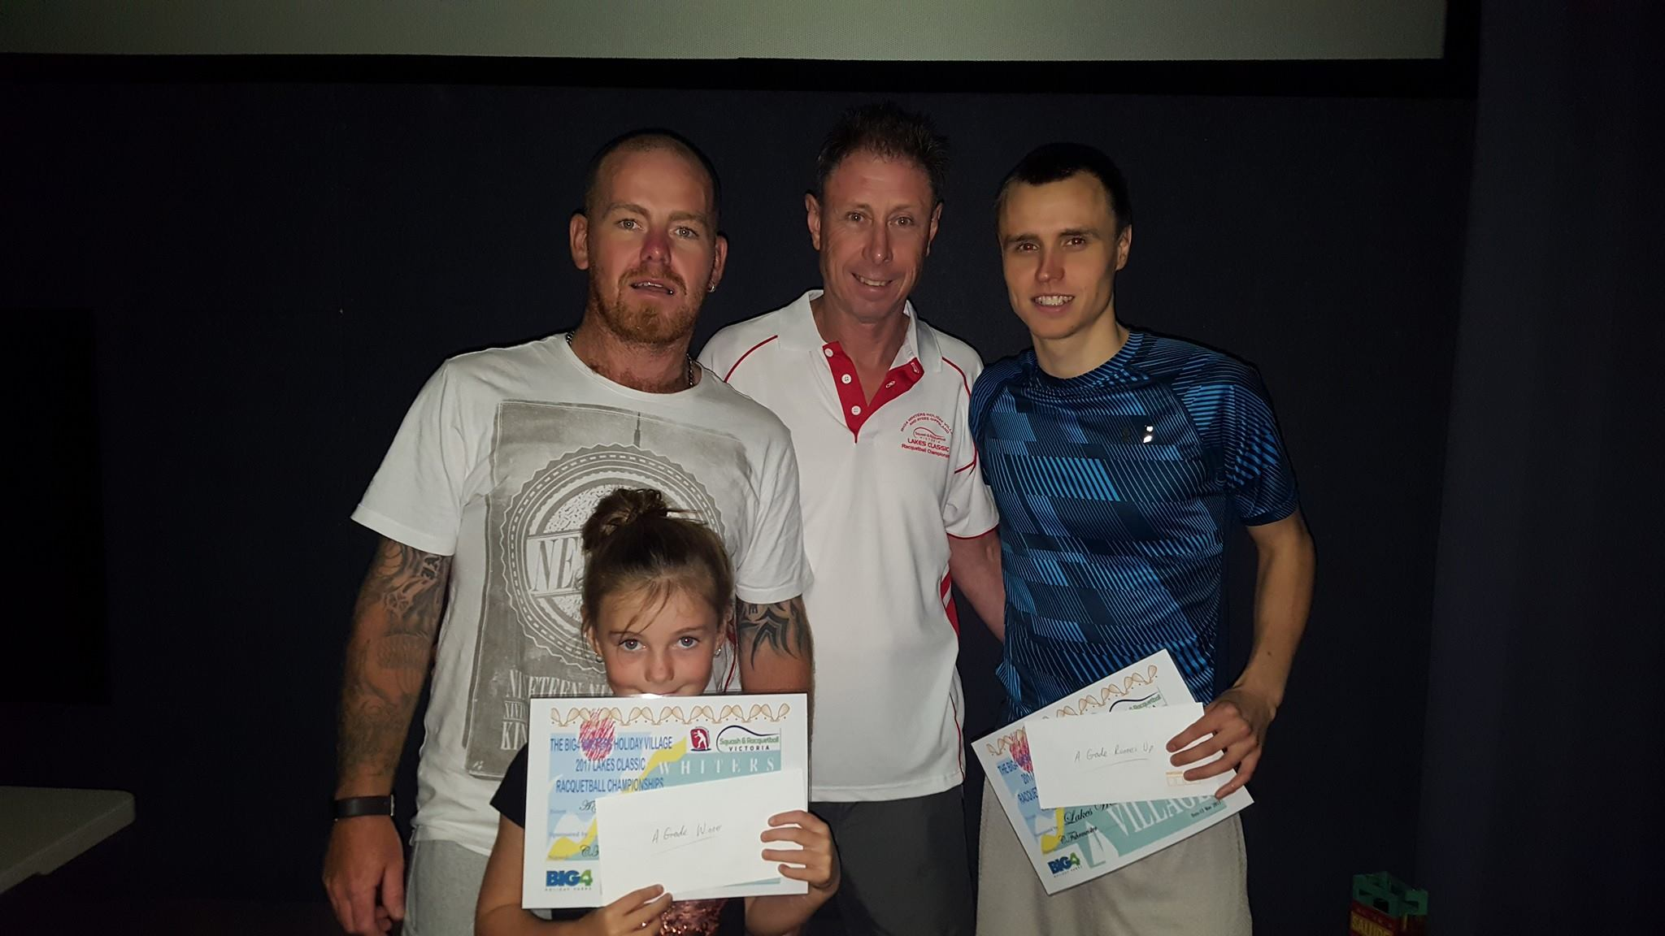

*Adam Lander, Michael & Matt Bayley*

B GRADE

South Australian Dave Whan set himself many goals this year which included climbing Mt. Everest, and playing in every National and Victorian GP circuit event in singles and doubles, both of which he achieved, but doing an enormous amount of travel in the process both on and off the court.

Fifteen year old Philip Gerontzos started the year in C Grade, was runner-up in the Victorian Open C Grade before moving into B Grade in September for the Ballarat Open and exiting at the semi final stage.

Both players comfortably won their semi finals, prior to playing out nearly sixty five minutes of unbelievable rallies, comebacks and counter punching, before Gerontzos captured the title, 22/20, 21/17.

In their respective semi finals, Whan defeated Lake’s Steve Theologou 21/6, 21/15, with Gerontzos accounting for Corio’s second seeded John Phillips, 21/7, 21/7.

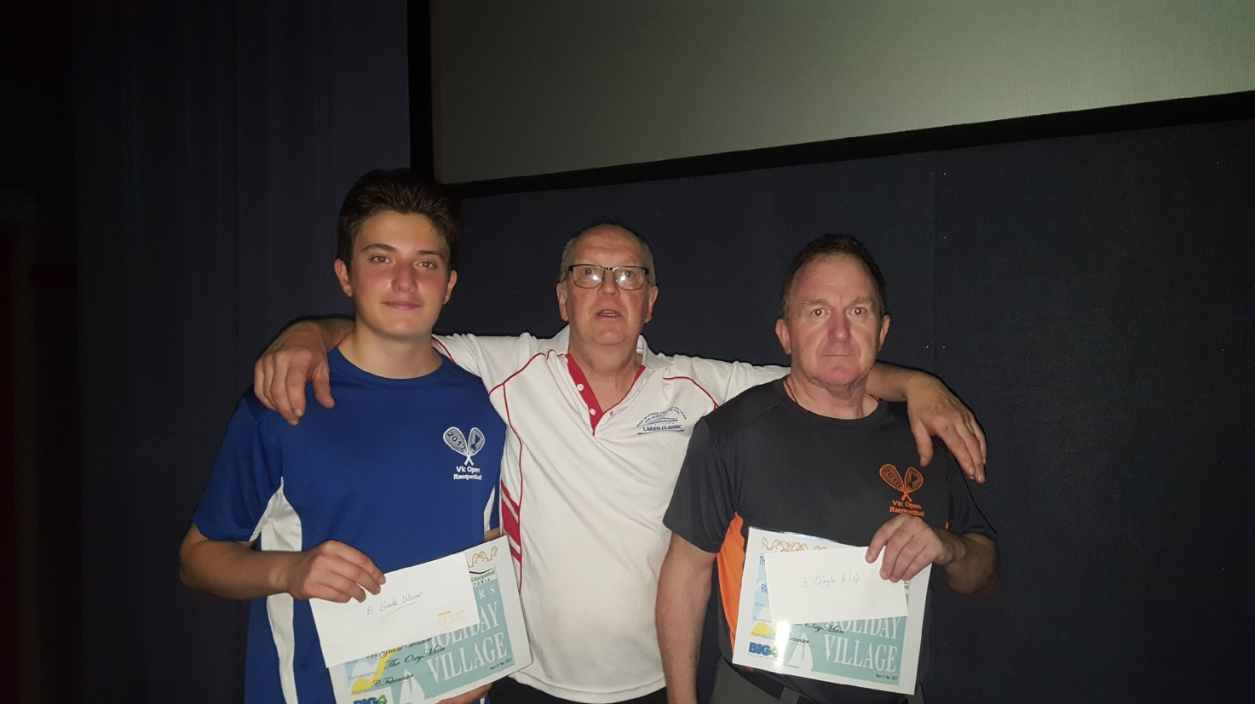

*Philip Gerontzos, Chris & Dave Whan*

C GRADE

Blake Caspersz has won every C Grade event he has participated in this year, but you could always throw a blanket over the rest of the field as to decide who would meet up with him at the pointy end of the event.

For this event it ended up being Michael Smits, the Manager of the Lakes Classics Naming Right’s sponsor, the Big4 Whiter’s Holiday Village, who won this event in 2016.

Whilst Smits was putting the sword to all and sundry in the bottom half of the draw including the Commercial Club’s Michael Brigden at the semi final stage, 21/14, 21/15, Caspersz was forced to claw his way back from a game down over the event’s host Chris “Furry” Fuhrmeister, in his penultimate match, 14/21, 21/9, 21/8, to keep his 2017 unbeaten record intact.

Although Smits was on top of his game, Caspersz was totally focussed on the end goal, and was attacking from the outset, eventually capturing his sixth GP title for the year after two very hard fought games, 22/20, 21/17.

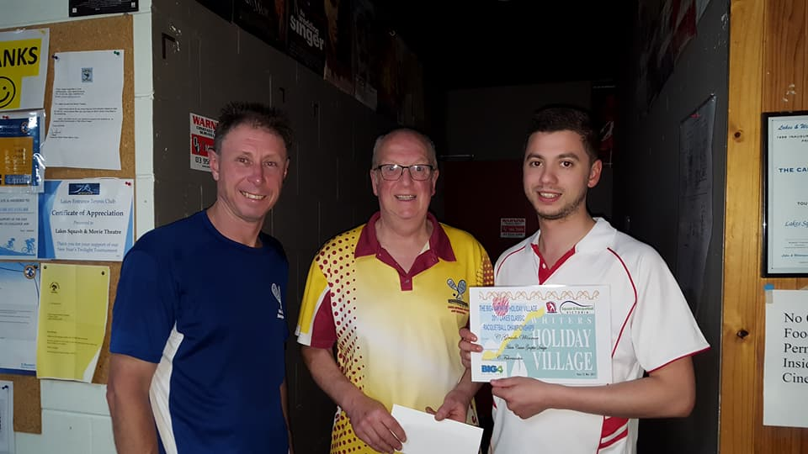

*Michael, Chris & Blake Caspersz*

D GRADE

This event provided the largest field with fifteen facing the starter including 2015 Lakes D Grade winner Floyd Cowan, plus fourteen year old Alex Brigden who won the Lakes F Grade event in 2016 and participating in his first D Grade GP event, with both eventually making it through to the final stanza.

After 104 hard fought points, Cowan fell over the line 21/19, 18/21, 22/20, to record his second GP title, with Brigden also impressing with his cool poise on many occasions throughout the match.

In their respective semi finals, Cowan overcame fourth seeded local Janita Theologou, 21/15, 21/14, with Brigden coming from a game down to oust another local Daniel Klerck, 17/21, 21/9, 21/15.

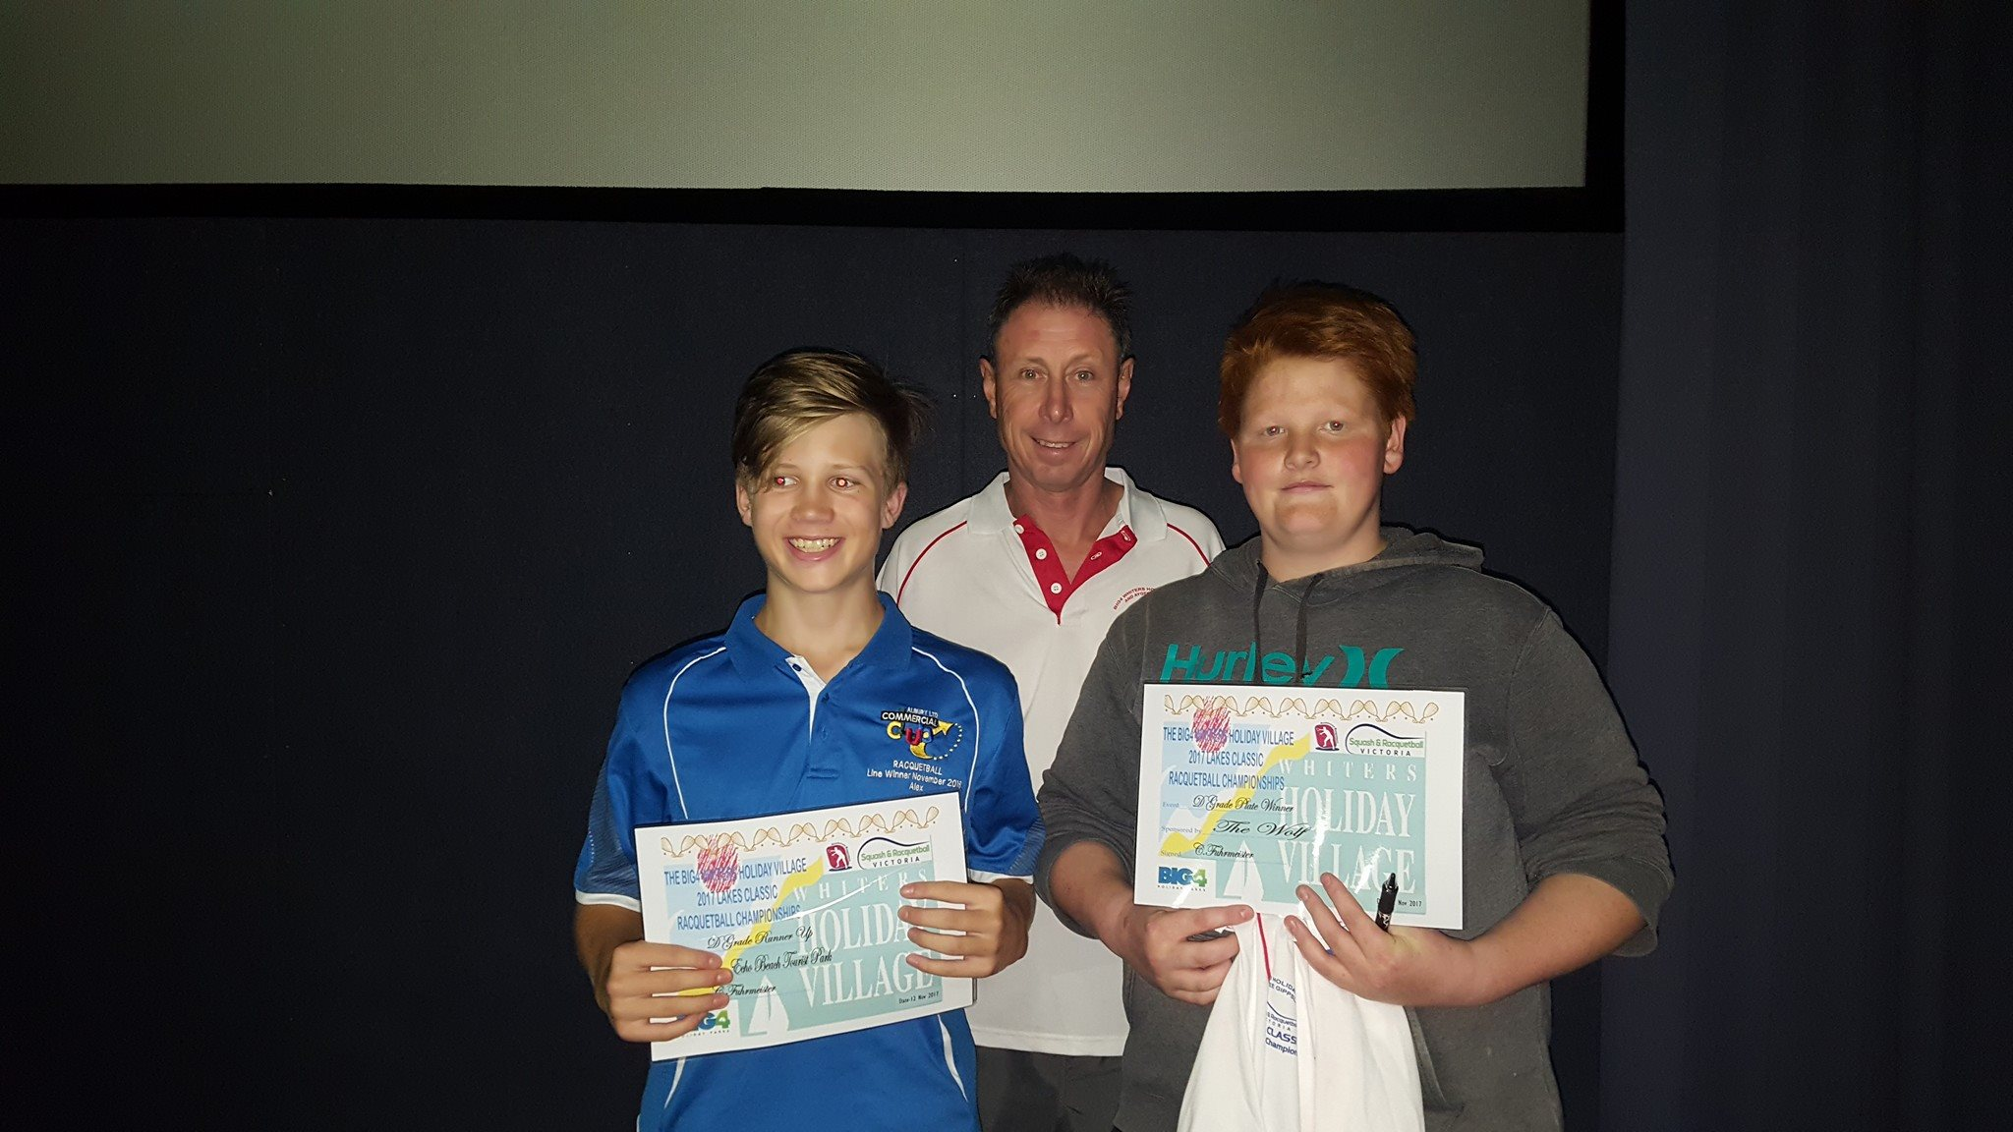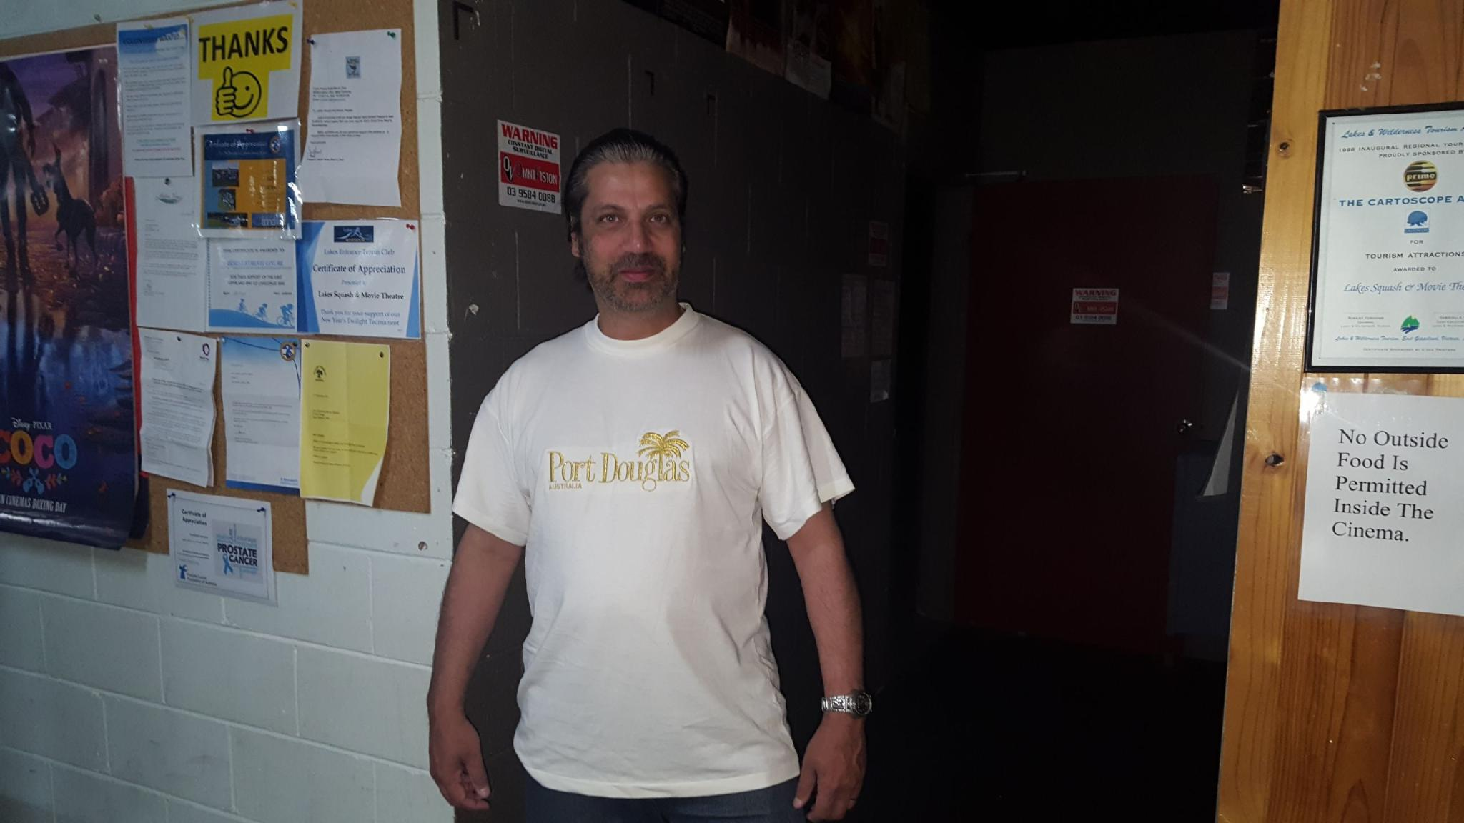

*Alex Brigden, Michael & Jarrod Marturano (plate winner) Floyd Cowan*

E GRADE

The final of this event was fought out by two Commercial Club Albury players, Cheryl Brigden and Dani Shaw, with Shaw holding out the top seeded Brigden, 21/17, 18/21, 21/6, and capture her first GP title.

In their penultimate matches, Brigden overcame Ballarat’s Nathaniel Caspersz, 21/9, 16/21, 21/10, with Shaw ousting Jackson Lander-Mitchell, 21/5, 21/6.

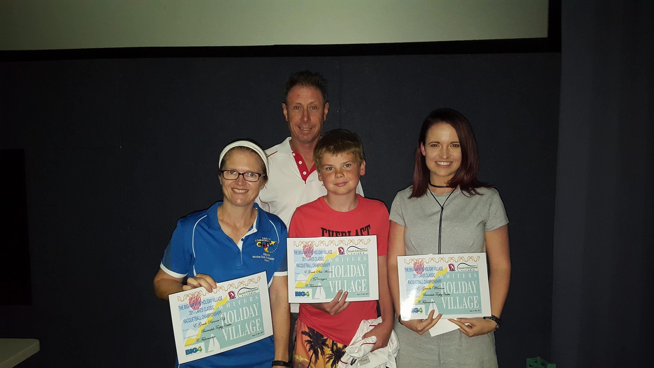

*Cheryl Brigden, Michael (back), Jackson (plate winner) & Dani Shaw*

F Grade

Two Brigden family members, Alex and Lillian played off in the final of this event last year, with the two youngest members, Amelia and Xavier, nine and eleven years respectively, participating this year

The local hope in this event was third seeded Talia Tatham who defeated Amelia in their quarter final encounter, 21/18, 21/5, and then ousted Corio’s second seeded Danica Morgan, 21/9, 21/6.

Meanwhile Xavier was storming his way through the top half of the draw with wins over Mulgrave debutant Amanda Pavia, 21/11, 21/9, and Corio’s fourth seeded Tegan Goulding, 21/15, 21/11, to reach the final stanza, which he won 21/5, 21/6, and then made it a double when he and Amelia took out the E Grade doubles title.



*Talia Tatham, Michael & Xavier Brigden*

**RESULTS**

|  |  |  |
| --- | --- | --- |
| SINGLES | | |
| Grade | **Winner** | **Runner-Up** |
| Men’s Open | Cam White | Steve Andrewartha |
| Women’s Open | Judy Wright | Kristel Proctor |
| A | Adam Lander | Matt Bayley |
| B | Philip Gerontzos | Dave Whan |
| C | Blake Caspersz | Michael Smits |
| D | Floyd Cowan | Alex Brigden |
| E | Dani Shaw | Cheryl Brigden |
| F | Xavier Brigden | Talia Tatham |

|  |
| --- |
| DOUBLES |
| Grade Winner Runner-Up |
| Open O’Donnell/ Stevenson White/Paramore |
| A Hain/Proctor Baxter/Gourley |
| B Bayley/Cooper Van Der Vegt/Robinson |
| C Fry/Smits M. Brigden/Falconer |
| D B. & A. Morgan Marturano/Kavanagh |
| E A. & X. Brigden D. Morgan/Goulding |

**Words: Paul Vear**

**Photos courtesy of Samantha Walker**