PHASE DIAGRAM WORKSHEET

Name:________________________________________Date:_____________

At standard temperature and pressure, bromine (Br₂) is a red liquid. Bromine sublimes when the temperature is –25 ⁰C and the pressure is 101.3 kPa. The phase diagram for bromine is shown below. Use this diagram for questions (1) – (9)
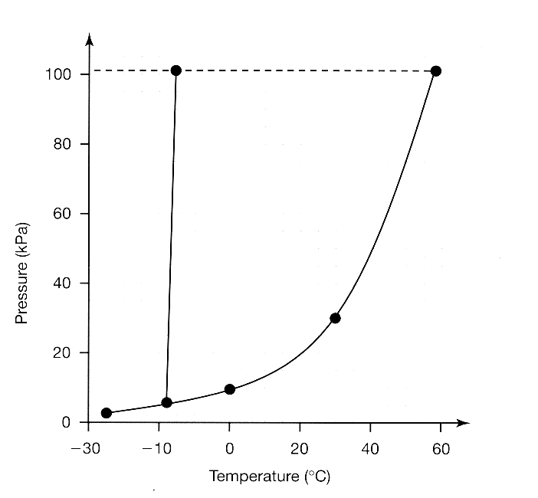

(1) Label each region of the graph as solid, liquid, or gas.

(2) Label the triple point, normal melting point, and normal boiling point on the
graph and estimate their values in the spaces below.

Normal Melting Point = _________________________

Normal Boiling Point = _________________________

Triple Point = _________________________

(3) Use the letter ‘A’ to label the line that gives the conditions for equilibrium
between solid and liquid phases of bromine, the letter ‘B’ to label the curve
that gives the conditions for equilibrium between liquid and vapor phases
of bromine, and the letter ‘C’ to label the curve that gives the conditions for
equilibrium between solid and vapor phases of bromine.

(4) Describe how the melting point of bromine changes with the external pressure. Based on the slope of the melting-point curve in the phase diagram, would you characterize the solid phase of bromine as more dense or less dense than the liquid phase of bromine?

________________________________________________________

________________________________________________________

________________________________________________________

(5) What is the boiling point of bromine when the external pressure is 75 kPa?

________________________________________________________

(6) Explain the significance of the triple point?

________________________________________________________

________________________________________________________

________________________________________________________

(7) Using arrows labeled ‘S’, ‘V’, and ‘M’, label those portions of the phase
diagram where sublimation, vaporization, and melting occur, respectively.

Circle the correct word in parentheses in each of the following sentences.

(8) Bromine vapor at 15 ⁰C (condenses, sublimes) when the pressure is
raised to 50 kPa.

(9) Bromine liquid at 70 kPa (vaporizes, freezes) when the temperature is
decreased to –15 ⁰C.

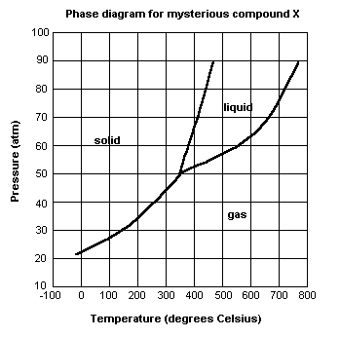For each of questions (10) - (15), refer to the phase diagram for mysterious compound X.

(10) What is the critical temperature of compound X? __________________________

(11) If you were to have a bottle containing compound X in your closet, what phase would it most likely be in?

__________________________________________________________________

(12) At what temperature and pressure will all three phases coexist?

__________________________________________________________________

(13) If I have a bottle of compound X at a pressure of 45 atm and temperature of 100⁰ C, what will happen if I raise the temperature to 400⁰ C?

__________________________________________________________________

(14) Why can’t compound X be boiled at a temperature of 200⁰ C?

__________________________________________________________________

(15) If I wanted to, could I drink compound X?

__________________________________________________________________

Use the following phase diagram for problems (16) – (22)
Water (liquid)
Water Vapor (gas)
Triple point
Critical point
PRESSURE
225 atm
1 atm
0.006 atm
0.01 °C 100°C 374 °C
TEMPERATURE
Ice
(solid)
(16) List the phase changes a sample of ice would go through if heated to its critical
temperature at one atmosphere pressure.

__________________________________________________________________

(17) At what range of pressure will water be a liquid at temperatures above its normal
boiling point?

_________________________________________________________________

(18) In what phase does water exist at its triple point?

_________________________________________________________________

(19) How does the melting point of water change as the pressure increases from 1 atm?

_________________________________________________________________

(20) What does the line separating the solid phase from the gas phase represent?

_________________________________________________________________

_________________________________________________________________

(21) What does the line separating the liquid phase from the gas phase represent?

_________________________________________________________________

_________________________________________________________________

(22) What is the vapor pressure of liquid water at 100 ºC?

________________________________________________________________

