Pigeon pose / Eka Pada Rajakapotasana
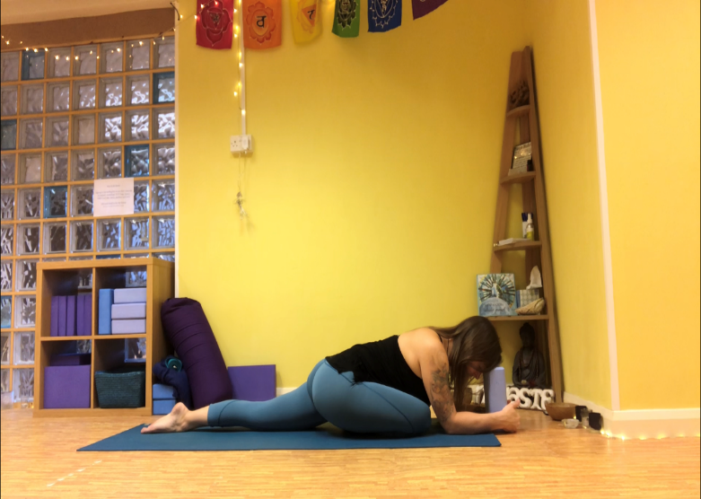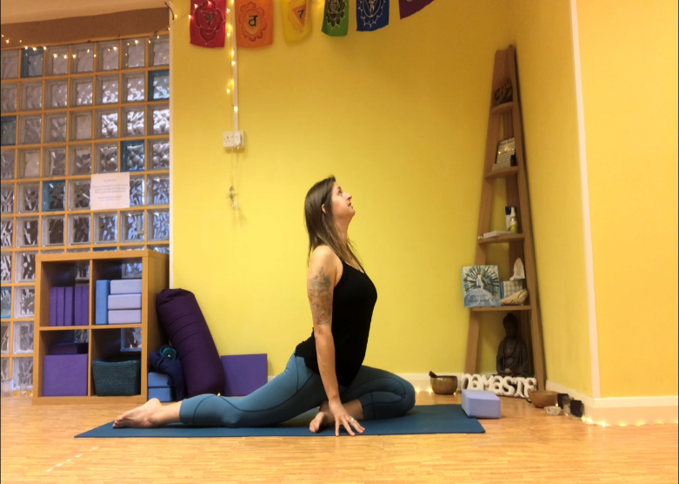

Pigeon pose is a hip opening pose. It can either be very comfortable or challenging so only hold for as long as feels comfortable and use props as required.
- From all fours slide 1 leg forward placing the knee in between the hands
- Slide the front leg across to place the foot in front of the thigh of the back leg
- Stretch the back leg away ensuring no weight is pushed into the knee
- Keep the back flat & hips even – don’t roll onto the front thigh
- Stay lifted or fold over the front leg as either variations pictured above
- Breath is relaxed
- Change sides when ready

Pose Benefits:
- Cooling
- Quiets the mind
- Front leg – stretches inner thigh & hip rotators
- Back leg – stretches hip flexors & works hamstrings

Contraindications:
- Knee or hip injury or replacement
- Hamstring injury

