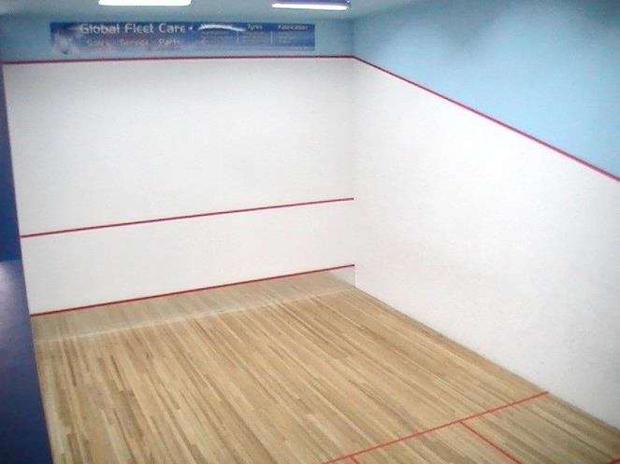
LISMORE SQUASH COURTS
FOR SALE

LARGE HOUSE, 2 BATH, 3 BED, 2 LOUNGE
6 WELL-MAINTAINED SQUASH COURTS
ON MAIN ROAD CLOSE TO CBD

Due to family circumstances we have to sell our house and courts.
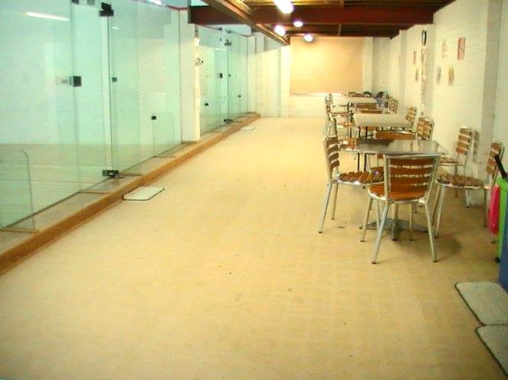
To save squash in Lismore we need either:
- An investor to buy and then rent back to us. Yes, we are willing to sign a lease upon sale. OR:
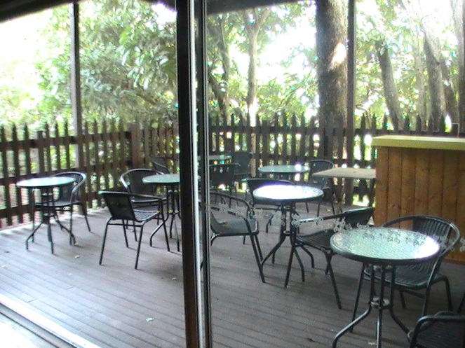
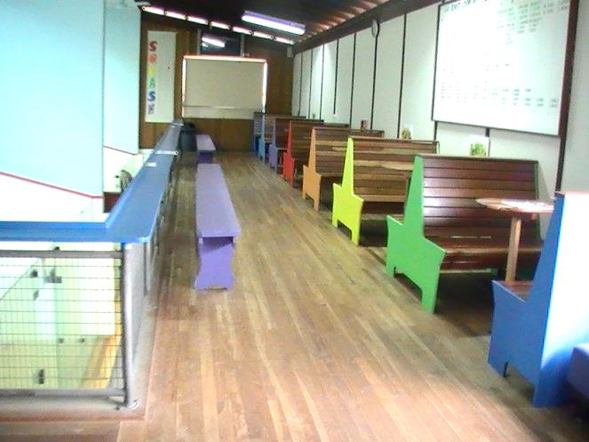
- A purchaser who wants the business as well and run it as such.

Squash is still strong in Lismore. We have 2 competitions with about 100 players in total. We hover around 30 juniors. There are also 16 teams of Rebound Volleyball and many regular social squash players.

The courts are maintained to a high standard.
Check out the ‘before and after’ photos at lismoresquash.com

Asking price:

House, Land and Courts: $595000

House, Land, Courts and Business: $605000

(Business price is ‘walk in walk out’ and includes stock, ladders, scaffolding, etc)

Contact:
Brenton Lewis and Beverley Lavender
18 Wyrallah Road, Lismore, NSW 2480
02 66212914

