Anatomical Evidence of Evolution Lab

Background
Much evidence has been found to indicate that living things have evolved or changed gradually during their natural history. The study of fossils as well as work in embryology, biochemistry and comparative anatomy provides evidence for evolution

Procedures and Observations

Part I. HOMOLOGOUS STRUCTURES

1. Carefully examine the drawings of the bones shown in Figures 1 on the next page. Look for similarities among the various animals

a. Color each part of the human arm a different color. (All bones of the wrist should be a single color, the bone groups of the hand should be a different single color.) Then color the corresponding bone in each of the other animals the same color as the human bone.

b. Describe the function of each set of bones below:

Table 1
Animal | Function
human
whale
cat
bat
bird
crocodile

c. Are the bones arranged in a similar way in each animal?

These structures are formed in similar ways during embryonic development and share like arrangements; however, they have somewhat different forms and functions. They are called homologous structures.

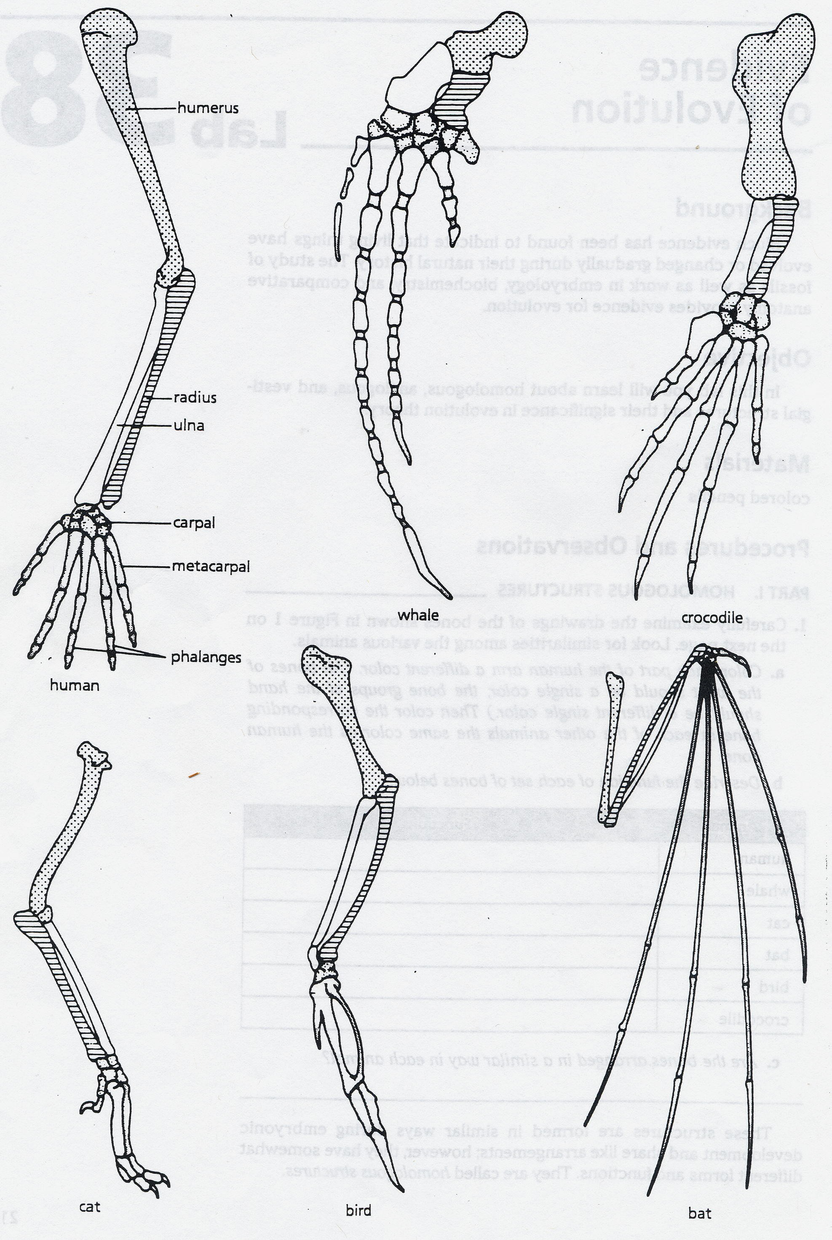

Part II. ANALOGOUS STRUCTURES

Examine the butterfly wing and the bird wing shown in Figure 2.
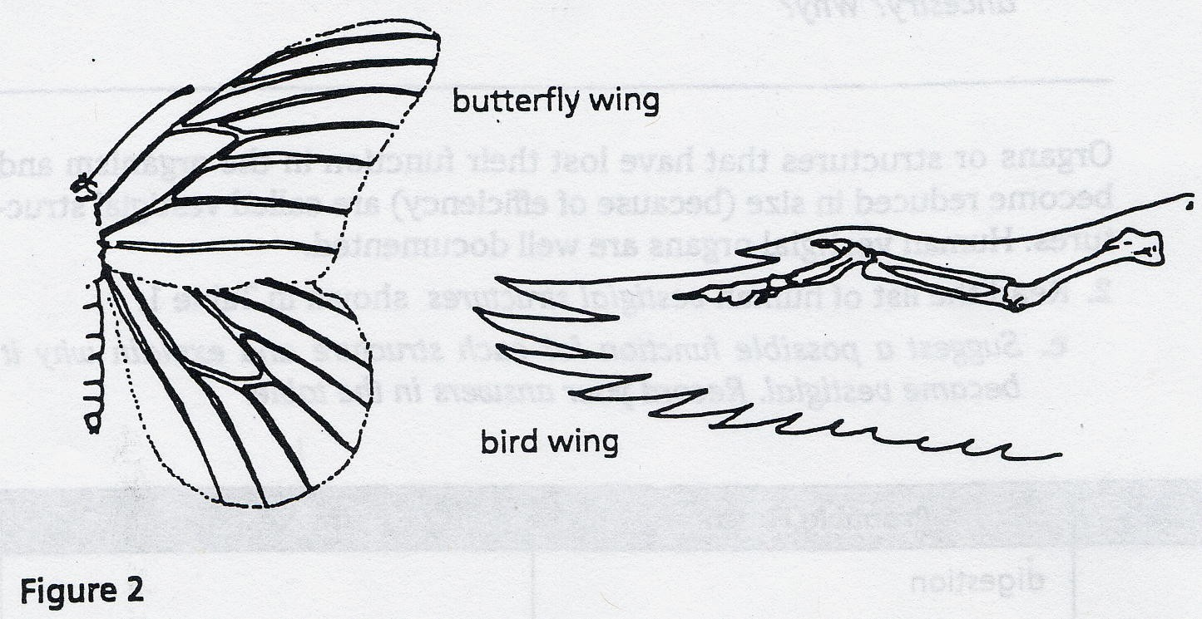

a. What function do these structures share?

b. How do the structures differ?

c. Do birds and insects share any structural similarities that would suggest they are closely related taxonomically?

_________________________________________________________________________________

Some apparently unrelated animals have organs with similar functions, yet are very different in structure and form. These structures are called analogous structures.

Part III. VESTIGIAL STRUCTURES
Gradual changes have occurred through time that have in some cases reduced or removed the function of some body structures and organs. The penguin’s wings and the leg bones of snakes are examples of this phenomenon.
1. The cave fish and minnow show in Figure 3 are related, but the cave fish
is blind.
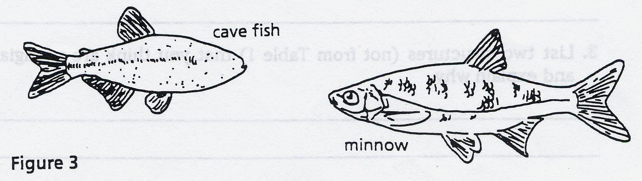

Explain why eyesight is not an important adaptation to life in a cave.

Organs or structures that have lost their function in the organism and become reduced in size (because of efficiency) are called vestigial structures. Human vestigial organs are well documented.

2. Read the list of human vestigial structures shown in Table 2.
Suggest a possible function for each structure after reading why it became vestigial. Record your answers in the table.

Table 2.
Structure | Probable Function | Why Vestigial?
appendix |  | Because it could have been used to harbor symbiotic bacteria for digestion of cellulose, which is no longer necessary with the modern diet of humans
coccyx (tail bone) |  | Not needed for walking upright
muscles that move ears |  | Rely more on other senses, especially vision
muscles that make hair stand up |  | Not needed when clothing was adapted
little toe |  | Not needed once humans adapted a ground-dwelling lifestyle instead of an arboreal one
wisdom teeth |  | Diet changed, fire used to cook & soften food

Analysis and Interpretations
1. Explain why the homologous structures in Part I are evidence of evolutionary relationships.

2. Explain the evolutionary relationship between the fin of a fish and the flipper of a whale.

3. Using your imagination, what parts of the human body might become vestigial in the next million years. Explain your reasoning.

