**Cells**

1. Put the following words in the correct order. How are living things organized?

Organism Organ Cell Organelle Organ/Body System Tissue

___________ 🡪 ____________ 🡪 ____________ 🡪 ____________ 🡪 ____________ 🡪 ____________

2. Match the cell organelle with its corresponding function.

1. Nucleus 1. Controls what enters and exits the cell
2. Mitochondria 2. Site of photosynthesis
3. Cell Wall 3. Clear jelly-like substances; site of chemical reactions
4. Lysosome 4. Short hair-like projections that help the cell move
5. Ribosome 5. Storage sac for food, water, waste
6. Cell Membrane 6. Genetic material found in the nucleus
7. Chloroplast 7. Controls cell activities
8. Flagella 8. Synthesizes proteins
9. Cilia 9. Long whip-like; for cell movement
10. DNA/Chromosomes 10. Makes energy for the cell; site of cellular respiration
11. Vacuole 11. Gives support; made of cellulose
12. Cytoplasm 12. Sac containing enzymes; breaks down waste

3. Put the organelles above in the Venn Diagram below. Which organelles are found in only plant cells? In only animal cells? In both?

Plant Cell Animal Cell

4. Why do plant and animal cells have different organelles?

_______________________________________________________________________________________________________________________________________________________________________________________________________________________________________________________________

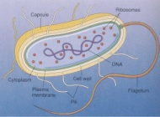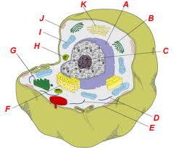5. Label the cells at the right. Which cell is eukaryotic? Which cell is prokaryotic? How do you know? _____________________________________________________________________________________________________________________________________________________________________________________________

**Body Systems**

1. Match the body systems with their functions.
2. Digestive System 1. Transports nutrients, oxygen, carbon dioxide
3. Respiratory System 2. Contract to allow movement
4. Skeletal System 3. Sends electrical signals to control body
5. Muscular System 4. Makes offspring
6. Nervous System 5. Removing waste
7. Circulatory System 6. Supports the body
8. Endocrine System 7. Exchanges gases
9. Reproductive System 8. Sends chemical signals (hormones) to control
10. Excretory System 9. Breaks down food into nutrients.
11. Read the following article and answer the questions that follow. As you read, underline important terms. Write questions in the margin. Put an “!” next to things you already learned!

**Body Systems Work Together**

**By Cindy Grigg (from edhelper.com)**

You know that your body is made of cells. When groups of cells do the same kind of work,they are called tissues. The word tissue comes from a Latin word meaning to "weave." Cells that make up tissues are sometimes "woven" together.

You have four main types of tissues: epithelial, nervous, muscle, and connective tissue.

Epithelial tissue covers the outside of the body. It also lines organs and cavities. Nervous

tissue sends electrical signals. Muscle tissue helps you move. Connective tissue joins bones

and cushions organs.

When groups of tissues work together, they are called organs. Some examples of organs are the heart, lungs, skin, and stomach. When organs work together, they are called systems. For

example, your heart, lungs, blood, and blood vessels work together. They make up the

circulatory system.

There are eleven systems in the human body: muscular system, respiratory system, digestive system, integumentary system (skin), skeletal system, circulatory (or cardiovascular) system,excretory (or urinary) system, reproductive system, nervous system, lymphatic system, and endocrine system. Each system has a special job.

All of your body systems have to work together to keep you healthy. Your bones and muscles work together to support and move your body. Your respiratory system takes in oxygen from the air. It also gets rid of carbon dioxide.

Your digestive system absorbs water and nutrients from the food you eat.

Your circulatory system carries oxygen, water, and nutrients to cells throughout your body. Wastes from the cells are eliminated by your respiratory system, your excretory system, and your skin.

Your nervous system controls all these activities with electrical impulses. If any system in your body isn't working properly, other systems are affected. Think of your body as a building. A building has a plumbing system, a heating system, a cooling system, an

electrical system, and a support system. If any system in a building breaks down, other systems can be affected.

As one example, think about a building's electrical system. Suppose a mouse chewed through an electrical wire to a furnace. Without electricity, the heating system would not work. If this happened in very cold weather, the plumbing system could be affected. Water pipes might freeze and burst. If a lot of water leaked into the building's walls, its support system would be damaged. Like a building's systems, your body's systems have to work together. Body Systems Work Together

1. Tissues are:

A. groups of systems doing the same work

B. groups of cells doing the same work

C. groups of organs doing the same work

2. How many types of tissue do you have?

A. eleven

B. three

C. ten

D. four

3. Groups of tissue that work together are called:

A. organs

B. connective

C. cells

D. epithelial

4. What do body systems consist of?

A. cells working together

B. organs working together

C. tissues working together

5. How many systems are there in the human body?

A. ten

B. five

C. eleven

D. twelve

6. Systems in a building are like:

A. systems in your body

B. members of a family

C. your nervous system

D. cells in your body

7. A building's foundation, walls, floors, and roof are most like which body system?

A. the nervous system

B. the respiratory system

C. the digestive system

D. the skeletal system

8. Your nervous system is like a building's:

A. plumbing system

B. electrical system

C. heating system

D. support system

**Homeostasis**

1. Homeostasis is ________________________________________________________________.
2. Homeostasis begins at the cellular level with the ________ ____________________________.
3. The cell membrane controls what ___________ and ___________ the cell.
4. How is your body maintaining homeostasis when you exercise?

______________________________________________________________________________________________________________________________________________________________________________________________________________________________________________________________________________________________________________________________________________________________________________________________________

1. a) What will happen if you drop a cube of sugar into a glass of ice tea?

________________________________________________________________________________________________________________________________________________________________________________________________________________________________________________________________________________________________________________________

b) What is the name of this process? _______________________________________________

c) Name 2 ways to speed this process up. ____________________________________________________________________________________________________________________________________________________________

1. Use the information and the provided pictures to answer the following questions. Moss cells are approximately 1% salt and 99% water. Tap water is approximately 1% salt and 99% water. A saline solution contains 6% salt and 94% water.

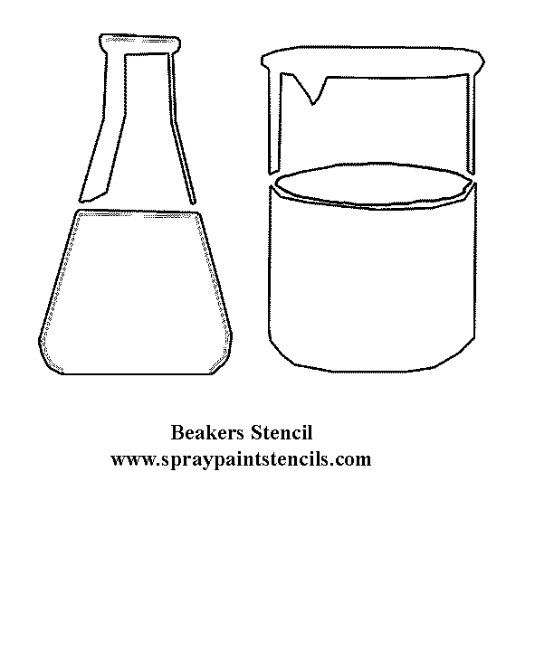a) What would happen to the moss cells placed in the saline solution? Label the diagram to show the movement of water and explain.

________________________________________________________

________________________________________________________

________________________________________________________

________________________________________________________

________________________________________________________

________________________________________________________

b) What would happen to moss cells placed in tap water? Label the diagram to show the movement of water and explain.

________________________________________________________

________________________________________________________

________________________________________________________

________________________________________________________

________________________________________________________

________________________________________________________

**HSA Practice Questions**

Directions: Read and answer each question. As you read, annotate your questions. Underline key words and circle the question words.

1. A scientist is trying to discover a new treatment to stop cancer cells from dividing. In the cancer cells, which of these processes will stop if the treatment is successful?
2. mitosis
3. chemosynthesis
4. binary fission
5. genetic recombination

*Streptococcus* is a type of bacteria that causes strep throat in humans. A frog is a multicellular organism that lives in aquatic environments.

1. Which of these is the type of reproduction used by *Streptococcus?*
2. binary fission
3. meiosis
4. crossing-over
5. budding
6. Which system in the frog produces chemicals that regulate functions in different parts of its body?
7. respiratory system
8. excretory system
9. endocrine system
10. circulatory system

A student designed an experiment to see if plants grow better when watered with a sugar solution. He divided the plants into six groups, measured the initial height of each plant, and calculated the average height for each group. Once a week for two months, he watered the plants in each group using a different sugar solution for each plant group. At the end of two months, he measured the final height of each plant and calculated the average height for each group. The student’s data are shown in the table below:

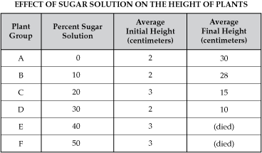

1. Which of these statements explains why the plants in Groups E and F died?
2. The high sugar content caused too much water to move out of the root cells.
3. The high sugar content caused too much water to move into the root cells.
4. The high sugar content prevented the plant from capturing energy
5. The high sugar content clogged the pores in the cell membranes.

Scientists recently discovered a new species that lives attached to the side of a tree. An organism from this new species:

* Is multicellular
* Has cell walls
* Has vascular tissues
* Makes its own food
* Has structures that absorb moisture from the air

1. Which of these is not true about cells in the new organism?
2. They contain nuclei
3. They use vacuoles for storage
4. They contain mitochondria
5. They use pseudopodia to move.
6. Which of these is an example of feedback in a biological system?
7. the movement of salts from cells into the bloodstream
8. the release of insulin into the bloodstream when blood sugar increases
9. the decrease in oxygen levels in the blood after vigorous exercise
10. the use of energy when muscles contract