

QTR Corporation
Deployment Guide

Author: WWT Multi-site Deployment Team, 2024
Table of Contents
Overview 2
Deliverable Requirements 2
Tool Requirements: 3
Onsite Check-In: 3
Preparation: 5
Firewall Replacement/Installation: 6
Decommissioning: 15
Completing the Installation and Check-Out: 16
Site Acceptance Form ** Live in MOP/ATP and be documented** 17

Overview
WWT has been contracted to refresh firewall(s) QuikTrip locations. This document serves as the deployment guide for the onsite technician. It must be read and understood in its entirety prior to commencing work.

Strict compliance with this procedure during the installation and cutover is mandatory, as no downtime or other negative impacts may affect customer operations.

Deliverable Requirements
Ensuring all deliverables are completed and received by the WWT team and are verified to be acceptable is a key component in completing this procedure.
Photos taken during this procedure must be of sufficient clarity and resolution to determine quality and accuracy of work performed.
Summary of Deliverables:
- Pre installation photo(s) of each MDF/IDF environment - including all network racks, cables and cable runs
- Pre- installation photo(s) of each NEW firewall to be replaced. FRONT and BACK of each old device should be taken with clear view of Serial Number details on back of device near power supply.
- Post installation photo(s) of each MDF/IDF environment - including all network racks, cables and cable runs
- Post installation photo(s) of each OLD firewall replaced. FRONT and BACK of each new device should be taken with clear view of Serial Number details on back of device near power supply.
NOTE: These should be taken after successful cutover and removal from cabinet/rack.
- Port cabling Matrix
- ATP results - confirmed verbally by QT OLE
- Site Acceptance Guide - confirmed verbally by QT OLE
- Technician should also advise the MOD or Secondary Manager cutover is complete and they are leaving site.

Tool Requirements:
Prior to arrival onsite, technicians must ensure they have the following devices, applications, tools, documentation, and protective gear:
- Laptop and power adapter with PuTTY software installed
  - Micro USB to USB connector for console cable
  - COM Port Driver
  - Console Cable
- Smartphone with charger
  - Cellular Hot Spot or internet dongle (if not included within Smartphone).
- Standard tool kit
  - 6’ ladder (12’ if possibly needed)
  - Drill with (P1 and P2 - Phillips bits)
  - Rack mounting screws, standard cage nut with screws size 12/24.
  - Screw extractor kit (optional)
  - Velcro strips (optional)
- Safety Equipment - Recommended
  - Hard hat
  - Safety Vest
  - Steel toe shoes/boots
  - Eye protection
  - Hearing protection

Onsite Check-In:
Follow this procedure to complete on-site check-in:
***CHECK OFF (or mark N/A) ALL STEPS AS THEY ARE ACCOMPLISHED. INCLUDING RELATED TIMESTAMP WHEN THEY WERE COMPLETED***
- 1. Prior to arrival, review the Work Order (WO) details as follows:
  - A. The WO should contain:
    - Site ID & Address
    - Current version of Site Deployment Guide (this document)
    - Cut Bridge information (to be emailed in-advance)
    - Scope of Work (SOW)
    - Bill of Materials (BOM)
    - QuikTrip Access Letter (physical copy must be presented onsite)
- 2. Acceptable attire is business casual (i.e. comfortable collared shirt, no t-shirts with graphics, and jeans without holes.) Technicians must always have their Connext-WWT badge visible, at all times.
- 3. Plan to arrive at requested START time. Once setup is complete, request approval from OLE to proceed with cutover. No network work should occur prior to 6:30pm local. Equipment setup is estimated to take roughly 45-60 minutes after check-in and access.
- 4. Upon arrival, log-in to the bridge and check in with the WWT Remote Facilitator/Cut Admin team via bridge and provide:
    - Your Name
    - Confirm Site ID and store location
    - Site Deployment Guide version and other procedural documentation for reference (MOP/ATP)
    - Your readiness to commence work
- 5. Make introductions with the site point of contact (POC)
  - Explain the reason for your visit, “Hi, my name is ______ I am with World Wide Technology (WWT) and I am here to refresh your firewall(s).”
  - Work with the POC and locate network cabinet/room and equipment for installation.
  - From there, proceed to contact QT OLE contact for remote access to the equipment cabinet(s).
  - Call (800) 375-0720:
    - Option 8
    - Option 8 WAN 2024 Project
NOTE: QT OLE will most likely join WebEx but if they are not already on the bridge, please contact them directly.
- 6. Proceed to the Preparation section of this document.

Preparation:
CRITICAL NOTES:
1. If at any time the local Point of Contact or anyone outside of the WWT PMO directs you to perform any OUT OF SCOPE or ADDITIONAL WORK, that request must be approved by the WWT and QT prior to accomplishment - no exceptions.
2. Do not destroy boxes, they will be used to return legacy equipment.
3. There are different styles of network cabinets. In 90% of QuikTrip stores, the security cabinet hangs from the ceiling.
4a. Generation 2.5 stores will have their security cabinet in the back room suspended from the ceiling outside the cooler door.
4b. Generation 3 stores will have their security cabinet suspended above the door in their tearoom.
4c. The security cabinet is in different areas of the remote stores and travel centers. You will need to talk with the store team about the location.
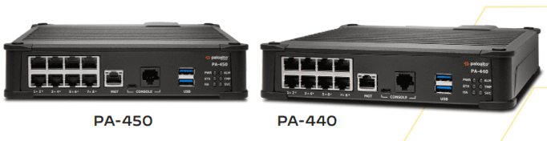
PENDING FINAL QT APPROVAL FOR THESE VIEWS
Figure 1
- 1. Locate, unbox, inventory and stage equipment for replacement.
  - A. Confirm inventory matches the BOM provided.
- 2. Before commencing work, take pre installation photo(s) of each MDF/IDF environment - including all network racks, cables, and cable runs - these photos are deliverables.
NOTE:
If any equipment is missing from the inventory, escalate to the WWT Remote Facilitator/Cut Admin to report, then to QuikTrip OLE for agreed resolution. Please also note that some sites may have just racks instead of cabinets.
- 3. Proceed to the Firewall replacement/installation section.

Firewall Replacement/Installation:
NOTE:
Refer to the PA 440/450 Installation Manual, by scanning the QR code (or using the link) below, for various installation requirements/mounting methods.
**Please also refer to the “WAN 2024 Store Installation Procedures” for Sections referencing INSTALLATION OPTION 1 vs. OPTION 2. OPTION 1 is what is expected/preferred, but if OPTION 2 is encountered please notify the QT OLE and MOD and confirm approval to proceed.**

PA-400 Series Next-Gen Firewall Hardware Reference (paloaltonetworks.com)
- 1. As required, install, mount, or set the new firewall(s), as follows. Firewalls should also be secured in provided rack trays (in equipment box/BOM) in either the racks or cabinets onsite.
  - A. Flat surface installation.
    - (1) The PA 440/450 has rubber feet on each corner to support horizontal or vertical placement, see figure 2.
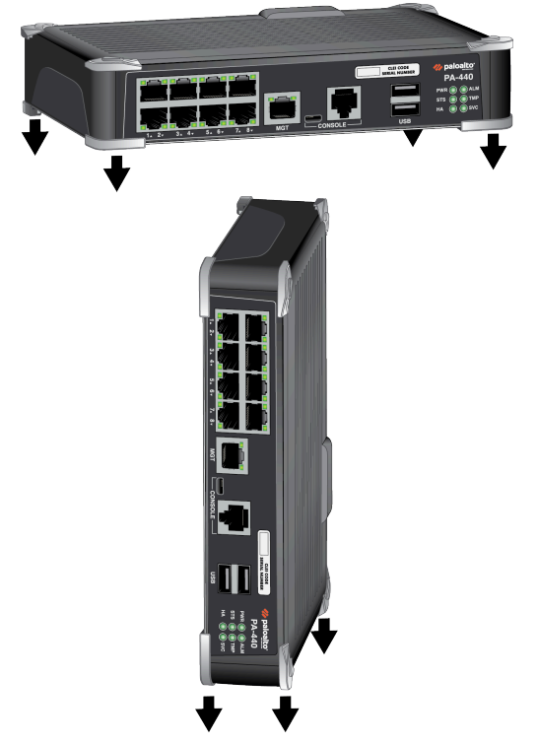
PENDING FINAL QT APPROVAL FOR THESE VIEWS
Figure 2
  - B. Wall mount installation **Wall mount installation is NOT expected**
    - (1) Using the PA-400 Quick Start Guide, mark locations for firewall mounting holes on the wall.
NOTE:
Ensure there are no utility services behind the wall, prior to drilling.
    - (2) Use a #1 or #2 Phillips-head screwdriver (as required) to install the appropriate screws into each of the three or four marked locations:
      - (a) Drywall
        - i. Press a drywall anchor slightly into the center of a template mark.
        - ii. Using your screwdriver, apply pressure while turning the anchor clockwise until the surface of the anchor is flush with the wall.
        - iii. Install a 1.25” anchor screw into the anchor until the bottom of the screw head protrudes 1/4” (.6cm) from the wall.
        - iv. Repeat this step for the other screw locations unless either is located over wood, in which case, use a .75” wood screw instead of a drywall anchor and screw.
      - (b) Plywood wall—Use your screwdriver to insert a .75” wood screw into the center of each template mark that is located over wood until the bottom of the screw heads protrude 1/4” (.6cm) from the wall.
    - (3) Align the holes on the bottom of the firewall with the screws on the wall and hang the firewall on the screws. Make sure the firewall is securely connected to each of the screws before you release it, see figure 3.

Figure 3
NOTE:
Do not connect the firewall to the AC Power source until directed.
  - C. Install the power adapter in the power adapter wall-mount bracket using the Velcro straps and cable tie. Make sure to align the cable tie with the notches in the bracket to prevent the power cord from falling out. Next, loop the two Velcro straps through the side openings on the wall mount and over the power adapter. Lastly, loop the Velcro straps back over the top of the power adapter to secure it into place, see figure 4.
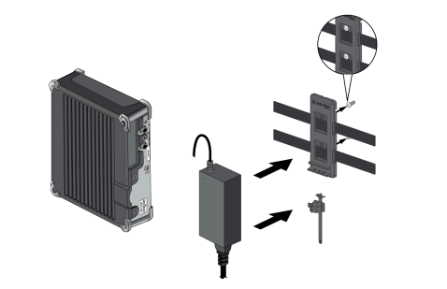
PENDING FINAL QT APPROVAL FOR THESE VIEWS
Figure 4
  - D. After you secure the power adapter to the bracket, mount the bracket next to the firewall using wood or drywall screws as appropriate, see figure 5.
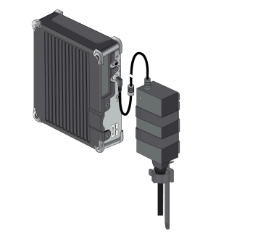
PENDING FINAL QT APPROVAL FOR THESE VIEWS
Figure 5
  - D. RACKTRAY mounting: Up to two individual PA 440 or PA 450 firewalls can be mounted in a 19” equipment rack using the PAN-PA-RACTRAY, requiring 1 RU of rack space.
    - (1) Slide one of the adjustable mounting brackets into one of the fixed mounting brackets to create a mounting rail. Repeat for the second mounting rail. The adjustable and fixed brackets are the same for the left and right side, see figure 6.
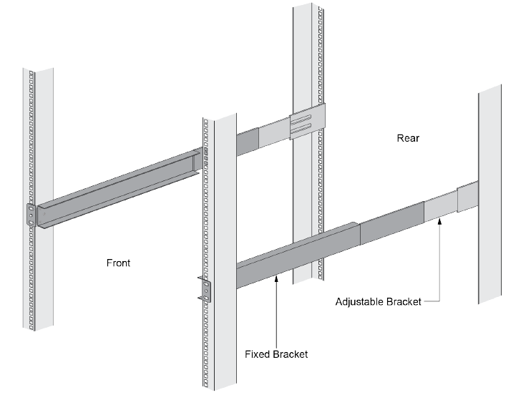
PENDING FINAL QT APPROVAL FOR THESE VIEWS
Figure 6
    - (2) Align the bottom edge of the mounting rails to the bottom of the 1 RU reserved for your firewall. Align the slotted holes in the adjustable mounting bracket to the holes on the rear of the equipment frame.
NOTE:
The mounting rails are designed for equipment frames that are 26” to 32” deep.
    - (3) Secure the rails to the equipment frame with mounting screws, see figure 7.
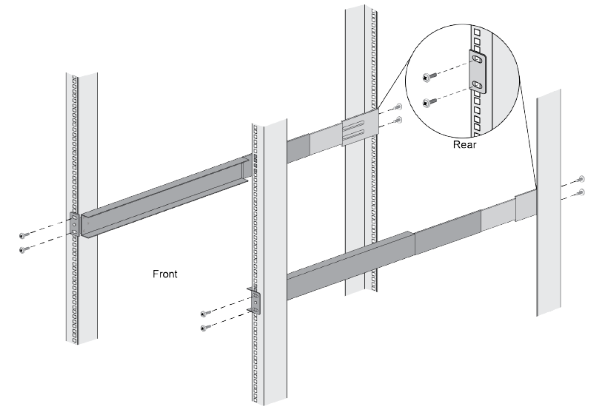
PENDING FINAL QT APPROVAL FOR THESE VIEWS
Figure 7
    - (4) With the front of the firewall facing forward, align the four rubber feet on the bottom of the device to the slotted holes in the mounting tray, see figure 8.
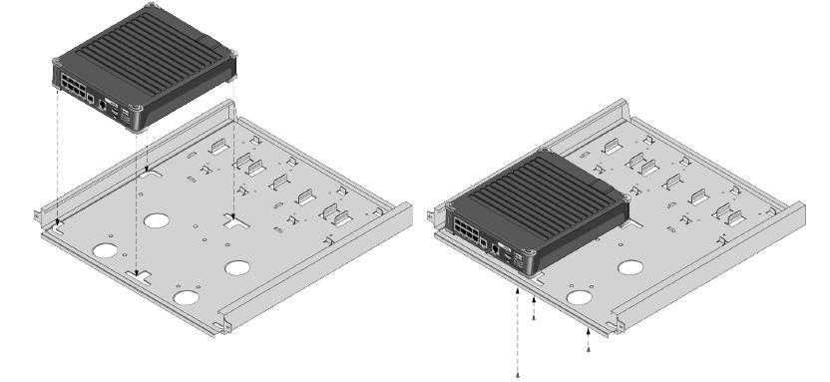
PENDING FINAL QT APPROVAL FOR THESE VIEWS
Figure 8

    - (5) While holding the firewall in place, carefully flip the tray over.
    - (6) Secure the firewall in place using three of the provided #6-32 x 3/16” flathead screws, see figure 9.
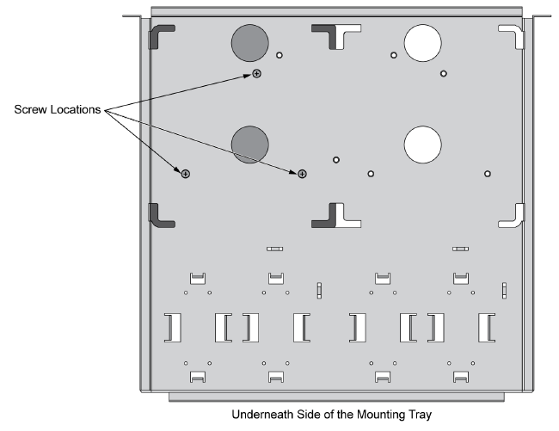
PENDING FINAL QT APPROVAL FOR THESE VIEWS
Figure 9
    - (7) If required, repeat for the second firewall, placing the second firewall adjacent to the the first firewall in the mounting tray.
    - (8) Carefully flip the tray to the upright position.
    - (9) Slide the firewall power supply into the marked position. Fasten the velcro strap around the power supply until it is secure in place, see figure 10.
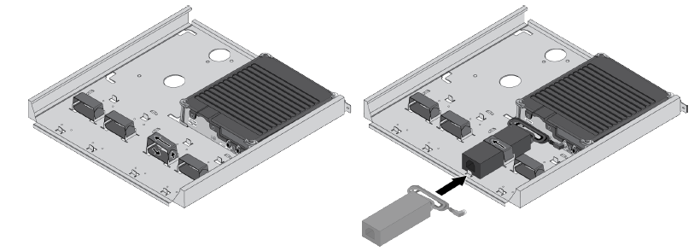
PENDING FINAL QT APPROVAL FOR THESE VIEWS
Figure 10
    - (10) Plug the power supply into the firewall, using the provided tie wraps, bind and secure the power supply cable to the metal hooks in the mounting tray.
    - (11) Repeat for second firewall, if required.
    - (12) Slide the mounting tray into the rails, previously fixed to the equipment rack, until flush with the front of the rail.
    - (13) Align the slotted holes in the mounting tray to the holes in the equipment frame. Secure the mounting tray to the equipment frame on both sides using 3 screws each, see figure 11.
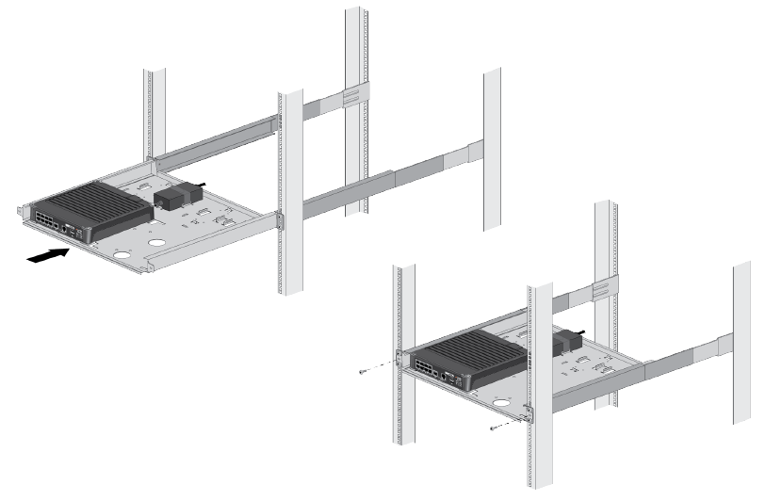
PENDING FINAL QT APPROVAL FOR THESE VIEWS
Figure 11
  - E. Connect the firewall(s) to a protected power source (i.e. Power Distribution Unit (PDU) or Uninterruptible Power Supply (UPS)), as follows:
    - (1) Remove the screw and star washer from the ground point on the back of the firewall.
    - (2) Crimp a 14AWG ground cable to a ring lug, place the ring lug over the screw and star washer, replace the screw to attach the cable to the firewall.
    - (3) Torque the screw to 25 in-lbs and connect the other end to ground.
    - (4) Connect the DC connector from the power adapter into the PWR 1 port on the firewall and tighten the connector nut to secure the cable to the firewall, see figure 12.
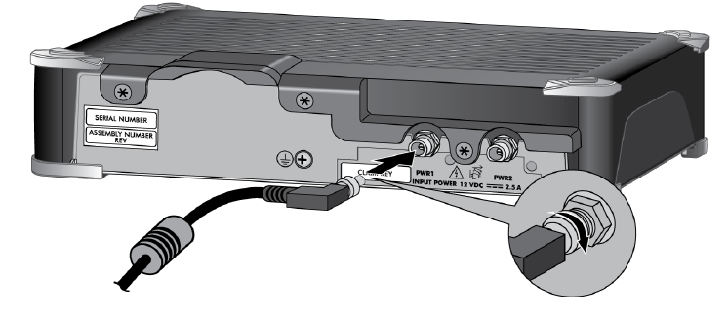
PENDING FINAL QT APPROVAL FOR THESE VIEWS
Figure 12
  - (5) Plug the AC connector from the power adapter into your AC protected power source (i.e. Power Distribution Unit (PDU) or Uninterruptible Power Supply (UPS)).
    - (a) After power is connected, the firewall will power up and the LED power light will turn green (next to the PWR1 port) and the front PWR LED will show green.
- 4. Connect cabling in a like for like swap (cables connected to old firewall will be connected in the same manner in the new firewall).
  - A. Document the upstream and downstream devices and ports that the firewall(s) are connected to on the Port Cabling Matrix, below.
Firewall 1 - Port Cabling Matrix
1 |  | 3 |  | 5 |  | 7 |  | MGT
2 |  | 4 |  | 6 |  | 8
Firewall 2 - Port Cabling Matrix
1 |  | 3 |  | 5 |  | 7 |  | MGT
2 |  | 4 |  | 6 |  | 8
  - B. Take a photo of the completed form, this is a deliverable.
- 5. Connect the firewalls to the Wide Area Network (WAN)/Internet connections per Customer instructions. CONNECT TO BRIDGE AND INFORM.
- 6. Connect the firewalls to the Local Area Network (LAN) connections per Customer instructions.
NOTEs:
1. Firewall configuration will be pushed to local PANW device by WWT Remote Engineers.
2. Remote engineers will ensure there are no errors during configuration push and the firewall is ready for ATP process.
- 7. Execute the firewall ATP:
  - A. Ensure that the firewalls are active and communicating via the visual indicators (Light-Emitting Diode (LED) color and flash pattern) as specified in the test procedures.
  - B. When the ATP is complete, have the site POC sign the document.
  - C. Take a photo of the completed ATP, signed by the site POC - this is a deliverable.
- 10. Verify that the remote engineers can access the devices.
- 11. Based on feedback from the remote engineers, ensure that the devices are in a normal operating state.
- 14. Proceed to the Decommissioning section.

Decommissioning:
- 1. Power down legacy firewall(s) and disconnect from the power source.
- 2. Deinstall/remove legacy firewall(s).
  - A. Place the deinstalled legacy firewall(s) in the boxes from the new firewall(s).
  - B. Apply return shipping label(s).
NOTEs:
Cosmetic repair is not in scope.
Device wipe, erasure, data, or configuration removal is not in scope.
- 3. After the new firewall(s) are installed and the legacy firewalls are deinstalled, take post installation photo(s) of each MDF/IDF environment - including all network racks, cables, and cable runs – these photos are deliverables.
- 4. Ensure Citrix devices (already powered down) are also removed from cabinets and boxed up with legacy Firewalls for disposal.
- 5. Take a post installation photo of each new firewall. ensure the connections and labels are legible, these photos are deliverables.
- 6. Provide site POC with return shipment.
- 7. Work with the POC to complete the Site Acceptance Form.
  - A. Take a photo of the Site Acceptance Form, this photo is a deliverable.
- 8. Proceed to the Completing the Installation and Check-out section.

Completing the Installation and Check-Out:
- 1. When all work has been successfully completed
  - A. Clean up all trash and debris - make sure the area looks as good or better than it did when you arrived.
  - B. Confirm all legacy equipment is boxed, labeled, and ready for safe transport to the nearest FedEx for drop-off.
  - C. Confirm all required photos have been taken.
  - D. If not already accomplished, using the Deliverable Checklist as a guide, upload deliverables to your Project team:
  - E. Check out with the WWT Remote Facilitator/Cut Admin

Overall Deliverable Checklist:
- Pre installation photo(s) of each MDF/IDF environment - including all network racks, cables and cable runs
- Pre installation photo(s) of each OLD firewall to be replaced. Front and back of each device should be taken with clear view of Serial Number details on back of device near power supply.
- Post installation photo(s) of each MDF/IDF environment – including all network racks, cables and cable runs
- Post installation photo(s) of each NEW firewall replaced. Front and back of each device should be taken with clear view of Serial Number details on back of device near power supply.
- Port cabling Matrix
- ATP results - to be confirmed per OLE remotely with Technician. Technician should then confirm general time/POC with WWT Cut Admin to be documented per site.
- Site Acceptance details - to be confirmed per OLE remotely with Technician. Technician should then confirm general time/POC with WWT Cut Admin as part of final check-out details.
- 2. Check-out with site POC and depart the site.

Site Acceptance Form - Must be fully documented before leaving site.
Customer name: QuikTrip |  | Site:
Date:
Customer Site Acceptance:
Provided firewall(s) function as required and all work has been completed satisfactorily. Request final confirmation and acceptance from QuikTrip OLE.
POC signature:
POC name (printed):
WWT Tech signature
WWT Tech name (printed):
Date:

Document Revision History
The revision history lists all changes made to this document during development and post-release. Provide a description of the change along with the name of the author and the date of the change.
Ver # | Author | Date | Description of Change
1.0 | John Rhodes | 3/13/2024 | Initial document
2.0 | Kim Mrozinski (PMO) | 5/21/2024 | Minor revisions
3.0 | Kim Mrozinski (PMO) | 6/20/2024 | Updates per review with QT team.
4.0 | Kim Mrozinski (PMO) | 8/5/24 | Minor revisions

