1. Based on the spending habits you tabulated on day 2, what does your bank account tell you about what you find important? If most of your money goes to clothes, then clothes are what you value

2. List 5 things that matter most to you
Eg: Family, travel, education etc.
1.
2.
3.
4.
5.

3. Does your bank account reflect the importance of these things in your life?

4. Take a few minutes to look at the image below and choose 5 values that resonate with you. List them in order of importance in the table below, with number 1 being the most important and number 5 being the least important. Try to link your values to the things that are important to you (question 2 above). [You can also list values that are not listed in the image]
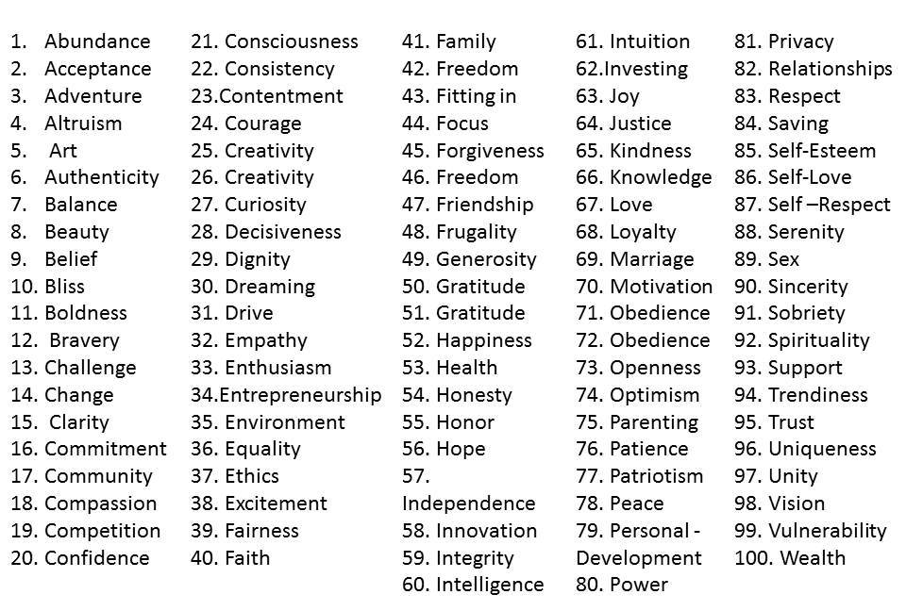

1.
2.
3.
4.
5.

5. What does it mean for you to really live these values?

6. Look at Day 2’s worksheet and brainstorm creative way to can spend money in alignment to your values. Write ideas below (don’t meddle with the numbers just yet)
Examples:
1. If you value connecting with friends on social media but your cell phone bill/ data costs are really high, maybe you can consider getting broadband and wi-fi for the house and connecting from home instead of spending so much money on your cell phone
2. If you value human connection and you spend lots of time at restaurants with friends, what about having weekly or monthly gatherings or potlucks at your home where everyone brings a dish and can show off their cooking skills

