Exam Style Questions

**Q1.** A car wheel nut can be loosened by applying a force of 200 N on the end of a bar of length 0.8 m as in **X**. A car mechanic is capable of applying forces of 500 N simultaneously in opposite directions on the ends of a wheel wrench as in **Y**.

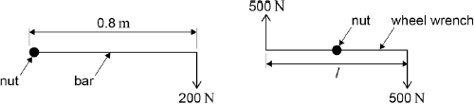  
**X**                                                        **Y**

What is the minimum length *l* of the wrench which would be needed for him to loosen the nut?

M(Nut) – Scenario 1

M = F x d = 200 x 0.8 = 160Nm

M(Nut) – Scenario 2

M = 500 x d + 500 x d = 1000d = 160Nm

* D = 0.16m
* L = 0.32m

**Q2.**          A sprinter is shown before a race, stationary in the ‘set’ position, as shown in the figure below. Force **F** is the resultant force on the sprinter’s finger tips. The reaction force, **Y**, on her forward foot is 180 N and her weight, **W**, is 520 N. **X** is the vertical reaction force on her back foot.

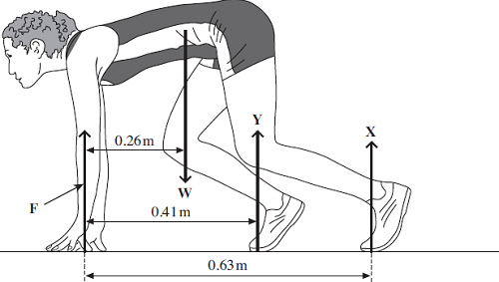

(a)     (i)      Calculate the moment of the sprinter’s weight, **W**, about her fingertips.

 M = F x d = 520 x 0.26 = 135.2… = 1.4 x 102Nm [1 mark for answer, 1 mark for unit]

(ii)     By taking moments about her finger tips, calculate the force on her back foot, marked **X**.

M(Fingertips)

* 0.26W = 0.41 x 180 + 0.63X [1 for correct distances for forces, 1 for correct moments expression]
* 0.63X = 135.2… - 73.8
* X = 97N [1]

(iii)    Calculate the force **F**.

Linear Equilibrium:

F + Y + X = W

* F = W – Y – X = 520 – 180 – 97… = 2.4 x 102N [1]

(b)     The sprinter starts running and reaches a horizontal velocity of 9.3 ms–1 in a distance  
of 35 m.

(i)      Calculate her average acceleration over this distance.

v2 = u2 + 2as

* a = [1] = = 1.2 ms-2 [1]

(ii)     Calculate the resultant force necessary to produce this acceleration and explain which force provides this forward force.

FRES = ma = $\frac{520}{9.81}$ x 1.2.. = 65N [1] this force is provided by a frictional force from the ground at the sprinters feet. [1]

**(Total 10 marks)**

**Q3.** (a)     Define the moment of a force about a point.

The moment of a force about a point is equal to the force multiplied by the perpendicular distance [1] between the line of action of the force and the pivot. [1]

**(2)**

(b)     The diagram shows a gripper which is used for hand strengthening exercises.

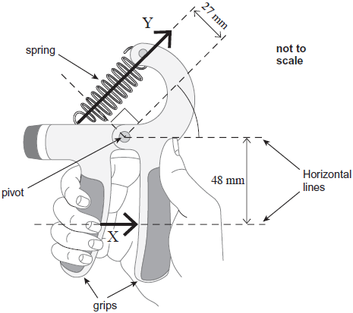

The diagram shows the gripper being squeezed. In this situation, the gripper is in equilibrium. The force produced by the fingers is equivalent to the single force **X** of magnitude 250 N acting in the direction shown above. A force, **Y**, is exerted by the spring which obeys Hooke’s law.

(i)      Calculate the moment of force **X** about the pivot. State an appropriate unit.

M = F x d = 250 x 48 x 10-3 = 12Nm [1 for answer, 1 for unit]

(ii)     Calculate force **Y**.

M (Pivot)

F x 27 x 10-3= 12 [1]

* F = 4.4 x 102N [1]

(iii)    The extension of the spring is 15 mm.

Calculate the spring constant *k* of the spring. Give your answer in N m–1.

F = kx

* k = $\frac{F}{x}$ = $\frac{444…}{15 x {10}^{-3}}$ [1] = 30kNm-1 [1]

(iv)    Calculate the work done on the spring to squeeze it to the position shown in the diagram.

W = ½ Fx = ½ x 444… x 15 x 10-3 [1] = 3.3 J [1]