.Dear Potential Sponsor,

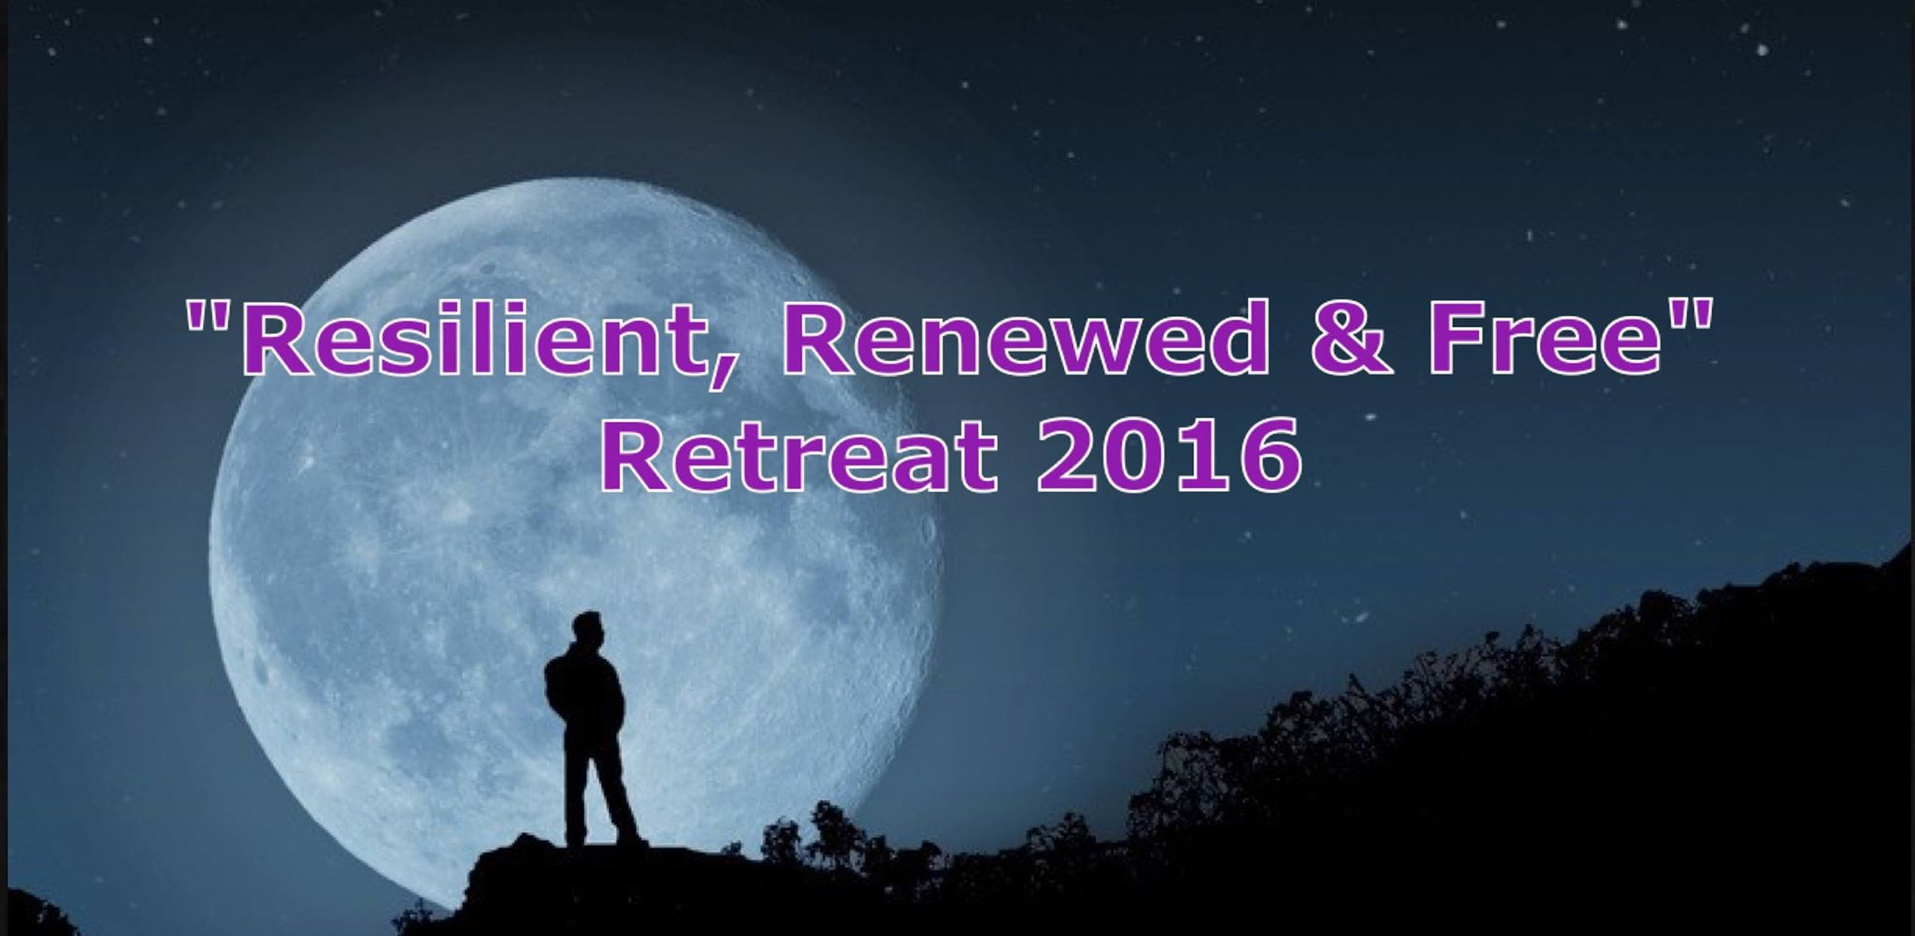

Resilient

Renewed

& Free

*You’re in for an uplifting and amazing weekend at this wonderful all-inclusive retreat hosted by*

*Events by R. and Events After Dark Men’s Society (EADMS).*

*This retreat will give you an opportunity to be amongst men from variety of backgrounds/ walks of life in effort to promote networking and establishing friendships.*

*Partake in team building exercises, sporting competitions and other games/activities with the opportunity to seize amazing prizes.*

*We cannot allow you to overlook the* ***delicious food and beverages****; not to mention* ***daily specialty retreat cocktails to cement the occasion.***

*This unique experience will take place on a 117 acre farm ranch offering a picturesque backdrop complete with bridges, streams and a lake for fishing.*

***Can’t wait to see you there!!!***

Events by R. and E.A.D.M.S. (Events After Dark Men’s Society) are excited to announce a new partnership in its first annual All Men’s Retreat being held in ***Fort Worth, TX culminating on September 15-19, 2016***.

This premier event brings together a demonstration of manhood and brotherhood by joining forces to create an extraordinary event that will hopefully change the lives of men in attendance.

Men from all parts of the country to showcase our ***“Resilience”***.

* Today’s man has to be tough as leather and flexible so we know that anyone that will be in attendance is just that, **“Resilient”,**
* Our guest are coming to this retreat because they also need to be **“Renewed”.**  Men need a chance to exhale and be pampered without any worries or cares of life’s everyday obstacles. Also by interacting with other men from all walks of life they will be able to build new friendships.
* Finally this retreat will set our guest **“Free”**. Freedom is defined as the ability to “act, speak or think as one wants without hindrance or restraint” and that is exactly the environment that this retreat will foster.

This retreat promises to be filled with:

* **Speakers and Open Forums on Social Issues, Health & Fitness, Volunteerism in Our Communities and Legal/Financial Q/A**
* **Five Days and Four Nights of Lodging & Meals- All-Inclusive (Breakfast/Lunch/Dinner)**
* **Friday Night Meet & Greet/Cocktail Party**
* **Saturday -Team Building Activities/Competitions**
* **Saturday Evening- Cookout/Pool Party**
* **Sunday Spiritual Nature Experience Time**
* **Sunday Evening Semi- Formal Farewell Dinner**
* **Additional activities and guest surprises!**

Your sponsorship will be a welcomed opportunity to showcase your products or businesses. Your sponsored products will be beneficial to our guest and at the same time introduce them to some items they may not necessarily be familiar with. Whether it pertains to health and wellness or personal lifestyle; we are quite sure this will be a great fit to market your products by letting us promote them through using our varied advertising opportunities. We welcome your sponsorship in any of the sponsorship packages listed on [www.sponsormyevent.com/resilient-renewed-free-male-retreat-2016-fort-worth](http://www.sponsormyevent.com/resilient-renewed-free-male-retreat-2016-fort-worth) Please feel free to contact us at your convenience if there are any other questions or concerns.

Looking forward in hearing from you soon,

Mr. Ricki Walker, Creative Director

Mr. Graylynn Viltz, Assist. Director

[Eventsaftdarkmsociety@gmail.com](mailto:Eventsaftdarkmsociety@gmail.com) 972.369.6257