Names: _______________________________________________________________________________________

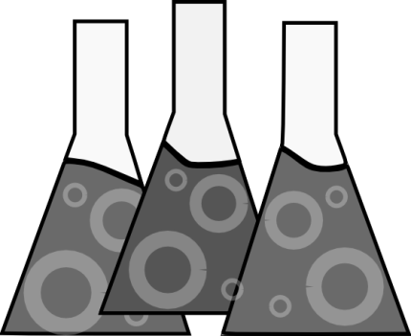Acids and Bases  
Using litmus paper and pH testing strips

**Objectives:**\* To test household solutions using litmus paper and pH test strips  
* To classify household substances as acids, bases, or neutrals  
* To describe properties of acids, bases, and neutrals

**Materials:**

* Litmus paper
* pH strips
* Plastic cups containing:
  + Water
  + Rain water (if possible)
  + Baking soda
  + Coffee
  + Lemon juice
  + Vinegar
  + Orange Juice
  + Coca Cola
  + Drain Cleaner
  + Ammonia (Windex)
  + Soapy water
* Paper towel
* Markers

**Pre Laboratory Predictions:**Look at each of the liquids being tested and make a prediction. Think about what you know about acids, bases, and neutral substances. Circle your guess.

|  |  |  |  |
| --- | --- | --- | --- |
| Water | Acid | Base | Neutral |
| Rain water | **Acid** | **Base** | **Neutral** |
| Baking soda | **Acid** | **Base** | **Neutral** |
| Coffee | **Acid** | **Base** | **Neutral** |
| Lemon juice | **Acid** | **Base** | **Neutral** |
| Vinegar | **Acid** | **Base** | **Neutral** |
| Orange Juice | **Acid** | **Base** | **Neutral** |
| Coca Cola | **Acid** | **Base** | **Neutral** |
| Drain Cleaner | **Acid** | **Base** | **Neutral** |
| Ammonia (Windex) | **Acid** | **Base** | **Neutral** |
| Soapy water | **Acid** | **Base** | **Neutral** |

REMINDER:

|  |  |  |
| --- | --- | --- |
| **Color** | **Blue Litmus** | **Red Litmus** |
| Acid | turns red | stays same |
| Base | stays same | turns blue |
| Neutral | Stays same | Stays same |

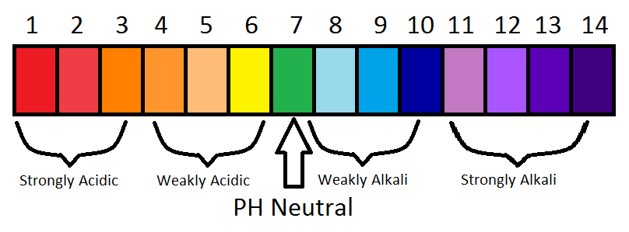

**Procedure:**

1. At each station, there will be a labeled cup of solution, red litmus paper, blue litmus paper, and pH strips.
2. Dip the red litmus paper into the cup. Next, dip the blue litmus paper into the cup. Finally, dip the pH strip into the cup. Compare the color to the pH chart. Write down the results in the data chart.
3. Determine if the substance is an acid, base, or neutral
4. Make sure you place your used litmus paper on your paper towel. DO NOT leave it at each station
5. Move to each station, repeating the above process.
6. Answer the post laboratory questions that follow.

**Data Table:**

|  |  |  |  |
| --- | --- | --- | --- |
| **Substance** | **Red Litmus Paper Observations** | **Blue Litmus Paper Observations** | **pH Scale # (1-14)** |
| Water |  |  |  |
| Rain water |  |  |  |
| Baking soda |  |  |  |
| Coffee |  |  |  |
| Lemon juice |  |  |  |
| Vinegar |  |  |  |
| Orange Juice |  |  |  |
| Coca Cola |  |  |  |
| Drain Cleaner |  |  |  |
| Ammonia (Windex) |  |  |  |

**Categorize Your Results:** Write the name of the substance in the appropriate box

|  |  |  |
| --- | --- | --- |
| **Acid** | **Base** | **Neutral** |
|  |  |  |

**Conclusion Questions:**

1. The pH scale goes from _____ to ______.
2. True or False: Acids and bases are common in everyday places such as your kitchen. _______
3. List **three properties** of acids and bases, and **two properties** of neutral substances.

|  |  |  |
| --- | --- | --- |
| **Acids** | **Neutral** | **Bases** |
|  |  |  |
|  |  |  |
|  |  |  |

1. Why are indicators such as litmus paper, pH strips, or even cabbage juice helpful to scientists?  
     
   ____________________________________________________________________________________  
     
   ____________________________________________________________________________________  
     
   ____________________________________________________________________________________
2. When litmus paper turns red, it identifies an ___________.
3. When litmus paper turns blue, it identifies a ____________.
4. Did the substances that turned the litmus paper red or blue always turn it the same shade of red or blue? What does that tell you about acids and bases?  
   ____________________________________________________________________________________  
     
   ____________________________________________________________________________________  
     
   ____________________________________________________________________________________
5. What is the pH range of an acid? _________. The pH of a strong acid would be closest to _____.
6. What is the pH range of a base? __________. The pH of a strong base would be closest to _____.
7. Label the following as true (T) or false (F). You may need to refer back to your notes:
   1. ____ Acids will not conduct electricity
   2. ____ Bases will conduct electricity
   3. ____ Acids taste bitter
   4. ____ Acids turn red litmus paper blue
   5. ____ An indicator is a substance that changes color in acids/bases
   6. ____ Bases turn litmus paper blue
   7. ____ Bases feel slippery
   8. ____ The pH of pure water is 7