The New Dating:
Changes in Undergraduate Romantic Pair Formation
John Doe
San Diego State University
2018

Acknowledgements: Put here the source of any grant funding you received for the project.

The New Dating: Changes in Undergraduate Romantic Pair Formation

Abstract
This is where your abstract will go. It should be on a separate page from the rest of your paper if you are submitting for publication, but for a class assignment you can typically begin your paper right after it. Your abstract should give a short summary of your research paper and what the reader should expect. It should be between 150-250 words. Think of it as a press release or an elevator pitch for your entire paper. Try to summarize the main couple points of each primary section (literature review, methods, findings, discussion) in a sentence or two each.

Keywords: romantic relationships, pair formation, college students, millennials, new technologies

The New Dating: Changes in Undergraduate Romantic Pair Formation
This is where your introduction will go, begin with an interesting “hook” to draw your reader’s attention to the import of your topic—maybe a relevant statistic or attention-grabbing quote or statement. There is no need to title it “Introduction,” people know that the first few paragraphs of a paper is the introduction. Start giving a little context for your paper. This would be a good spot to state your research question(s) or hypotheses (hypothesis are more common in quantitative papers). You could also tell the reader why your topic is important to society. Do cite literature in your introduction, but it does not have to be as in-depth as in the literature review. For most college papers, a single page or page and a half of double-spaced introductory material will be sufficient.
Literature Review
Your literature review is next. You can write “Literature Review” as above, or you can title it something else based on your topic, like, “How Romantic Relationships Have Evolved.” First-level headings should be centered and bolded.
A good literature review is almost always broken into sub-parts based on the topics of the sources you are citing. Plan for about three sub-sections, give or take one. The sub-sections should logically build toward your research question. In this example, if the paper is on changes in how relationships are formed, I might have sub-sections on 1) new technologies, 2) changing cultural values toward sexuality and cohabitation, and 3) delayed marriage due to expectations for college and career formation for both genders. While that may not be an exhaustive list of all possible sub-topics on what influences relationships today, it has a face logic to it. You can tell the reader what you will cover, and then begin the sections.

The Impact of New Technologies on Romantic Relationships
Second-level headings are not in all capital letters, but they are bolded. But the first letter of each word is all capitals, other than connector words (e.g., and, it, on, of).
Apps and mobile devices. If you choose to use third-level headings—like I put here—they are in italics, only the first word is capitalized, place a period at the end, and keep it in-line with the text that follows it.
You will want to begin citing right away in your literature review. The vast majority of your citations—like 90 percent—should be simple paraphrased citations rather than quotes. The simplest case is when you write a sentence that needs a citation and include it at the end before the period like this (Smith, 2017). When the author's name is introduced in the text, the year comes right after their name, such as: Smith (2017) wrote about changing gender expectations in dating. If you decide it is one of the few instances where you want to use a direct quote in your paper then you will add quotation marks and a page number after the quote. For example: Smith reported that "heterosexual men increasingly expect their female partners to have gainful employment before considering dating them" (p. 226). The abbreviation "p." is for page and "pp." for pages. Both should be lower cased (only uppercased with block quotes).
Block quotes are for quotes that are over 50 words, and should be single spaced and indented from the rest of the paper. This is a block quote.
As stated by Smith (2017):
This is a block quote. It should be used incredibly sparingly, probably not more than once in a literature review, if used at all. The exception is that you can use them more frequently in your findings section if you are quoting your own interviewees (you would not need a page number in that case). Use block quotes when the content of what you are quoting is important to get verbatim, not just because you like the way the author says something and would rather not paraphrase it yourself. You put the page number after the period in a block quote. (p. 226)

When using quotes, start the sentence in your own words before switching to the quote, do not put a quote as an entire stand-alone sentence; and NEVER quote something that has a quote of something else inside of it. If you like what is quoted, then hunt down that source and quote and cite it directly yourself.
You may cite multiple sources in a single sentence. For example: Multiple scholars have found that changes in cohabitation patterns are contributing to the age of first marriage (Jamison, 2014; Zang & Hansen, 2012; O’Brien, Schwartz, & Clementine, 2008). Or even better, if you can make it a relevant list, for example: Multiple scholars have found that changes in cohabitation patterns due to parental influences (Jamison, 2014), religious influences (Zang & Hansen, 2012), and economic influences (O’Brien et al., 2008) are contributing to the age of first marriage. If there are three or more authors, use all three last names the first time you cite them, and then switch to only the first-author’s last name and “et al.” for all subsequent times you cite them—as I did above with O’Brien.
Once you have covered all of the sections in your literature review, it is good to write a transition paragraph or sentence to lead into your methods section. One common way is to remind us of your research question.
Methods
Your methods section will go here. You will most likely also have some subheads for this section; common ones might be: data, sample, materials, variables, or procedures. The sections you have depend on the materials you are using, the kind of method you are using (experiment, interviews, surveys, etc.), and if it is a quantitative or qualitative paper.
At minimum make sure you have sections that explain who, what, and how. The “who” has to do with your sample; tell us the number and demographics of the people involved (a table is often nice as well). The “what” are the tools you used. Do not say things like journal articles or Microsoft Word. But do include things like your interview protocol (the questions), voice recorders, software for data analysis, any pre-made scales or inventories, etc. Write it out in sentence form, not as a bullet-point list. The “how” are the steps you took to get the people, conduct the study, and analyze the data.
You have two main goals in a methods section. One, you want to make clear how you gathered your data and to convince the reader that it was done in a way that is logical and will produce acceptably unbiased results. Two, give enough detail that somebody could re-create your study if they wanted to, that is an important part of the scientific method. Your methodology section is typically much shorter than both your literature review and your findings section. A page or two will suffice for most college paper assignments.
Findings
Your findings section (as is more commonly called in qualitative papers) or results section (as is more commonly called in quantitative papers) goes next. It will also have a few subheadings breaking up your key findings into sections. A quantitative paper will have tables of statistical output along with text descriptions of what you found. A qualitative paper will have more quotes from interviewees and thick descriptions from field observations. If you did interviews and you quote people, be sure to use pseudonyms and to give a couple relevant demographics about each person quoting. The first time you use a pseudonym, include a footnote telling the reader that all names are pseudonyms; something like this: Sandra, a junior using the dating platform eHarmony, said, “I used to think meeting people online was weird, but it’s very mainstream now.”
When you use tables (which have rows and columns of data) or figures (anything that is not a table), you should call them out in-text before you get to them. You can often just tuck it into a relevant sentence within parentheses (See Table 1). Then you would put the table somewhere nearby below it. Number all tables consecutively, and number them separately from your consecutive numbering of figures. Also, put table numbers and titles above the table, but for figures put the numbers and titles below the figure. Below is an example table from the paper “Career Funneling” I published.
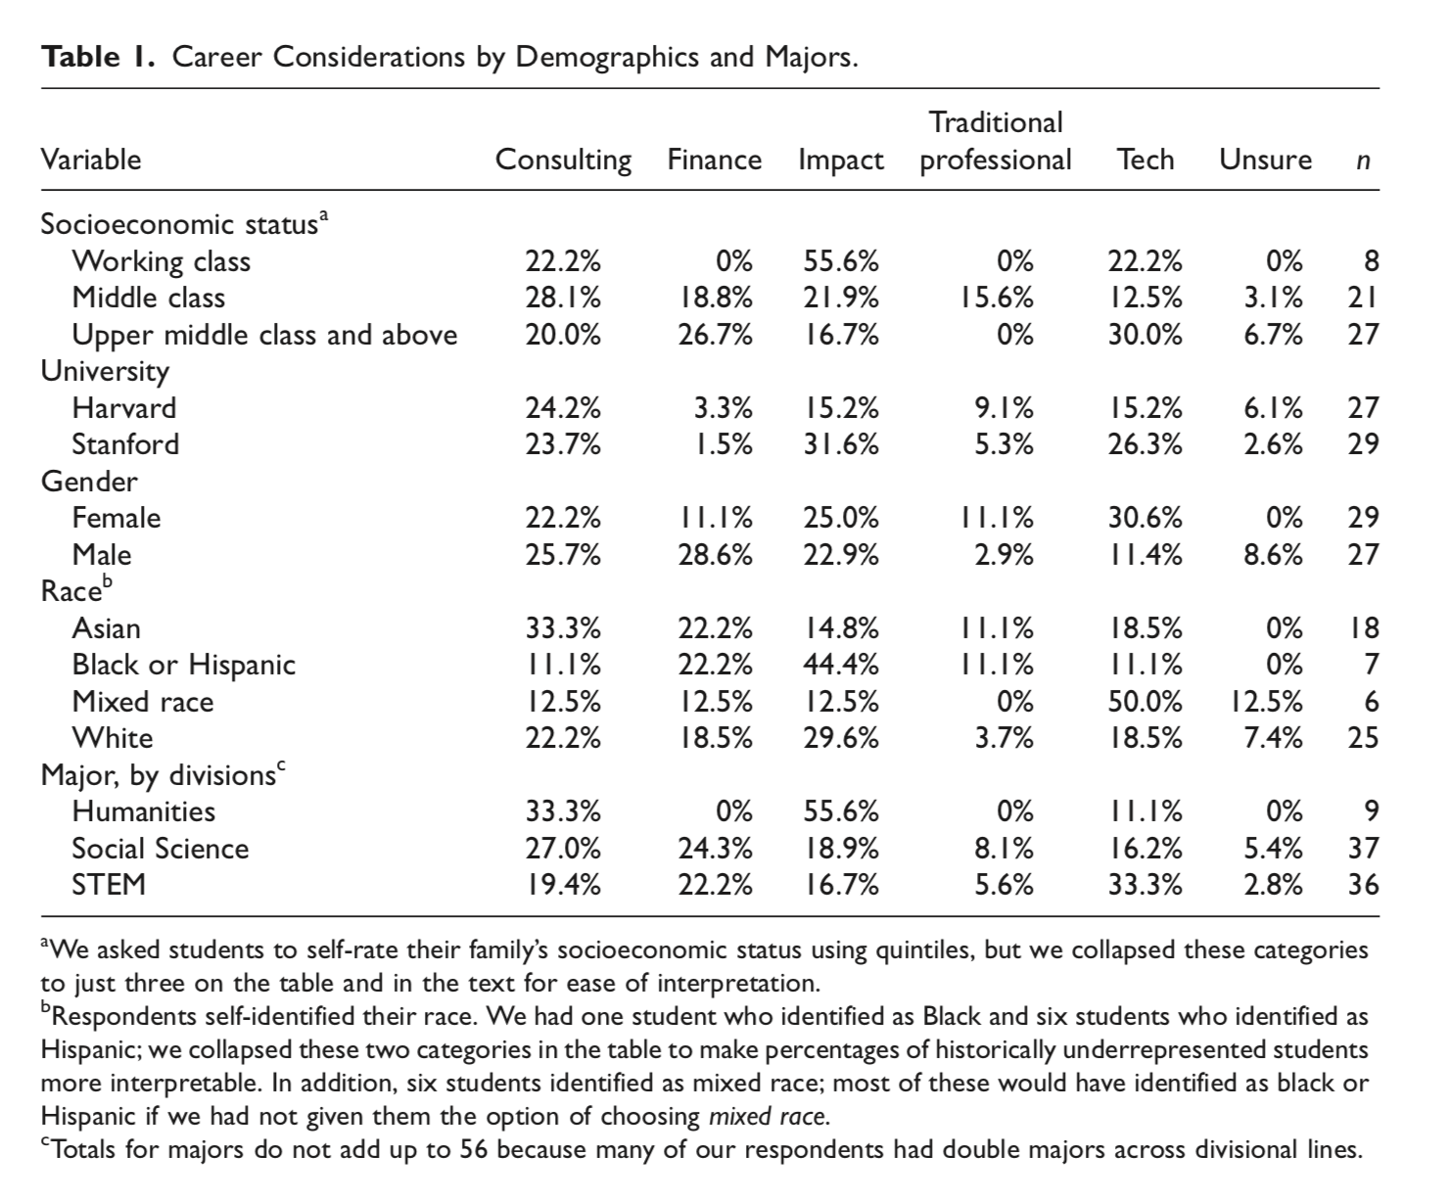
Then for a figure, you label it at the bottom. See Figure 1 below for an example, it comes from a paper I published called “Selling Students.”
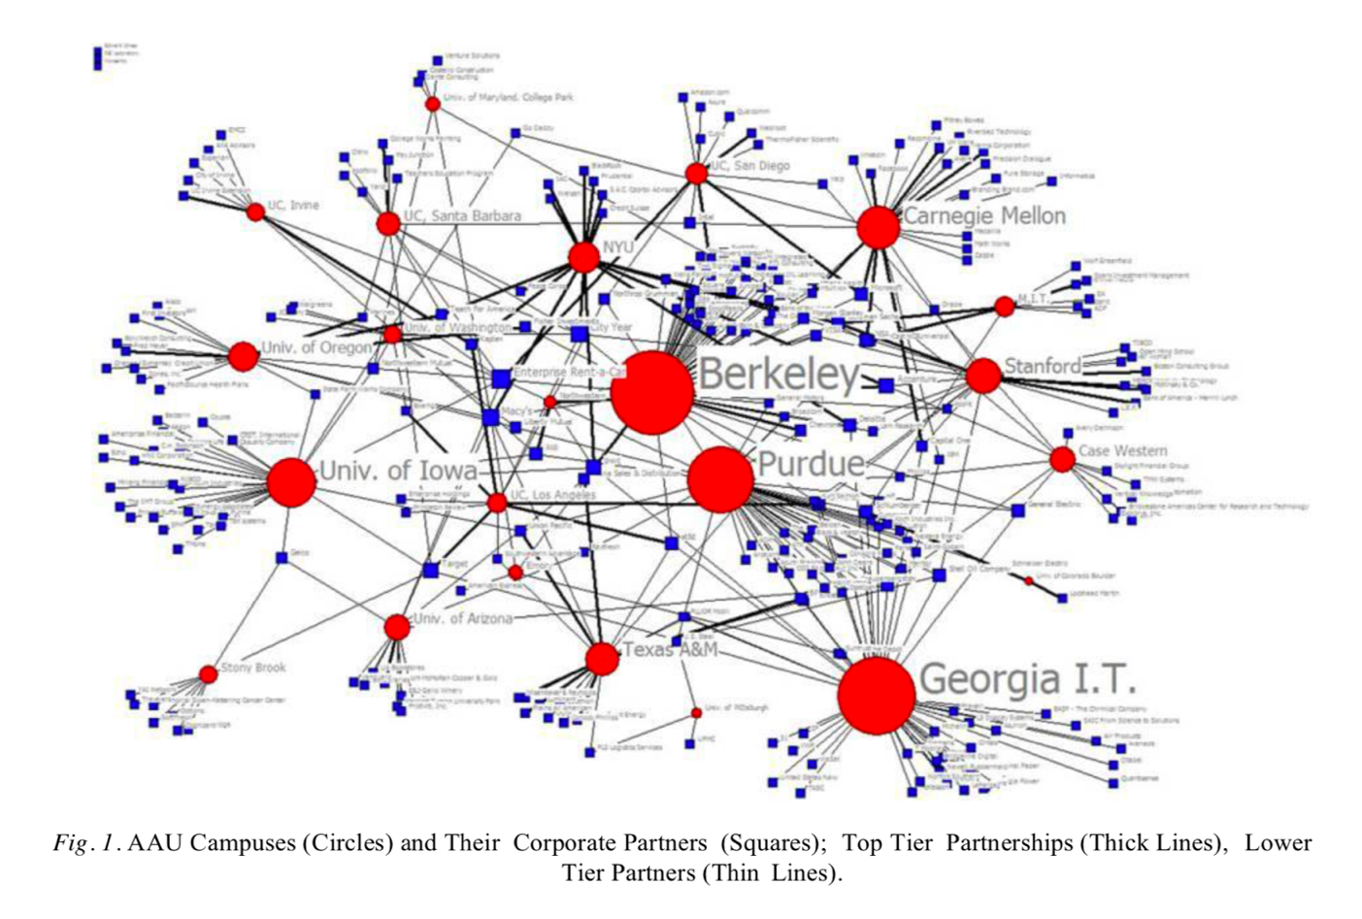
Whenever you give a table or a figure be sure to describe the important thing for the reader to notice in-text. Do not just leave the table or figure to speak for itself without explaining the key points. Also, do not start or finish a section of your paper with a table or figure; all sections should start and finish with words not images.

Discussion
This is where you tell the reader what your findings or results mean. You interpret the outcomes and give context, such as whether your outcomes support or contradict the existing literature. You may also note for future researchers any limitations in your study that you had to overcome, that they may be able to build off of. For example, you may be using a publicly available data set that did not ask a couple questions you thought would have been helpful. You could include those questions for a future researcher. But do not put as a limitation anything about challenges you had collecting data or writing the paper—like “it was hard to get articles because they were behind a paywall” or “I have a job so I didn’t have much time to collect data.” If you do not have a good limitation, just skip that.

Conclusion
This is where you will wrap up your paper. You can make it a first or second level heading, or just an un-marked final paragraph of your discussion. Make sure to reiterate your claims and research questions. Most people skim papers by reading the abstract and conclusion, so make sure you make good use of these pieces to explain the key points of your paper succinctly. The conclusion is like the abstract but can be a little longer and a little more fluid. Do not just copy and paste your abstract again at the end, they should not be a verbatim match.

References
(For a Journal Article)
Author1 (last name, first and middle initial), Author2 (last name, first initial), & Author3(last name, first initial). (Year). Title of article not in italics. Name of Publication in italics, Volume number in italics (Issue number not in italics), Page numbers separated by a dash.
Cutler, G. H., Bogue, J., & Krass, K. (2009). Online dating today. American Technology Review, 99(8), 109-111.

(For a Book)
Author1 (last name first), Author2, and Author3. Year. Book title in italics: Capitalized first word only in title and subtitle. Location of publisher: Publisher’s Name.
Smith, J. & Davis, S. (2012). Ear buds: Why millennials can’t put down their smart phones. Berkeley, CA: University of California Press.
(Note: Only capitalize the first letters of the first word in the title and sub-title of journal article titles or book titles, plus any proper nouns. All other words start lowercase. The exception are journal titles, those all start with capitals.)
Appendix A
Dating Website Statistics
Appendices are where you can put extra graphs, demographic information, code structures (for qualitative projects), interview question lists, and other data. Anything that could be helpful to some readers, but messes up the flow of the paper can go into an appendix.

Appendix B: College Student Demographics

All interviewee names are pseudonyms to protect their confidentiality.

