I. Name the congruent triangles.

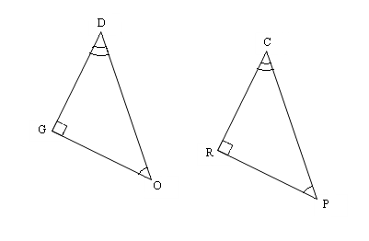
1. 2.
C
G
O

A
R
E

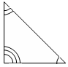
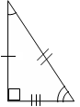
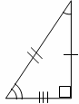
3. 4.
B
O
X
F
O
X
I
A

L
E
N
R

II. Name the congruent triangle and the congruent parts..
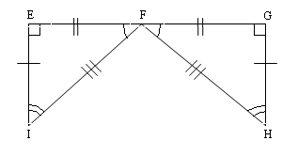
7.

Use the congruency statement to fill in the corresponding congruent parts.

8.

9. . Find x. 10. Find y.
R
Q
N
M
P
x°
A
B
C
D

21°
(3y)°

35º

Third Angles Theorem (add to Theorems, Postulates and Definitions Card) –

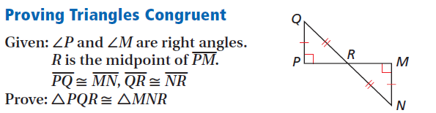

Triangle Congruence Worksheet #1
For each pair of triangles, tell which postulates, if any, make the triangles congruent.

12. ΔABC ≅ ΔEFD ______________ 13. ΔABC ≅ ΔCDA ______________
C
A
D
B
C
A
B
D
F
E

14. ΔABC ≅ ΔEFD ______________ 15. ΔADC ≅ ΔBDC ______________
A
C
B
D
F
E
A
B
D
C

21. ΔMAD ≅ ΔMBC ______________ ΔABE ≅ ΔCDE ______________
A
B
E
C
D
D
A
C
B
M

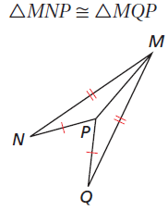
23. ΔACB ≅ ΔADB ______________ 23. ______________
A
C
D
B

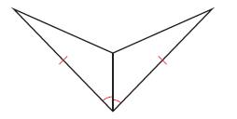
23. ______________

Triangle Congruence Worksheet #2
I. For each pair of triangles, tell which postulate, if any, can be used to prove the triangles congruent.

1. ΔAEB ≅ ΔDEC ______________ 2. ΔCDE ≅ ΔABF ______________
A
E
C
D
B
A
D
E
F
B
C

3. ΔDEA ≅ ΔBEC ______________ 4. ΔAGE ≅ ΔCDF ______________
A
B
C
D
E

5. ΔRTS ≅ ΔCBA ______________ 6. ΔABC ≅ ΔADC ______________
A
B
D
C
T
S
R
B
C
A

7. ΔBAP ≅ ΔBCP ______________ 8. ΔSAT ≅ ΔSAR ______________
Given: BD bisects ABC

T
S
R
A
A

B
D
P

C

II. For each pair of triangles, tell: (a) Are they congruent (b) Write the triangle congruency statement. (c) Give the postulate that makes them congruent.

L
O
V
E
1. 2. 3. Given: T is the midpoint of WR
A
B
D
E
C
A
E

T
W
R

a. ______________ a. ______________ a. ______________

b. Δ_____ ≅ Δ _____ b. Δ_____ ≅ Δ _____ b. Δ_____ ≅ Δ _____

c. ______________ c. ______________ c. ______________

4. 5. Given: IH Bisects WIS 6.
L
U
G
E
I
W
H
S

a. ______________ a. ______________ a. ______________

b. Δ_____ ≅ Δ _____ b. Δ_____ ≅ Δ _____ b. Δ_____ ≅ Δ _____

c. ______________ c. ______________ c. ______________

7. 8. 9.
H
P
A

T
M

a. ______________ a. ______________ a. ______________

b. Δ_____ ≅ Δ _____ b. Δ_____ ≅ Δ _____ b. Δ_____ ≅ Δ _____

c. ______________ c. ______________ c. ______________

10. Given: I is the midpoint 11. 12.
of ME and SL
C
F
M
L
I

S
E
A
B
D
E

a. ______________ a. ______________ a. ______________

b. Δ_____ ≅ Δ _____ b. Δ_____ ≅ Δ _____ b. Δ_____ ≅ Δ _____

c. ______________ c. ______________ c. ______________

III. Using the given postulate, tell which parts of the pair of triangles should be shown congruent.

1. SAS 2. ASA 3. SSS
F
A
D
E
B
C
C
A
B
D
E
F
A
B
C
D

_______ ≅ ________ ________ ≅ ________ _______ ≅ _______

4. AAS 5. HL 6. ASA
P
R
S
Q
P
S
T
R
Q
D
C
B
A

_______ ≅ ________ ________ ≅ ________ _______ ≅ _______

For each problem below, write a two-column proof on a separate piece of paper.

I. Proving Triangles Congruent:

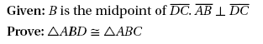
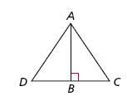
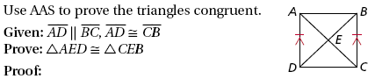
1. 5.

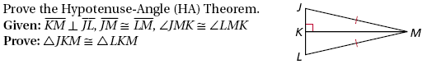
2.

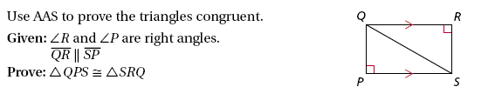
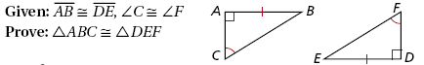
3. 6.

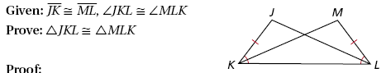
4.

II. Using CPCTC

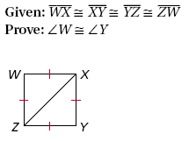
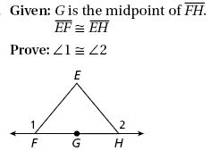
7. 10.
1
2

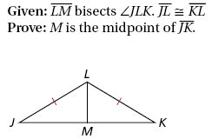
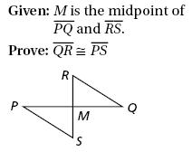
8. 11.

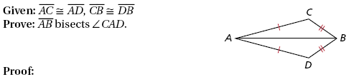
9.

Review: Triangles and Triangle Congruence

You will need a separate piece of paper to show all your work. This review is not comprehensive; always be sure to go back through your old homework and quizzes.
C
A
R
G
E
O
- I can write a congruency statement representing two congruent polygons
- Write a congruency statement for the two triangles at right.

- I can identify congruent parts of a polygon, given a congruency statement
- List ALL of the congruent parts if

  - I can use algebra to find the side lengths and angle measures of congruent polygons
X
Y
W
Z
V
2
2p
20
(7p+13)
- Find p.

- Find x.
D
C
(2x
+ 7)°
1
2
B
A
(x
– 8x)°

- I can name the five ways to prove triangles are congruent
- Name the 5 ways to prove triangles congruent.

- I can prove triangles are congruent
For each pair of triangles, tell: (a) Are they congruent (b) Write the triangle congruency statement. (c) Give the postulate that makes them congruent.

A
B
C
D

A
W
T
E
R

- Given: I is the midpoint
of ME and SL
M
L
S
I

E

- I can mark pieces of a triangle congruent given how they are to be proved congruent
P
R
S
Q

- What information is
missing to use HL?

- What information is missing to use SAS?
D
C
A
B

IV. For which value(s) of x are the triangles congruent?

3. x = _______________ 4. x = _______________
A
D
1
m ∠3 = x²

m ∠4 = 7x - 10
B
E
C
2
3
4
4x + 8
7x - 4
A
B
R
C

W
S
R
Z
T
x² + 2x
x² + 24

5. x = _______________
x² + 3x
D
A
B
C
9x - 8

- I can write a two-column proof over congruent triangles

- Complete and review ALL proofs on the proofs worksheet.

