Lab Safety
View the picture and answer the questions.
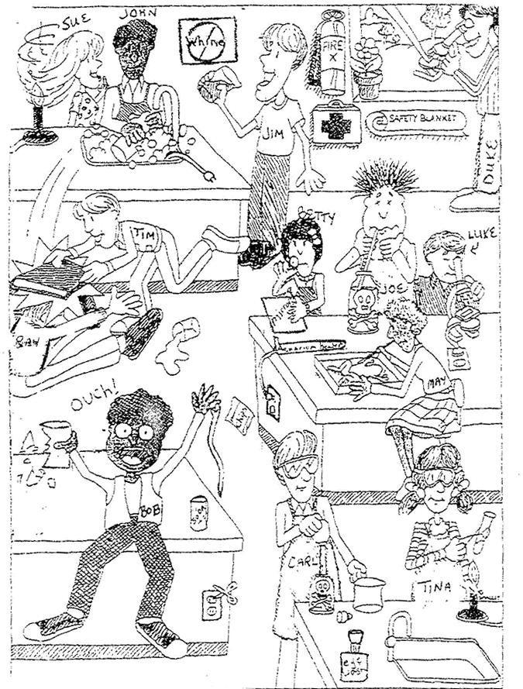
NAME_____________________________ Period_________ date__________
Questions:
1. List 3 unsafe activities shown in the illustration and explain why each is unsafe. 1. 2. 3.
2. List 3 correct lab procedures depicted in the illustration. 1. 2. 3.
3. What should Bob do after the accident?
4. What should Sue have done to avoid an accident?
5. Compare Luke and Duke's lab techniques. Who is following the rules?
6. What are three things shown in the lab that should not be there?
1. 2. 3.
7. Compare Joe and Carl's lab techniques. Who is doing it the correct way?
8. What will happen to Ray and Tim when the teacher catches them?
9. List three items in the illustration that are there for the safety of the students in the lab.
10. What is Betty doing wrong?
NAME_________KEY_________________ Period_________ date__________
Questions:
1. List 3 unsafe activities shown in the illustration and explain why each is unsafe. 1. DRINKING LAB CHEMICAL – IT COULD BE POISONOUS 2. NOT HAVING HAIR TIED BACK – COULD GET INTO CHEMICALS, CATCH ON FIRE 3. NOT WEARING ASFETY GOOGLES – CHEMICALS ETC COULD GET INTO EYE
2. List 3 correct lab procedures depicted in the illustration. 1. WEARING APRONS 2. NOT HORSING AROUND 3. TEST TUBE POINTED AWAY FROM TINA’S FACE
3. What should Bob do after the accident?
DO NOT TOUCH THE GLASS; CALL THE TEACHER TO TAKE CARE OF IT.
4. What should Sue have done to avoid an accident?
TIE BACK HER HAIR
5. Compare Luke and Duke's lab techniques. Who is following the rules?
LUKE IS FOLLOWING THE RULES, DUKE IS NOT HOLDING THE MICROSCOPE CORRECTLY AND IS PLAYING WITH IT

6. What are three things shown in the lab that should not be there?
1. POTATOE CHIPS 2. SODA 3. SISSORS IN THE PLUG
7. Compare Joe and Carl's lab techniques. Who is doing it the correct way?
CARL IS DOING THINGS CORRECTLY, JOE IS DRINKING THE CHEMICAL AND DOESN’T HAVE HIS GOOGLES ON

8. What will happen to Ray and Tim when the teacher catches them?
THEY WILL GET WRITTEN UP AND LOOSE LAB PRIVILEDGES

9. List three items in the illustration that are there for the safety of the students in the lab.
FIRE EXTINUISHER, SAFTEY BLANKET, EYE WASH STATION, FIRST AID KIT
10. What is Betty doing wrong?
APPLYING MAKE-UP INSTEAD OF DOING THE LAB.

