Three rules determine the electron arrangement in an atom: the aufbau principle, the Pauli exclusion principle, and Hund’s rule.

Lesson Summary
Electron Configurations An electron configuration describes the arrangement ofelectrons in an atom.
The aufbau principle says that electrons occupy the orbitals of lowest energy first.
According to the Pauli exclusion principle, each orbital can contain at most two electrons. The two electrons must have opposite spin.
Hund’s rule states that single electrons occupy orbitals in a specific sublevel until each orbital contains an electron. Then electrons pair with these single electrons.
Some electron configurations are exceptions to these rules because of the relative stability of half-full sublevels.
After reading Lesson 5.2, answer the following questions.
Electron Configurations
1. The ways in which electrons are arranged into orbitals around the nuclei of atoms are called _________ .
Match the name of the rule used to find the electron configurations of atoms with the rule
itself.

2. aufbau principle | a. When electrons occupy orbitals of equal energy, one electron enters each orbital until all the orbitals contain one electron with the same spin direction.
3. Pauli exclusion principle | b. Electrons occupy orbitals of lowest energy first.
4. Hund’s rule | c. An atomic orbital may describe at most two electrons.

5. Look at the aufbau diagram, Figure 5.5. Which atomic orbital is of higher energy, a 4f or a 5p orbital?
6. Fill in the electron configurations for the elements given in the table.
Use the orbital filling diagrams to complete the table.

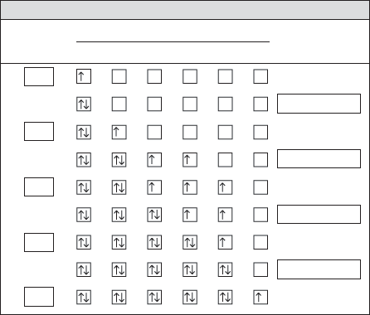
Electron Configurations for Some Selected Elements
Orbital filling
Element | 1s | 2s | 2p_{x} | 2p_{y} | 2p_{z} | 3s | Electron  configuration

1s¹

He

1s²2s¹

C
1s²2s²2p³

O

1s²2s²2p⁵

Ne

1s²2s²2p⁶3s¹

7. In an electron configuration, what does a superscript stand for?

8. In an electron configuration, what does the sum of the superscripts equal?

9. Is the following sentence true or false? Every element in the periodic table follows the
aufbau principle.
10. Filled energy sublevels are more than partially filled
sublevels.
11. Half-filled levels are not as stable as levels, but are more
stable than other configurations.

Section Review Questions:

1. What are the three rules for writing the electron configurations of elements?

2. Use Figure 5.5 to arrange the following sublevels in order of decreasing energy: 2p, 4s, 3s, 3d, and 3p.

3. Why do the actual electron configurations for some elements differ from those assigned using the aufbau principle?

4. Why does one electron in a potassium atom go into the fourth energy level instead of squeezing into the third energy level along with the eight already there?

5. The atomic number of arsenic is 33. What is the electron configuration of an arsenic atom?

