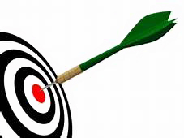 | What is My Goal? _____________________________________________

Use this chart to help you be clear on what your goal is.
- Describe the goal:
- What is it that you need or want to accomplish?
- On a scale of 1 to 10, 10 being most important, how would you rate this goal?
- What would be the impact on your life if this goal were achieved?
- How soon do you want to accomplish this?
- Do you have the resources you need to accomplish this?
- Is this goal consistent with your values?
- What do you intend to do/have?
- Is it a priority?
- What about it is important to you?
- Do you want it or does someone else want it for you?
- You won’t succeed unless it is a priority and something YOU want to accomplish.
- How committed to the goal are you?
- What are you willing to do for this priority?
- Pretend you have succeeded in accomplishing the goal.
- Take a few minutes, close your eyes, and visualize it. Feel it, smell it, taste it.
- How will others regard you?
- How will you regard yourself?
- How does it improve your life?

