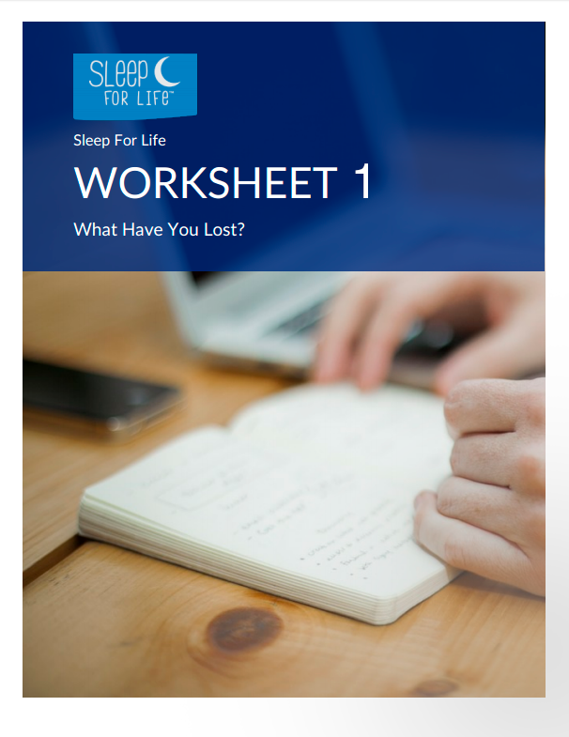

WORKSHEET 1:
WHAT HAVE YOU LOST?

Take some time, right now, to write down a few words describing what insomnia has cost you. Write down everything you can think of. It doesn’t need to be a great essay. It just needs to represent your thoughts and feelings. Get it all out. Keep going for at least 20 minutes, until you can’t think of another single word to say.

- What negative effect has having insomnia had on your career or job?

- What negative effect has having insomnia had on your relationships?

- What negative effect has having insomnia had on your social life?

- What has having insomnia stopped you from doing?

- What is the worst aspect about having insomnia?

Keep this worksheet safe. You will need it later.

