Name_______________________ Period_______________________

Unit 1: Introduction to Chemistry, Measurement and Scientific Method

**Skills:**

1) Accuracy vs Precision

2) Calculate % error

3) Use and Convert Sci Notation.

4) Measure using Sig Figs

5) Understand metric units and prefixes

6) Use Dimensional Analysis

7) Solve Density Problems

8) Graphing Skills

**Unit 1: Vocabulary:** **Complete throughout unit. Due on test day!**

|  |  |
| --- | --- |
|  | **Definition** |
| **Accuracy** |  |
| **Precision** |  |
| **Metric System** |  |
| **Significant Figure** |  |
| **Percent Error** |  |
| **Volume** |  |
| **Mass** |  |
| **Kelvin** |  |
| **Dimensional Analysis** |  |
| **Density** |  |
| **Meniscus** |  |

**What is “Measurement and Can Science exist without it?**

**Types of Measurement**

* **Quantitative**: ____________________________________________
* **Qualitative**: _____________________________________________________________

**Skill 1: Accuracy vs Precision**

* **Precision:** ________________________________________________________
* **Accuracy:** How close your measurements are to the ______________________ value.

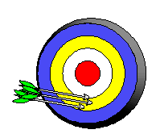

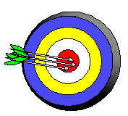**Label Each Scenario:**

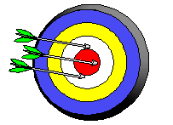

Can a SERIES of throw be both accurate and not precise?

**GENERAL Rule For Scientific Measurement:**

**We want measurements to be ________________ (close to accepted) and _____________ (similar with each other)**

**Practice:**

A student made multiple weightings of a sample of aluminum:

Trial 1: 39.54 g

Trial 2: 39.49 g

Trial 3: 39.51 g

If the actual mass of the aluminum sample was 45.72 g, determine the accuracy and precision of the students measurements.

1. Accurate and Precise
2. Accurate and imprecise
3. Not accurate and precise
4. Not accurate imprecise

**Skill 2: Percent Error Calculation**

**Equation (see reference tables):**

**Ex:**

**The boiling point of water is 100 degrees C. You and your partner calculate it to be 99.1.**

**What is the percent error?**

A student finds the density of copper to be 8.218 g/cm3. The actual density of copper is 8.960 g/cm3. Find the percent error in her measurement.

**Practice:**

1. A student determines the density of zinc to be 7.56 grams per millimeter. If the accepted density is 7.13 grams per millimeter, what is the percent error of this calculation?
2. A student takes an object with a accepted mass of 200 grams and measures it using a balance, she records the mass of the object as 196.5g. What is her percent error.
3. A student determines the length of a sample to be 10.3cm. Its actual length is 11.1. What is her percent error? If she measures it a second time and finds it to be 10.3cm, are her measurements accurate or precise or neither?

**Skill 3: Utilize and Convert Scientific Notation:**

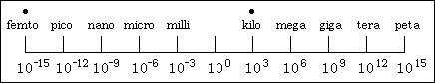Throughout the year we will encounter VERY small and big numbers. We use scientific notation to represent these numbers in powers of tens.

* Remember:
  + Keep all non zero numbers,
  + Count your loops, loops place decimal
  + Move right = negative exponent
  + Move left = positive exponent
* 5,300,000 m can be written as _____________________
* 0.00000375 g can be written as _____________________

**Examples**: Write the following in scientific notation

1. 34500000 kg = _____________ 3) 0.000301 cm = _____________
2. 7561000 m = ____________ 4) 0.000000002091 mg = ______________

**Examples**: Convert the following from scientific notation to standard

1. 4.51 x 10 3 g = ____________ 3) 5.12 x 10 - 6 kg = ______________
2. 8.91 x 10 - 4 km = ____________ 4) 5.234 x 10 7 cm= ___________

**Convert the following numbers into scientific notation:**

1) 3,400 ___________________

2) 0.000023 ____________________

3) 101,000 ____________________

4) 0.010 ____________________

5) 45.01 _____________________

6) 1,000,000 _____________________

**Convert the following numbers into standard notation:**

8) 2.30 x 104 _______________________

9) 1.76 x 10-3  _______________________

10) 1.901 x 10-7  _______________________

11) 8.65 x 10-1 ________________________

12) 9.11 x 103 ________________________

**Skill 4: Measure Using Sig Figs**

**Significant Figures are:**  **“All the digits that can be known precisely in a measurement, plus a last estimated digit.”**

In science, reporting data honestly is paramount. Measurement can only be as precise as your ______________________________ measuring device.

–        Coffee cup vs. a graduated cylinder

**Rules for Significant Figures**

•          **Rule 1: Every nonzero digit in a reported measurement is assumed to be significant**

•          **Rule 2: Zeros in the middle or to the right of a number and to the right of a decimal point are significant**

–        402.7  ….number of sig figs?___________

–        42.700 ….number of sig figs? ___________

–        42.7000 ….number of sig figs?____________

–        4 000 027 ….number of sig figs? ____________

•          **Rule 3: Zeros to the left of a number are not significant** (even if they are to the right of a decimal point)

–        0.42 ….number of sig figs?_____________

–        0.042 ….number of sig figs? _____________

–        0.0030 ….number of sig figs? _____________

–        0.003 ….number of sig figs? ____________

•          **Rule 4: Zeros at the rightmost end of a measurement that lie to the left of an *understood* decimal point are not significant**

–        300 meters ….number of sig figs? _____________

–        7000 meters ….number of sig figs? _____________

–        27210 meters ….number of sig figs? _____________

**The Calculator …..**

* In general, a calculated answer cannot be more precise than the least precise measurement from which it was calculated.

**Scientific Notation**:

* All Non _______________ are significant.

**Addition and Subtraction**

Rule: Round to the same number of decimal places as the measurement with the least number of decimal places

1. 31.3 + 54.45 ________ 4. 5.068 - 0.1 _______

2. 22.59 + 21 ________ 5. 45.6 - 22.12 + 11 ______

3. 0.023 + 20.1 ________ 6. 0.0123 +5.689 – 0.014 ______

**Multiplication and Division**

Rule: Round to the same number of significant figures as the measurement with the least number of significant figures

1. 4 * 78 ________ 4. 78.632 / 52.3 _______

2. 0.0235 * 9 ________ 5. 1569 / 24 * 2 _______

3. 0.014 * 0.01 ________ 6. 596 * 32 ) / 22 _______

**White Board Practice Work Space:**

**Skill 5: Understand the Metric System:**

* + - In chemistry (and all sciences) the International System of Units (SI) is used. It is a universal set of units that allows scientists from around the world to be consistent with each other.
    - TABLE __________ is a list of _______________________________________
    - The SI system is a decimal system, meaning prefixes are used to change SI units by a power of 10
    - TABLE __________ is a list of ________________________________________

**What UNIT describes the following?**

a. Mass _______ d. Time: ______

b. Volume _______ e. Temperature: ______

c. Energy _______ f. Pressure: ______

**On the Number Line!**



Simple Conversions TO OR FROM THE BASE CAN USE THE MNEMONIC:

K_______ H_______ D______ U_______ D_________ C________M__________

* Determine the number of mm in 1600 m.
* Determine the number of m in 1600 mm.
* Determine the number of mm 14.3 cm.

1. If a substance weighs 2.00 grams and you need the mass in kilograms, will the number appear to become smaller or larger? Explain your answer.
2. If a liquid has a volume of 5800 mL and you need the mass in Liters, will the number appear to become smaller or larger? Explain your answer.
3. If a substance has a mass of 0.00235 grams and you need the mass in milligrams, will the number appear to become smaller or larger? Explain your answer.
4. Convert the following:

a. 900 km = __________ m h. 568 mm = __________ m

b. 200 kg = __________ g i. 52 mg = __________ g

c. 5.00 m = __________ km j. 0.025 J = __________ mJ

d. 7000 J = __________ kJ k. 0.859 s = __________ ms

e. 800 cm = __________ m l. 0.0256 m = __________ um

f. 20 cg = __________ g m. 0.000589g = __________ ng

g. 2.0 L = __________ cL n. 0.00005987 m= __________ pm

Skill 4b: Use the Metric System and Sig Figs to take measurements:

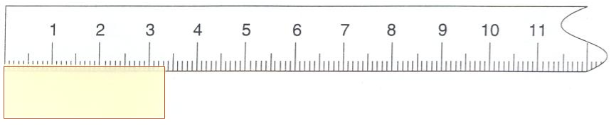

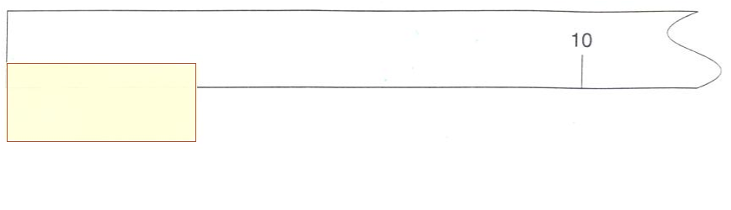

Measurement ________ Measurement _________

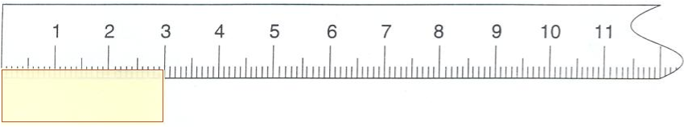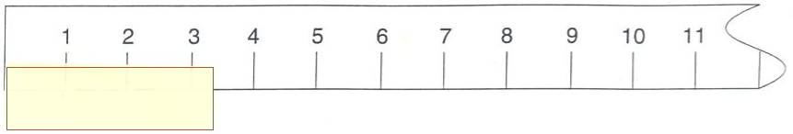

Measurement ________ Measurement __________

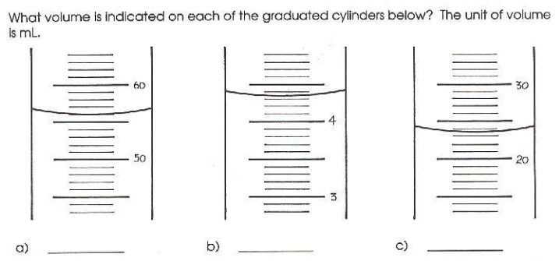

**Temperature vs. Heat**

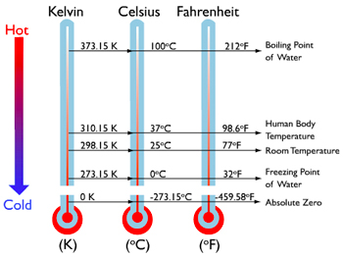

* + **Temperature**:
  + **Heat**:
  + **Absolute Zero:**
  + **Temperature Scales (See Reference Tables):**

K = oC + 273 K = Kelvin oC = degrees Celsius

* **Convert**:

1. 200degrees Celsius to Kelvin B) 500 K to oC

* **Remember**: Kelvin uses bigger values and is always ___________________________



Winners See Me!

**Skill 6: Using Dimensional Analysis:**

**Why is this useful?**

**Steps:**

1. Identify the units you need AT THE END OF THE PROBLEM!
2. Write out the conversion factor you need to go from one unit to the other.
3. Start on the left, with your given information. Multiply the conversion factor so that you units cancel.
4. Multiply your numbers across like fractions!
5. Remember sig figs for your final answer

Examples:

1. Convert 3598 grams into pounds ( 1 lb =454 g)

Note, This would be a two-step conversion using our loop method but is one step using this method.

1. How many ml are in 7.86 dl ?
2. Convert 450mg to kg.

Practice Using Dimensional Analysis Only:

1. 100cm to dm
2. 34.7 kg to dg
3. 45 ml to km

**Skill 7: Density Flipped Lesson!**

Density: What factors will affect the density of a material?

* **Mass: __________________________________________________________________**

**Measured in: ____**

* **Volume: ________________________________________________________________**

**Measured in: ____**

* **Density: ________________________________________________________________**

**Measured in: ____**

Equation (see reference tables):

**Examples:**

* + - 1. A person brings in what he thinks to be a gold ring to a jewelry store. The ring has a mass of 4.5 g and a volume of 0.233 cm3. Is this a gold ring? (Hint: find the density and compare it on Table S)

**Givens:**

**Want:**

**Equation and Answer:**

**Want:**

* + - 1. A piece of scrap metal made of ***iron*** has a volume of 305.5 cm3. Find the mass of the iron.

**Givens:**

**Want:**

**Equation and Answer:**

* + - 1. A rock has a mass of 120.5 g. It is put into 103.35 mL of water and the water rises to 118.42 mL. Find the density of this rock.

**Givens:**

**Want:**

* + - 1. What is the density of an unknown block having a mass of 972.3 g and dimensions of 4.57 cm by 15.32 cm by 11.28 cm.

**Givens:**

**Want:**

* + - 1. A sample of a chemical has a mass of 10 g and a volume of 30.5ml. What is the density of the sample expressed to the correct number of sig figs?
      2. **Using your reference table determine** which element has the greatest density?

**Silver, Helium, Calcium, Nickel**

* + - 1. A student collected this data

Mass of water and graduated cylinder: 23.3g

Mass of graduated cylinder: 10g

Mass of water ____________________g

Volume: 19.3ml

What is the density of water?

**Skill 8: Scientific Graphing**

**Follow these Steps:**

1. Determine the Independent and Dependent Variables
   1. Independent is the one that is ________________
   2. Dependent is the data you collect
2. Put the Independent on the X-axis and the Dependent on the ______.
3. Label your axis.
4. Scale your axis appropriately
   1. Remember you want to take up as much of the grid as possible!

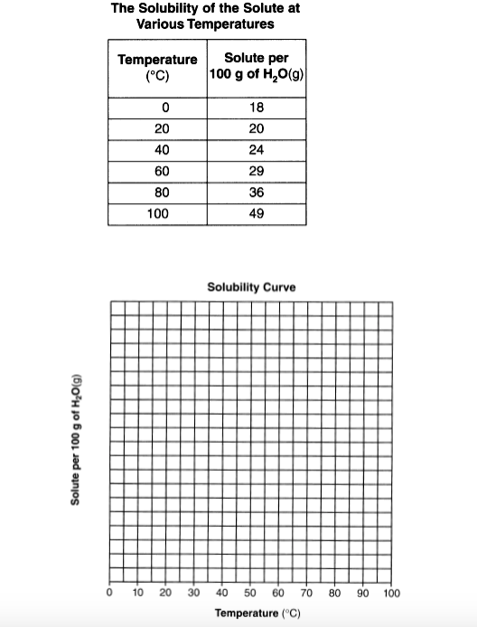

**Example:**

Base your answer on the data table, which shows the solubility of a solid solute.

Independent Variable: _______________

Dependent Variable:

_____________________

a. On the grid provided (print this page), mark an appropriate scale on the axis labeled "Solute per 100 g of H2O(g)." An appropriate scale is one that allows a trend to be seen.

b. Plot the data from the data table. Circle and connect the points.



Name_______________________________

Name_______________________________________________  
A substance is solid at 150C. A student heated at one-minute intervals and that data is shown below.

|  |  |  |  |  |  |  |  |  |  |  |  |  |
| --- | --- | --- | --- | --- | --- | --- | --- | --- | --- | --- | --- | --- |
| 0 | 1 | 2 | 3 | 4 | 5 | 6 | 7 | 8 | 9 | 10 | 11 | 12 |
| 15 | 32 | 46 | 53 | 53 | 53 | 53 | 53 | 53 | 53 | 53 | 60 | 65 |

Based on the information above, what are the independent and dependent variables?

Independent: _________________

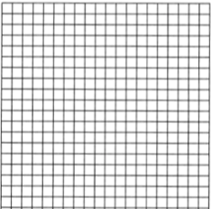Dependent: __________________

On the Grid below,

* Properly label the axis
* Mark an appropriate scale
* Plot, circle and connect your points

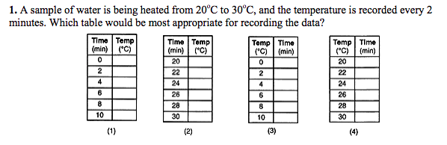

**Reminder Question:**

**Convert 12900ng to kg Must Use Dimensional Analysis ___________________**