Flashing Arcs and Crater-Clouds: Revisiting Volcanology in Southern Italy
2025 CCCP Summer Workshop

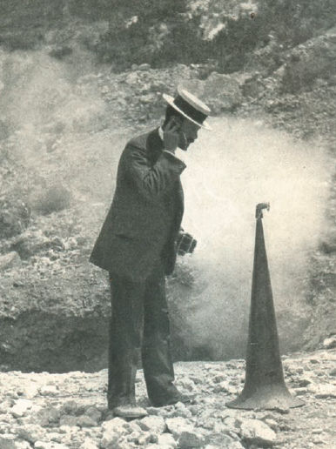

Frank Perret with Geophone in Southern Italy, 1907.

Research Questions

American inventor, engineer, and early seismologist, Frank Perret returned to Naples in 1905 with a geological listening aid designed to amplify and record the subterranean soundscape of Mount Vesuvius. Having worked with Thomas Edison in New York, Perret was uncommonly familiar with media technologies of the early 20th century. His seismic audio probe was the first instrument to capture geological vibrations as sound waves, but it was far from the first attempt to register the volcanic activity of Mt. Vesuvius. The Antiquarium of Pompeii opened in 1875, collecting and exhibiting artifacts from ancient Pompeii and its destruction by the eruption of Vesuvius in 79 CE. Paintings by Pierre-Jacques Volaire from 1771, Joseph Wright of Derby from 1775, and by scores of others, depict eruptions from the 18th century. Perret’s geological auditing instruments added to an existing complex of architectural, museological, and representational systems organized around Italy’s volcanism.

Today, Vesuvius and the other volcanoes of Southern Italy are peppered by an expanded field of research centers, geological stations, and museums of antiquities and volcanology. Following in the footsteps of Perret, this workshop will travel to Southern Italy to register the links between geology, media systems, museums, and the nexus of cultural institutions that intersect with Italy’s volcanoes and its geomorphology. In conversation with recent work on media ecologies, this workshop will propose and test an idea of cultural geology. The workshop will inquire how geology and volcanology have been viewed, heard, measured, described, and understood through cultural institutions and related practices, and how and to what ends traces of these activities have been collected and put on display not only for scientists and engineers but for a wider public. It will ask how these institutions foreground ideas of cultural stability or volatility, of knowledge and its antithesis, against the background of historical and potentially imminent violent and explosive geological activity.

How do histories of environmental risks and natural catastrophes such as volcanic activity manifest not only in the destruction of buildings and of lives but also in a landscape of cultural institutions, as well as artifacts, media, technologies, and social activities?

Methodology and Process

This workshop will visit a series of cultural and scientific institutions and sites affiliated with the volcanoes of Southern Italy. We will begin where Perret began, in Naples, visiting the vulcanological observatory overlooking Mount Vesuvius, along with museums, national parks, archaeological sites, and volcanic islands in the vicinity. Additionally, we will visit Catania, in Sicily, home to the Etna Vulcanological Museum, the San Nicolò La Rena monastery’s volcanology museum, and the International Institute of Volcanology of Catania, along with the Mount Etna volcano and nearby volcanoes and sites of the Aeolian Islands. In Rome we will visit the National Institute of Geophysics and Volcanology, also seeking out cultural traces of volcanic activity in the Vatican Museum and other sites. Students will be tasked with interpreting systems of environmental observation, from their surveillance instruments and knowledge frameworks to the media channels and institutional apparatuses through which they reach multiple audiences.

Output and Findings

Students will produce their own recordings or registrations of the cultural geology of Southern Italy. This could take many forms, from diary films to creating their own recording devices or systems of testing and display.

Vulcanological imprints and recordings are not of course confined to the domain of technoscientific research related to volcanology, or to archaeological sites and museums, but infuse urban and rural environments, gastronomy, tourism, art, cinema, literature, and other aspects of life in Southern Italy that students might choose to focus on.

