**Acid Base** **Titrations** Name ________________________

Date _______________

1. The following drawings represent solutions at various stages of the titration of a weak acid, HA, with NaOH. (The Na+ ions have been omitted for clarity). To which of the following regions of the titration curve does each drawing correspond:

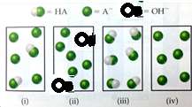

* 1. before addition of NaOH _____
  2. after addition of NaOH but before equivalence point _____
  3. at equivalence point _____
  4. after equivalence point _____

1. Match the following descriptions of titration curves with the diagram

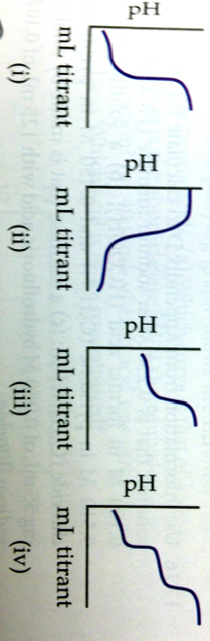

* 1. strong acid added to strong base _____
  2. strong base added to weak acid _____
  3. strong base added to strong acid _____
  4. strong base added to polyprotic acid _____

1. Equal volumes of two acids are titrated with 0.10 M NaOH resulting in the two titration curves shown in the following figure.

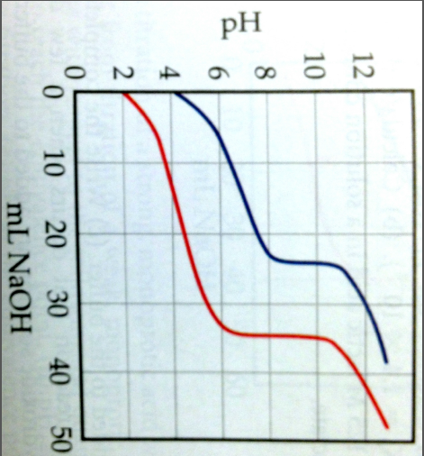

2

1

* 1. Which curve corresponds to the more concentrated acid solution? Explain.
  2. Which corresponds to the acid with the smaller Ka? Explain.

1. How does titration of a 0.10 M strong, monoprotic acid with a 0.10 M strong base differ from titration of a 0.10 M weak, monoprotic acid with a 0.10 M strong base with respect to the following:
   1. Quantity of base required to reach the equivalence point.
   2. pH at the beginning of the titration
   3. pH at the equivalence point.
   4. pH after addition of a slight excess of base.
   5. choice of indicator for determining the equivalence point.
2. Predict whether the equivalence point of each of the following titrations is below, above, or at pH 7:
   1. formic acid titrated with NaOH _____________
   2. calcium hydroxide titrated with perchloric acid _____________
   3. pyridine titrated with nitric acid _____________
3. Assume that 30.0 mL of a 0.10 M solution of a weak base B that accepts one proton is titrated with a 0.10 M solution of the monoprotic strong acid HX.
   1. How many moles of HX have been added at the equivalence point?
   2. What is the predominant form of B at the equivalence point?
   3. How can the pH be determined at the equivalence point?
   4. Which indicator, phenolphthalein (Ka = 10-8) or methyl red (Ka = 10-5), is likely to be the better indicator for this titration?
4. The titration curve below represent a weak base B with a strong acid. On this curve, indicate the points that correspond to the following:

B + H+ ⮀ BH+

1. the stoichiometric (equivalence point)
2. the region with maximum buffering
3. pH = pKa
4. pH depends only on [B]
5. pH depends only on [BH+]
6. pH depends only on amount of excess strong acid

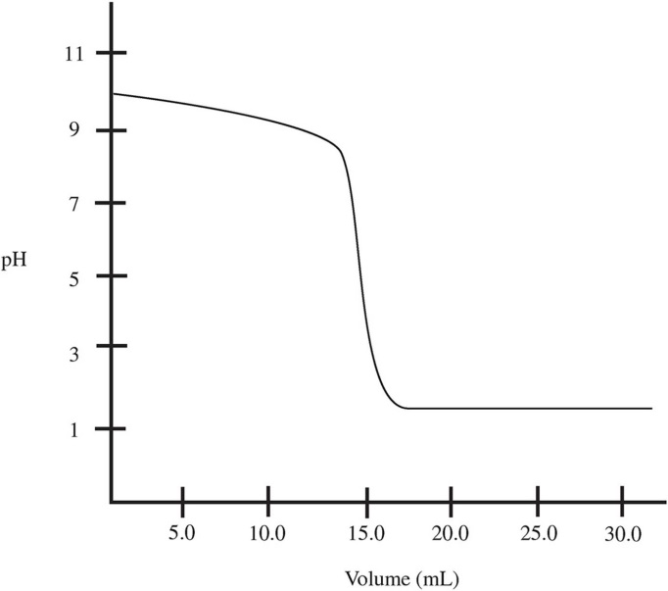

`

1. Calculate the pH at the halfway point and at the equivalence point for each of the following titrations:
   1. 100.0 mL of 0.10 M HC7H5O2 (Ka = 6.4 x 10-5) titrated by 0.10 M NaOH
   2. 100.0 mL of 0.10 M C­2­H5NH2 (Kb = 5.6 x 10-4) titrated by 0.20 M HNO3
   3. 100.0 mL of 0.50 M HCl titrated by 0.25 M NaOH
2. What is the concentration of HNO­3­ if 50.00­­ mL were titrated according to the curve below.

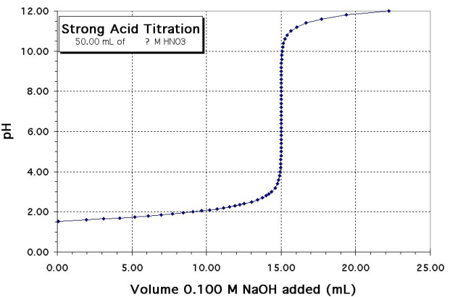

1. 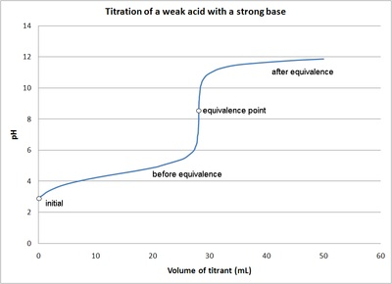 A 0.250 M solution of weak acid, HA, is titrated with 0.150 M KOH, generating the following titration curve. Determine the K­a of the weak acid.