**Leslie Pool Close Out Checklist**

|  |  |  |
| --- | --- | --- |
| **DONE** | **CABLE RUN** | **DESCRIPTION OF TASK** |
|  | Run 1 (LP1) | Runs 1 and 2 – Extend two CAT5e cables from patch panel jacks 1 and 2 to Cash Wrap. Terminate with RJ45 jacks under the counter in the LEFT console. Label the jacks ‘LP1’ and ‘LP2’ to correspond with their respective patch panel jacks. |
|  | Run 2 (LP2) |
|  | Run 3 (LP3) | Extend two CAT5e cables from patch panel jacks 3 and 4 Cash Wrap. Terminate with RJ45 jacks under the counter in the CENTER console. Label the jacks ‘LP3’ and ‘LP4’ to correspond with their respective patch panel jacks. |
|  | Run 4 (LP4) |
|  | Run 5 (LP5) | Extend two CAT5e cables from patch panel jacks 5 and 6 to Cash Wrap. Terminate with RJ45 jacks under the counter in the RIGHT console. Label the jacks ‘LP5’ and ‘LP6’ to correspond with their respective patch panel jacks. |
|  | Run 6 (LP6) |
|  | Run 7 (LP7) | Extend two CAT5e cables from patch panel jacks 7 and 8 to the Water Test counter. Terminate with RJ45 jacks under the counter. Label the jacks ‘LP7’ and ‘LP8’ to correspond with their respective patch panel jacks. |
|  | Run 8 (LP8) |
|  | Run 9 (LP9) | (Wireless AP Network Connection) Extend one CAT5e cable from patch panel jack 9 to terminate at an RJ45 jack mounted on the ceiling near the back wall of the showroom, centered left to right. |
|  | Run 10 (LP10) | Extend one CAT5e cable from patch panel jack 10 to shop counter. Terminate with RJ45 jack under counter. Label the jack ‘LP10’ to correspond with the patch panel jack. |
|  | Run 11 (LP11) | Extend one CAT5e cable from patch panel jack 11 to Store Manager’s desk. Terminate with RJ45 jack. Label the jack ‘LP11’ to correspond with the patch panel jack |

|  |  |  |
| --- | --- | --- |
| **YES** | **NO** | **DESCRIPTION OF TASK** |
|  |  | Did you terminate the end of the cable for the Access Point with an RJ45? |
|  |  | Did you leave the AP cable exposed from the ceiling for the Installer to identify where the AP cable is located? |
|  |  | Did you install the surge Protector in the rack? |
|  |  | Have you completed testing? |
|  |  | Have you completed documentation of the testing? |
|  |  |  |
|  |  | **PHOTOS** |
|  |  | Have you taken the required photos? |
|  |  | Closeup and wide angle up of the rack |
|  |  | Close and wide angle up of the back board |
|  |  | Photo of AP Cable |
|  |  | Photo of each termination end point |
|  |  | Photos of the patch panel (labeled) |

**Project Overview:**

Windstream is providing Internet & voice services for Pet supermarket locations. Windstream is converting existing locations to an SD WAN overlay network with Hosted Voice Analog for Pet Supermarket stores. Primary access will be cable/broadband, reused T-1, or new T-1, with 4G LTE secondary. New Stores and sites reusing primary circuit will require a Hotcut. Full installation is completed in two visits

**Site Visit 1:** Site Survey – completed prior to cabling and installation dispatch

**Site Visit 2:** **Today’s Visit: Cabling/Installation (Professional Services with Partner team OSBT)**

* Data Cabling
* Installation of 12U Wall Mounted Rack (Backboard if applicable)
* Installation of (1) Customer provide Meraki Access Point (AP) (if site requires a lift or ladder above 10 feet)
* Installation of Customer provided Switch

**Windstream Professional Services** will dispatch (OneSource Partner for **Visit 2)** technicians to Leslie’s Poolmart locations, which already have surveys completed. The intent of the onsite visit for each location is to perform data cabling, installation of (1) 12U racks, installation of (1) customer provided switch, and installation of (1) customer provided AP. If the circuit was not delivered at the time of survey but is on location at the time of the installation, the OSBT tech will need to complete an extension from the DEMARC to the rack – Port 24 on the provided patch panel, with approval from OSBT before completing.

**Windstream Contact Information:**

* **OneSource Partner Team:** (888) 787-8324
* **OSBT Operations Manager:** Latasha Williams – Cell: 832-758-4033
* **OSBT Project Coordinator:** Janie Smith - Cell: 713-397-5571
* **Windstream Professional Services** **PM**: Narayanan “Rayan” Sreshta – Office: 206-204-0867
* **Windstream Service Delivery Project Manager**:
* **Leslie’s Poolmart**
* **Helpdesk:**
* **Contact:**

**Installation Standards**

* All Instructions are for Installer unless otherwise specified.
* The installation equipment must be arranged in such a way that allows for future accessibility.
* Cables must be neatly bundled with no loose wires left unorganized.
* 2 foot Patch cables will need to be left at the rack for future use.

**Visit 2 – Cabling and Installation (Pro Services)**

**Activity Upon Arrival at Site**

|  |  |  |
| --- | --- | --- |
| □ | Make Contact with Local Contact Person (LCON) and -- locate |  |
| □ | Check Work Order and attachment |  |
| □ | In case of access denial, contact: -----------------------------  Access issues preventing the tech from completing the scope of work will need to be escalated quickly to Leslie’s Poolmart and OneSource team. Example: No access to network cabinets, offices, or network rooms. | **1 Notify OneSource team** – (888) 787-8324 |
| □ | Locate the projected rack location and confirm the location of the media player -------------------- | **Manager’s Office – If any issues on this location, please notify the OSBT Team.** |
| □ | **Before Photos**  **After Photos**  **Cable Test Results**  **Signed Work Order**  **Patch Panel Images (Labeled Ports)**  **Terminated Cable Drops Labeled**  **LIC/JSA Documentation (Lift required sites only)** | *Upload all photos to your ticket* |

**Installation Process**

* 1. **OneSource Tech**: Proceed straight to the Manager’s office and locate the proposed adequate wall space for the 12U wall mounted rack.
     1. If determined during the survey that a backboard is needed – technician will complete the rack installation.
     2. Confirm the Media Player location in relation to the Rack location.
     3. Confirm if the circuit has been delivered – If so, tech is to determine if an extension is needed between the circuit location and rack location.
     4. Once rack is in place, install (1) 24-Port Patch Panel and (1) UPS Surge Protector
  2. **OneSource Tech**: Technician will complete (11) Cat5e Cable Drops:
  3. 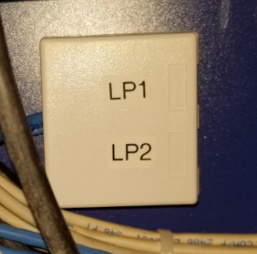 Labeling Example 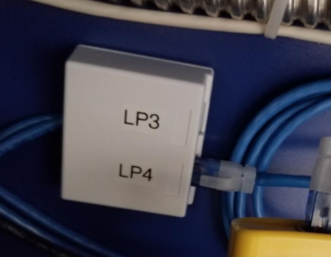
     1. **Runs 1 and 2** – Extend two CAT5e cables from patch panel jacks 1 and 2 to Cash Wrap. Terminate with RJ45 jacks under the counter in the LEFT console. Label the jacks ‘LP1’ and ‘LP2’ to correspond with their respective patch panel jacks.
     2. **Runs 3 and 4** – Extend two CAT5e cables from patch panel jacks 3 and 4 Cash Wrap. Terminate with RJ45 jacks under the counter in the CENTER console. Label the jacks ‘LP3’ and ‘LP4’ to correspond with their respective patch panel jacks.
     3. **Runs 5 and 6** – Extend two CAT5e cables from patch panel jacks 5 and 6 to Cash Wrap. Terminate with RJ45 jacks under the counter in the RIGHT console. Label the jacks ‘LP5’ and ‘LP6’ to correspond with their respective patch panel jacks.
     4. **Runs 7 and 8** – Extend two CAT5e cables from patch panel jacks 7 and 8 to the Water Test counter. Terminate with RJ45 jacks under the counter. Label the jacks ‘LP7’ and ‘LP8’ to correspond with their respective patch panel jacks.
     5. **Run 9** – (Wireless AP Network Connection) Extend one CAT5e cable from patch panel jack 9 to terminate at an RJ45 jack mounted on the ceiling near the back wall of the showroom, centered left to right. (Install Access Point Check with MOD)
     6. **Run 10** – Extend one CAT5e cable from patch panel jack 10 to shop counter. Terminate with RJ45 jack under counter. Label the jack ‘LP10’ to correspond with the patch panel jack.
     7. **Run 11** – Extend one CAT5e cable from patch panel jack 11 to Store Manager’s desk. Terminate with RJ45 jack. Label the jack ‘LP11’ to correspond with the patch panel jack.
     8. 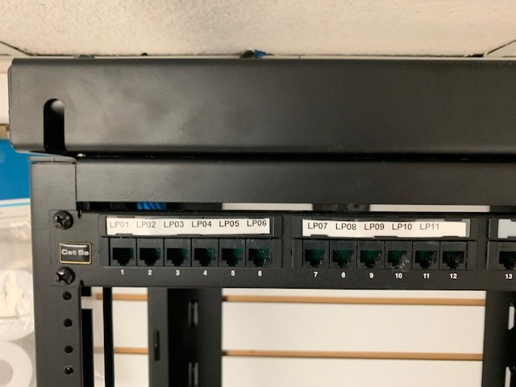***Run 24*** *– Extend one Cat5e cable from the patch panel to jack 24 to the Circuit/DEMARC Location. Terminate with RJ45 jack. Label the jack ‘LP24” to correspond with the patch panel jack. (If Applicable)*

**Labeling of Rack**

Finished Rack 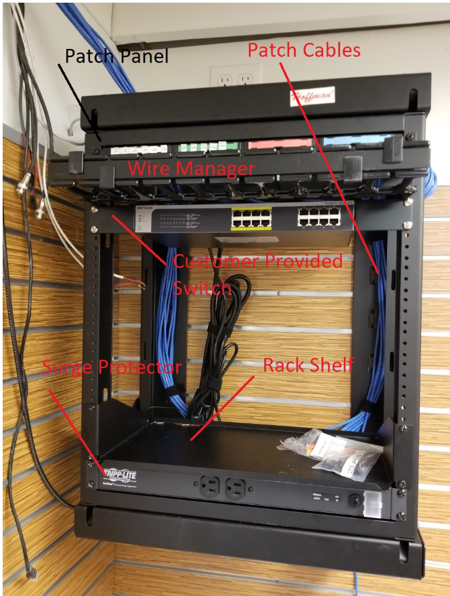

* 1. 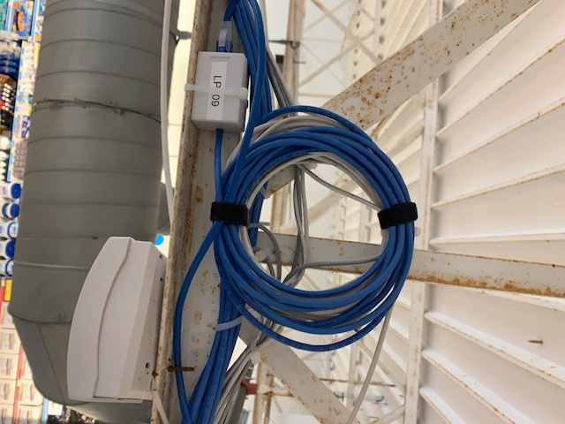**OneSource Tech**: Once the cable drops are complete, the technician will conduct cabling testing to both ends of the Cat5e cable drops.
     1. **If site requires lift,** technician will be installing (1) customer provided Meraki Access Point in the center of store floor. Technician must confirm with MOD that there is plenty of adequate floor space to maneuver the lift.
     2. Technician must test on both ends of the cables and provide all test results with collateral. 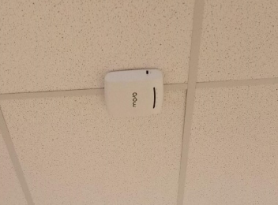

**Upon Completion**

* Verify the lines are all terminated and tested
* Clean up wires, plastic, paper, or any other trach left over from installation. Dispose of all debris into customer-approved debris bin.
* **Take “after” photos of the completed cable drops, rack installation, switch installation, cabling test results and AP installation.**
* Complete Work Order Documentation.
* See Manager before leaving site and obtain signature on Work Order.
* **Once the install is complete**, contact the OSBT Support Center for final checkout.
  + **DO NOT LEAVE SITE WITHOUT MAKING THIS CALL AND GETTING RELEASED BY OSBT.**

**Scope of Work Exclusions**

The Scope of Work for this MOP EXCLUDES the following:

* + Installation or troubleshooting of other equipment, cables, software the AIC is not installing or which is not listed in this document
  + Ongoing monitoring or support of any device, software, or equipment not expressly included in the Master Services Agreement
  + Ground Wire over 100'
  + Wiring over 300'
  + Backboard over 4' X 8' X 3/4"
  + Moving existing customer equipment to make room for backboard
  + Fiber cable
  + Cat3,4,6, or 7 Cable
  + Conduit Installation
  + Any Electrical work requiring licensed electricians
  + Installation of new grounding electrode system/pipe/etc.
  + Drilling through masonry, firewalls or walls leading to exterior of the customer premise
  + Wiring external to the suite/premise (with the exception of the circuit extension)
  + Cable runs through plenum
  + Cable runs via conduit without available pull string
  + Running replacement pull string
  + Vertical heights in excess of 10 feet
  + Installation of multi-gang wall plates(single wall plates supported)
  + Cable runs between floors, buildings, crawl space or attics

**Parts and Materials**

**TECH REQUIRED TOOLS/MATERIAL:**

* Laptop with Windows 7 or Later Operating System
* Microsoft Office
* TeamViewer 14
* Cisco / ADTRAN Console Cable (USB to DB9)
* Mobile Hotspot
* 2000’ (2) boxes of cat 5e/6 Cable
* Modular Adapters
* Spare Power strip
* Digital Camera /High end Smartphone
* Label Maker
* Small Parts - RJ-45 Couplers and Connectors, RJ-11 Connectors, Mounting Equipment (Rack Nuts and Screws), Biscuit Jacks
* 8’ Ladder
* Hand tools – Pliers, Multi-Tool, Flashlight, Power drill, LONG drill bits, masonry bits, A general-purpose drill bit set, and a hole-saw, Crimpers, Punch down Tool, Wire Strippers, Screwdrivers (Phillips and Flathead), Tape Measure, Sheetrock Saw, Utility Knife, Torx (Star-shaped) Bits. Fish Tape and/or Glow Rods, LED Headlight.
* Cleaning tools - Compressed air can, Velcro, Tie-Wraps, Magnets, Small Broom or Vacuum
* Diagnostic tools – Multimeter, Loop back plug.
* Cable tester/ certifier

**OSBT PROVIDED MATERIALS:**

Cat5e cable 1000ft box

Cat5e keystone Jack

Cat5e mod plugs

Single Port Faceplate

Dual Port Faceplate

RACK 12U 12IN BL

Cat5e 24-port Patch Panel 19in

1U Horizontal wire manager

Velcro 1/2IN VELCRO BLK 75FT

Rack Equipment Tray 1U

J-Hooks

12 outlet surge protector

11 2 foot patch cables

