

AMCB New Store Installation Instructions

Prepared By: Real Estate Infrastructure
Document Version: 3.3
Published Date: August 28, 2017
Modified Date: June 13, 2023

Revision History

Version Number | Revision Date | Summary of Changes | Modified by
V1.0-1.6 | Unknown
1.7 | August 16, 2017 | Added bridge line, spare equipment, EMV Testing instructions | Denise Matis
1.8 | August 28, 2017 | Added Retail testing instructions and information about pin pads | Denise Matis
1.9 | September 7, 2017 | Added DOA and Temp GO equipment instructions and install checklist instructions | Denise Matis
2.0 | September 11, 2017 | Added instructions to upload pictures via The Box | Luzett DeChristopher
2.1 | September 25, 2017 | Added Grand Opening day support instructions, updated command bridge info, updated site support catalog sheet, updated VOIP install and TCR instructions | Denise Matis and Mike Wallace
2.3 | May 2, 2018 | Remove references to IBM. Updated contact information for the server build team. Updated site catalog picture upload instructions. Corrected typos and misspellings. | Luzett DeChristopher
2.4 | October 12, 2018 | Updated server team email address. Removed contacts for the EMV ICP testing. Added instructions to cross connect the fax and cash advance lines. | Luzett DeChristopher
2.5 | October 15, 2018 | Removed reference to Conference Bridge, Added updated switch port configuration sheets | Denise Matis
2.6 | February 13, 2019 | Added updated Network install Procedures for SDWAN, updated format and wording | Denise Matis
2.7 | March 4, 2019 | Updated Laser Services and ACF procedure, updated Network install procedures, emergency/911 phone and privacy screen instructions | Denise Matis
2.8 | August 13, 2019 | Updated VOIP install procedures and added wireless port activation steps. Added additional info to Retail Testing | Denise Matis
2.9 | April 9, 2020 | Updated SDWAN install v3 and Cisco 9200 layout | Denise Matis
3.0 | October 20, 2020 | Updated TCR instructions to include new email address and requirement for incident ticket to be submitted in order for the configurations to be completed. | Luzett DeChristopher
3.1 | October 10, 2022 | Updated Ricoh references to Lexmark | Denise Matis
3.2 | January 06, 2023 | Added Universal Workstation install instructions and updated TCR instructions | Denise Matis
3.3 | June 13, 2023 | Updated TCR config instructions | Denise Matis
3.4 | August 16, 2023 | Added Lobby Leader and Wealth Office install Instructions | Luzett DeChristopher

Contributors
The following individuals contributed to this document.
Name | Title
Cliford Oberholtzer | TD Server Build Technician
Michael Wallace | TD Server Build Technician
Patrick Borbi | TD Server Build Technician
Denise Matis | TD ITS ERE Focal
Luzett DeChristopher | TD ITS ERE Focal

Approvals
The following individuals approved this document.
Name | Title | Approval Date
Luzett DeChristopher | ITS ERE Lead
Jeff Brown | Soroc Project Manager
Contents
1 STORE INSTALLATION 4
1.1 WAN Equipment 4
1.2 SERVER 4
1.3 Wifi 5
1.4 TELLER, PLATFORM, MFD PRINTERS 5
1.5 Phones 5
1.6 NETWORK CRADEN PRINTERS (PASSBOOKS) 6
1.7 EMV ICP PRINTERS 6
1.8 CSRs and Tellers 6
1.9 TCR 6
2 Asset Management 8
2.1 Workstations 8
2.2 Asset Capture Form 8
2.3 Site Support Catalog Information 8
2.4 Capture Pictures 8
3 End of Day Checklist 13
4 Retail Testing 13
5 Grand Opening Day 13
5.10 Temp GO EMV Printer/Workstations – for NYC only 14

STORE INSTALLATION

A new store is turned over to Retail 2 days prior to the Grand Opening. All Technology equipment is installed and tested onsite prior to this date.

- Network equipment is shipped to the local Tech HUB and will need to be brought to the Store for the WAN install
- The "MAC and Teller/CSR pallets" will be delivered by Laser the morning of the Store install
  - Laser will assist in unboxing the equipment and will remove any trash.
- Laser Services and SOROC verifies the equipment received matches the ACF that Laser brings with the equipment. If there are no discrepancies, then Laser Services can complete their delivery.
- In the event of any discrepancies, the SOROC tech will need to assist with finding a resolution. Once a resolution is reached then Laser Services can complete their delivery. If there is missing or additional equipment, then SOROC will need to notify the ERE Focal immediately.
- The SOROC tech will need to submit an ACF for all received equipment and send it tdacf@td.com and the ERE Focal. This needs to be completed before the end of the day.
Please bring the following spare equipment with you to the install and GO:

- Asset tags for the TIC scanners
- 10 and 5 feet patch cables
- Power cables
- Mice
- Keyboards
- TIC Scanners
- 1 Tellers and 1 Platform PC pre-imaged

WAN Equipment
- Install the Data UPS in the rack shelf
  - Install the preconfigured management card for UPS
  - Connect the UPS to a power source
  - Connect the temperature probe to Universal I/O Port1, and feed the cable to the top of the rack following proper wire management techniques.
- Install WAN/LAN equipment

  - Connect Network ports to the switch ports as noted in the Switch port config sheet. This includes the ATM, Security ports and wireless access points
  - Contact AMCBFSLevel2Team@td.com if additional ports need to be labeled in the switch, Copy the TD ERE Focal

Wifi

- Patch the wireless APs into ports 11 and 12 on the switch using white patch cables. (13 and 14 can be used as well if needed)
- Once activated by the Network Team, you will need to assist in testing

SERVER

- The server should be installed first thing after the WAN equipment
- Server should be online by noon on the day of installation
- Install the Server UPS in the rack shelf
  - Install the preconfigured management card for UPS
  - Connect the UPS to a power source separate from the circuit used for the Network UPS.
  - Connect the temperature probe to Universal I/O Port1, and feed the cable to the top of the rack following proper wire management techniques.
  - Connect the Network port to the switch ports listed in the Switch port config sheet.
- The Server is installed in the rack shelves.
  - Connect both power supplies in the back of the server. One goes to UPS1 and the second goes to UPS2.
  - Connect NIC 1, 2, and ILO to the switch ports listed in the Switch port config sheet.
  - Install one monitor with Ergomart SL102 Limbo Low Profile LCD Stand and server keyboard
  - Send an email to the Server Team to notify that the server is online at the store. Send email to ITS-AMCB-ServerBuild-Team@td.com. Copy the TD ERE Focal.

TELLER, PLATFORM, MFD PRINTERS

- Activate network jacks for all printers to the switch ports listed in the Switch port config sheet.
- Lexmark will deliver and install the printers and configure them for use
- Attach additional Asset tags provided to each Tic Scanner and Craden passbook printer.

Phones

- Install the Voip phones, use black patch cables at the desks (where visible to customers)
- Activate network jacks for all phones to the switch ports listed in the Switch port config sheet as Teller or CSR.

- Additional pots lines cross connect:
  - Cross connect the fax to data jack by the copier/MFD
  - Cross connect cash advance line to data jack by the cash advance machine on one of the sitdown teller stations.
  - Cross connect one of the 911 lines to the data jack behind teller line for the Emergency/911 phone (ATT-CL2940)

NETWORK CRADEN PRINTERS (PASSBOOKS)

- Installs Passbook printer(s) with jetdirect box
- Activate network jacks for all passbook printers to the switch ports listed in the Switch port config sheet.

EMV ICP PRINTERS

- Activate the network jack for the Card printer. See the Switch port config sheet for port designation.
- EMV printer will be setup by DataCard.
- Once Store staff receives their card stock and login IDs (usually 2-3 days prior to opening), please email John.Joyce@td.com to perform a remote test. Provide him with the Store name and workstation asset tag and he will remote into the machine and send a test print. Copy TD ERE Focal on the email.

CSRs and Tellers

- Install CSR and Teller workstations
- PC hangers should have been installed by the cable vendor. – notify TD ERE Focal if any are missing
- Install Ergomart SL102 Limbo Low Profile LCD Stand, if applicable, on standup teller stations and drive thru monitors
- Install privacy screens on any window or customer facing monitor
- Plug pin pads into a USB port on the front of the PC. Record pin pad serial numbers (located on the back of the device, starts with H) and send them to the TD Focal
- Activate network jacks for all workstations to the switch ports listed in the Switch port config sheet.
- Work with general contractor and vendors to resolve construction/furniture issues impacting workstation installation (for example: missing grommet holes)
- Report any DOA devices/equipment asap to the TD Focal
- Report any missing or extra equipment asap to the TD Focal
- Perform wire management on all workstations (See photos at the end of this document as examples)
- For Universal Workstations:
- For Lobby Leader workstations:
- For Wealth/FA offices:

TCR

- TCRs will be delivered and installed by Glory
- Connect the 9 pin COM cable from the TCR to the PC to the left of the TCR. Connect to the Expansion COM port not the main mother board IO port.
- PC on the left side of TCR is primary.
- PC on the right is the secondary
- After connection is complete, email TD ERE Focal the Store Name and primary and secondary workstation numbers. Please use the following format when sending the email:
  - Email Subject Line: <Store Name> – Encore TCR Workstation Configuration Request
  - Email Body
Hello,
Please configure the following workstations for Encore and TCR:
Store Name:
TCR 1 Primary Workstation:
TCR 1 Secondary Workstation:

TCR 2 Primary Workstation:
TCR 2 Secondary Workstation:
Thank you,

- TD ERE Focal will open an Incident ticket for the AMCB-Ops-Application team to remote into the PCs and login to Encore and configure them. And to check the Encore ini file has the correct store information and that the din.mdb file is present on the server. Ticket will be assigned to TS-AMCB-Ops-Application
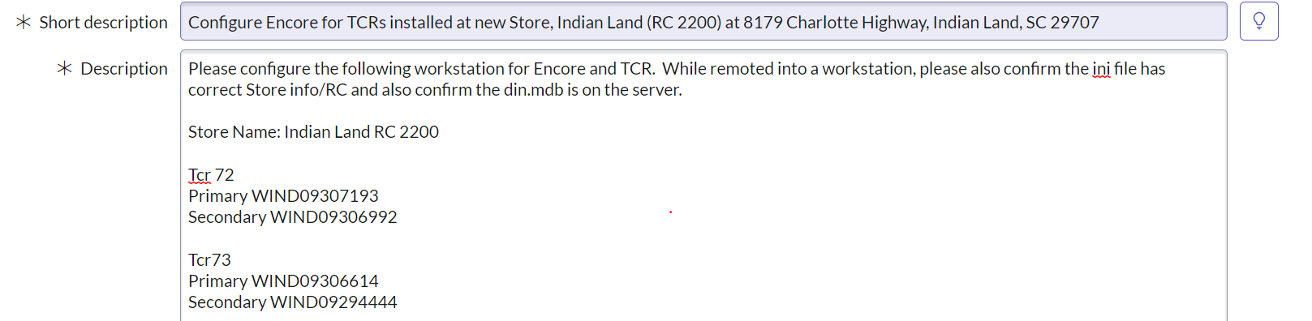

Asset Management

Asset Capture Form

- Complete asset capture form and submit, copy TD ERE Focal on the email

Capture Pictures

- Store front from street
- Lobby, Teller line, Platform from main entrance
- Teller line from behind
- Printers, TCRs
- Front and rear of ATMs
- One of the phones
- Drive Thru Inside and outside
- Alarm Panel
- Fire Alarm Panel
- Server/LAN
- Upload pictures for the site support catalog:
  - When ready to upload pictures for the site support catalog please login to the TD Site Catalog Editor and follow your process to update the site pictures.

2.5 Wire Management
Below are a series of pictures that displays how the store equipment should be set up and installed. Please note every store will be a little different, these pictures provide a general idea of how the finished work should look. The overall goal is to make sure all equipment is installed as neatly as possible.
CSR Desks:
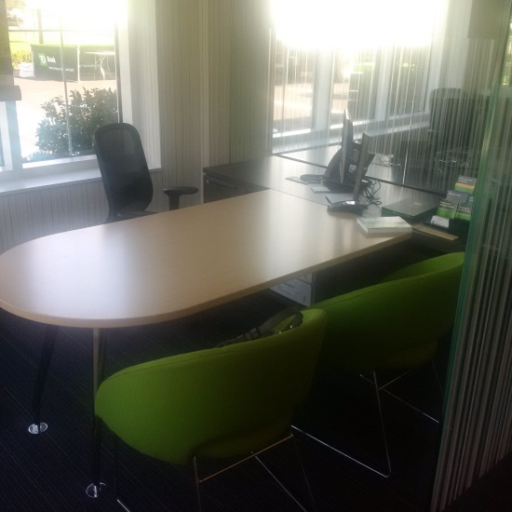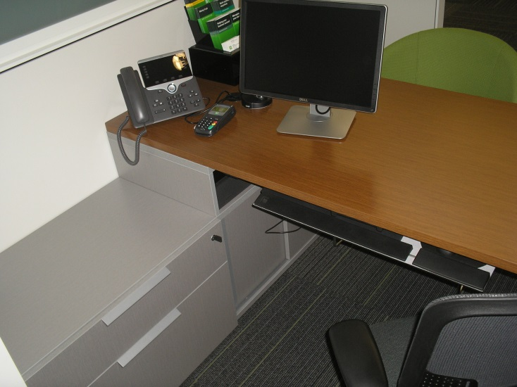
Teller Line:
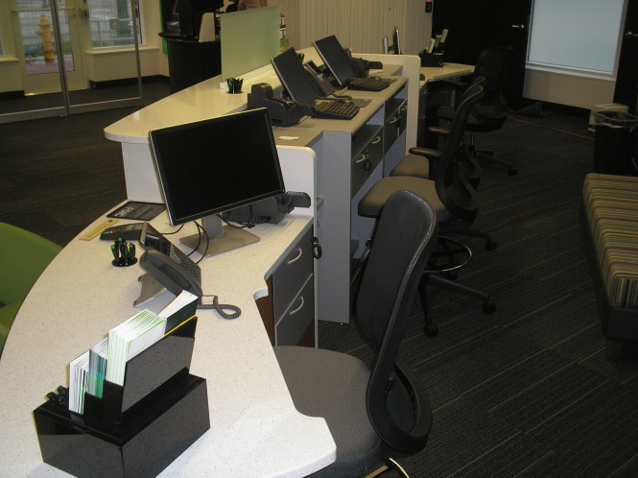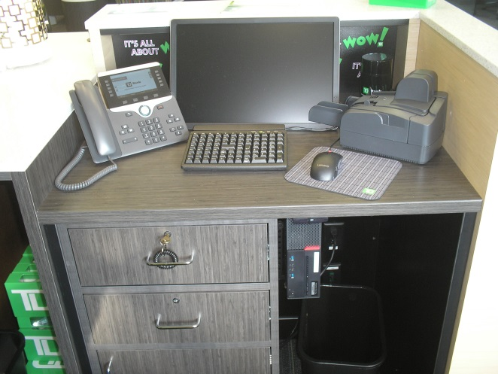
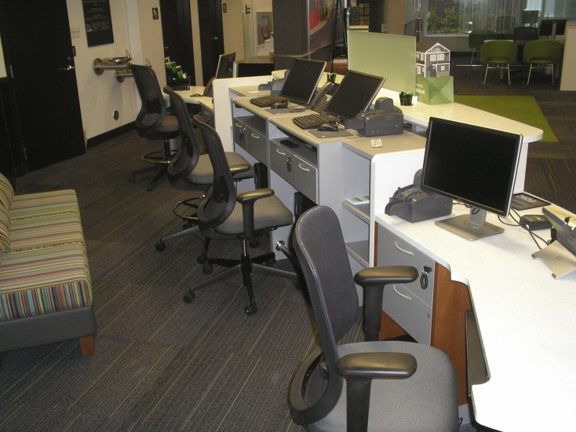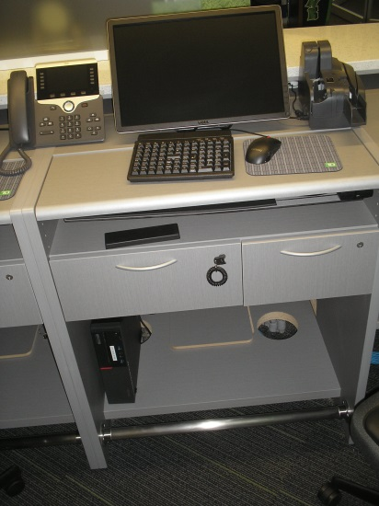
Drive-Thru:
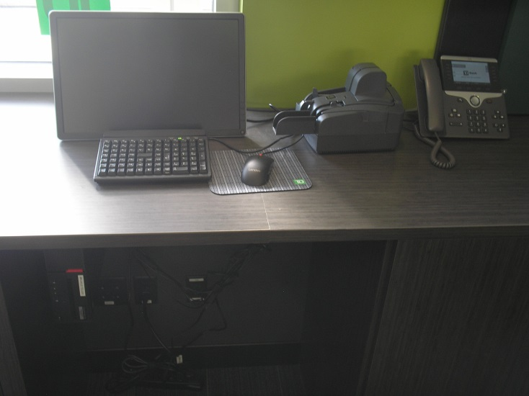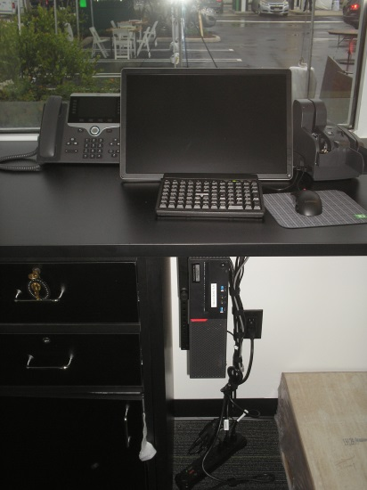

Greeter Station:
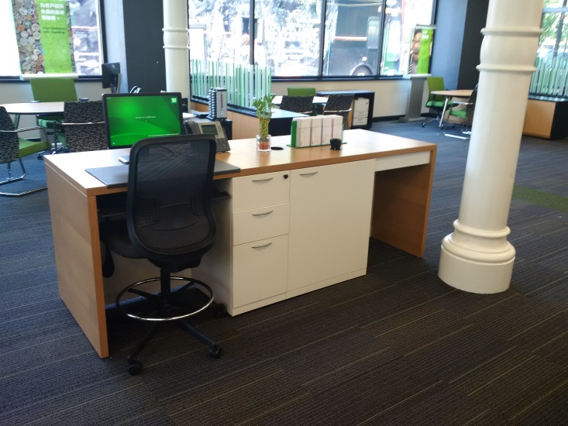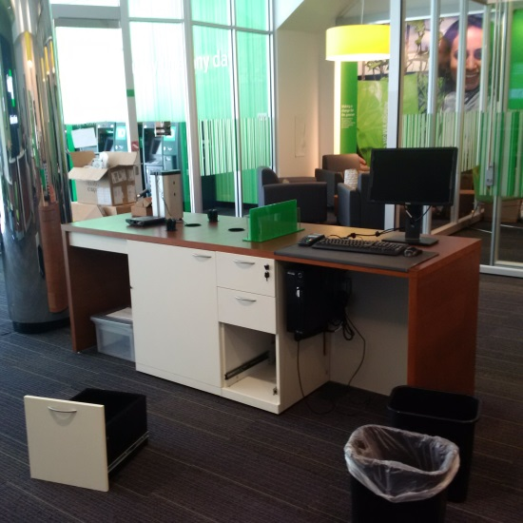

Quickstation:
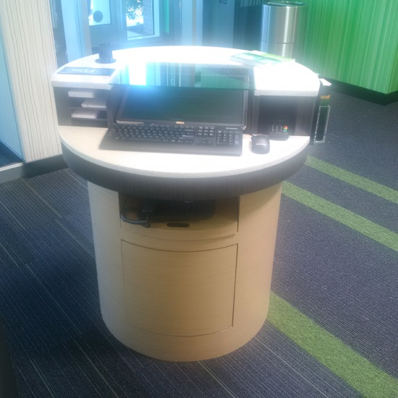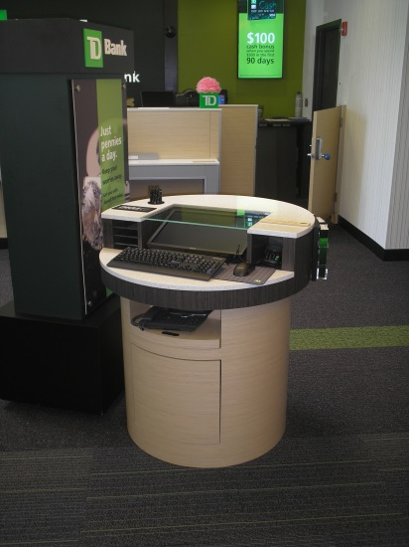
Settlement:
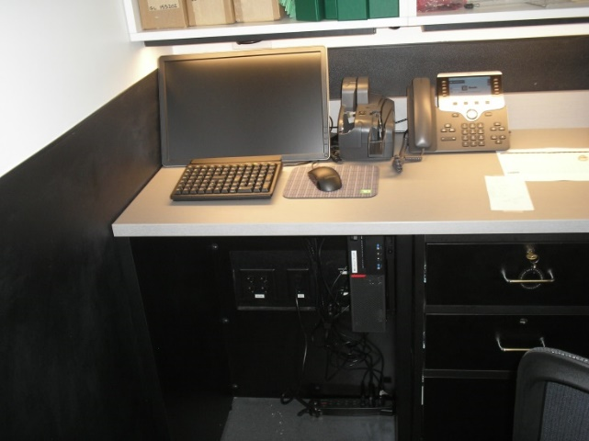
Printers:
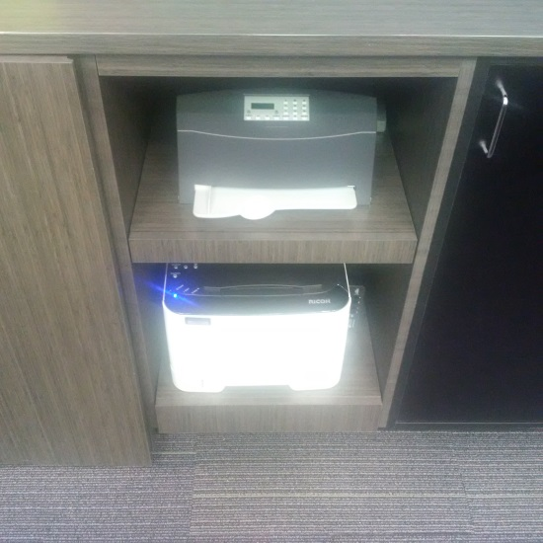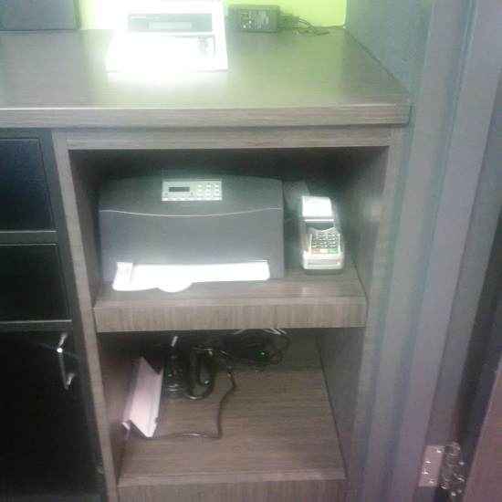
Data Closet:
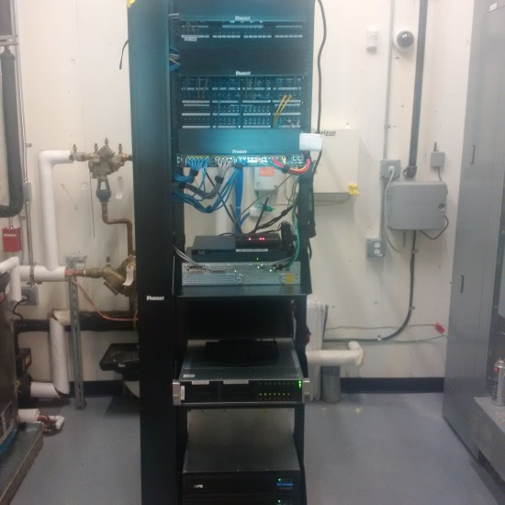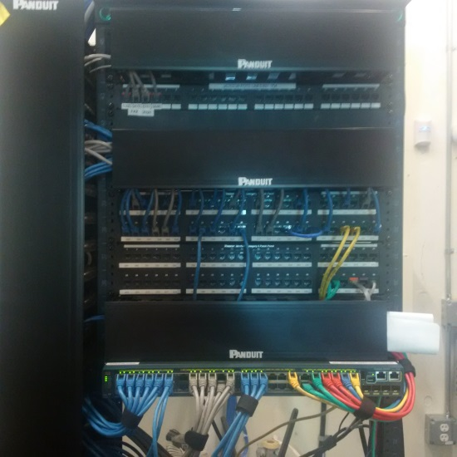
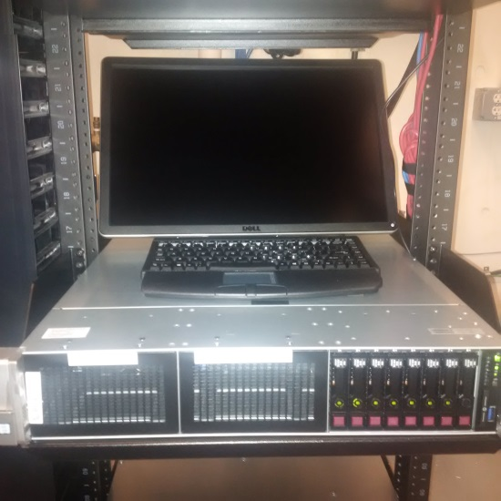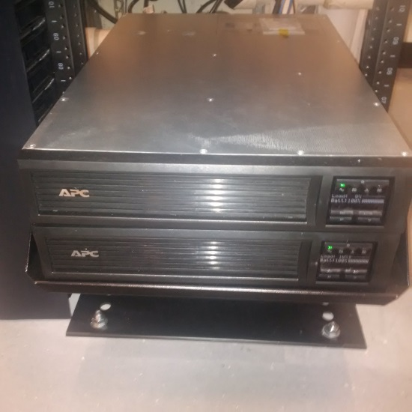
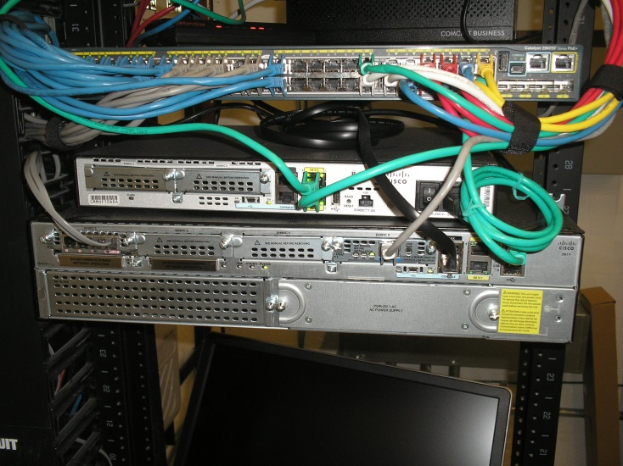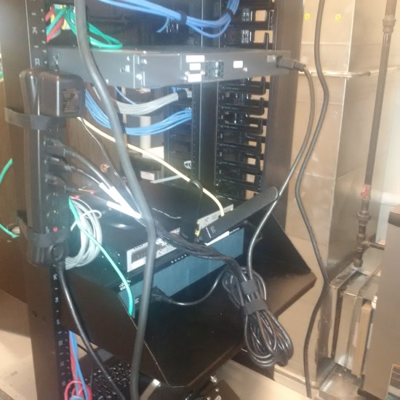

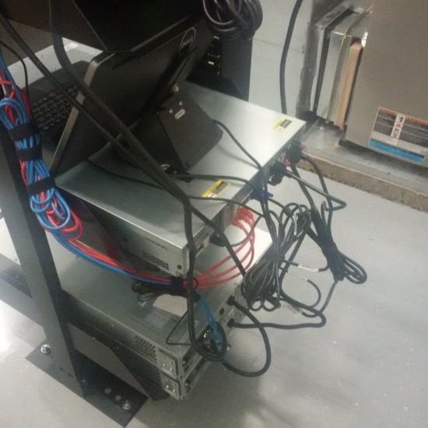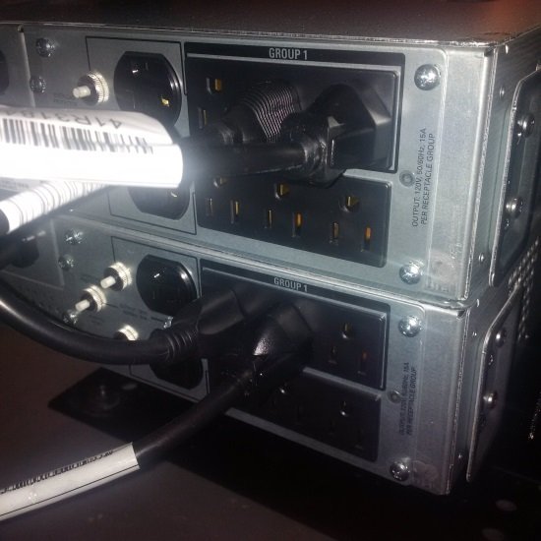

End of Day Communication

Send the TD ERE Focal updates at the end of the day and notify them of any issues immediately

Retail Testing

- EMV ICP - Once Store staff receives their card stock and login IDs, please email John.Joyce@td.com to perform a remote test. Provide Store name and asset tag to remote into. Copy TD ERE Focal on the email.
- After the store receives notification from Access Management that their IDs have been setup, please have the employees' login and test each PC and their access using the approved test script. Employees are required to sign and return the forms to the ERE Focal.

Grand Opening Day

- Ensure you have spare equipment with you including pre-imaged CSR and Teller PCs
- Lexmark issues should be reported through the TD Service Desk. Call 1-866-523-4357
- EMV printer issues should be reported to the TD Service Desk and escalated to DataCard. Entrust DataCard will be on call for hardware related issues and should be onsite within an hour.
- Other issues can be reported to the TD Service Desk 1-866-523-4357
- Send periodic emails to the TD Focal keeping them updated on the progress of the GO. Send at 8am, noon and after the GO ends. Send emails sooner if there are issues to report.

