Day 1 Worksheet: Redesign Your Business Card

Before you begin, here’s something to keep in mind:

When exploring your life purpose, it’s more insightful to ask the question “what is my life purpose” repeatedly rather than to expect an answer in one sitting.

This approach is helpful because sometimes it’s more powerful to have a fluid journey rather than a rigid answer.

We then have space to let our purpose unfold or to become aware of multiple life purposes we’re already actively fulfilling.

Also, try asking the question to yourself in different settings. Think about it the next time you’re doing some sort of habitual chore, like washing the dishes. In this half-focused state you’ll be amazed at what your mind will tell you. You can also sit quietly and meditate on the question.

If you mix up your strategy and as long as you keep asking the question, you’ll start to have clarity on what inspires you. You might see an overarching theme that speaks to a bigger life purpose or the question itself might take you on a meaningful journey!

Remember always, the odds of you being born are 1 in 400 trillion. There is no one else that has the unique combinations of life experiences, passions, and qualities that only you have. This means you are meant to do something no one else can do.

This also means that you’re job doesn’t define you - you define your job by applying this uniqueness to it for the benefit of others.

The goal of this worksheet is to get you thinking in that direction with a few fun questions. The bigger answers will come over time.

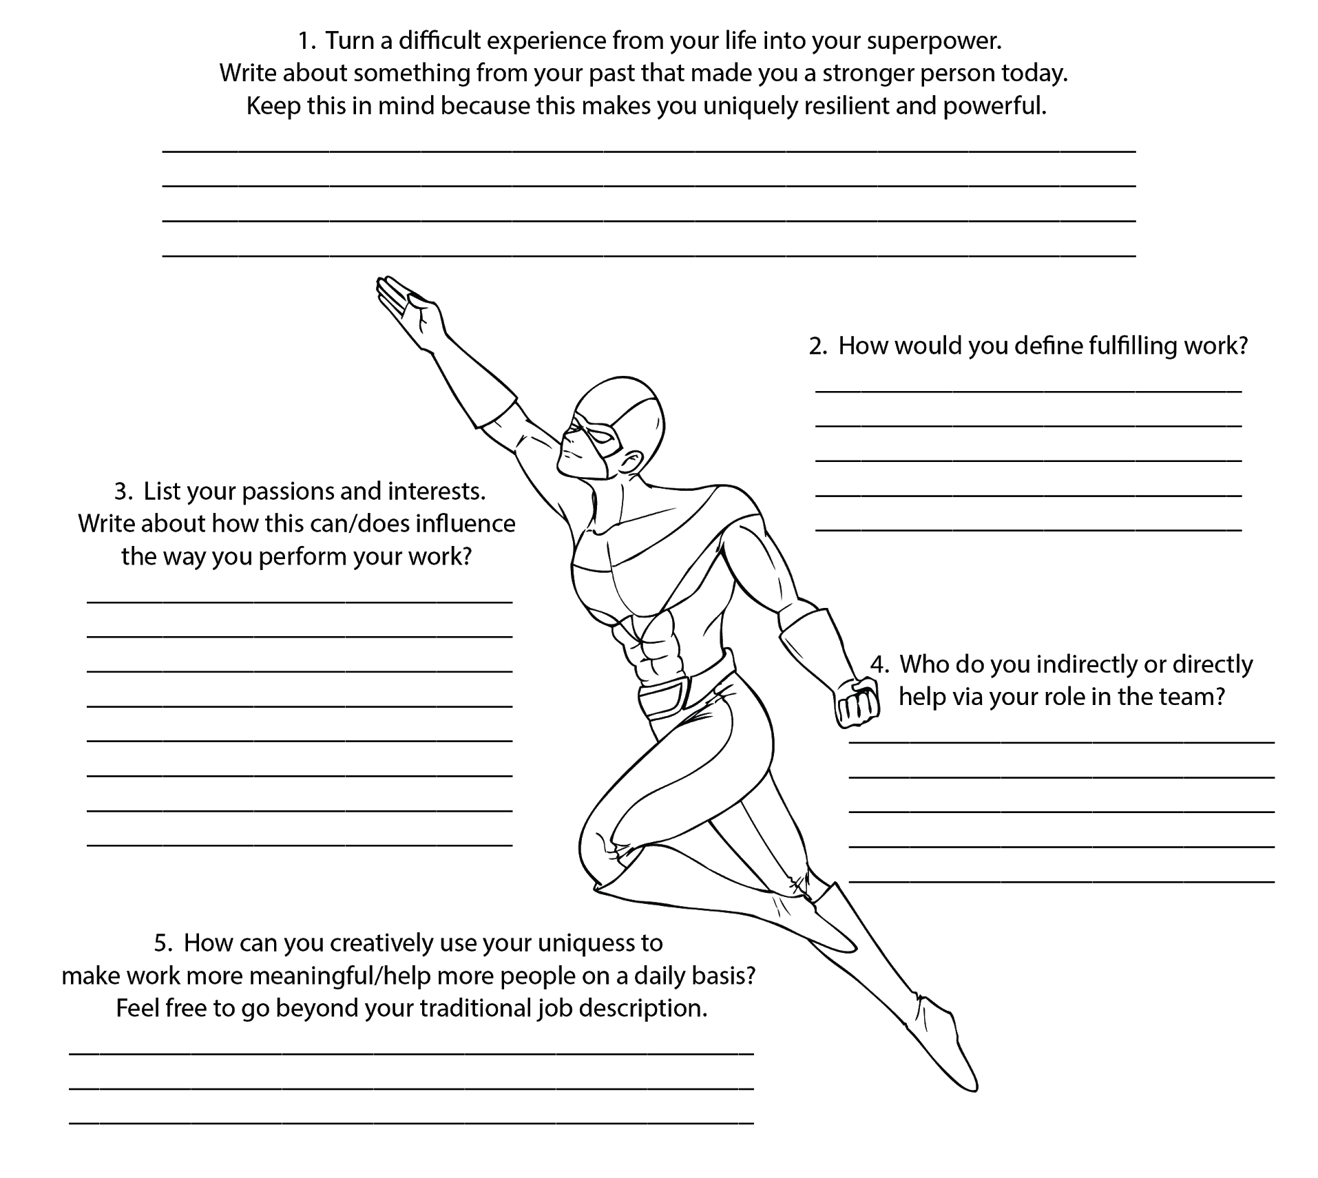
Give Yourself A Superhero Name: _______________________________________

Give Yourself A One-of-a-Kind Job Title: ___________________________________

