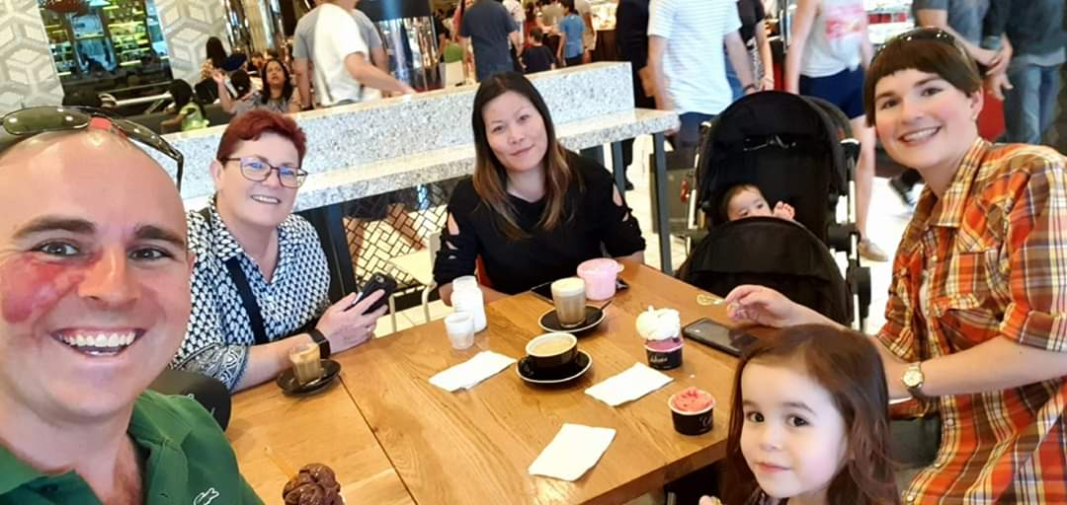
VISION One Year from Now:
- Edward Zia is to be a Global Influencer when it comes to Creating Master Persuaders & Influencers.
- He is surrounded by a wonderful community of people who support, love and drive each other across Earth.
- There is a clear sense of Strength, Helping Each Other, Action, Transparency, Fun, Intelligence and Winning.
- Success requires producing great content, speaking to lots of top people daily and delivering value!

Key Areas to WATCH OUT for:
- Cashflow is king and only work with people who pay and respect themselves and others.
- Avoid energy vampires.
- Don’t get side-tracked.
- Stay POSITIVE and BE SMART!

The Game Plan:
- Lead as a LinkedIn Influencer with light support from Instagram and Facebook.
- Speak to Leads with high quality messaging and calls.
- Invite people to Webinars, drive my Meetups, the Vault and offer Discovery Sessions.
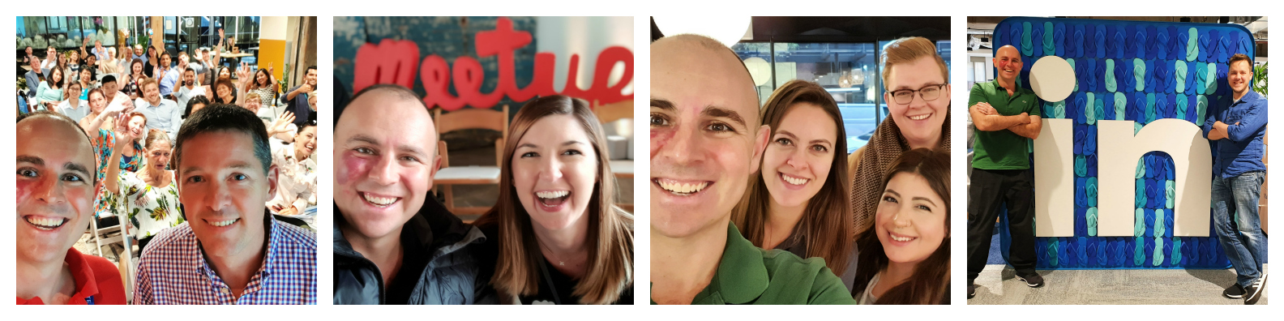
- Sign up 1 x New Client Each Day and make a MASSIVE impact!

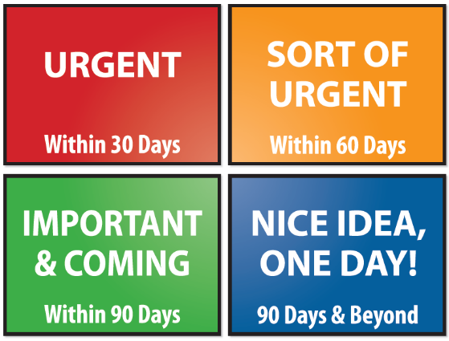
Urgent (within 30 days):
- Build strength and work out.
- Great Content & Work LinkedIn Hard.
- Fill Webinars with 100+ people per time.

Important (within 60 days):
- Drive heavy workshops & Online Sales.

Coming (within 90 days):
- Build your following & residual.

Future Tech:
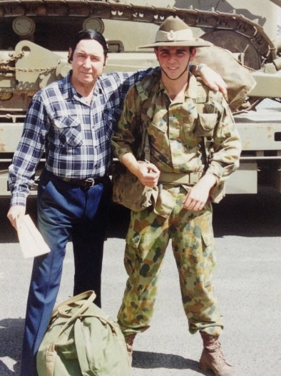
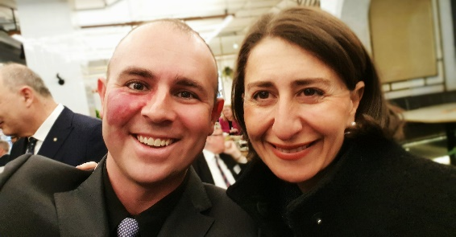
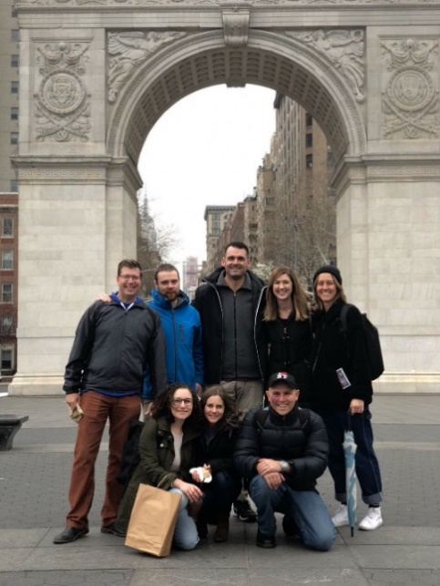
- Heavy 3 Day Workshop (or not).

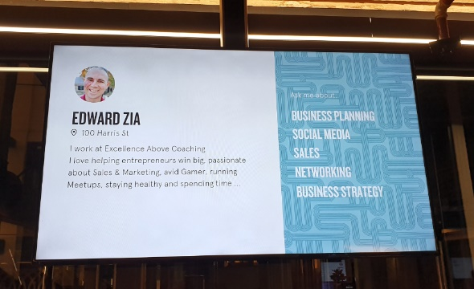
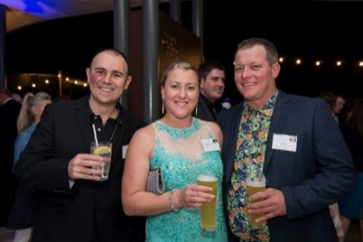

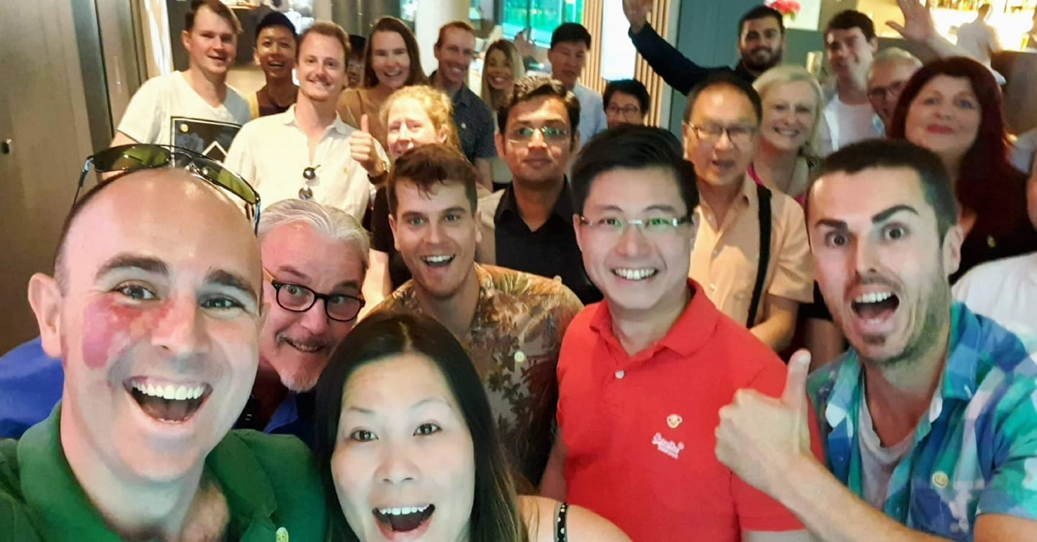
Daily:
5 x Phone Calls
5 - 10 x Social Media Posts
100+ x Respond to ALL MESSAGES
5 x Prayer / “In the zone”
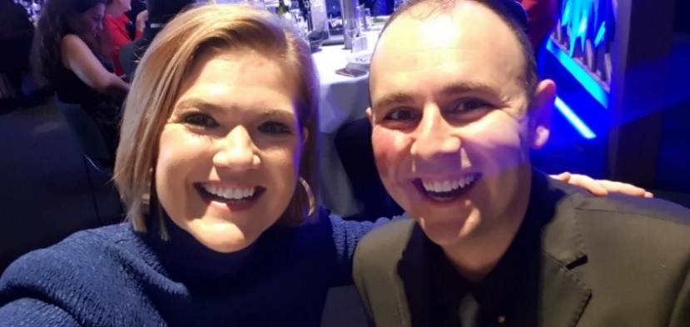
Weekly:
1 x Personal Database Email
1 x Meetup Email
1 x Live Webinar
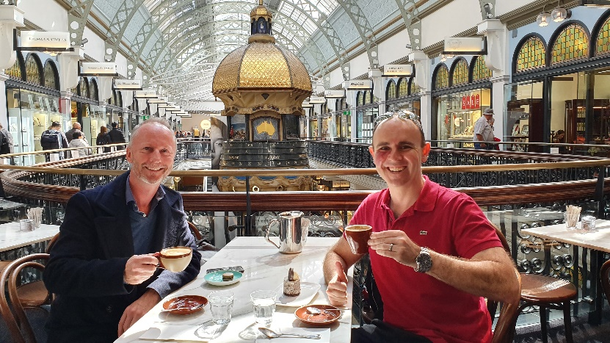
Monthly:
2 x Events
1 x Review
