Name:

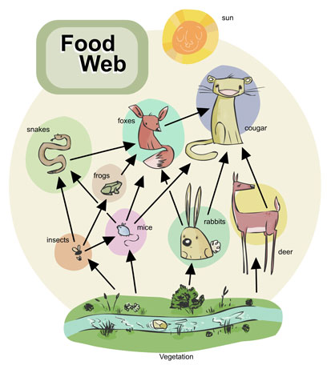Food Web Project

As we have been studying ecology for the past 2 weeks, we have

looked at the nutritional relationships among organisms that live with

one another. We have also studied the connections between organisms

and how they may aid in the recycling of materials in an ecosystem. In this project you will demonstrate that you understand this material by following the directions below. This project will be your evaluation for the 1st part of our ecology unit.

1. You will prepare a **food web** for a selected region on poster board or construction paper showing the connections of at least **12** organisms in that region. You can use pictures, print outs or drawings to show the connections between the organisms you selected.
2. From your food web write out **3 food chains** and **label** each organism as either producer, primary, secondary, or tertiary consumer. **(Do this on the back of your poster)**
3. Choose one of your food chains and make a pyramid of biomass with those organisms. **(Do this on the back of your poster)**
4. When you are finished, ask your teacher for the questions sheet and answer the questions about your project.

The possible regions you can select your organisms include: grassland, desert, tropical rainforest, taiga, deciduous (temperate) forest, ocean, freshwater, and the tundra. Below write in your selected region and **list** the organisms you will use to make your food web.

Selected Region:

Organisms being used:

Name:

1. Identify 3 herbivores from your food web.

2. Identify 3 carnivores from your food web.

3. Are there any omnivores in your food web? What are they?

4. Where would the decomposers be placed in your food web?

5. What role do decomposers play in a food web?

6. Does the food web illustrate a population, community, or ecosystem?

7. Are the food webs or food chains more stable? Explain.

8. Name 3 abiotic factors that could affect your food web.

9. How does the nitrogen cycle play a role in recycling materials in your food web?

Food Web Project Rubric

|  |  |  |  |  |  |
| --- | --- | --- | --- | --- | --- |
|  | 0 | 5 | 10 | 15 | 20 |
| Organisms | 1-3 organisms are part of the selected region. | 4-11 organisms are part of the selected region. | 12 or more organisms are part of the selected region. |  |  |
| Design a food web | Food web contains less than 2 organisms. | Food web contains 2-5 organisms and/or the flow of energy for 9-12 organisms is incomplete or incorrect. | Food web contains 6-11 organisms and/or the flow of energy for 5-8 organisms is incomplete or incorrect. | Food web contains 12 or more organisms and/or the flow of energy for 1-4 organisms is incomplete or incorrect. | Food web contains 12 or more organisms and the flow of energy is correctly shown. |
| Creativity/neatness | No pictures, diagrams or pictures in food web. | Used some pictures, diagrams, or drawings and/or they are not neatly placed in the food web. | Used pictures, diagrams, or drawings and they are neatly placed in the food web. |  |  |

Total: /40

|  |  |  |  |  |  |
| --- | --- | --- | --- | --- | --- |
|  | 0 | 2 | 4 | 6 |  |
| Write out 3 food chains | No food chains produced and/or all food chains are incorrect. | Only 1 food chain is correctly written out and labeled and/or most organisms are mislabeled. | Only 2 food chains are correctly written out and/or some organisms are mislabeled. | All 3 food chains are correctly written out and labeled. |  |
| Draw pyramid of biomass | All organisms placed improperly or no pyramid drawn. | 3 organisms are placed improperly. | 1-2 organisms are placed incorrectly. | Pyramid correctly shows the order of biomass for a food chain. |  |

Total: /12

Answer questions correctly: /8

Overall grade: /60