REPORT ON 2018 WANGARATTA JEWELLERS OPEN RACQUETBALL CHAMPIONSHIPS
Following an absence of twelve months the Wangaratta Jewellers Open Racquetball Championships returned to its previous position on the Victorian Racquetball Grand Prix Circuit, securing no less than one hundred and forty entries, and providing $6,000 in prize money and prizes, plus under the excellent leadership of the Club’s President Barry Patterson and a brilliant team, staged a magnificent event.
After the historic renaming ceremony of the Wangaratta Squash Courts to the John Broadway Squash and Racquetball Courts on the Friday evening, the first batch of combatants took to the courts and what ensued was two days of highly competitive matches with several going down to the wire, including the Men’s and Women’s Open finals.
Australian Open champions Cam White and Sarah Fitz-Gerald have virtually owned the Wangaratta Men’s and Women’s Open Championship events respectively since their inception in 2004 and 2006 respectively, but in 2018 with both champions missing, these events were captured by two players claiming their very first National or Victorian Grand Prix Circuit title.
The inaugural John Broadway Memorial Award was presented to Wangaratta’s Andrew Gibson, for his outstanding sportsmanship and support throughout the weekend
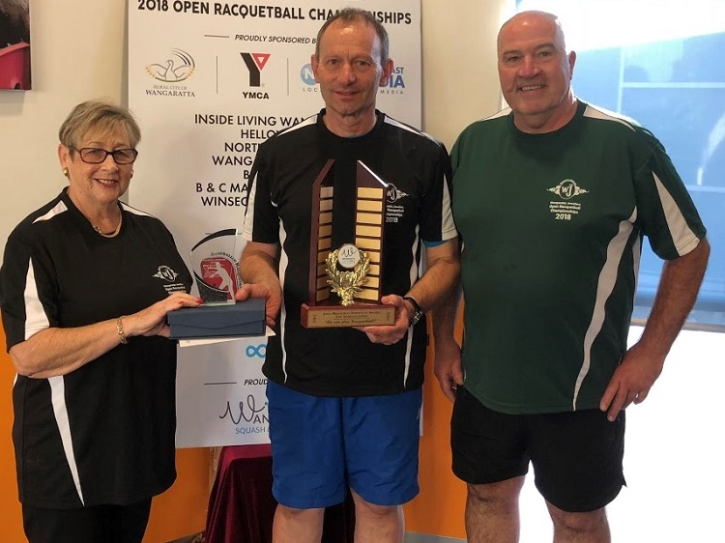
L-R: Elaine Broadway, Andrew Gibson & Barry Patterson
SINGLES
Grade | Winner | Runner-Up
Men’s Open | Ryan McCarter | Garry Pedersen
Women’s Open | Sue Dunlop | Kristel Proctor
A | Daniel Lewis | Matt Bayley
B | Steve Theologou | Jacob Van Der Vegt
C | John Broz | Michael Brigden
D | Alex Brigden | Jordan Tamburini
E | Nelson Howard | Zach Tamburini
F | Jessica Wilcock | N/A
Junior Girls | Amelia Brigden | N/A
Junior Boys | Xavier Brigden | Blake Sutcliffe

SPECIAL PRESENTERS:
MATT BARRY (WANGARATTA JEWELLERS), ELAINE BROADWAY & BARRY PATTERSON
MEN’S OPEN
Bayswater’s Ryan McCarter stole the show in the Men’s Open event claiming the scalp of Geelong’s ultra consistent second seeded Peter French at the semi final stage, 21/13, 16/21, 21/12, then in an enthralling ninety minute final, which contained numerous gut busting rallies, he came from a game down to overcome French’s stable mate, top seeded Garry Pedersen, 15/21, 21/16, 21/14, and catapult him to the top of the Victorian GP rankings points table.
To reach the final Pedersen ousted five times Australian Open Champion Geoff Wilcock, who was making his return to the GP singles circuit, 21/3, 21/6, at the semi final stage.
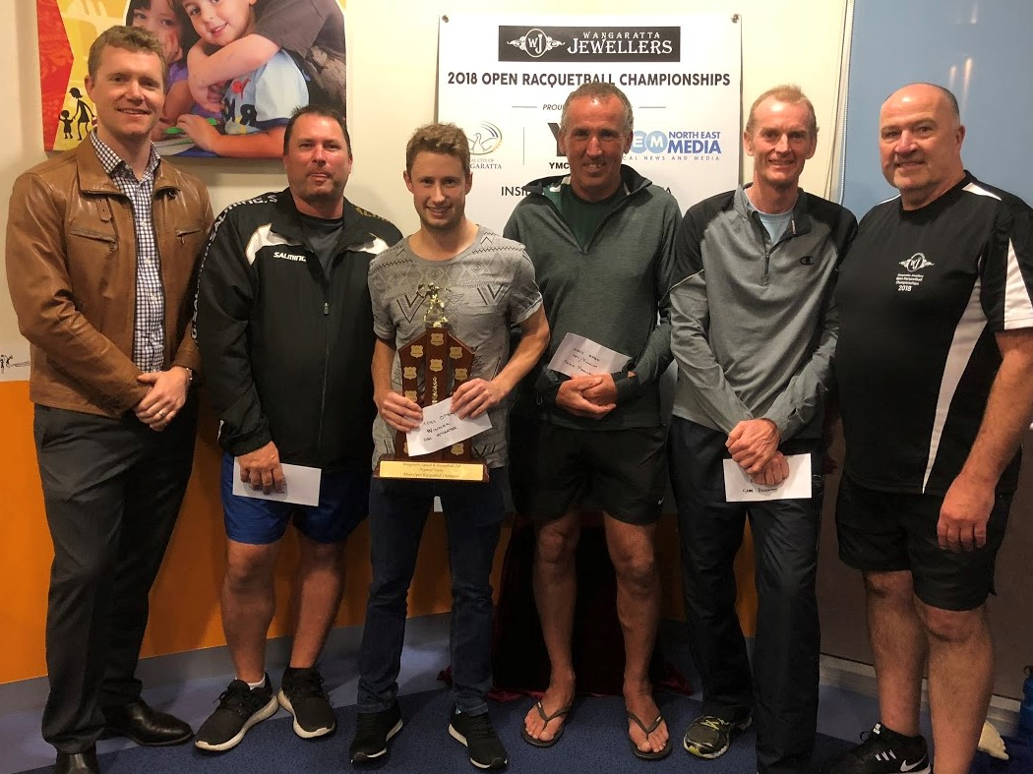
L-R: Matt Barry, Geoff Wilcock, Ryan McCarter, Peter French, Garry Pedersen & Barry Patterson
WOMEN’S OPEN
The Women’s Open also contained a high quality and evenly balanced field, but in the end it was Geelong’s second seeded Sue Dunlop, a perennial podium finisher in GP circuit events, and Bayswater’s 2017 National and Victorian GP Circuit Champion Kristel Proctor who met up in the final stanza.
In a replica of the Men’s Open final, the Women’s final was an eighty eight minute nail biter, punctuated by many long rallies and unbelievable returns, resulting in both players being virtually out on their feet before Dunlop fell over the line the winner, 21/16, 17/21, 22/20, which also moved her into top position on the Victorian rankings table.
In their respective semi finals, Proctor overcame SS&A’s Kathy Donnolley, 21/18, 21/7, whilst Dunlop overpowered Commercial Club’s Carolyn Takle after a titanic struggle in their first game, 22/21, 21/7.
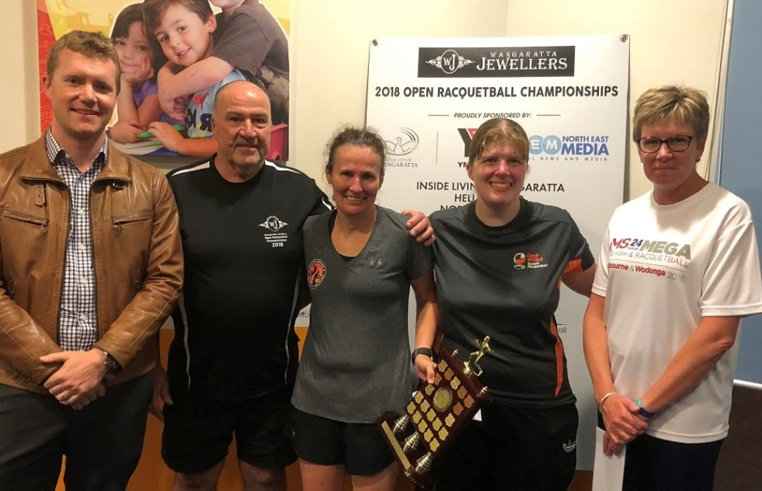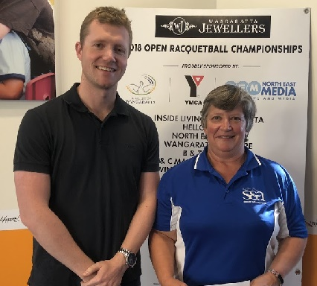
L-R: Matt Barry, Barry Patterson, Sue Dunlop, Kristel Proctor & Carolyn Takle Matt Barry & Kathy Donnolley
A Grade
Although a very strong field faced the starter for this event, it was Westerfold’s Daniel Lewis who made it two A Grade titles on the trot, following his victory in the ESRA Open event, and is now also perched on top of the rankings table.

Lewis accounted for Corio’s top seeded Adam Lander at the semi final stage, 21/17, 21/12, before overcoming Mulgrave’s most consistent Matt Bayley in a very entertaining final, 21/18, 21/17.

To reach the event’s climax, Bayley put paid to the chances of a local win in this event ousting Wangaratta’s top player Dean Milligan, 21/8, 21/8, in their semi final.

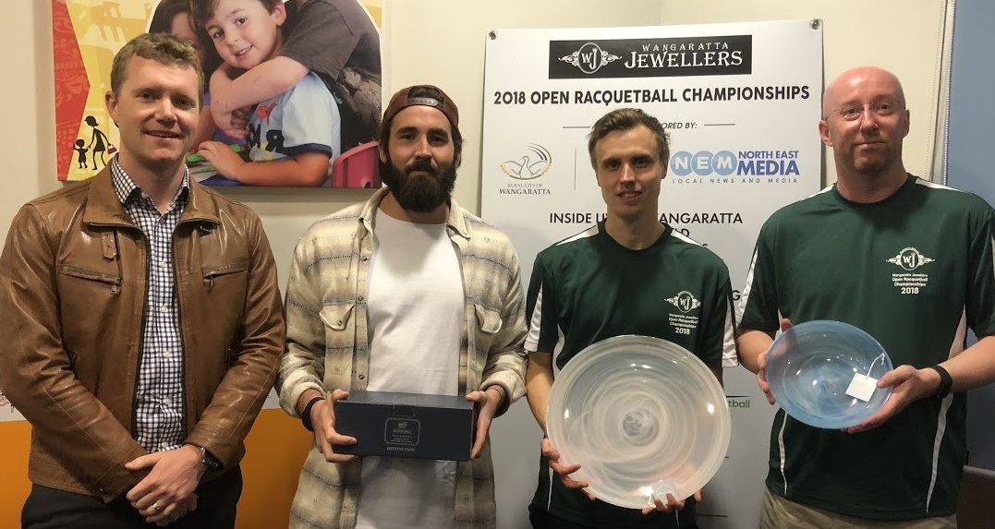
L-R: Matt Barry, Daniel Lewis, Matt Bayley & Rob Hay
B Grade
One of the most improved players on the GP circuit over the past twelve months has been Lakes Entrance’s Steve Theologou who also sits on the top of the rankings table in his grade following his annexing of the ESRA title, then making it a running double after winning this event.
To reach the final Theologou downed the 2016 winner of this event, Commercial Club President Mark Treloar at the quarter final stage, 21/18, 21/9, then staved off a brave challenge from Commercial Club’s Cory Sutcliffe in their semi final, 21/11, 21/19.
Whilst Theologou was methodically working his way through the top half of the draw, another Lakes player, fourth seeded Jacob Van Der Vegt was cutting a swathe through the bottom half, which included taking out Wodonga’s Campbell Shobbrook, who was returning after an eighteen month absence due to a debilitating back injury, 21/16, 21/17, and Westerfold’s third seeded Peter Walters at the semi stage, 21/15, 21/14.
In the final Theologou gained early leads in both games which he did not relinquish, taking it out, 21/12, 21/12.
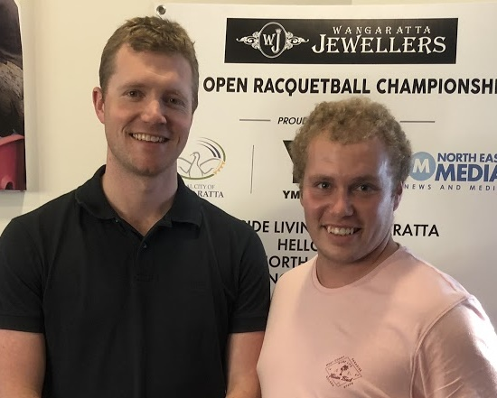
L-R: Matt Barry, Steve Theologou & Matt Tench Matt Barry & Jacob Van Der Vegt
C GRADE
In what looked like the most even field on the singles program, it was Wangaratta’s John Broz who stormed through the field winning all four matches, the last three in three games, to capture the host club’s only title victory for the weekend.
After overcoming Corio’s Brandon Morgan in straight games, Broz had the temerity to knock over the Commercial Club duo of third seeded Ross Falconer, 21/16, 20/22, 21/11, then second seeded Tim Darmody, 21/12, 14/21, 21/19.
Meanwhile, the Commercial Club’s “Iron Man” and fifth seeded Michael Brigden, was putting the sword to all and sundry in the top half of the draw, including Wangaratta stalwart Shaun Quinn, 22/21, 21/18, Lakes Entrance “Warhorse” Chris Fuhrmeister, 21/18, 13/21, 21/17, and then Bendigo’s top seeded Anthony Dzioba, 21/14, 13/21, 21/14.
As with many other singles contests at this tournament, the final was another lengthy and spine tingling encounter with Broz finally capturing the title, 21/17, 16/21, 22/21, and in the process forever to be known at the Wangaratta Club as “ THE CHAMP.”
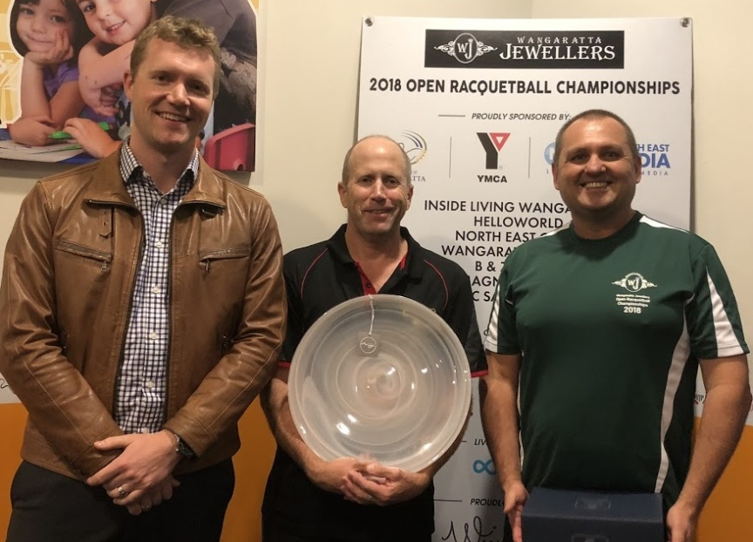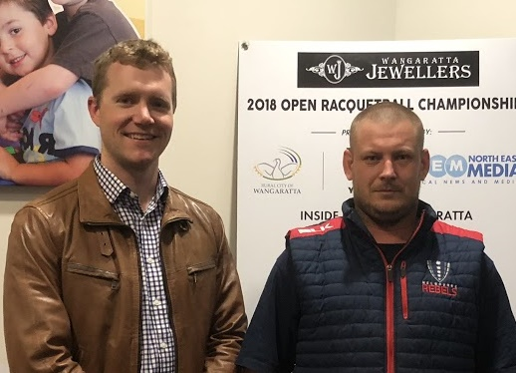
L-R: Matt Barry, Michael Brigden & John Broz Matt Barry & Grant Bradley
D GRADE
This event contained a wide range of age groups, including two teenagers who ended up claiming the major silverware, with the youngest taking out the title.
Wodonga’s Jordan Tamburini and Commercial Club’s Alex Brigden were seeded to meet in the finale, and if this was to happen, another very tight encounter was assured following Jordan’s win over Alex at the semi final stage of the ESRA Open event, 22/21 in the third game.
Tamburini was unstoppable in the top half of the draw, reaching the final after accounting for eighth seeded Annie Jarratt and fourth seeded Zac Thomas in straight games at the quarter and semi final stages respectively.
In the bottom half of the draw Brigden was also living up to his seeding, taking out Commercial Club’s Paul Morgan, 21/17, 21/15 at the quarter final stage, then coming from a game down to overpower Bendigo GP debutant David Drew, 20/22, 21/14, 21/12, in his penultimate match.
The final was another epic battle as the two players went point for point for seventy minutes prior to the fourteen year old Brigden winning the one hundred and twenty fifth and final point and claiming the title, 21/19, 21/22, 22/20, although Tamburini still retains the lead on the rankings table.
In the D Grade Plate Final another young and upcoming player Wangaratta’s Andy Gibson, had the audacity to defeat Club Coach Heather Meldrum, 16/14, 15/9.
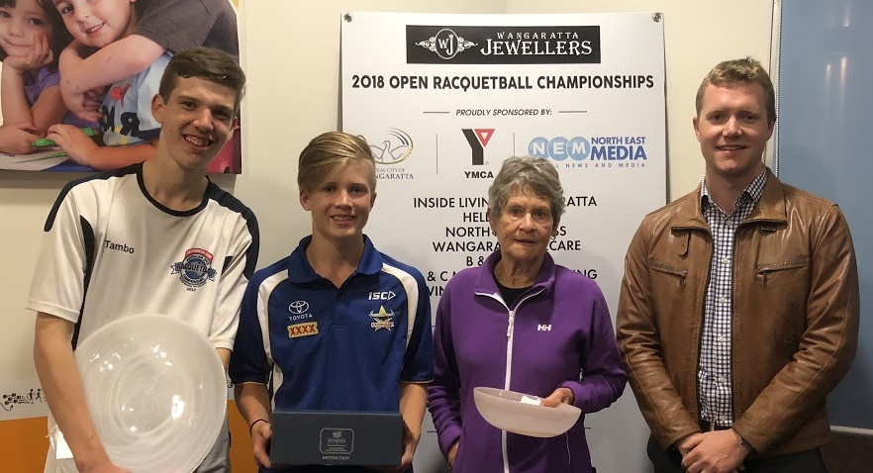
L-R: Jordan Tamburini, Alex Brigden, Heather Meldrum & Matt Barry Matt Barry & Andy Gibson
E GRADE
This event was littered with junior players of which two fourteen year olds progressed to the final stanza.
Wodonga’s Zach Tamburini headed up the seedings, and like his brother Jordan in the D Grade event, progressed through to the final on the back of two straight game wins, which included Wangaratta’s fourth seeded Judy Lowen, whilst Dromana’s seventh seeded Nelson Turner was also powering towards the finish line taking out all three of his matches as well in straight games, including wins over second seeded Lillian Brigden, and Commercial Club’s sixth seeded Elsabe Du Plooy.
As with virtually all of the singles finals another action packed and lengthy final ensued, with Howard coming from a game down to annex the title, 18/21, 21/16, 21/12, but Zach is still on top of the rankings table.
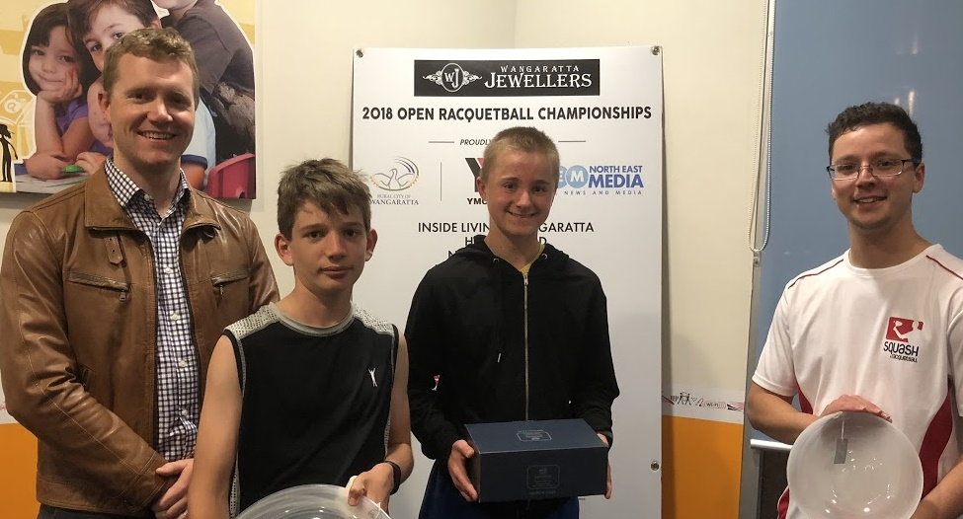
L-R: Matt Barry, Zach Tamburini, Nelson Howard & Nathaniel Caspersz
F GRADE
Jessica Wilcock also played in the E Grade event, and was also declared the winner of this event.
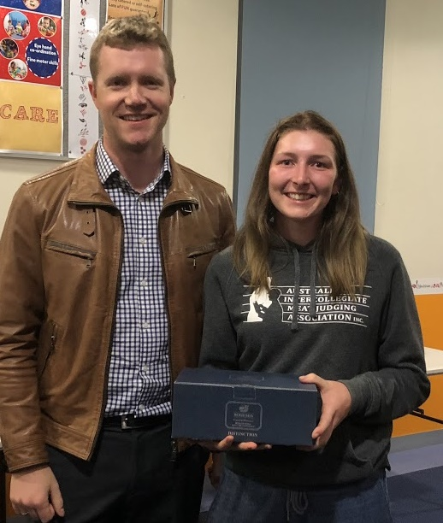
L-R: Matt Barry & Jessica Wilcock
Junior Under 13’s
This was a five player round robin event with Commercial Club’s pocket dynamo Amelia Brigden claiming the Girl’s event and brother Xavier finishing on top in the Boy’s event over Commercial Club’s Blake Sutcliffe, with GP debutants, Wangaratta duo, Campbell Hobbs and Xavier Dodgshun finishing in third and fourth place respectively.
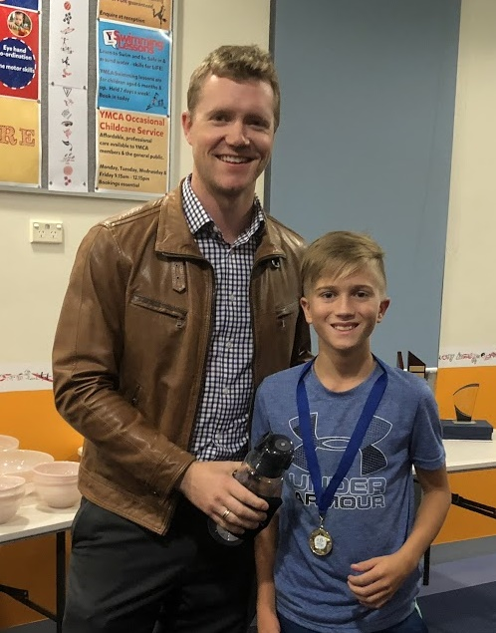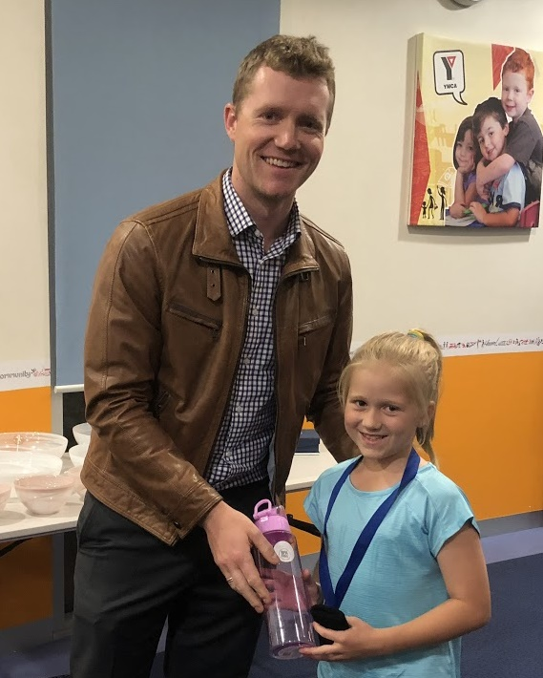
L-R: Matt Barry & Xavier Brigden- (Missing Blake Sutcliffe) L-R: Matt Barry & Amelia Brigden
DOUBLES
Grade Winner Runner-Up
Open D. O’Donnell/C. Stevenson G. Wilcock/K. Proctor
A M. Bayley/R. Cooper C. Rollauer/D.Milligan
B S. Tiet/M.Tench J. Phillips/T. Chivers
C D. Parkinson/M. Westman K. Donnolley/M.Sutcliffe
D X. & C. Brigden A. & A. Gibson
E E. Du Plooy/L. Melville M. & M. Hobbs

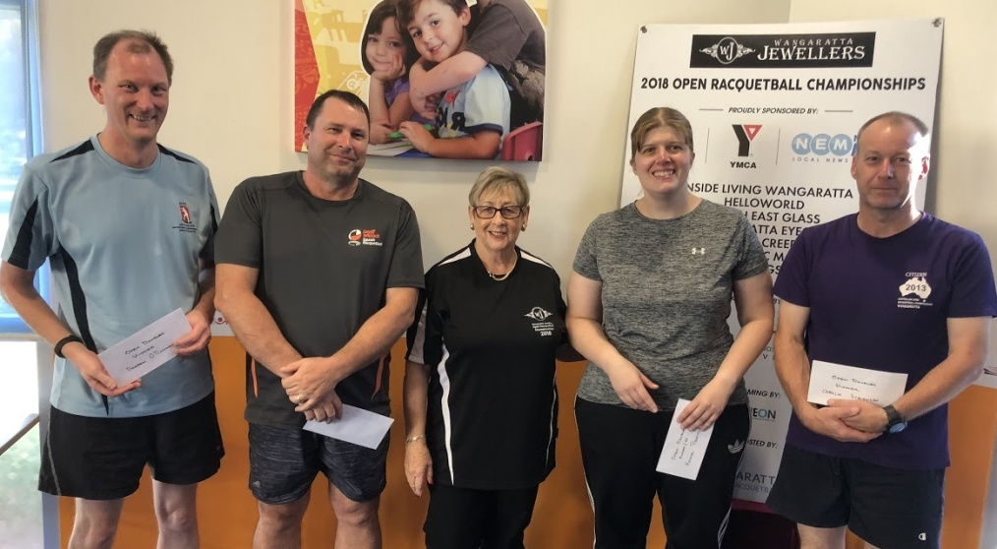
Open - L-R: Darren O’Donnell, Geoff Wilcock, Elaine Broadway, Kristel Proctor & Charlie Stevenson
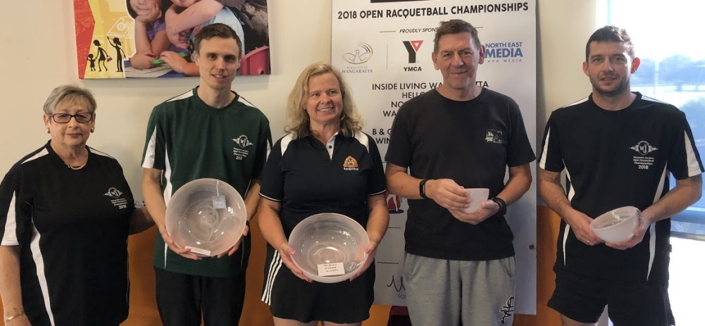
A Grade - L-R: Elaine Broadway, Matt Bayley, Rayleen Cooper, Chris Rollauer & Dean Milligan
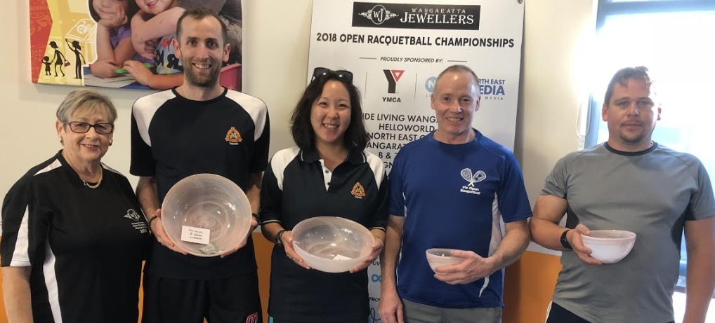
B Grade - L-R: Elaine Broadway, Matt Tench, Sylvia Tiet, John Phillips & Tyson Chivers
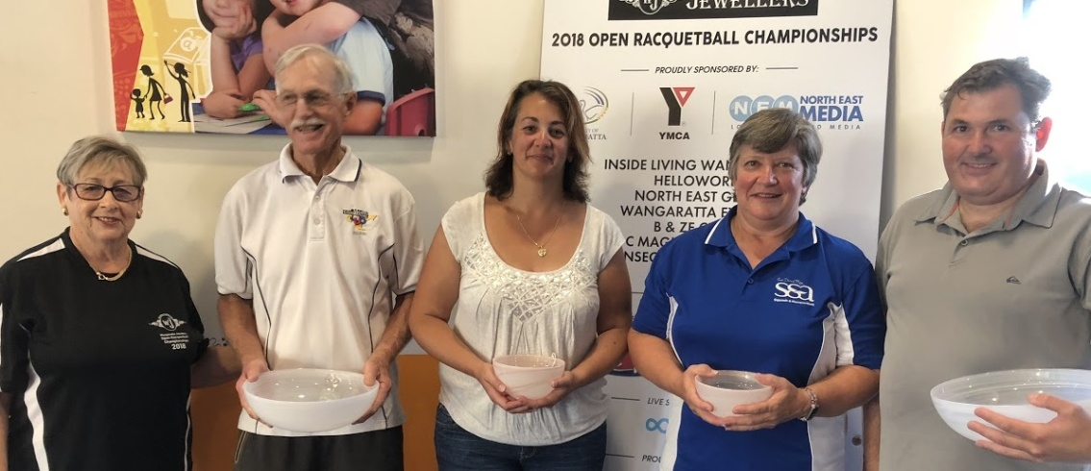
C Grade - L-R: Elaine Broadway, David Parkinson, Michelle Sutcliffe, Kathy Donnolley & Matt Westman
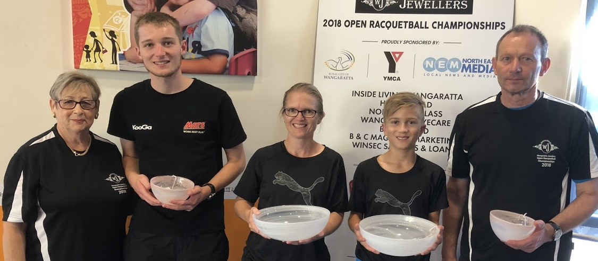
D Grade - L-R: Elaine Broadway, Andy Gibson, Cheryl Brigden, Xavier Brigden & Andrew Gibson
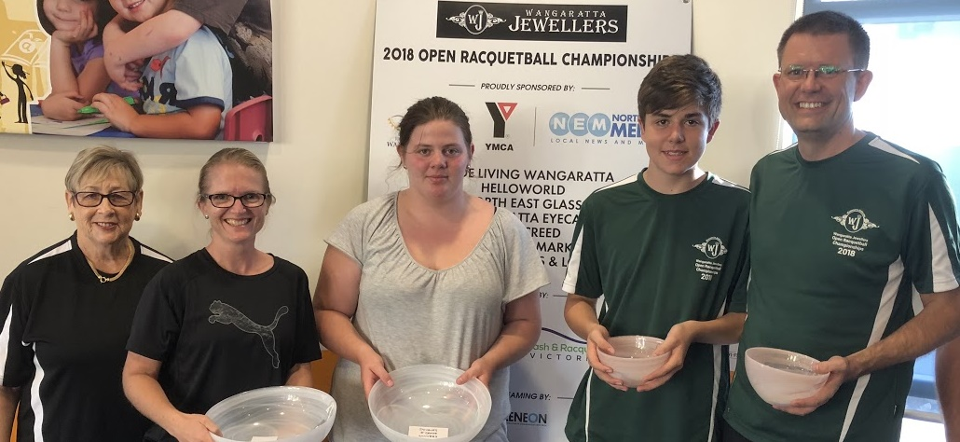
E Grade - L-R: Elaine Broadway, Cheryl Brigden (for Elsabe Du Plooy), Laura Melville, Mitchell Hobbs & Matt Hobbs

Words: Paul Vear
Photos: Courtesy of Dean Milligan

