**Five Below / NetFortris – Circuit Turnup Process (WIP)**

**Project Overview**:  
Five Below will be installing new wired internet circuits through NetFortris at all retail locations. Many retail locations have existing wired internet circuits through a different partner, some retail locations do not currently have a wired internet circuit. All retail locations have a 4G connection (via Cradlepoint), either for backup in instances where a wired internet circuit is present or primary in instances where there is an existing wired circuit.

The following scope of work outlines the actions required by the on-site NetFortris technician on the day of cutover. At a high level, the technician will arrive on site, identity themselves and their purpose to the store manager, locate the newly installed circuit, test it, contact Five Below IT, work with them to connect the new circuit to Five Below’s Meraki network equipment, and validate store functions.

**Pre-requisites (equipment / information the technician needs):**

* Carrier notes outlining where the modem was installed and the circuit ID on the modem tag
* Materials required to extend the circuit (if applicable) into the manager’s office (cables, tools, ladder, etc.)
* IP information for the circuit (usable IP address(es), subnet mask, gateway)
* Windows laptop with Ethernet port
* Ethernet cable for testing
* Cellphone with data plan
* Label maker

**Step-by-step circuit turnup process:**

1. Technician will arrive on site and identify themselves to the MOD (manager on duty) as a technician from NetFortris here to perform an internet upgrade. Your arrival will be communicated to the MOD prior to scheduled date. If the manager has any concerns with providing access, the technician should email [WANRefresh@fivebelow.com](mailto:WANRefresh@fivebelow.com) with the store number and the technician’s contact information. Someone will reach out to the store to confirm the appointment is legitimate.
2. Technician will contact the NetFortris turn-up team to check in and obtain any information not already received as part of the pre-requisites (modem install location, handoff interface, circuit ID, IP information for testing).
3. Technician will locate the carrier-installed device (modem, router, etc), verify it is the new device and NOT the existing device based on the circuit ID, and validate power to the device.
4. **If the carrier device is already in the Five Below network rack located inside the store manager’s office**, connect an ethernet cable to the handoff port of the carrier device, proceed to step 6, and test the circuit.
5. **If the carrier device is not in the Five Below network rack located inside the store manager’s office**, the technician will investigate options to extend the circuit into the store manager’s office. Options in order of preference:
   1. Extend the carrier’s line into the manager’s office and place the carrier device in the Five Below network rack inside the store manager’s office
   2. Extend a cable from the handoff interface of the carrier’s device and terminate into an available patch panel port (FB to confirm specific details on this). Label that patch panel port ‘Internet’ and run a cable from that patch panel port to be used for Five Below’s internet connection.
   3. If the extension would require additional equipment (i.e. a lift or other hardware) to complete, investigate if an existing extension is in place for the current wired circuit. If that is the case, we can make use of the existing extension. NOTE: DO NOT MOVE THE EXISTING CONNECTION WITHOUT CONTACTING FIVE BELOW IT PER THE INSTRUCTIONS IN STEP 8.
6. Input the circuit IP information obtained from NetFortris into the laptop NIC, plug the cable from the carrier device handoff port into the laptop ethernet port, and validate an internet connection can be made using the newly installed internet circuit. Run the below tests and capture the information with screenshots for Five Below IT:
   1. Open a command prompt and type ipconfig. Take a screenshot of the ethernet adapter configuration containing the IP address, subnet mask, and default gateway.

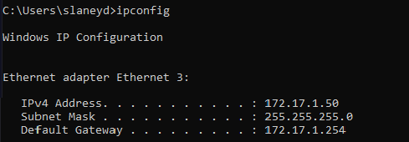

* 1. Browse to <https://www.speedtest.net/> - once the page loads, select ‘GO’ to run a speed test. Once complete, take a screenshot of the results, example below:

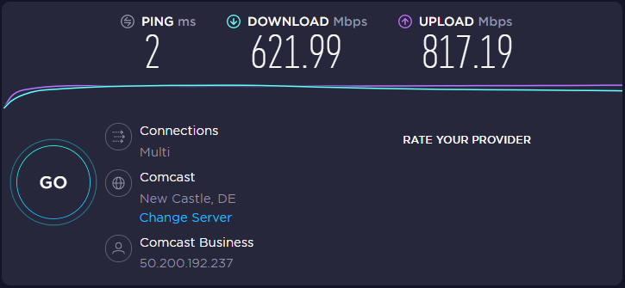

1. If there are any issues obtaining a connection from the circuit, please engage the NetFortris turn-up team to validate the provided information is correct and have the issue investigated with the underlying carrier.
2. With the above information captured and a working circuit validated, please reach out to Five Below IT using the following e-mail template and the information captured above. Someone from Five Below IT will call the reach number provided and work with you on connecting the new circuit to Five Below’s network equipment.
   * E-mail template (the e-mail must be sent to [WANRefresh@fivebelow.com](mailto:WANRefresh@fivebelow.com)):
     + Subject line: Store XXXX (insert store number) – NetFortris Circuit Install
     + Body: Hello, the circuit at this location is ready to be turned up. Please contact me at your earliest convenience to connect and test.
       - Technician name: (insert name)
       - Technician phone number: (insert phone number)
       - Circuit IP information: (insert screenshot of ipconfig output)
       - Circuit speed test result: (insert screenshot of circuit speed test results)
3. Once the email is received, a Five Below technician will reach out at their earliest opportunity. Please allow ~15 minutes before sending a follow-up e-mail if you do not receive a call.
4. When connected with the Five Below technician, they will walk you through disconnecting the existing internet connection from the Meraki router, connecting the new internet circuit, and testing connectivity from the store. *** FB has internal documentation for the cut over process
5. Five Below to add details here – but the basic ask is that once cutover is complete, the technician remove the old modem/carrier device, box it up, label it, and inform the manager it needs to be kept in their office until further notice from IT. Again, we will align on an internal process and update this.