**STAR SHINE Fashion Show**

Please allow us to introduce the clubs that will involve in this **Fashion Show**：**University of Western Ontario COSA**携手**University of Toronto Missisauge CSSA**, **Guelph University CSSA**, **Sheridan College CSSA**, **University of Toronto St. George CSSA**, **University of Toronto Scarborough CSSA**, **McMaster University CSSA**, **University of Toronto St. George CMC, and University of Toronto Scarborough CMC**.

There will be free deserts and a cocktail after party after the show!!! First drink will be champagne and it is freeeeeeee!!!!!

On top of that, the lighting and sound system is controlled by our premium sponsor!!!! We will not tell you how he is in charged for those celebrities concerts!!!! :P

At the beginning of the show, there will be an band performance! During the show, there will be 5 singers performing for us. Some of them has got the first place in a lot of singing contest. One of them, called Waner Zhao, she had been singing with Liyuan Peng( who is the leader in Chinese singing field and wife of Chinese president Jinpin XU) when she was young!!! Come and watch the show!!! You will be surprised!

Now , this is the Intro of our designers:

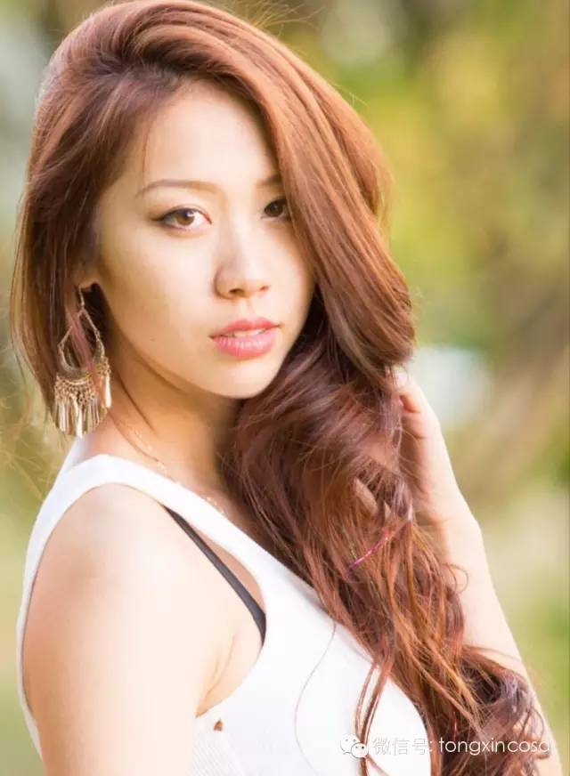

**Lin Qi**

Fashion Design Student

Ryerson University

Has attended Miss Asia Canada Contest

*Fashion to me is a form of art, and a place to spread my creativity. My passion for designing started when I was a little girl and I still have the same dream to design bridal, thus inspirations for my designs are mostly from fairytales and fantasies.*

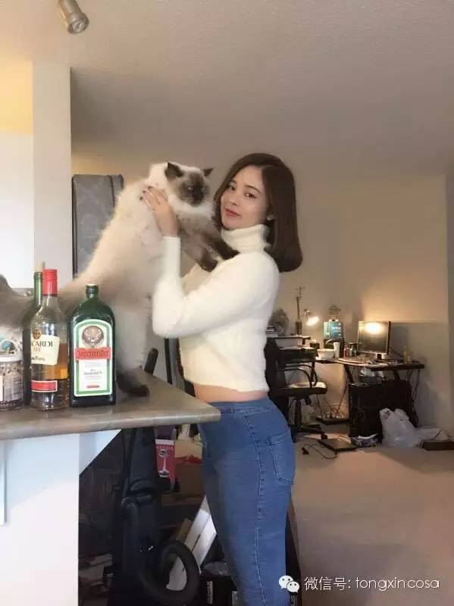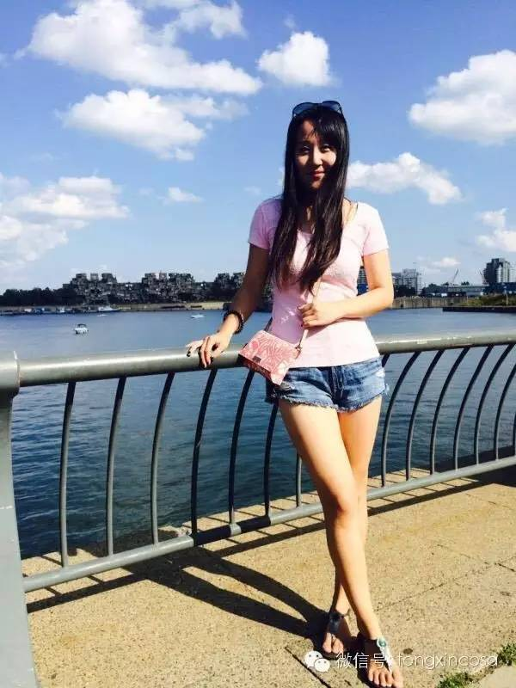

**Hang Zhou and Annie Zhang**

*We aim at to show the sexy of an lady from inside out. By studying in Fanshawne College, we learned how to use the lines of clothing to reveal the best of a woman body!*

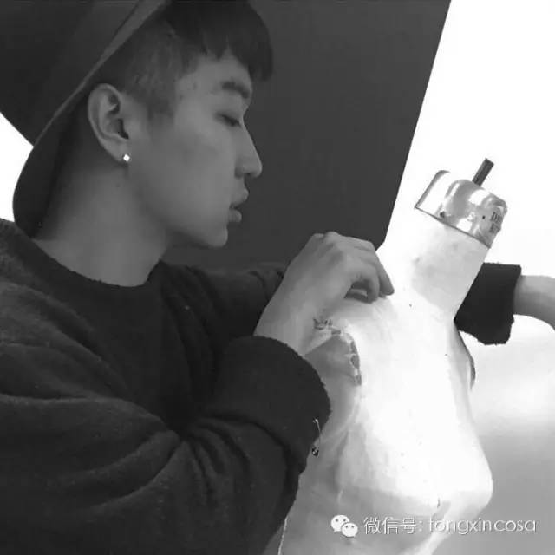

**Haorui Liang**

Seneca College

*The themes of my line is usually coming from the rocks and the flying birds. They represent how I want the freedom to be by my side and how I was the clothing to be comfortable and sexy.*



**Leona**

VP Events of UWO COSA

*Every little thing in my life is my inspiration. When I close my eyes, the moments that inspire me the most will give the thoughts and elements that I want to use with one certain line. When it comes to design, there is no nationality and no boundaries. I want to reveal the best thing out of a woman’s body and spirit.*

There will be three prized given out to the audience during the show, being worthed $1500, $800 and $300 respectively.

**19:00p.m.－20:30p.m. Fashion Show**

**20:30p.m.－21:00p.m. Celebration of the Show**

**21:00p.m.－23:00p.m. After Party**

For the sponsors who are sponsored in this show, we offer an exclusive position for advertisement and collaboration