Purpose
The purpose of this information is to give the reader an understanding of the E-Sports Bush League, as well as an understanding of the e-sports industry and how the E-Sports Bush League will operate within that industry. It will also demonstrate how the E-Sports Bush League will be beneficial to those individuals involved with e-sports tournament competition.

Introduction
What exactly is e-sports? The answer as you might have guessed is a computer- based competition played on a specific manufactures platform; such as Xbox, between one or more individuals.

In 1980 Atari held The Space Invaders Championship, which featured its popular game and attracted over 10,000 participants from across the United States; thus ushering in the competitive game industry.

Further development of e-sports occurred in the 1990’s with the development of the Internet. Now, instead of playing someone in the same room a player could challenge someone thousands of miles away. Large scale e-sports tournaments such as the Nintendo World Championships began, as did the introduction of television shows featuring eSports.

- sports went global in 2000 when South Korean based World Cyber Games Inc. hosted the World Cyber Games, an international competition sponsored by Samsung Electronics and Microsoft.

The emergences of online streaming services have also contributed to the growth of e-sports, and are the most common method of watching tournaments. Twitch, an online streaming platform launched in 2011, routinely streams popular eSports competitions.
In 2013, viewers of the platform watched 12 billion minutes of video on the service. During one day of The International, Twitch recorded 4.5 million unique views, with each view watching for an average of 2 hours.

Video games companies are also embracing the eSports potential of their products. In 2014, Nintendo hosted an invitational Super Smash Bros. 4 competitive tournament in lieu of their traditional Electronic Entertainment Expo (E3) press conference. Halo developers 343 Industries announced in 2014 plans to turn Halo into an e-sport with the creation of their own dedicated Halo league and a prize pool of $50,000

Individuals are not just watching online, in 2013 Season 3 League of Legends World Championship took place at a sold-out Staples Center. In 2014 the event took place in front of 40,000 spectators in Seoul, South Korea.

Today large prize-pools have led to an increase of professional players participating in sponsored events, while the number of amateur players is decreasing. This is one of the key reasons for the need of a platform like E-Sports Bush League that will provide a place for amateurs to compete, and to train for professional tournaments.

The Opportunity
Competitive e-sports is growing rapidly with the number of events increasing from 32 in 2000 to 1058 in 2015. This trend is expected to continue as the industry becomes more main stream. Despite this the competitive gaming industry is still new and sectors of that industry; such as training platforms like E-Sports Bush League are still in the infancy stage.

The company’s early entry into the market will allow it to create a brand, and develop a customer base, before other competitors enter the market. Sponsors will have the opportunity to be involved with not only with the exponentially growing e-sports industry, but also the growing support industries.

Year | # of Events | Prize Pool
2000 | 32 | $514,078
2001 | 35 | $772,573
2002 | 35 | $843.146
2003 | 88 | $1,309,012
2004 | 148 | $2,057,645
2005 | 237 | $3,622,576
2006 | 262 | $4,341,924
2007 | 267 | $6.024,207
2008 | 342 | $6,312,786
2009 | 377 | $3,500,122
2010 | 669 | $5,230,233
2011 | 1201 | $9,687,484
2012 | 1456 | $13,125,288
2013 | 1534 | $19,801,310
2014 | 2131 | $35,663,492
2015 | 1058 | $15,557,309
Source: E-sportsearnings.com

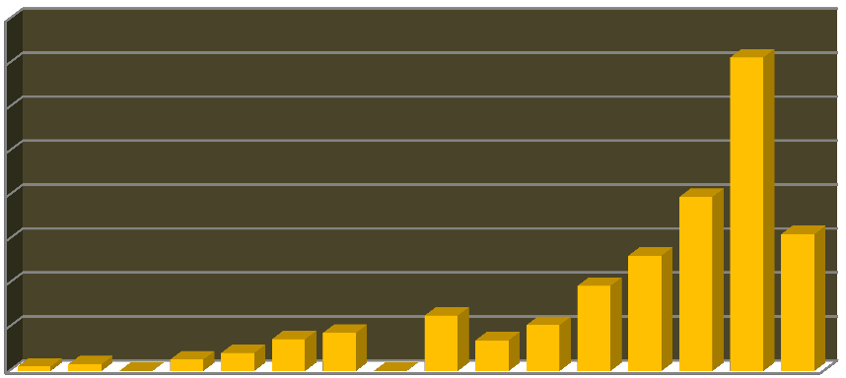The Industry1
Prize Pool (2000 - 2015)
$40,000,000
$35,000,000
$30,000,000
$25,000,000
$20,000,000
$15,000,000
$10,000,000
$5,000,000
$0
The e-sports market, already worth $194 million per year, is set to more than double in size by 2017 according to a "conservative scenario" from research firm Newzoo, which pins a predicted value of $465 million on the sector within two years.

Released as part of a free preview to its new report "The Global Growth of E- sports: Trends, Revenues and Audience Towards 2017", the figures equate the growth of e-sports to that of analogous athletic sports like Ice Hockey and American Football, estimating that there could be as many people watching e- sports in 2017 as there are watching the NFL now. Extrapolating from that growth, the report estimates that there could be as much as $1 billion worth of revenues being generated by e-sports within two years.

"In terms of audience, the number of e-sports Enthusiasts will jump from 89 million last year to 145 million in 2017," the report reads. "Another 190 million will watch e-sports competitions occasionally, showing that competitive gaming has evolved to a Spectator Sport with a fan base comparable to that of Volleyball, American Football or Ice Hockey. Following a year of explosive growth in audience and money involved, 2015 will be pivotal in determining the future of e-sports."
1. Source: Gameindustry.biz

Size
The following represents the population of US residents between the ages of 14 to 29 years of age. Populations are based on the latest figures available from the US Census Bureau and New York based Super Data Research Inc.

- Males 14 to 29 years of age = 32,953,433
- Females 14 to 29 years of age = 31,774,758
- Korea and China continue to dominate $612M global eSports market. The ongoing investment in N. America and Europe by digital-only publishers drives overall growth and audience expansion.
- The global eSports audience is 134 million strong and growing. Investment in innovative business models, platforms and derivative businesses further spurs growth in competitive gaming.
- Competitive gaming is a marketing strategy, not a revenue driver. In addition to traditional marketing efforts, organizing events and streaming content improves awareness and retention.
- Thirteen percent (13%) of live-stream viewers watch eSports. Almost half of eSports viewers in the U.S. use Twitch.tv, the world’s largest live streaming site for game content. Roughly half of eSports viewers participate in some type of competitive gaming, mostly online through platforms.
- Corporate sponsorships total $111 million in North America (2015E). Brand owners and advertisers are expected to adapt to emergent forms of entertainment, which will grow sponsorship deals across the segment.

The Market

Target Customers | % Of Customers
Males 14 to 29 years of age (Skilled) | 46%
Males 14 to 29years of age (Un-skilled) | 29%
Females 14 to 29 years of age (Skilled) | 18%
Females 14 to 29 years of age (Un-skilled) | 7%
Target Customers
7%
18%
Males 14 to 29 years of age
(Skilled)
46%
29%
Males 14 to 29 years of age
(Un-skilled)
Females 14 to 29 years of age (Skilled)
Females 14 to 29 years of age (Un-skilled)

Target Markets | % Of Customers
United States | 76%
Asia | 12%
Western Europe | 9%
Other | 3%
3%
Target Markets
9%
United States
15%
Asia
Western Europe Other
76%

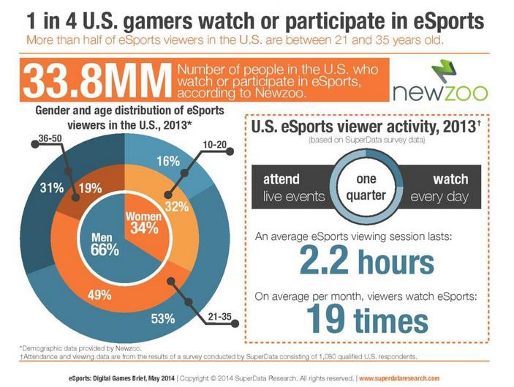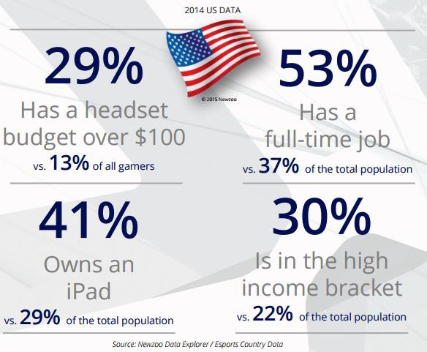Statistics

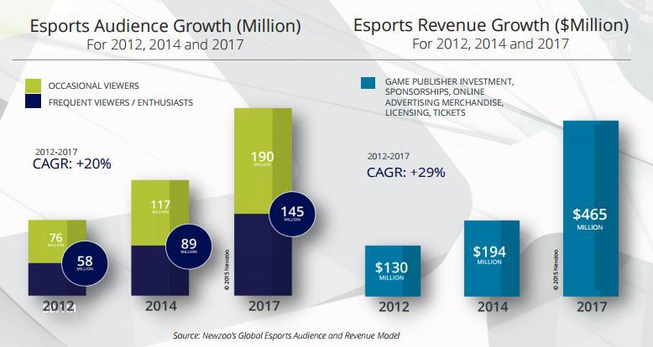

Size
The following represents the population of US residents between the ages of 14 to 29 years of age. Populations are based on the latest figures available from the US Census Bureau and New York based Super Data Research Inc.

- Males 14 to 29 years of age = 32,953,433
- Females 14 to 29 years of age = 31,774,758
- Korea and China continue to dominate $612M global eSports market. The ongoing investment in N. America and Europe by digital-only publishers drives overall growth and audience expansion.
- The global eSports audience is 134 million strong and growing. Investment in innovative business models, platforms and derivative businesses further spurs growth in competitive gaming.
- Competitive gaming is a marketing strategy, not a revenue driver. In addition to traditional marketing efforts, organizing events and streaming content improves awareness and retention.
- Thirteen percent (13%) of live-stream viewers watch eSports. Almost half of eSports viewers in the U.S. use Twitch.tv, the world’s largest live streaming site for game content. Roughly half of eSports viewers participate in some type of competitive gaming, mostly online through platforms.
- Corporate sponsorships total $111 million in North America (2015E). Brand owners and advertisers are expected to adapt to emergent forms of entertainment, which will grow sponsorship deals across the segment.

