Module 1: Event Registration
In this module, you will be introduced to the basics of OpenWater by building an event registration program. The lesson will guide you through the process of creating a simple program for collecting responses and payments from users.

Topics Covered:
- Creating a new Program
- Application Name Field
- Dependent Fields
- Price Rules
- Confirmation Emails
- Public Website

Part A: Try a Sample Form
Before you begin creating your own program, fill out this sample registration to get a sense of what you will be building.

Part B: Organization Information & User Profile Fields
We’ll now get started with creating your own event registration program. Make sure that you have your sandbox instance of OpenWater open on your computer.

(*Note: Even if you do not plan on using OpenWater for event registrations, the lessons in this module can be applied to creating any basic program for collecting information and payments!)

- Before you add your first program, you’ll first need configure your Organization Information and User Profile. Open the System Settings dropdown menu, then click Organization Information. 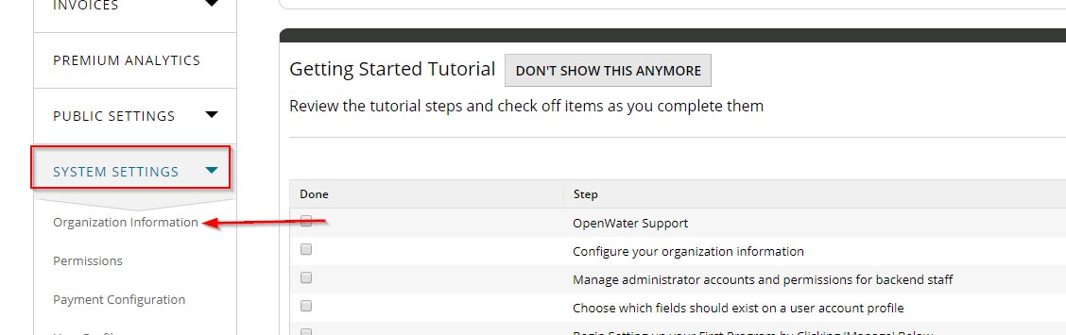
- On the next page, fill out the fields with your own information, then click Save. 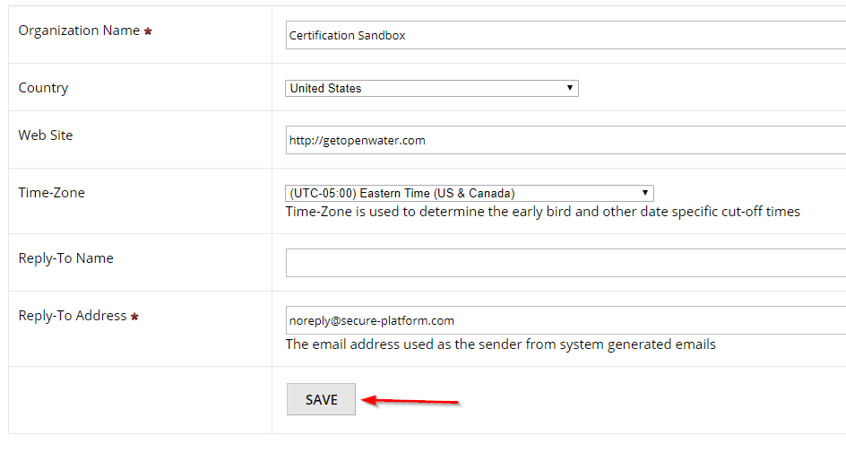

- Next, open the System Settings dropdown menu and click User Profile. The User Profile are the fields that a new user must fill out in order to access your programs. Click Manage to edit the fields. For now, we’ll only require First Name, Last Name, and Email Address. 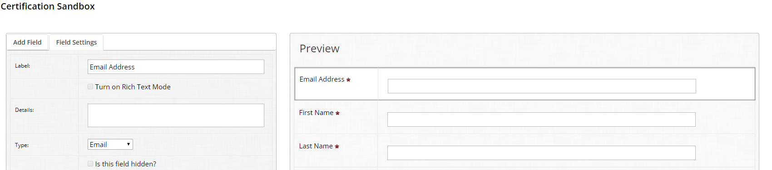

Part C: Set Up Your First Program
Now that you have configured your Organization Information and User Profile, you are ready to start work on your first program!

- We’ll begin by building a sample registration form. In your sandbox instance, click Programs on the left menu and then Add Program. 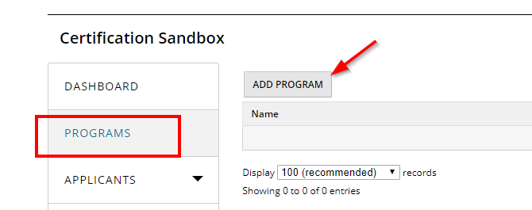

- OpenWater includes an Event Registration starter template, however today we will build our own template, piece by piece. Begin by clicking Start from Scratch. 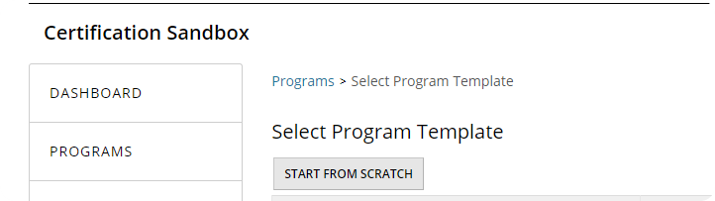
- Let’s give our event a name. We’ll call this program “Lunch and Learn”. Once you’ve typed that into the Program Name field, click Save. 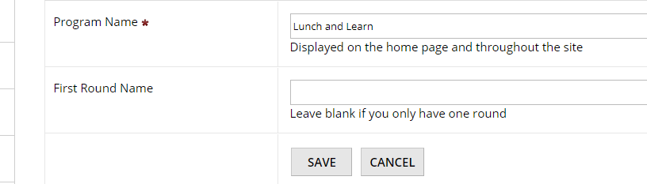
- After clicking Save, you will be redirected to the Program Configuration page. We will cover these settings in detail in a later part of the training. For now, click on the Dashboard to reorient yourself.
- Let’s continue by clicking Manage on our newly created Event Registration program. 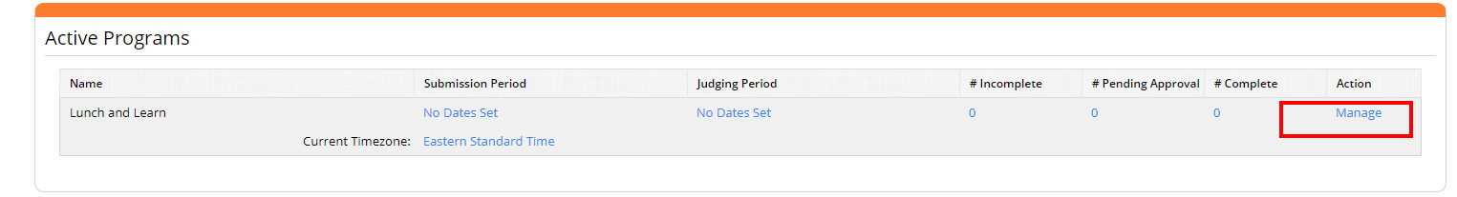
- To launch our program, we will need to configure the following settings:
- Submission Form
- Confirmation Page
- Confirmation Emails
- Open/Close Dates

- Submission Form: Application Title Field
  - The first field that we will set up is the Application Title Field.
  - Click on Round settings > Submission Form and click Select next to the page titled ‘Applicant Information’. On the following page, click Manage. 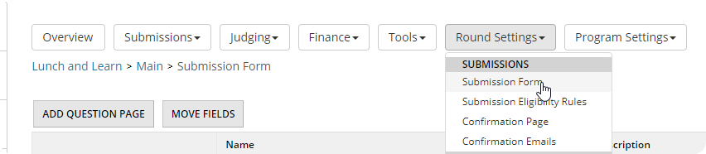
  - The Application Title Field is what a submission will be displayed as throughout OpenWater. The name should be chosen carefully as it cannot be changed later. The Application Title will typically be the name of the person, team, or project that is being submitted. (*Note: The Application Title Field cannot be deleted) 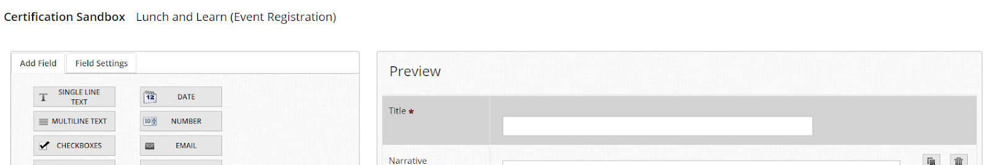
  - Set the label of the Application Title Field to ‘Attendee Name’. Set the First Title to ‘First’ and the Second Title to ‘Last’. You have the option to set this field to auto-fill with the name of the person who is filling out the form. 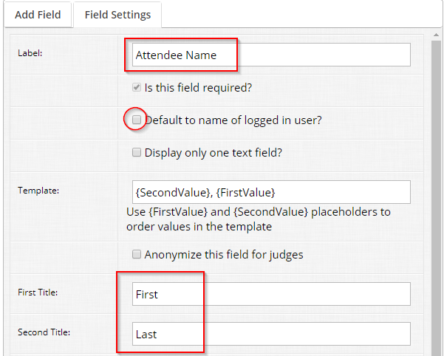

- Submission Form: Dependent Radio List Fields
  - Next, add a Radio List Field to your submission form. Set the label to ‘Registration Type’ and add two values: ‘Professional’ and ‘Student’. Finally, set the field to required.
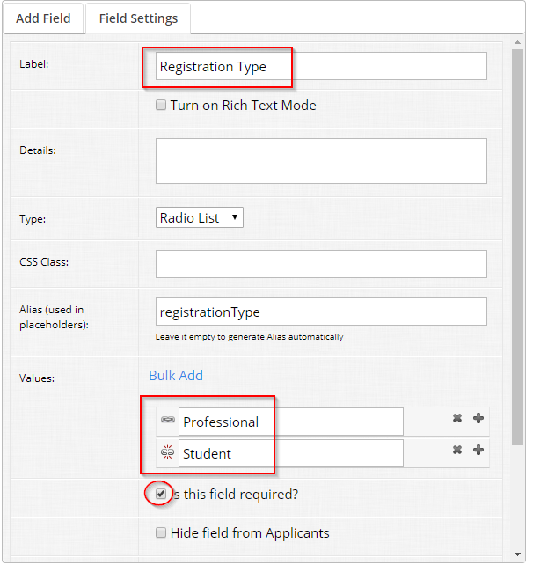
OpenWater Super User Tip
If you have a very long list of values to add as options for a radio list field (or a dropdown list field), you can use the Bulk Add button to save time. Just copy and paste a list of your options into the textbox to add them all at once!
  - The Chain-Link icon can be used to create Dependent Fields. Clicking on a the Chain-Link icon next to ‘Student’ will take you to another page of the form builder, where you can add dependent fields that will only appear if a user selects ‘Student’. Add a dependent File Upload that requires users to upload a copy of their Student ID. (*Note: When you are done adding the file upload field, make sure that you click Back, and not Close.) 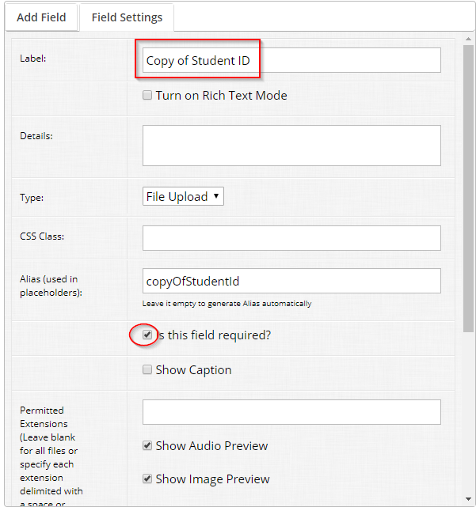

- Submission Form: Additional Fields
  - You will want to collect some additional information from people who are registering for your event. Add a Single Line Text Field to collect ‘Company/Affiliation’ and another Radio List Field for ‘Dietary Restrictions’.
    - In the ‘Dietary Restrictions’ field, set a dependent single line text field for the ‘Other’ option so that users can specify their restriction.
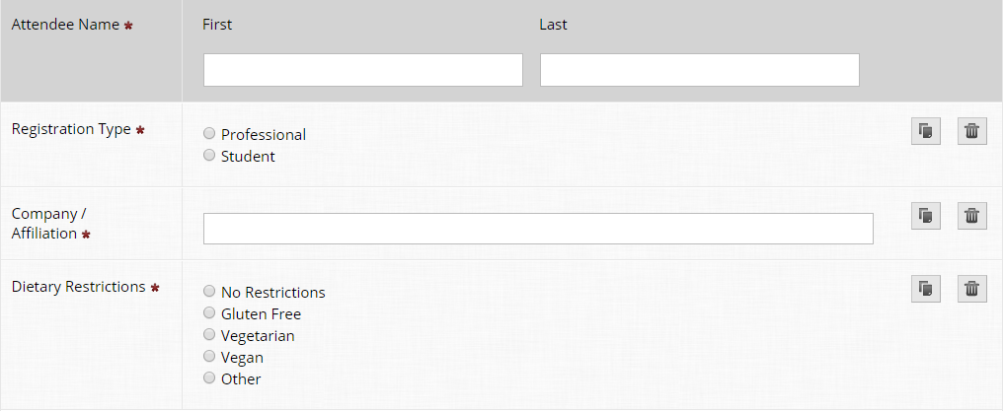
Congratulations, you’ve finished setting up a basic submission form! Make sure that you click Save before closing the form builder.

- Confirmation Page and Confirmation Email
  - Next, we will proceed to setting up the Confirmation Page. Go to Round Settings > Confirmation Page.
  - Use the Insert Variable button to add the ‘Attendee Name’ variable to the Confirmation Page. Match your text to the screenshot below.
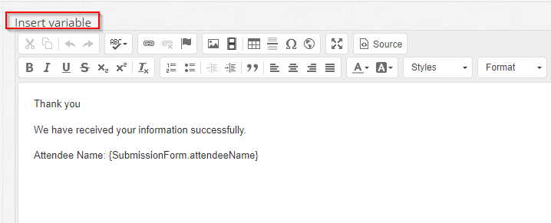

  - We’ll do the same for the Confirmation Email. Go to Round Settings > Confirmation Emails.
OpenWater Super User Tip
When setting up your Confirmation Email, you have access to a special variable called {PublicDownloadApplicationPdfAsApplicantUrl}.

This variable will automatically insert a link that will allow the user to download a pdf copy of their submission form!
  - Click Add Email and name the email ’Confirmation’.
  - Set the Subject of the email to ‘Lunch and Learn Registration Confirmation’. The Message can be same text that you used for the Confirmation Page.

- Open/Close Dates
  - Finally, we will configure the Open/Close Dates for the program. Go to Round Settings > Open/Close Dates.
  - Set dates for both submitting submission and the judging period, then click Save.

Part D: Price Rules, Coupons
Phew! We’ve finished setting up the basic building blocks for our event registration program. This next section will cover some more advanced settings and how to make your submission form available online.

- Let’s go back to the Admin Panel and configure Price Rules
  - Go to Round Settings > Pricing > Submission Fees.
  - Click Add Price Rule. Name your new rule ‘Professional Fee’ and charge $20.00, then click Save.
  - Add a condition under the heading ‘Meets [all] of the following conditions’.
    - Set the condition based on the following screenshot.
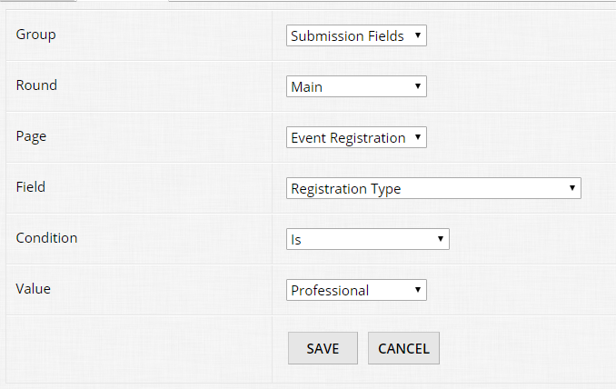
  - Return to the list of submission fees by clicking the breadcrumb for Fees
  - You can now clone the Fee you created for Professionals, and make the appropriate changes for students. Let’s charge student’s $5. Remember to change the conditions, as well!

- Now let’s add a coupon. Go to Round Settings > Pricing > Coupons
  - You will see a default, unremovable coupon
    - This is useful when you wish to have automatic discounts applied (e.g. group registration). We will save this as an advanced exercise
  - Click Add Coupon. Name your coupon ‘Free Registration for Volunteers’, set the code as ‘volunteer’, enable the coupon, and set the Number of Uses Allowed in Total to ‘5’.
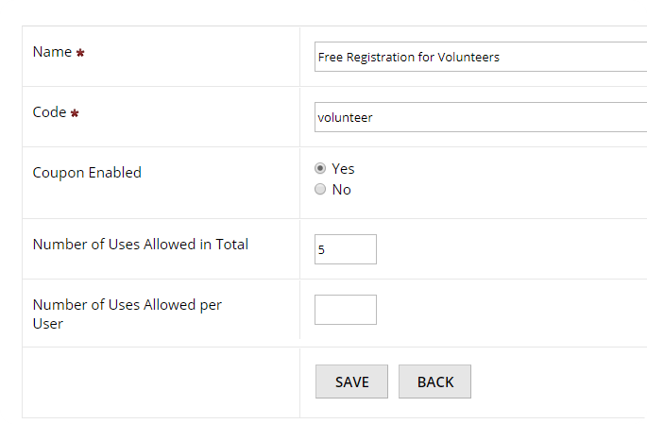

  - On the Price Rules tab, add a rule under the heading ‘Set Rules for Overall Cart’.
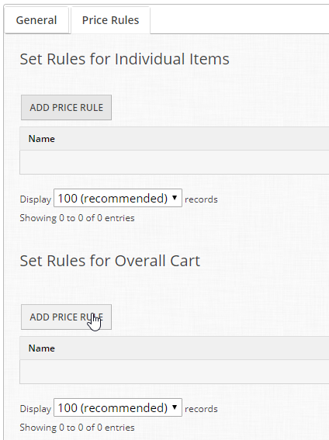
  - Name your rule ‘Waive Registration Fee’ and set it to discount by 100%. Click Save and Set Conditions (*Note: Because this coupon is triggered by a code, you do not need to set any additional conditions. What are some uses you can think of for conditional discounts?) 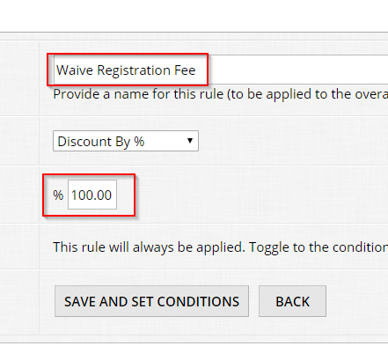

Part E: The Public Website
Now that the submission form is set up to collect information, and the price rules are configured to charge the correct amounts, we can make the form available online!

- Before you start editing the website, head back to the manage page for your event registration program. You’ll now see a box titled Market Programs.
  - Highlight the url next to Direct to Program and copy it to your clipboard. 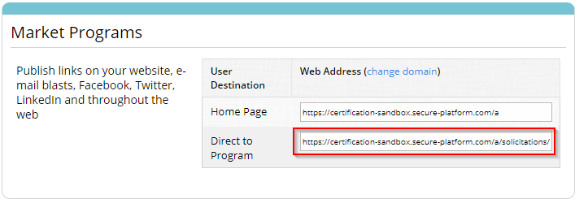
- Go to Public Settings > Website. This is the main component of the OpenWater content management system. You will use these screens to edit all the content available on your landing pages and microsites.
OpenWater Super User Tip
You may have noticed some phrases in OpenWater that don’t quite match what you use in your day-to-day workflow, such as ‘application’ or ‘submission’. You can edit these terms to fit your specific needs! Try searching System Phrases in the help center and see what you can find.
- We’re going to add a link on your home page that will go directly to the event registration form that you just built. Click Edit next to the Home page.
  - Type ‘Lunch and Learn Registration’ into the Content box, and set it as a hyperlink to the direct to program url that you just copied. 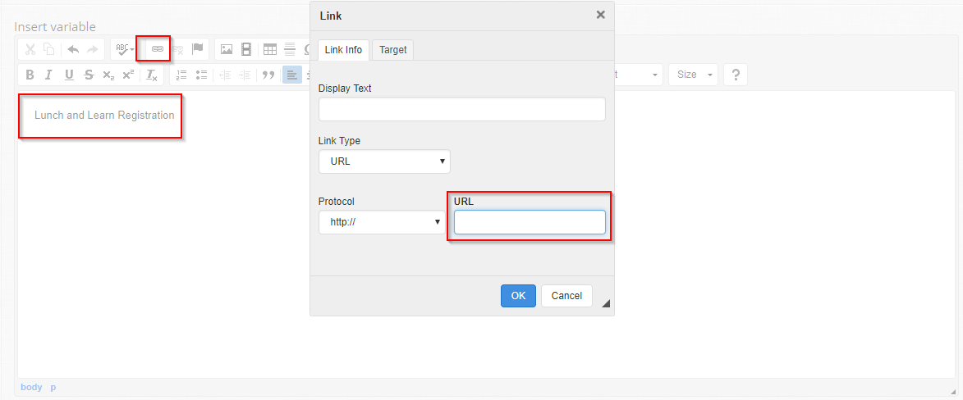

Sample Exam Questions: Module 1
You should answer these questions as if a coworker who is using OpenWater has asked you for help. You can find the answers to these questions at the end of the manual. Remember to use the OpenWater Help Center if you get stuck!

- How do you set a field as required?
- How do you gain access to the Direct to Program URL?
- How do you add a dependent field to an option on a radio list field?

Module 2: Scholarship Application
Now that we have covered the basics of creating a simple program with OpenWater, we are going to dive even deeper into some of the advanced features of the submission engine.

Topics Covered:
- Categories
- Category Groups
- Letter of Reference
- Table Field
- Advanced Applicant Settings
- Pending Approval

Part A: Try a Sample Form
Before we get started, fill out a Sample Application to get a sense of what you will building:
https://certification-sandbox.secure-platform.com/a/solicitations/home/2

Part B: Setting Up Categories and Category Groups
To get started, you’re going to create new program from scratch. Try doing this without looking back at the steps that you followed in Module 1.’

- Call your new program Scholarship Application.
- After saving the program, scroll down to the Categories heading and click Configure. 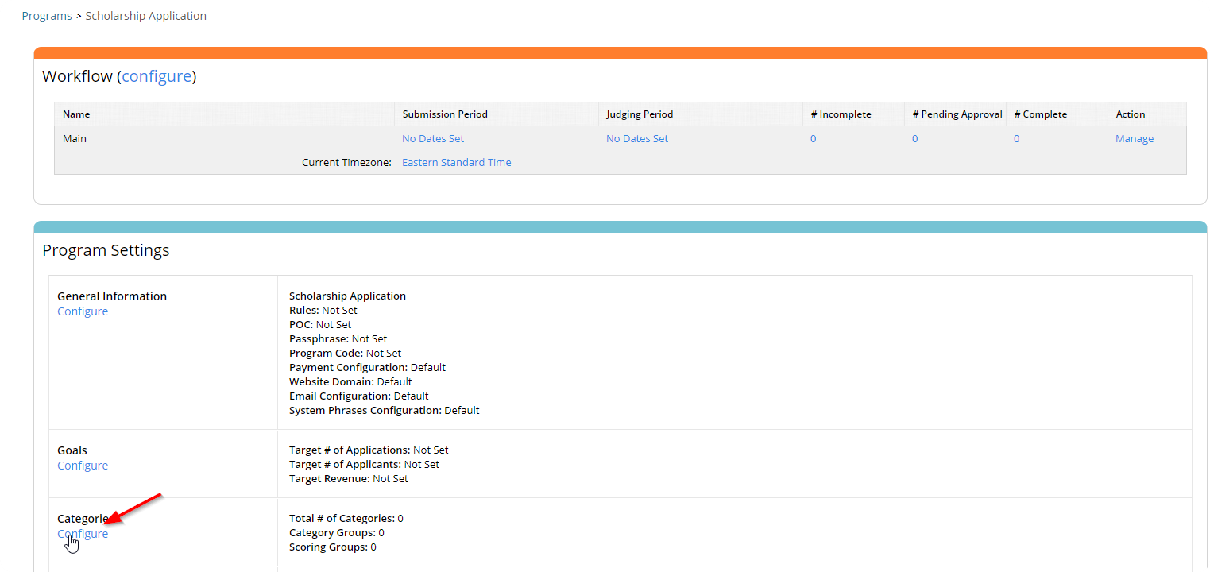

- You will be taken to a page with 3 tabs: Categories, Category Groups, and Scoring Groups (for now we’re going to ignore this last tab).
  - Categories are OpenWater’s mechanism for subdividing submission information.
  - Category Groups are OpenWater’s mechanism for allowing variance in the submission form.
- For the Scholarship Application program, we are going to use two category groups: Undergraduate and Graduate. Click on the Category Groups tab and add both groups. 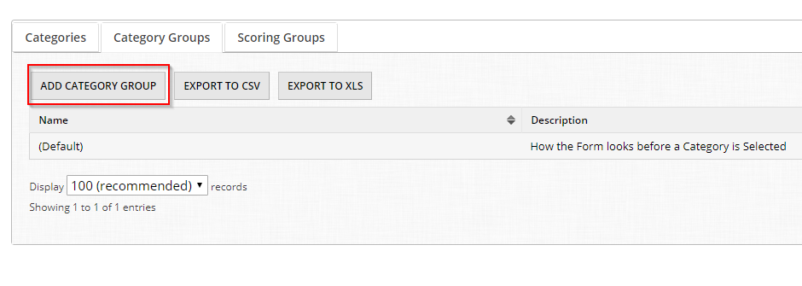
- Now go back to the Categories tab. This program is going to have two categories, also called ‘Graduate’ and ‘Undergraduate’.
  - We will also give the Undergraduate category two subcategories, called ‘Voyager Scholarship’ and ‘Rising Senior’.
- As you add your Categories, you’ll notice that you need to give more information than the Category Groups.
  - Code should be a short descriptor, usually only a few letters or numbers to identify the category.
  - Name is the actual name of the category, which will be seen by anyone entering your program.
  - Category Label is an optional internal override of the Category Name.
  - Description is text that will appear to any person who has selected the category.
  - Category Group will be the group that this category is sorted in to. Make sure that you select the correct group!
  - The final two checkboxes are optional settings that can be used to individually set limits on entries into this specific category.

Part C: Setting up Your Submission Form
Once our categories and category groups have been configured, we can continue to build out our program’s submission form. This will build on the skills that you developed in Module 1.

- Using what you learned in Module 1, set up the first page of the submission form. You’ll notice that a dropdown menu called Category has automatically appeared. Rename this field to Scholarship. Your first page should look like this: 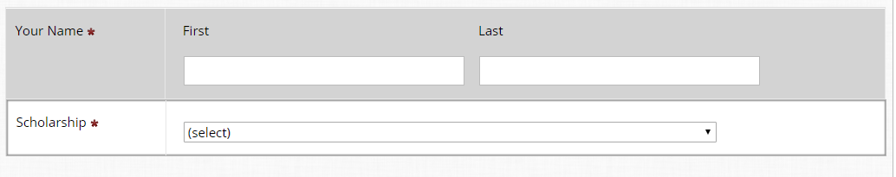
- This submission form is going to have multiple pages. Click Add Question Page and title the new page Letter of Reference.
  - Add a Letter of Rec field to the page. We’re going to keep the default settings for this field, but take a minute to scroll through the field settings and see what you can customize in this field. When you’re done, save the page and close the form builder.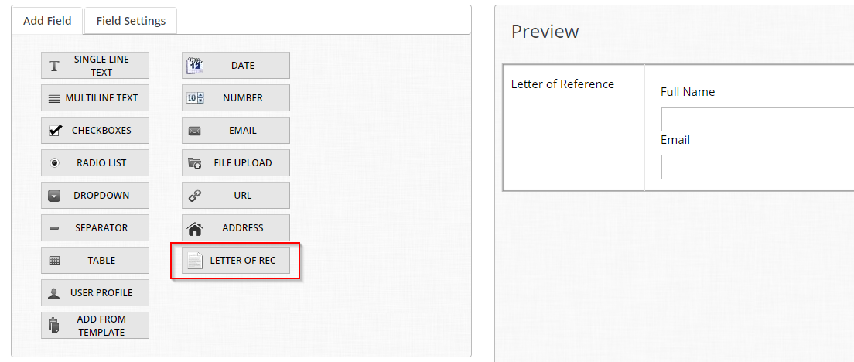

- Add a third page to your form and call it Publications.
  - This page will be for the Graduate category only, to provide a list of publications that they have produced. We will use Category Group Settings to make sure that only applicants to the Graduate Scholarship see the page.
  - Add a Table Field to the page. In the field settings, click Configure Category Group Settings. Set the Action as Hidden for the (Default) and Undergraduate category groups, then click Save and Return to Form. 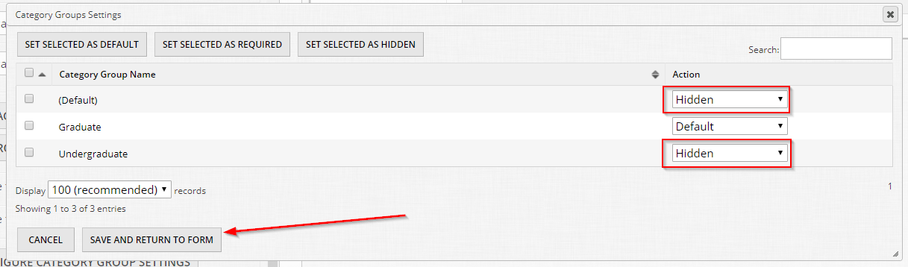
  - Now let’s set up the remaining settings for the Table Field
    - Set the Label to ‘Publications’
    - Set Details to ‘Provide a list of publications where your research has appeared.’
    - Change Maximum Allowed to 5
    - Set Item Name to ’Publication’
    - Set Item Name Plural to ‘Publications’
    - Click Manage Fields. Add a Single Line Text Field labelled ‘Publication Name’ and a Date Field labelled ‘First Appeared On’. Click Save and then Back.
    - Click Edit Row Template. Click Insert Variable and add both variables to the template. Before the variables, add some descriptive text. 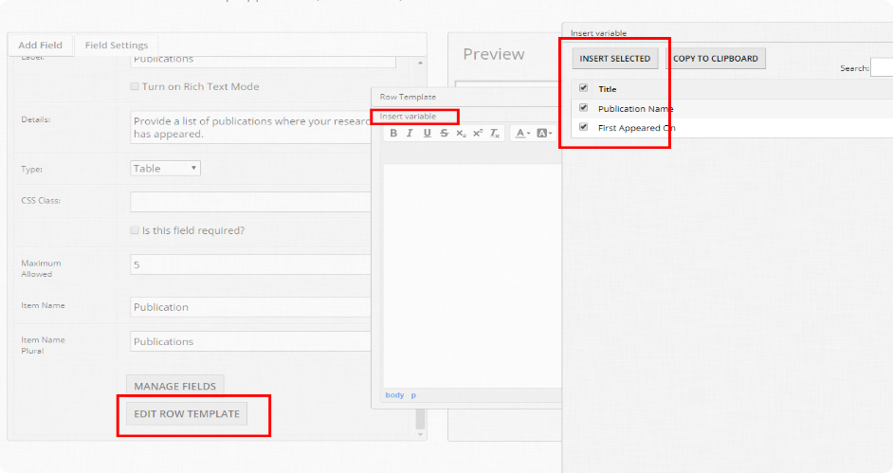
    - Your final settings should match this screenshot: 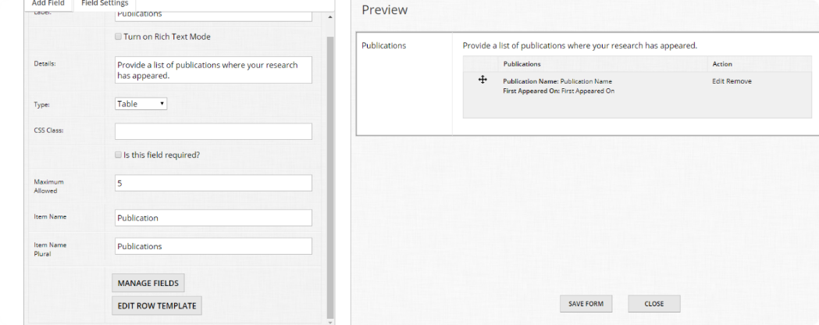

Well done! You have now finished setting up the submission form for your Scholarship Application. Using the same skills that you learned in Module 1, add a link to this form to your public website homepage. Take some time to submit a few test entries and make sure that the Publications Page is only appearing when you select the Graduate category. Hint: Don’t forget to set your Open/Close dates!

Part D: Advanced Applicant Settings
Now that the submission form is built and tested, we’re going to look at some more advanced settings that you can use to customize the applicant experience for your program.

- Pending Approval
  - Pending Approval is a workflow step that keeps newly accepted submissions in a special area until they have been reviewed by an administrator.
  - On the main dashboard, if Pending Approval is used, applications will appear here: 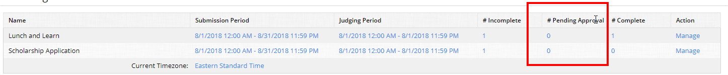
  - Pending Approval can be turned on via Round Settings > Advanced >
Require all Submissions to be approved by an admin staff member before sending to judges

- Other applicant settings can be accessed by going to Program Settings > Applicant Settings.
  - You can limit the number of applications a person can make, for example to limit to 1 application per submitter. 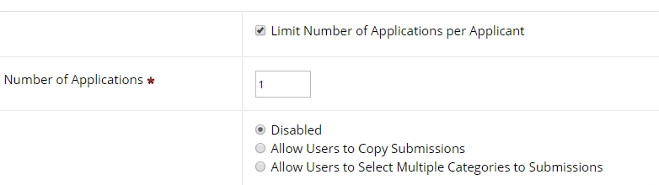
  - Custom Save and Finalize Popup message refers to the message that an applicant sees immediately before submitting their form. Here is an example of the default text: 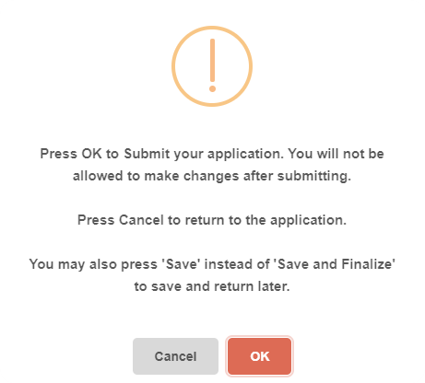
  - By default, users can tab through each page of an application. Required Field Validation will occur when they try to submit, you can override this setting and validate when they press Next. 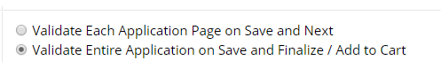
  - If a group of people is working on a single submission, you can enable collaborator support. This will allow a single person to finalize an application, but multiple people to work on it.

  - Using the same Insert Variable concept, you can override the default PDFs that are generated for applicants with custom formatting. In addition, you can merge images and other PDFs attached to an application onto that PDF. 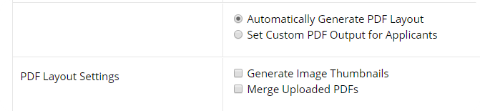
  - If you made a mistake with the Application Name field, you can update it with other fields from the forms. This will not impact all views, but should help you out on various submissions and judging screens. 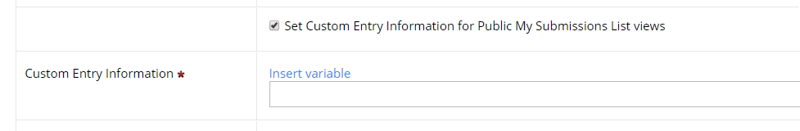
  - If your program is in high demand and you wish to have a hard limit on the total number of entries, you can use the last setting on this page. 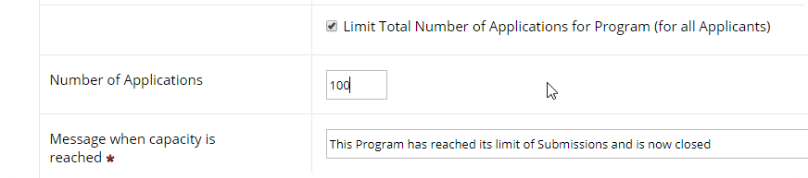

Congratulations! You have now completed Module 2 of the OpenWater Certification Program.

Sample Exam Questions: Module 2
You should answer these questions as if a coworker who is using OpenWater has asked you for help. You can find the answers to these questions at the end of the manual. Remember to use the OpenWater Help Center if you get stuck!

- How do you set a field as hidden for a specific category group?
- How do you allow multiple users to work on the same submission form?
- How do you turn on Pending Approval?

Module 3: Review
We have spent the last two modules learning how to create dynamic and useful submission forms. We will now shift our focus to the reviewing side of the platform. We will also cover how to create galleries that can showcase entries to the public.

Topics Covered:
- Eligibility Rules
- Auto-Scoring
- Gallery
- Evaluation Mode
- Ranking

Part A: Program Duplication and Form Set Up
For this module, we will create a third program, but rather than taking the time to start from scratch, we will duplicate the Scholarship Application program. Duplicating a program is a great way to save time if you want to create a similar program without having to recreate all your work.

- To duplicate a program, click Programs in the left-hand menu, then Settings next to the program that you wish to duplicate. 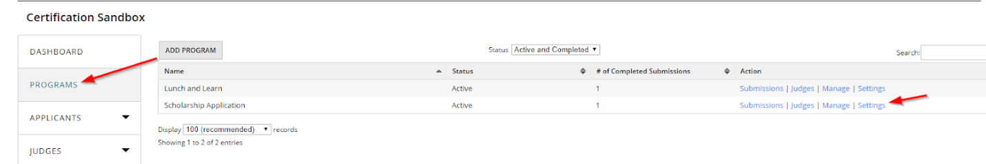
- Scroll to the bottom of the next page and click Duplicate This Program. 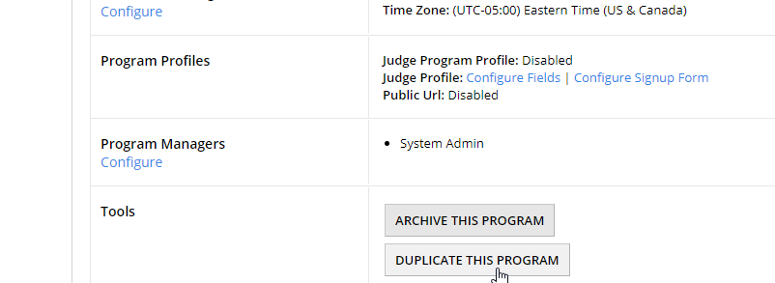

- We will call our new program Scholarship Application Module 3. Choose to duplicate all settings except Judges, Program Notes, and Submissions. 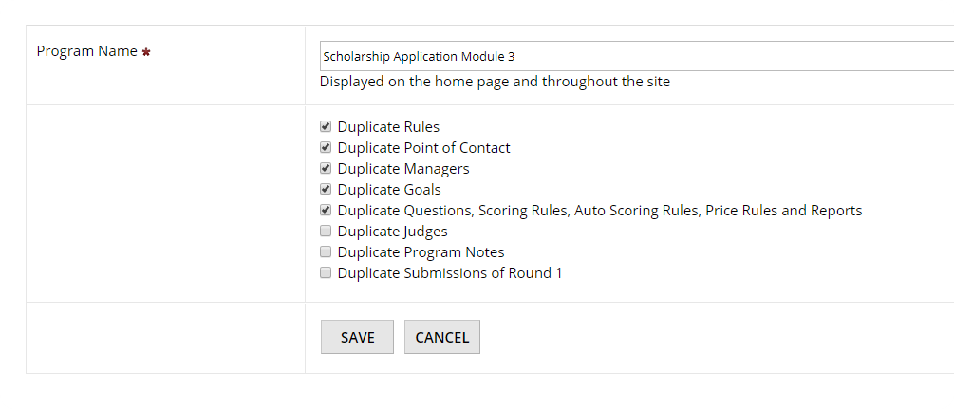
- Set the Open/Close Dates for your new program and add a link to the submission form on your public website home page.
- We’re going to make some edits to the submission form that will make this example a little bit easier.
  - Delete the Letters of Reference and Publication pages from your form.
  - Add a new page to the form called Criteria.
    - Add a date field to the page, labelled ‘Graduation Date’.
    - Add a radio list field to the page, labelled Gender. Give the field the options ‘Female’, ‘Male’, and ‘Prefer not to specify’.
      - In the field settings, click the checkbox to Hide Field from Judges. 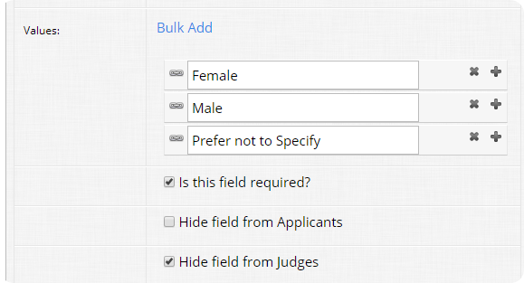
    - Add a Multi-line Text Field, labelled ‘Essay’.
      - In the field settings, click the checkbox Is this field scored? Set the instructions and values to match this screenshot: 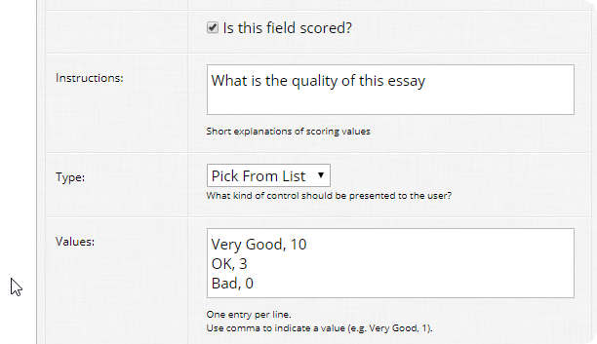

Part B: Eligibility Rules
Now that our third program is created and the submission form is edited, we can get started working on our eligibility and scoring settings.

- Eligibility Rules are used to make sure that only qualified applicants are completing your submission forms. They are very helpful for managing the number of completed entries that you received and for cutting down on administrative review time.
- To enable Eligibility Rules, click Round Settings, then Submission Eligibility Rules. 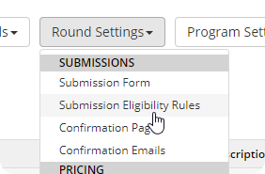
- Choose the options to Block Ineligible Submissions and to Check Eligibility on Save and Next in addition to Save and Finalize / Add to Cart. 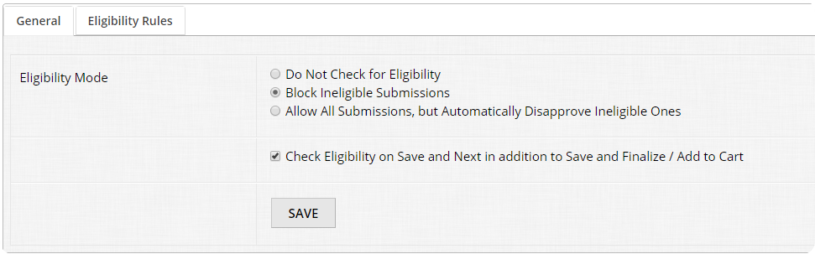
- Add an eligibility rule to block people graduating before 2019. Set your rule to match this screenshot:
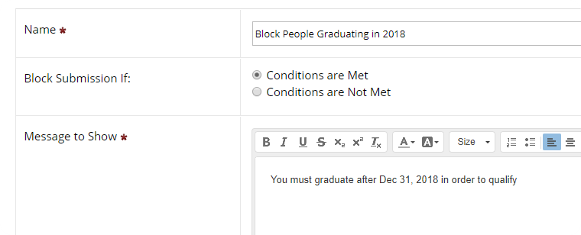
- Eligibility Rules use conditions, like those that we used to create our price rules in Module 1. Add a condition that matches this screenshot: 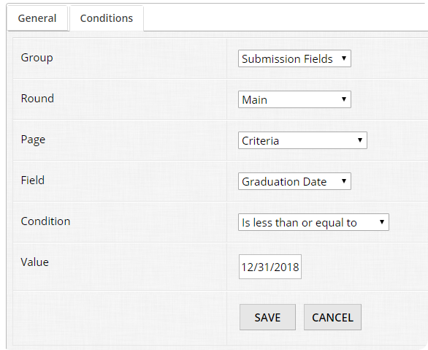
- Now go to your submission form and test your new rule. Try entering a graduation date that is before December 31st, 2018 and see what happens.

Part C: Auto-Scoring
Auto-scoring is another feature that can help save administrative and reviewing time, particularly for programs with very long scoring rubrics.

- To configure Auto-Scoring, click Round Settings, then Configure Auto-Scoring. 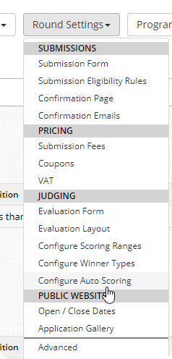

- Add a new Auto Scoring Rule to add 5 points if the gender is female. Match your settings to this screenshot:
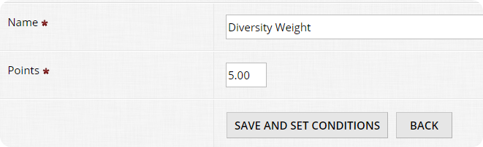
- Again, Auto-Scoring uses the familiar conditions engine that you have already used for price rules and eligibility rules. Set a condition that matches this screenshot: 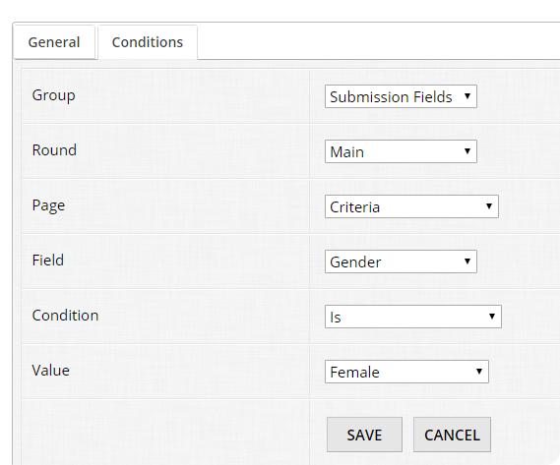

- Now that your auto-scoring rule is set up, submit two test entries to your program, one for a male and one for a female.
  - Once you have finished your test entries, return to the Dashboard and check your Pending Approval Entries by clicking the number ‘2’ in the correct column. On the next page, you will see a column for Auto-Score. Your female entry should have 5.00 points, while the male entry should have 0.00 points.

The next parts of Module 3 will explore Gallery, Evaluation Mode, and Ranking Mode for review. To properly configure and test these settings, you will need some more test entries submitted to your program. Take a few minutes to complete 10 more test entries. Hint: Don’t forget to move your test entries from Pending Approval to Complete. If you’re not sure how to do this, try searching ‘Pending Approval’ in the OpenWater Help Center.

Part D: Public Gallery
Public Galleries are a great way for you to display and highlight the entries that you have received or the winners that you have selected. OpenWater galleries can be customized in lots of ways to make them suit many different needs.

- To enable the Public Gallery, click Round Settings, then click Application Gallery. 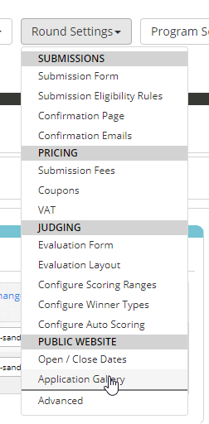

- Click the checkbox to Enable Public Gallery. This will cause other settings to appear on the screen. 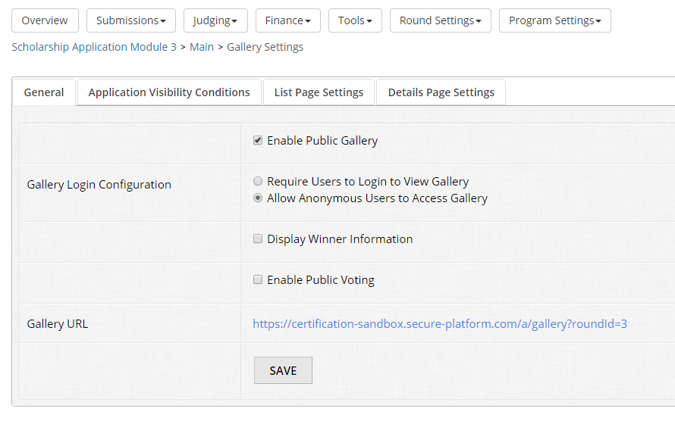
  - The Application Visibility Conditions controls what shows up in the gallery. For now, we can leave the conditions to Completed Applications. If you’d like a challenge task, try setting the condition to only show items with an Auto-score value above 1.00.
  - The List Page Settings configure how the gallery will look when viewing the overall list of items.
    - In the Header section, add the text ‘This is a Header’.
    - In the Description section, insert the variable for the Essay field from the submission form.
    - In the Sidebar Content section, insert the test ‘This is a Sidebar’.
    - You can leave all the other List Page Settings as they are. Click save at the bottom of the page.
  - To test what you’ve just configured, return to the General tab of the Gallery Settings and click the Gallery URL. Your application gallery should look something like this: 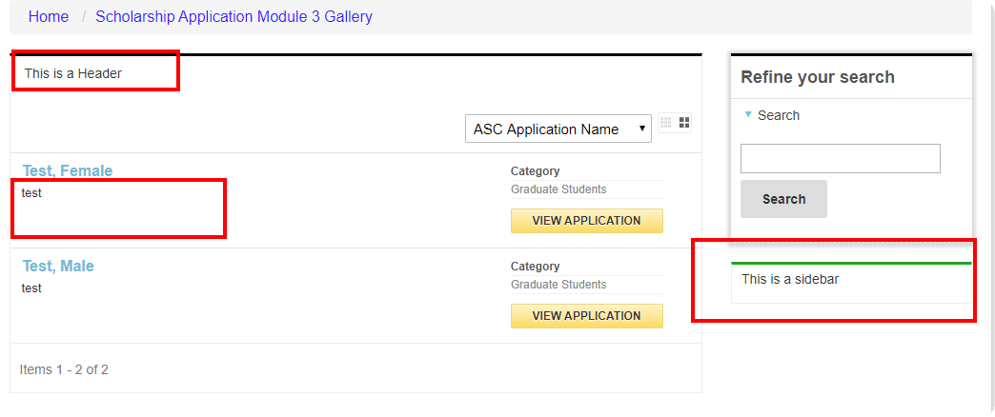

- Let’s go back to the Gallery Settings and configure the Details Page Settings. This is what someone will see when they click on a specific item in your gallery.
  - Set the Description section to say ‘Test Description’.
  - Set the Other Information section to say ‘Essay’ and then insert the variable to generate the essay from the submission form. 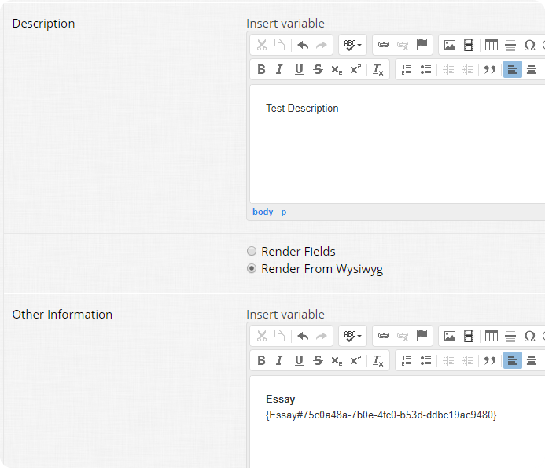
  - Save your work and go back to the Gallery URL. Click on one of your test entries and see what you have done.
  - Finally, go back to the Details Page Settings and select Render Fields, rather than Render from Wysiwyg (*Fun Fact*: Wysiwyg stands for What You See Is What You Get).
    - Check off the following fields: 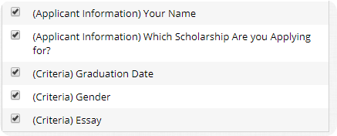
    - Go back to your Gallery URL and see how this has changed the details page.

Excellent job! You have now set up a fully functioning gallery. This example was simple, but hopefully you can see how you can use this feature to build complicated galleries that display specific auto-generated information.

Part E: The Evaluation Form
It’s now time for us to dive in to one of the largest and most important parts of the OpenWater system: The Judging Module. This will be how you can assign and review all the data that you have collected with your submission form.

- To start, click on Round Settings, then click Evaluation Form.
- Click Select next to the default question and review the different options.
  - The primary option for evaluation questions is the Type. A question can be set as Number Scores, Free Text Scores, File Upload, Pick Lists, and Separators.
  - You will also notice that you have the option to hide/show based on Category Group. This is like how we changed the Category Group Settings in Module 2.
- Add a test evaluation question for each type available. When you’re done, you should have six questions in total. 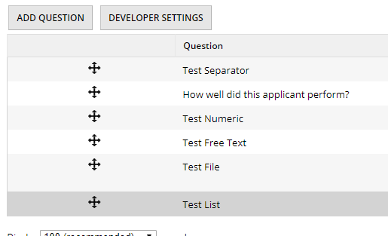
- We’ll now test out the evaluation form that you just built. Go to Judging and click View/Add Judge. 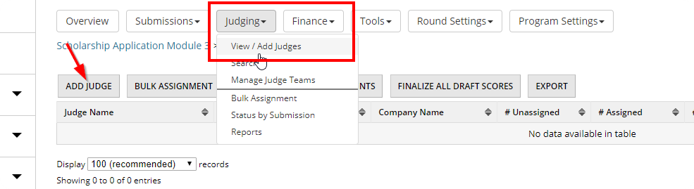
  - Click Add Judge and add yourself as a judge.
  - Click the number in the # Unassigned column and assign yourself all the available test entries. (Hint: if you don’t see any unassigned entries, you may have forgotten to move them from Pending Approval.)

- Now that you have assigned yourself as a judge to the test entries, click Public Website at the very top of your screen. You should now see a button in the left-hand menu that says My Judging Assignments. Click the button and then open one of your test entries.
  - On the left side of your screen you will see the information from the applicant’s submission form. On the right, you will see the evaluation form that we just built. Note that under the Essay field there is an inline option for score. This is because we selected Is this field scored? scored when adding that field to the submission form. 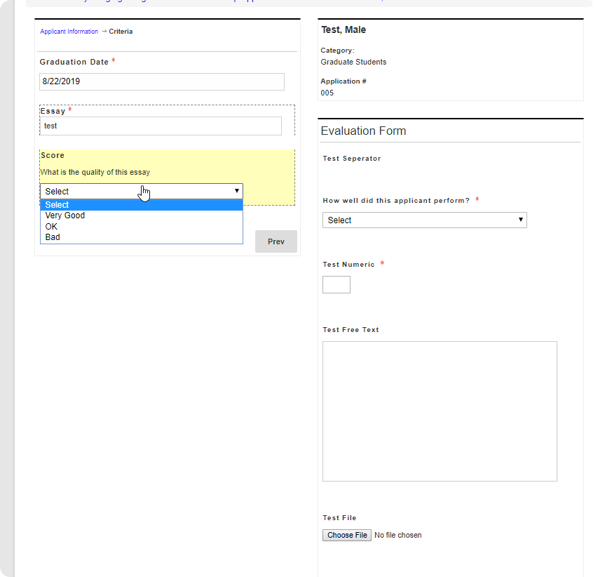

- We’ll now look at some advanced judging options. First, click on Round Settings, then click Evaluation Layout.
  - The Evaluation Layout can be configured in an almost identical fashion to how we set up our public gallery earlier in this module. Try playing around with some of the settings.
- Some programs will require judges to be able to see the scores and comments that other judges have left on their assigned entries. You can enable this by going to Round Settings, Advanced, then clicking on the Advanced tab. 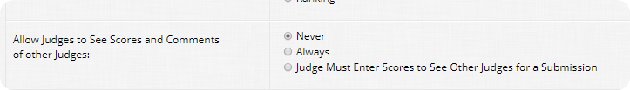
- Other Judge Settings can be found in Program Settings > Judge Settings.
  - Update your Judge Settings as follows: 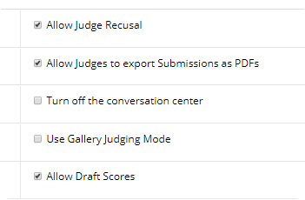
  - Now go back to the public website and view your Judging Assignments.
    - The First thing you will notice is if Gallery Judge Mode is turned off, the Judge sees a list of applications. 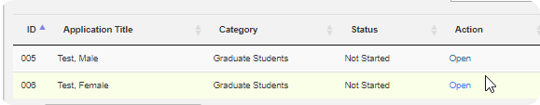
    - The Recusal Feature allows a judge to indicate a conflict of interest. Recuse yourself from one assignment.

    - The Conversation Center allows judges to share comments with one another as they review entries. 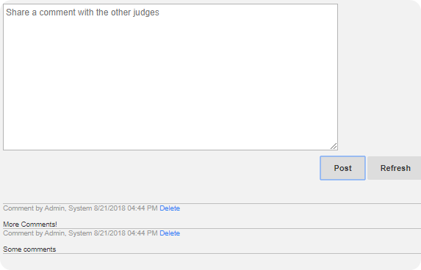
    - Draft Scores allow judges to save their progress, which is very helpful for long evaluation forms.
  - Now that you have recused yourself from an entry, back in the admin panel you will see an option for Recusals. 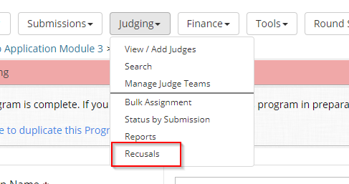
    - You can choose to Restore a Recusal or Quickly assign to another Judge. Click Select on the recusal to see the options.
  - This training will not cover Bulk Assign. Bulk Assign uses the same types of conditions you saw in Price Rules to help quickly distribute submissions to judges. If you would like to learn more, try searching Bulk Assignment in the OpenWater Help Center.

- Go back to Program Settings > Judge Settings, and turn Gallery Judging Mode back on. 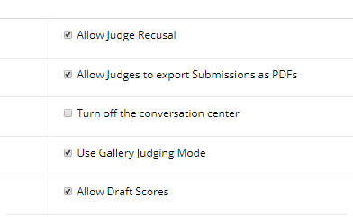
- Now, go back to the public side and complete all your judging assignments.

Part F: Scoring, Rounds, and Ranking
Nice work completing all those judging assignments! You should now have a good sense of how to set up the evaluation form and what a judge must do to review their assignments. We’ll now look at assigning winners and scoring.

- In the admin portal go to Round Settings > Configure Winner Types, and add Gold and Silver as two new types. Winner Types are an internal method for tracking designations of winners within the OpenWater system.
  - Next go to Tools > Scores/Results. Click on Judging Results next to View All Categories. Here you see a list of entries in order of score.
  - For test purposes, check off all the entries. Click Set Both, choose Gold and Forward to Next Round, then click Set.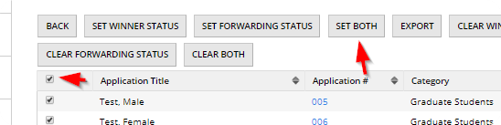
  - Winner Types can also be used to configure a gallery of only winners that is available to the public.

- So far, we have only used the Evaluation Module for review. We can also configure evaluation to use ranking. Let’s explore the Ranking Module.
  - First, click Program Settings, then Workflow.
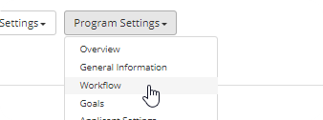
  - Click Add Round and name your new round Ranking. Set this round to Judging Only. 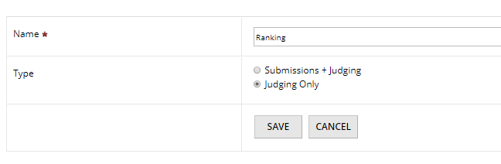
  - Before setting the round to Ranking, you must first go to the Evaluation Form and delete all evaluation questions.
  - Now go to Round Settings > Advanced and click on the Advanced tab. Change the Judge Evaluation Mode to Ranking.
- Now that Ranking Mode is enabled, you can go to Round Settings and see an option for Rank Settings. Click that page.
  - Change Default Number of Submissions to Rank to ‘5’ and click Save. 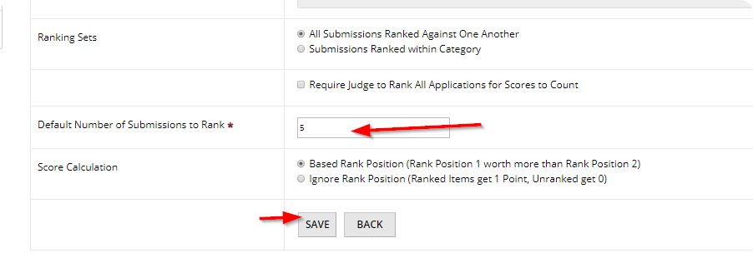
  - Each individual round has its own Open/Close Dates. Configure your new Ranking Round so that it is open for judging.
  - Judging assignments are also round specific. Add yourself as a judge for the new round and assign yourself your test entries.
- Go back to the public website and click My Judging Assignments. You will now see an option for the Ranking Round. 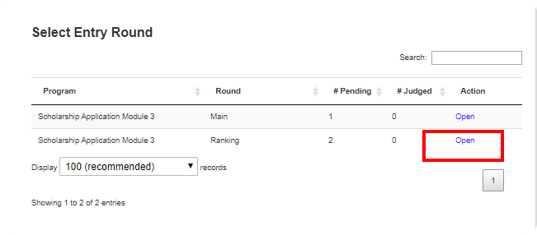
  - Take some time to explore the features of Ranking Mode. You will notice that you can customize the layout of the judging portal using similar methods as Evaluation Mode.
  - Ranking mode supports extensive options, such as Rank Per Category and Weighted Voting. If you would like to learn more about these features, try searching ‘Ranking’ in the OpenWater Help Center.

Congratulations! You have now completed Module 3 of the OpenWater Certification Program. Pat yourself on the back; you’re almost done!

Sample Exam Questions: Module 3
You should answer these questions as if a coworker who is using OpenWater has asked you for help. You can find the answers to these questions at the end of the manual. Remember to use the OpenWater Help Center if you get stuck!

- How do switch from Evaluation Mode to Ranking Mode?
- How do you turn on draft scores for judges?
- How do you add a new round to a program?

Module 4: Abstract Collection
This is an optional module for those who run an annual meeting that involves collecting abstracts and putting them into sessions. For those that do not have this workflow we encourage you to spend this time working on implementing the tasks from the previous modules.

Topics Covered:
- Session Chair Workflow
- Session Scheduler

Part A: Create a Call for Papers Program
The call for papers is our standard abstracts workflow. If the Call for Session Topics starts in January, often the Call for Papers will be in March.

- Add a New Program, using the Abstracts Collection Template. 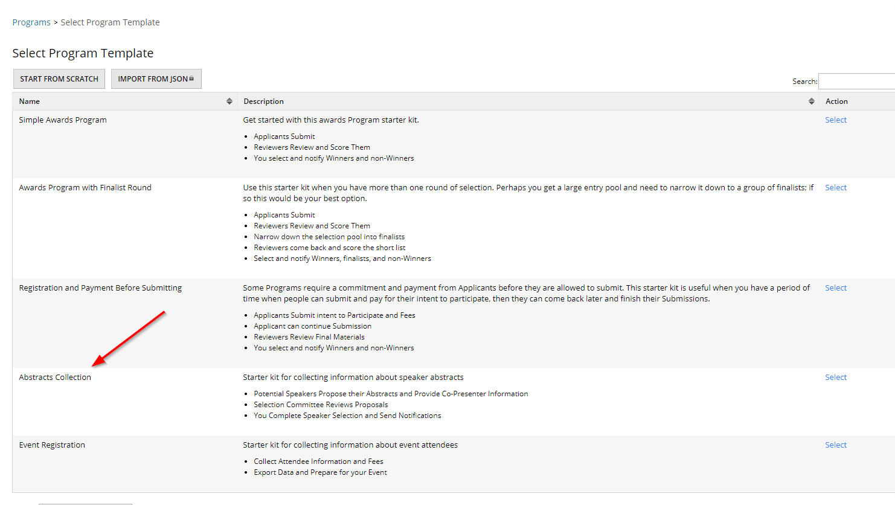

- For our example, we’ll call the program OpenWater Annual Meeting.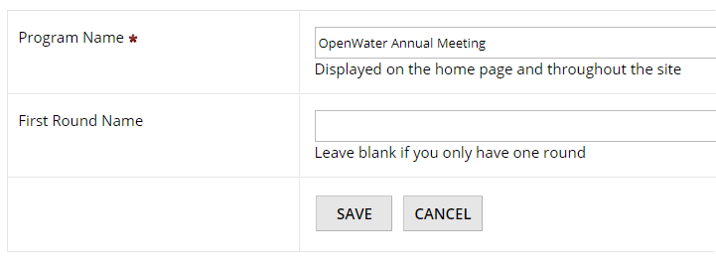

- In most topic proposal programs, abstracts are submitted by individuals or small teams. There are then Session Chairs who are responsible for building sessions out of the groups of abstracts. We will use the Categories to organize the sessions in for our call for papers.
- Add the Following Categories to Your Program: Improving Corporate Culture, Innovation in Awards Management, Innovation in Grants Management, Use of APIs and Custom Code, and I’m Not Sure.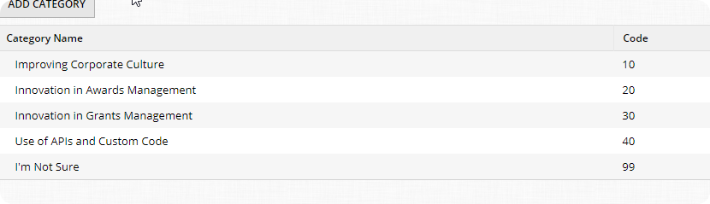
  - In this workflow, paper submitters are submitting to an actual Session. In a later step, we will assign Session Chairs to each of these.
  - Session Chairs will get a first opportunity to pull in abstracts that were submitted to their Session Topic. If they don’t like a session, they can open it up to all Session Chairs.
  - Anything submitted to “I’m Not Sure” will be available to all session chairs on a first come first serve basis.

Part B: Prepare the Form and Add Test Data
- For this example, we will be using the default submission form that comes with the Abstract Collection program template. However, since this module requires a good bit of data entry, you will want to alter the form to make life easier for yourself. Delete the Primary Presenter and Co-Presenters pages, and set all of the fields in the Proposal Page to optional.
- Add Open/Close Dates to your program so that you can access the front-end of the submission form.

Great, now you are ready for data entry!

- Use the below table to help you add data quickly.
  - *Note: This feature will help you save time for data entry: https://help.getopenwater.com/manage-your-submissions-and-applicants/manage-applicants/add-a-new-submission-on-behalf-of-an-applicant
  - It is important you take the time to add this data with separate user accounts. We’ll be using this data to look at checking conflicts later.

Submitter Name | Submitter Email | Topic | Abstract Title | Content
John Smith | john@example.com | Improving Corporate Culture | Healthy Snacks in the Office | Use http://watchout4snakes.com  /wo4snakes/Random/  RandomParagraph
John Smith | john@example.com | Innovation in Awards Management | Specialty Foods Gala
John Smith | john@example.com | Innovation in Grants Management | Bike League Best Cities case Study
Jane Doe | jane@example.com | Use of APIs and Custom Code | Bi-Directional Integration Standards
Jane Doe | jane@example.com | I’m Not Sure | Dogs to Work and Empathy
Jane Doe | jane@example.com | Improving Corporate Culture | Bring your Child to Work Day how it Helps
Mario Lopez | mario@example.com | Innovation in Awards Management | Hiring Good Talent for your Awards Show
Mario Lopez | mario@example.com | Innovation in Grants Management | Best Places to Work Fund
Mario Lopez | mario@example.com | Use of APIs and Custom Code | Netforum vs iMIS
Jamie Fox | jamie@example.com | I’m Not Sure | Website Down Time and how that Impacts Your Organization
Jamie Fox | jamie@example.com | Improving Corporate Culture | Work From Home or Work in Office which is Better
Jamie Fox | jamie@example.com | Innovation in Awards Management | Impact of Ad Budget Decline on Awards Industry
Kanye West | kanye@example.com | Innovation in Grants Management | Women in STEM a Case Study of Excellence
Kanye West | kanye@example.com | Use of APIs and Custom Code | C# Sample Code on Common Workflows
Kanye West | kanye@example.com | I’m Not Sure | The Best Awards Program of All Time
John Paul | johnp@example.com | I’m Not Sure | Grain of Salt a Study
John Paul | johnp@example.com | Improving Corporate Culture | The Carrot Principle
John Paul | johnp@example.com | Innovation in Awards Management | Live Judging with iPads Dos and Don’ts
Mariah Carey | mariah@example.com | Innovation in Grants Management | The In Person Interview for Grantees
Mariah Carey | mariah@example.com | Use of APIs and Custom Code | Building Resilience in Push Back
Mariah Carey | mariah@example.com | I’m Not Sure | Music Competitions and Ballots
Ruth Ginsburg | ruth@example.com | Improving Corporate Culture | Equality in the Workforce
Ruth Ginsburg | ruth@example.com | Innovation in Awards Management | Taking a Video Competition Online
Ruth Ginsburg | ruth@example.com | Innovation in Grants Management | Ensuring Diversity yet total Fairness

Nice work adding all that data!

Part C: Build out Sessions and Session Chairs
- Turn on Sessions by going to the Session Settings page. 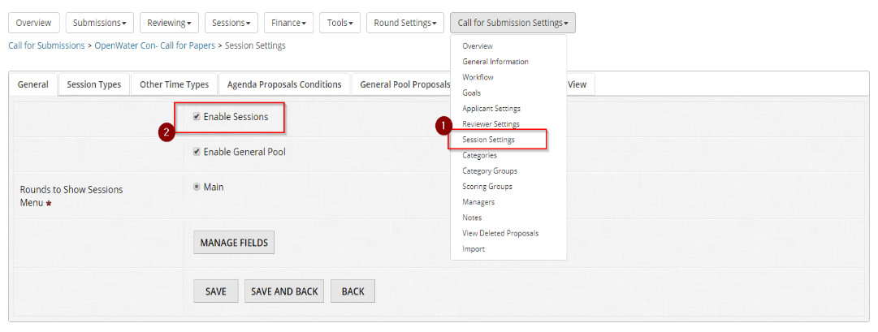
- Click the Session Types tab and then add Session Types. Two common session types are ‘Oral’ and ‘Poster’. Add both to your program.
  - Oral Sessions are typically time constrained. In this case, we are saying an Oral Session is 60 minutes, with 10 minutes per speaker.
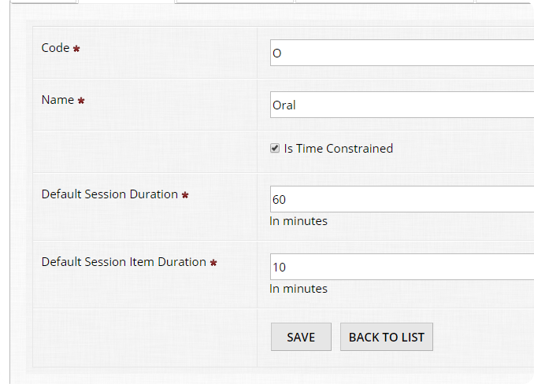
  - Poster Sessions are typically not time constrained, so you can leave that box unchecked.
- Other Time is useful if Session Chairs need to add things to the schedule that are not abstracts. Let’s add ‘Coffee Break’ and ‘Discussion’ as two possibilities. These options will come in handy when we are creating our schedule, later in the module. 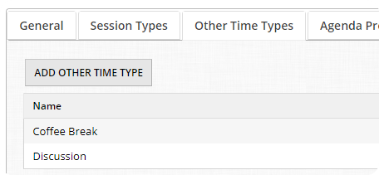
- Agenda Proposal Conditions specify what the default options are for pulling Abstracts to be made available for sessions. Typically, we just want Complete sessions. However, we can also be more advanced, such as taking sessions that received a minimum judge score of 5. For this example, let’s just stick with Complete condition. 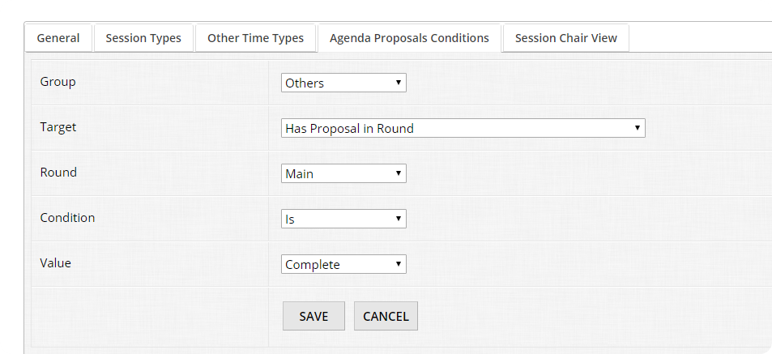
- The Session Chair View configures the public view that all Session Chairs will see.
  - Allow Public Session Creation and Editing will allow any user with the link to submit a session and agenda.
  - The Landing Page Header is a place where information that Session Chairs will see when they log in.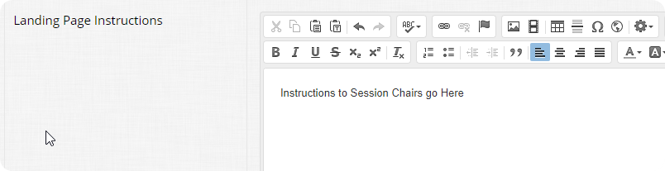
  - Agenda List Header is what will show at the top of the agenda page.
  - Proposal Display Text is what appears when the Session Chair is searching for abstracts. 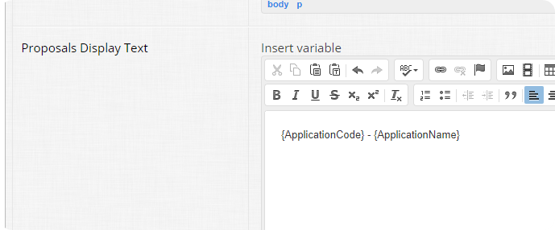
  - Proposal Search Fields allows you to configure the kind of fields on which Session Chairs can base a search. 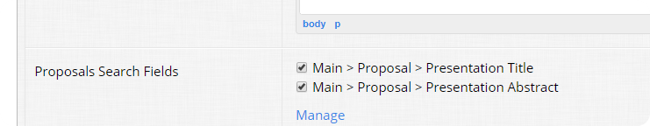
- Back on the General tab, you’ll see that you can Manage Fields. The session can have custom fields, just like an abstract. For this exercise, we won’t be covering this feature. Some examples are to collect learning objectives, and A/V needs as part of the session, from the session chair.
- Go back to the round and you’ll see a new option for Sessions. click on Manage Sessions. 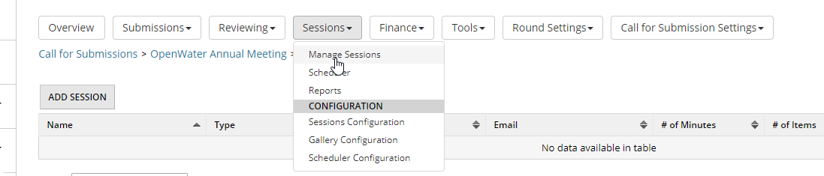

  - This screen is where you will add the sessions for your proposal program. Click Add Sessions and match the next screen to the following screenshot: 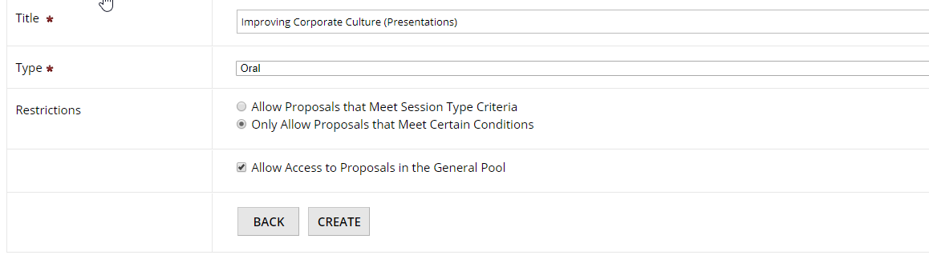
  - Click Create, then head over to the Agenda Proposals Conditions tab. Match your conditions to the ones in this screenshot: 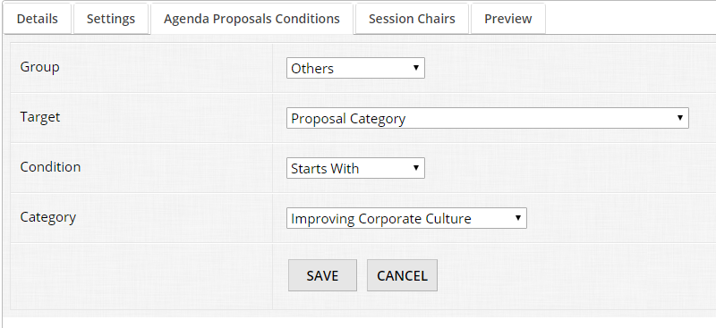
  - Finally, go to the Session Chairs tab and add your session chair. 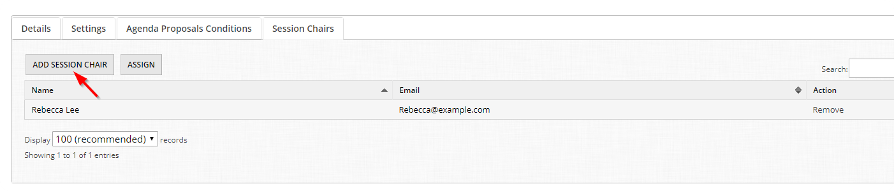

- Now that we’ve added one together, use your skills to add the following sessions to your program.

Title | Type | Restrictions | Conditions | Chairs
Improving Corporate Culture (Presentations) | Oral | Allow General Proposals and those that Meet Certain Conditions | Category Starts with Improving Corporate Culture | Rebecca@example.com
Improving Corporate Culture (Posters) | Poster | Allow General Proposals and those that Meet Certain Conditions | Category Starts with Improving Corporate Culture | Rebecca@example.com
Innovation in Awards Management (Presentations) | Oral | Allow General Proposals and those that Meet Certain Conditions | Category Starts with Innovation in Awards Management | Alexis@example.com
Innovation in Awards Management (Posters) | Poster | Allow General Proposals and those that Meet Certain Conditions | Category Starts with Innovation in Awards Management | Alexis@example.com
Innovation in Grants Management (Presentations) | Oral | Allow General Proposals and those that Meet Certain Conditions | Category Starts with Innovation in Grants Management | zack@example.com
Innovation in Grants Management (Posters) | Poster | Allow General Proposals and those that Meet Certain Conditions | Category Starts with Innovation in Grants Management | zack@example.com
Use of APIs and Custom Code (Presentations) | Oral | Allow General Proposals and those that Meet Certain Conditions | Category Starts with Use of APIs and Custom Code | zack@example.com
Use of APIs and Custom Code (Posters) | Poster | Allow General Proposals and those that Meet Certain Conditions | Category Starts with Use of APIs and Custom Code | zack@example.com

Great job adding all of that data!

Part C: Add Test Entries as Session Chairs
- Now log in / impersonate those session chairs.
- You will see a new option for My Sessions in the left menu. Play around with the features as a Session Chair.
  - You can add abstracts to a session.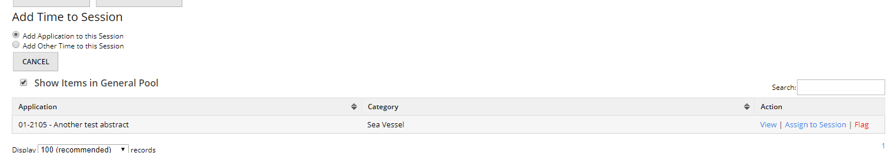
  - Click Assign to Session to add it.
  - Click Flag to see what happens if you want to mark an abstract as inappropriate. You can either move the abstract to the general pool or alert the conference organizer to remove it altogether. 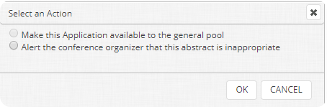
  - After adding time, you can move the abstract up and down in order, or edit the minutes allocated. 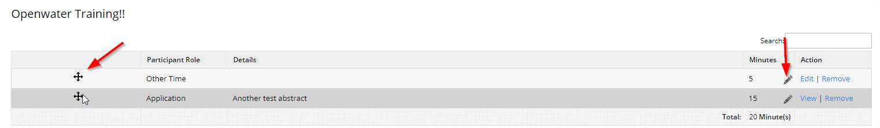
- Go ahead and start assigning abstracts to sessions from both the Public and Admin screens.

Part D: Setup Gallery Configuration
Almost at the tail end!

- The Sessions module has its own gallery configuration, which can be accessed by clicking Sessions, then Gallery Configuration. 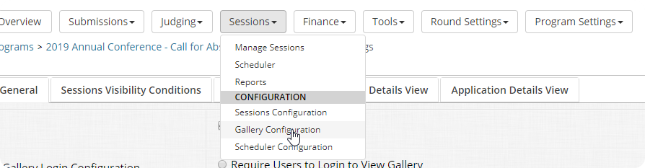
- You will recognize that most of the gallery is the same as a typical OpenWater public gallery, which we explored in Module 2. The main difference is that you can define a gallery view for the Session with a new placeholder called ‘SessionItemTable’. 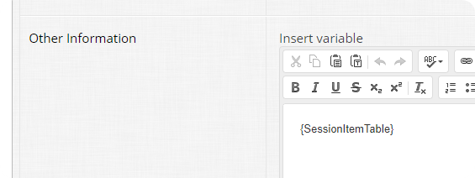
  - This will render a table of all assigned Abstracts to the Session in the gallery.
- You can also set a specific Abstract Detail View compared to a Session Detail View. 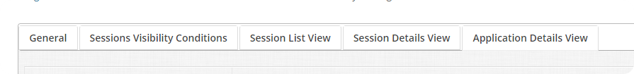
- Configure the gallery how you would like it, then go back to the General Tab and click the Gallery URL to preview your work. 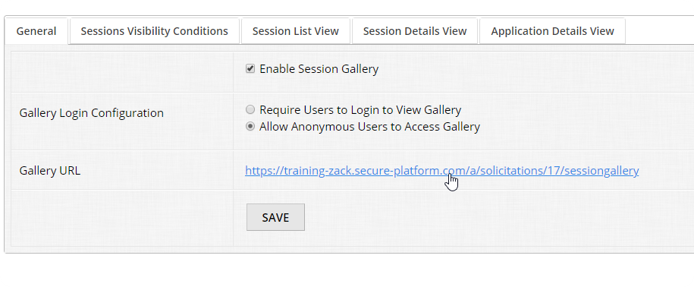

Part E: Setup Scheduler Configuration
Finally, we will setup the Scheduler Configuration and test how you can build your schedule within OpenWater.

- Click Sessions, then click Scheduler Configuration. 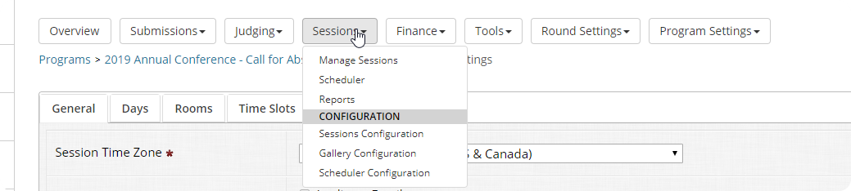
- Choose the Session Time Zone and what fields to Check Against for Conflicts.
  - The Ignore List will be used to whitelist addresses to ignore from conflicts. For example, admin@conference.org may be on all the sessions, you can type that in the ignore list to avoid false positives. 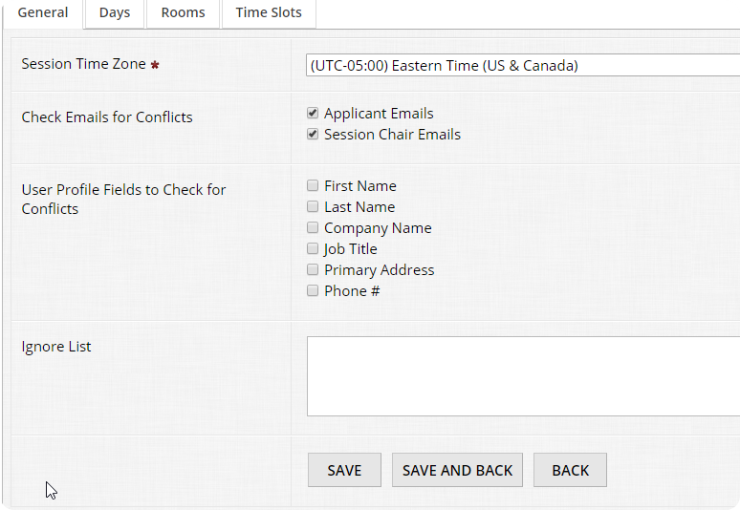
- Go to the Days tab and add a few days. 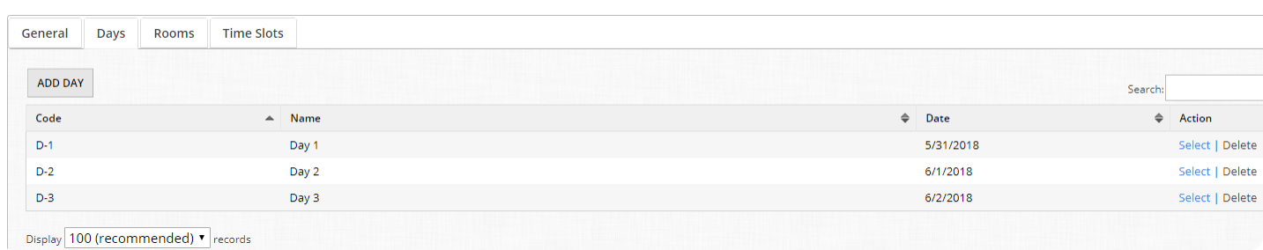
- Go to the Rooms tab and add a few rooms. 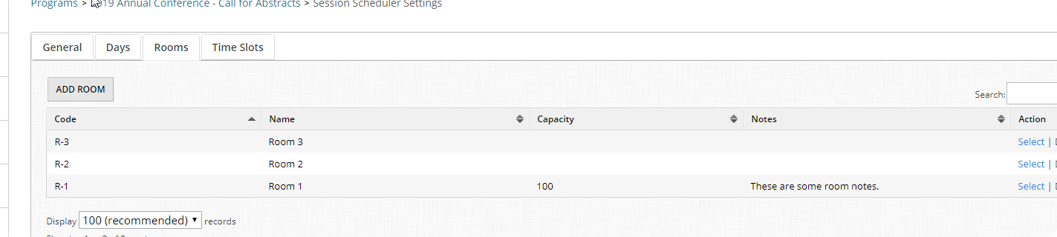
- Go to the Time Slots tab and add a few time slots. 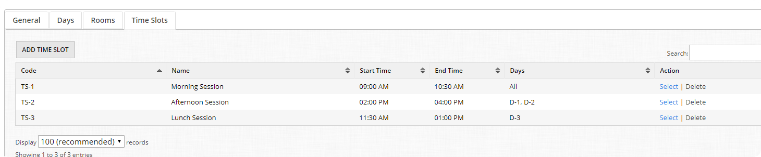
- To give you a sense for a common set up of the scheduler, our customers typically have a 4 day conference, with 20 rooms (each with 6 time slots).
- As you add days / rooms / time slots you’ll notice the Code column. We auto-generate a scheduler ID based on DAY_ROOM_TIMESLOT, this way it is easy to print a program and know where and when a session is taking place.

Part F: Create Your Schedule
Phew! That was a lot of data entry. The final step of the process is building your schedule with the OpenWater Scheduler.

- You can access the scheduler by clicking Sessions, then clicking Scheduler. 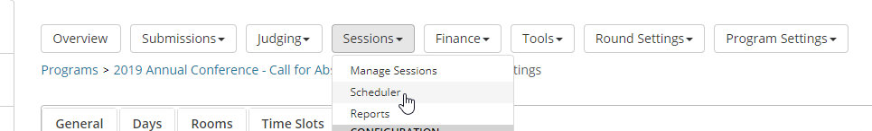
- On the left, you will see a column with all the available sessions. To place a session on the schedule, first hit Click to assign, then click on the block in the schedule where you would like to add the session. 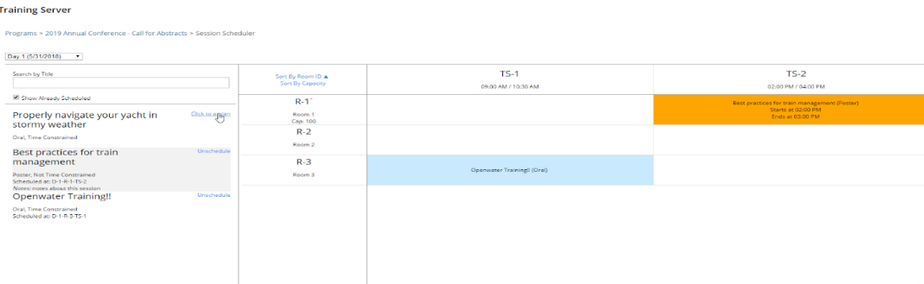
- You can right click a Session to Set Notes, Set a Custom Start / End Time, Move to Another Slot or Unschedule the session. 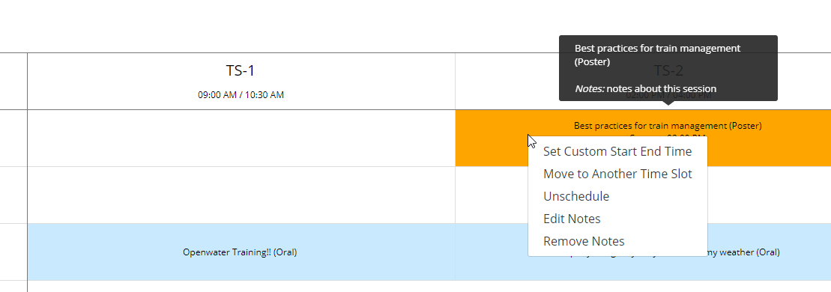
- If you right click an empty slot, you have the option to Block it. This is helpful for blocking time for lunch, coffee breaks, room setup, etc. 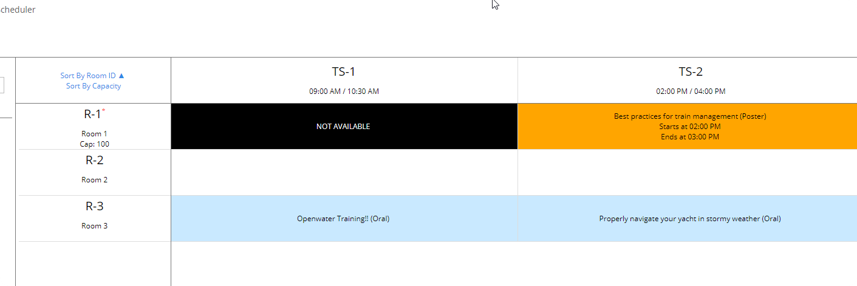
- Have some fun adding things to the schedule and moving them around!

Sample Exam Questions: Module 4
You should answer these questions as if a coworker who is using OpenWater has asked you for help. You can find the answers to these questions at the end of the manual. Remember to use the OpenWater Help Center if you get stuck!

- How can you add custom fields to a session (not an abstract submission form)?
- How can you ‘whitelist’ an email address from conflicts in the Scheduler?
- How do you turn on Sessions in a program?

Sample Exam Question Answers
Module 1
- First, open the form builder to the page with the field that you want to set as required. Turn on the checkbox that says “Is this field required?”
- To access the Direct to Program Link, you need to have the Open/Close Dates set for your program. Click on Round Settings, then Open/Close Dates. Once the dates are set and saved, go back to the round overview. The Direct to Program Link will be in the Market Programs box.
- After you have added a radio list field, click the chain link icon next to the option to which you wish to add a dependent field. On the next page, add the field(s) that you want, then click Save and Back to return to the main form builder.

Module 2
- Open the form builder and select the field that you want to hide. In the field settings, click the Configure Category Group Settings button. Next to the category group for which you want the field to be hidden, change the dropdown menu to say “Hidden”.
- To turn on collaborators, click Program Settings, then Applicant Settings. Turn on the checkbox the checkbox that says “Allow Multiple Collaborators to Edit an Application”.
- To turn on Pending Approval, click Round Settings, then Advanced. On the next page, switch Submission Finalization Action to the option that says “Require all Submissions to be approved by an admin staff member before sending to Judges”.

Module 3
- To switch from Evaluation Mode to Ranking Mode, click on Round Settings, then Advanced. Go to the Advanced tab on the next page. Change the Judge Evaluation Mode to say “Ranking”.
- To turn on Judge Draft Scores, click on Program Settings, then Judge Settings. Turn on the checkbox that says “Allow Draft Scores”.
- To add a new round to a program, click Program Settings, then Workflow. Click the button that says “Add Round” on the next page.

Module 4
- To add custom fields to a session, click Sessions, then Sessions Configuration. On the next page, click the button that says “Manage Fields”. Select the question page, then add the fields with the form builder.
- To whitelist an email from scheduling conflicts, click Sessions, then Scheduler Configuration. Add the email that you want to whitelist to the Ignore List.
- To turn on Session, click Program/Call for Submission Settings. Turn on the checkbox that says “Enable Sessions.”

