Name:________________________________ Date: _____________ Period:_____ **Student #_____**

**1.3 Exploring Cultural Identity**

**Learning Targets**

* Compare and contrast how a theme or central idea of a text is developed in an academic and a literary nonfiction text.

**Vocabulary**

* Voice
* Dynamic

**Before Reading**

**1.** Look at the picture on the opening page of this unit. What do you notice about the photo?

|  |
| --- |
| Similarities:  Differences: |

**During Reading**

**2.** Writers express their **voice** through their use of language. As you read the two texts in this activity, identify stylistic differences that establish one voice as academic and the other as informal.

|  |
| --- |
| Academic voice:  Informal voice: |

**3.** As you read each text, underline or highlight information that helps to define the concept of cultural identity. Then make a list of all the cultural terms and cultural elements introduced or discussed in the texts.

|  |
| --- |
|  |

**Informational Text**

**What Is Cultural Identity?**

1. Children begin to develop a sense of identity as individuals and as members of groups from their earliest interactions with others (McAdoo, 1993; Sheets, 1999a). One of the most basic types of identity is ethnic identity, which entails an awareness of one’s membership in a social group that has a common culture. The common culture may be marked by a shared language, history, geography, and (frequently) physical characteristics (Fishman, 1989; Sheets, 1999a).
2. Not all of these aspects need to be shared, however, for people to psychologically identify with a particular ethnic group. Cultural identity is a broader term: people from multiple ethnic backgrounds may identify as belonging to the same culture. For example, in the Caribbean and South America, several ethnic groups may share a broader, common, Latin culture. Social groups existing within one nation may share a common language and a broad cultural identity but have distinct ethnic identities associated with a different language and history. Ethnic groups in the United States are examples of this …

|  |
| --- |
| List examples of shared cultural identities: |

1. … Anthropologists and other scholars continue to debate the meaning of this term. Garcia (1994) refers to culture as:

The system of understanding characteristics of that individual’s society, or of some subgroup within that society. This system of understanding includes values, beliefs, notions about acceptable and unacceptable behavior, and other socially constructed ideas that members of the society are taught are “true.” (p. 51)

Geertz (1973) asserts that members of cultures go about their daily lives within shared webs of meaning. If we link Garcia and Geertz’s definitions, we can imagine culture as invisible webs composed of values, beliefs, ideas about appropriate behavior, and socially constructed truths.

|  |
| --- |
| What is meant by the "Invisibility of one's own culture"? |

1. One may ask, why is culture made up of invisible webs? Most of the time, our own cultures are invisible to us (Greenfield, Raeff, & Quiroz, 1996; Philips, 1983), yet they are the context within which we operate and make sense of the world. When we encounter a culture that is different from our own, one of the things we are faced with is a set of beliefs that manifest themselves in behaviors that differ from our own.
2. In this way, we often talk about other people’s cultures, and not so much about our own. Our own culture is often hidden from us, and we frequently describe it as “the way things are.” Nonetheless, one’s beliefs and actions are not any more natural or biologically predetermined than any other group’s set of beliefs and actions; they have emerged from the ways one’s own group has dealt with and interpreted the particular conditions it has faced. As conditions change, so do cultures; thus, cultures are considered to be **dynamic**.

|  |
| --- |
| Based on this paragraph what culture will an adopted child have? |

1. Individual cultural identity presents yet another layer of complexity. Members of the same culture vary widely in their beliefs and actions. How can we explain this phenomenon? The argument for a “distributive model” of culture addresses the relationship between culture and personality (García, 1994; Schwartz, 1978). This argument says that individuals select beliefs, values, and ideas that guide their actions from a larger set of cultural beliefs, values, and ideas. In most cases, we do not consciously pick and choose attributes from the total set; rather, the conditions and events in our individual lives lead us to favor some over others. In summarizing Spiro’s concept of “cultural heritage,” García (1994) draws a distinction between “cultural heritage” and “cultural inheritance.” Cultural heritage refers to what society as a whole possesses, and a cultural inheritance is what each individual possesses. In other words, each individual inherits some (but not all) of the cultural heritage of the group.

|  |
| --- |
| Explain the difference between "cultural heritage" and "cultural inheritance.” |

1. We all have unique identities that we develop within our cultures, but these identities are not fixed or static. This is the reason that stereotypes do not hold up: no two individuals from any culture are exactly alike. While living inside a culture allows members to become familiar with the total cultural heritage of that society, no individual actually internalizes the entire cultural heritage. In fact, it would be impossible for any one person to possess a society’s entire cultural heritage; there are inevitably complex and contradictory values, beliefs, and ideas within that heritage, a result of the conditions and events that individuals and groups experience. For example, arranged marriage has long been a cultural practice in India based on the belief that the families of potential spouses best know who would make a desirable match. More and more frequently, however, individuals reject the practice of arranged marriage; this is partly due to the sense of independence from family brought on by both men's and women’s participation in a rapidly developing job market. The changing experience of work is shifting cultural attitudes towards family and marriage. These different experiences and the new values, beliefs, and ideas they produce contribute to the dynamic nature of culture.

|  |
| --- |
| Consider the authors' use of the words “static” and “dynamic” in this paragraph to explain the concept of cultural identity. What can the reader conclude about the authors' point, and how does that relate to cultural identity? |

**After Reading er Reading**

**4.** Write a summary of each section of this text.

|  |
| --- |
| **Ph 1-2:**  **Ph 3-4:**  **Ph 5:**  **Ph 6-7:** |

**5.** What is your understanding of cultural identity based on this text?

|  |
| --- |
|  |

**6.** Reflect on invisible aspects of your culture. What differences exist between you and the culture you grew up in?

|  |
| --- |
|  |

**7.** What are some examples of your culture? Explain how these aspects are **dynamic**.

|  |
| --- |
|  |

**Informational Text**

**Ethnic Hash** *by* Patricia J. Williams from *Transition*

|  |
| --- |
| What does the metaphorical title suggest about William’s cultural identity? |

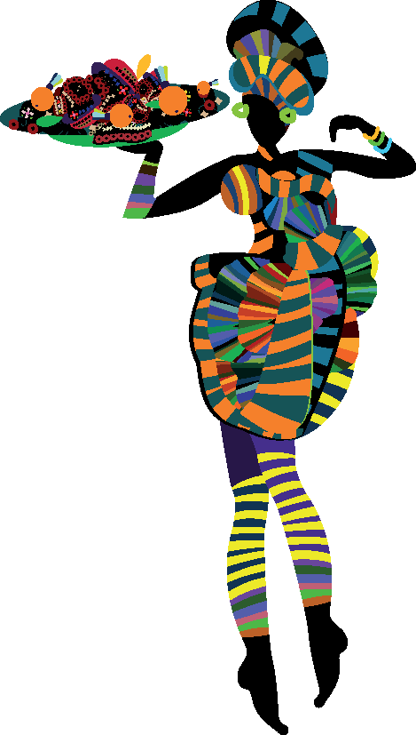

1. Recently, I was invited to a book party. The book was about pluralism. “Bring an hors d’oeuvre representing your ethnic heritage,” said the hostess, innocently enough. Her request threw me into a panic. Do I even have an ethnicity? I wondered. It was like suddenly discovering you might not have a belly button. I tell you, I had to go to the dictionary. What were the flavors, accents, and linguistic trills that were passed down to me over the ages? What are the habits, customs, and common traits of the social group by which I have been guided in life—and how do I cook them?

**Word Connections: Foreign Words**

*Hors d’oeuvre* is a French term that is often used to describe appetizers served before a meal.

Think of Pu Pu Platter here in Hawaii

1. My last name is from a presumably Welsh plantation owner. My mother chose my first name from a dictionary of girls’ names. “It didn’t sound like Edna or Myrtle,” she says, as though that explains anything. I have two mostly Cherokee grandparents. There’s a Scottish great-grandfather, a French-Canadian great uncle, and a bunch of other relations no one ever talks about. Not one of them left recipes. Of course the ancestors who have had the most tangible influence on my place in the world were probably the West Africans, and I can tell you right off that I haven’t the faintest idea what they do for hors d’oeuvres in West Africa (although I have this Senegalese friend who always serves the loveliest, poufiest little fish mousse things in puff pastries that look, well, totally French).

|  |
| --- |
| William’s style is relatively informal, creating a casual, engaging voice. What distinguishes this essay from an academic voice? |

1. Ethnic recipes throw me into the same sort of quandary as that proposed “interracial” box on the census form: the concept seems so historically vague, so cheerfully open-ended, as to be virtually meaningless. Everyone I know has at least three different kinds of cheese in their fondue. I suppose I could serve myself up as something like Tragic Mulatta Souffle, except that I’ve never gotten the hang of souffles. (Too much fussing, too little reward.) So as far as this world’s concerned, I’ve always thought of myself as just plain black. Let’s face it: however much my categories get jumbled when I hang out at my favorite kosher sushi spot, it’s the little black core of me that moves through the brave new world of Manhattan as I hail a cab, rent an apartment, and apply for a job.

Although it’s true, I never have tried hailing a cab as an *ethnic*…

1. So let me see. My father is from the state of Georgia. When he cooks, which is not often, the results are distinctly Southern. His specialties are pork chops and pies; he makes the good-luck black-eyed peas on New Year’s. His recipes are definitely black in a regional sense, since most blacks in the United States until recently lived in the Southeast. He loves pig. He uses lard.
2. My mother’s family is also black, but relentlessly steeped in the New England tradition of hard-winter cuisine. One of my earliest memories is of my mother borrowing my father’s screwdriver so she could pry open a box of salt cod. In those days, cod came in wooden boxes, nailed shut, and you really had to hack around the edges to loosen the lid. Cod-from-a-box had to be soaked overnight. The next day you mixed it with boiled potatoes and fried it in Crisco. Then you served it with baked beans in a little brown pot, with salt pork and molasses. There was usually some shredded cabbage as well, with carrots for color. And of course there was piccalilli—every good homemaker had piccalilli on hand. Oh, and hot rolls served with homemade Concord grape jelly. Or maybe just brown bread and butter. These were the staples of Saturday night supper.
3. We had baked chicken on Sundays, boiled chicken other days. My mother has recipes for how to boil a chicken: a whole range of them, with and without bay leaf, onions, potatoes, carrots. With boiled chicken, life can never be dull.
4. The truth is we liked watermelon in our family. But the only times we ate it–well, those were secret moments, private moments, guilty, even shameful moments, never unburdened by the thought of what might happen if our white neighbors saw us enjoying the primeval fruit. We were always on display when it came to things stereotypical. Fortunately, my mother was never handier in the kitchen than when under political pressure. She would take that odd, thin-necked implement known as a melon-baller and gouge out innocent pink circlets and serve them to us, like little mounds of faux sorbet, in fluted crystal goblets. The only time we used those goblets was to disguise watermelon, in case someone was peering idly through the windows, lurking about in racial judgment.
5. I don’t remember my parents having many dinner parties, but for those special occasions requiring actual hors d’oeuvres, there were crackers and cream cheese, small sandwiches with the crusts cut off, Red Devil deviled ham with mayonnaise and chopped dill pickles. And where there were hors d’oeuvres, there had to be dessert on the other end to balance things out. Slices of home-made cake and punch. “Will you take coffee or tea?” my mother would ask shyly, at the proud culmination of such a meal …

|  |
| --- |
| Tone is the writer’s or speaker’s attitude toward the subject. What tone does Williams use in the first few paragraphs? How does the tone shift in the essay? |

**Quadroon Surprise**

1. 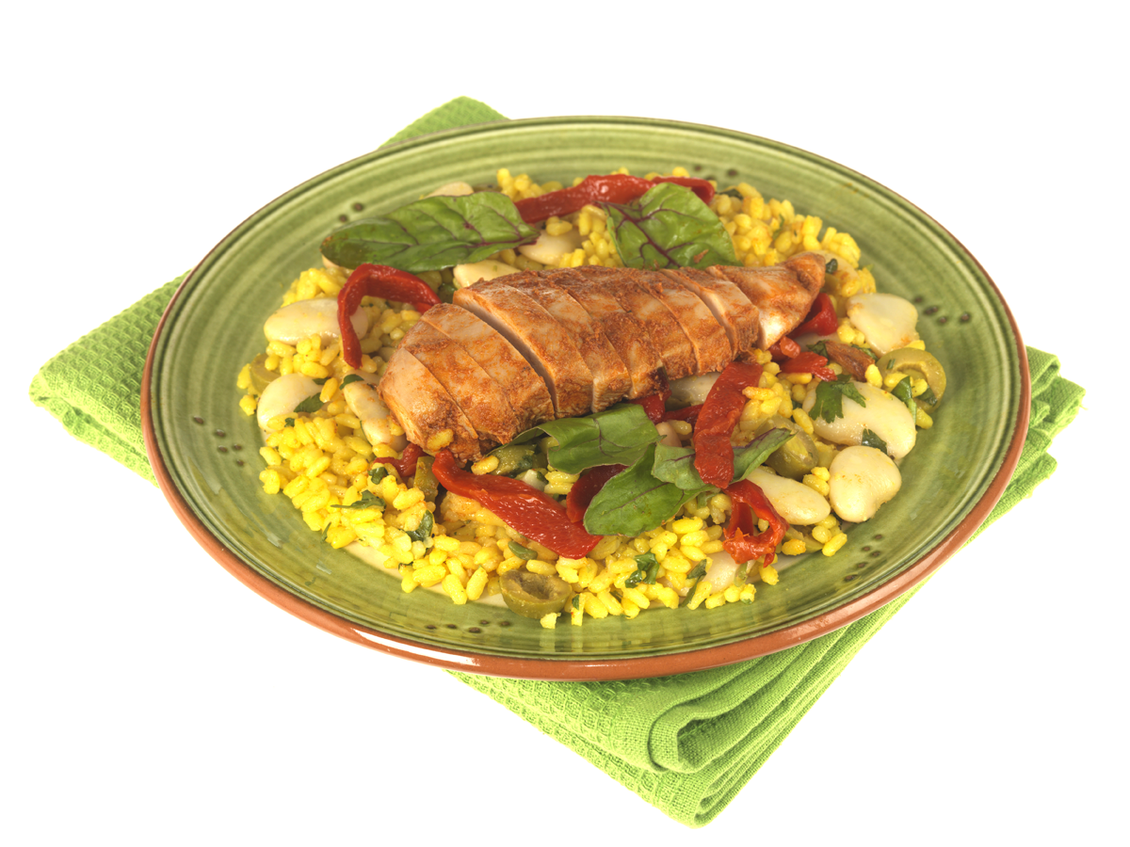Some have said that too much salt cod too early in life hobbles the culinary senses forever. I have faith that this is not the case, and that any disadvantage can be overcome with time and a little help from Williams-Sonoma. Having grown up and learned that you are what you eat, I have worked to broaden my horizons and cultivate my tastes. I entertain global gastronomic aspirations, and my palate knows no bounds. After all, if Aunt Jemima and Uncle Ben[***1***](https://hawaiihi.springboardonline.org/ebook/book/110074261/B1DF27904F3B49D2A474E25A23931B9F) can Just Get Over It, who am I to cling to the limitations of the past? Yes, I have learned to love my inner ethnic child. And so, I leave you with a recipe for the Twenty-first Century:

***Chicken with Spanish Rice and Not-Just-Black Beans***

***Boil the chicken***

***Boil the rice***

***Boil the beans***

1. Throw in as many exotic-sounding spices and mysterious roots as you can lay your hands on—go on, use your imagination!—and garnish with those fashionable little wedges of lime that make everything look vaguely Thai. Watch those taxis screech to a halt! A guaranteed crowd-pleaser that can be reheated or rehashed generation after generation.

Coffee? Tea?**After Re**

**ading**

**________________________________________________________________________**

**After Reading**

**8. Group Discussion:** With your group, discuss how Patricia Williams represents her cultural identity in her essay.

|  |
| --- |
|  |

**9.**When you hear the term “academic voice,” what comes to mind? What are some features do you associate with this style of writing?

|  |
| --- |
|  |

**10.**Many readers associate academic voice with “dull and boring,” but it need not be that way. Revisit “What Is Cultural Identity?” to identify specific stylistic techniques the authors use to make the text both engaging and academic.

|  |
| --- |
|  |

**11.**In contrast to academic voice, many writing situations and genres call for a more informal voice. Reread the opening paragraph of “Ethnic Hash,” and identify specific stylistic elements that establish a less formal voice.

|  |
| --- |
|  |

**Writing Prompt**

Choose a characteristic of culture and use it to explain your cultural identity. (ex: food, dress, etc.)

Be sure to:

* Use an informal voice to engage your audience.
* Develop your response with vivid details and descriptions.
* Use diction and punctuation to create an appropriate tone.***heck Your Understanding***

**Exit ticket**

Why might an author choose an informal voice when talking about their culture?

|  |
| --- |
|  |