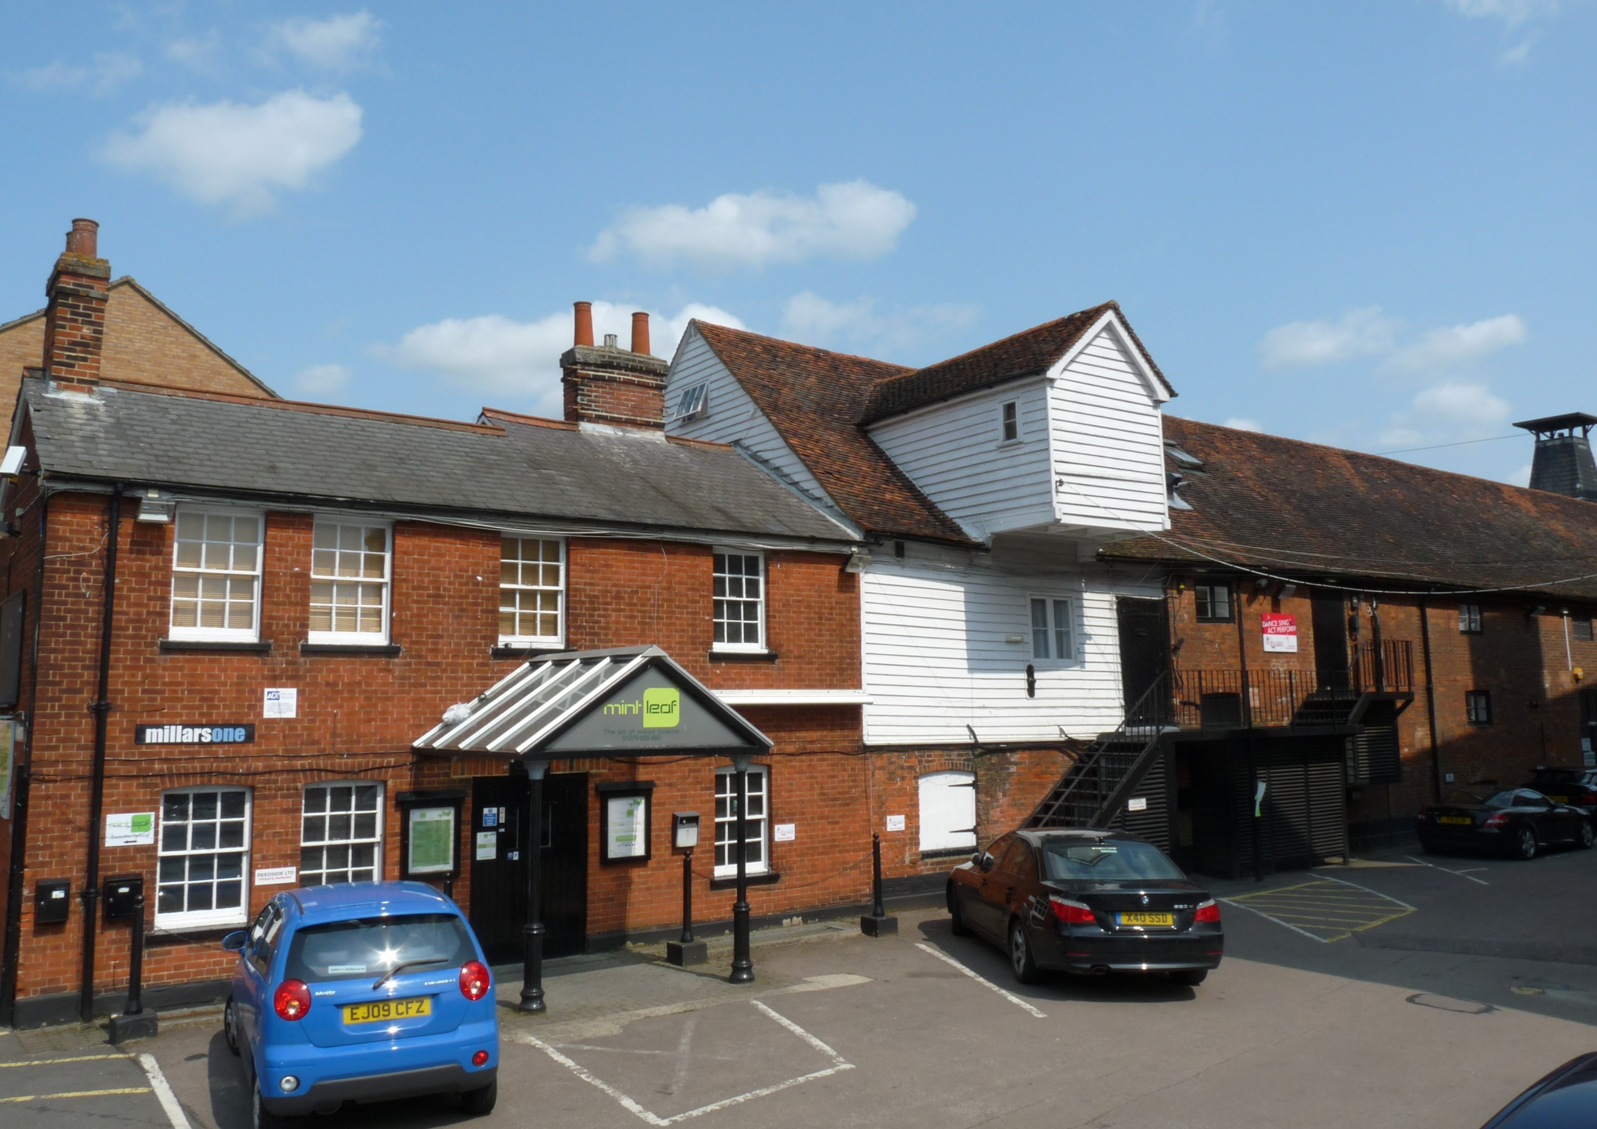

Freehold Investment For Sale

Millars One, Southmill Road, Bishops Stortford, Hertfordshire, CM23 3DH

Executive Summary

- Freehold mixed-use commercial units for sale, including six newly created self-contained character apartments.
- Desirable Historic Market town close to Stanstead Airport and the M11
- Substantial former Malting building extending to approximately 7,198 Sq. Ft (668.7 Sq. M)
- Close to train station and town centre
- Market Rental Value £123,800 per Annum
- Offers in region of £2,200,000 for the Freehold

Location

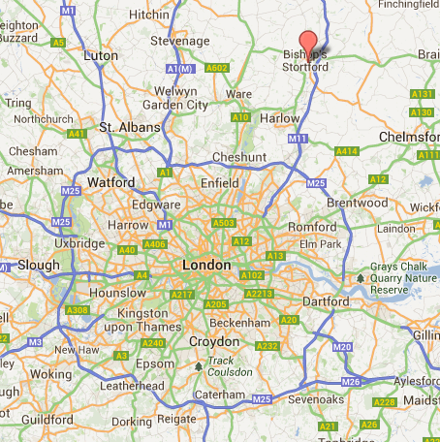

Millars One is located in the historic market town of Bishops Stortford in East Hertfordshire approximately halfway between London and Cambridge. Bishop Stortford is an affluent and desirable town that sprawls around the river Stort. It benefits from being close to the M11 which provides direct access to the M25 and London southbound; and the North of England northbound. It is also the closest large town to Stanstead Airport, is part of the London commuter belt and has a highly qualified workforce. The town centre is undergoing many changes, with the demolition of the old multi-storey car park and surrounding area to make way for a new town centre area. There is also building of new city-type apartments and penthouses on the riverside and around the town centre.
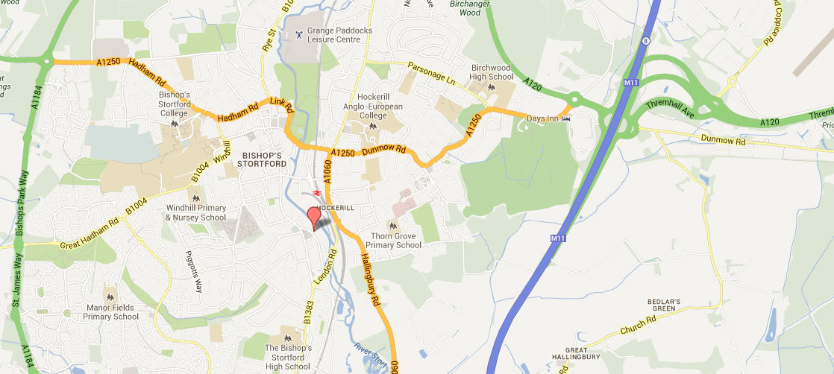

Millars One is located on Southmill Road, to the south of the town centre within the larger Millars Complex and is situated adjacent to the River Stort and the contemporary designed “Goods Yard” footbridge that has created a new commuter route to and from the bustling train station.

Description

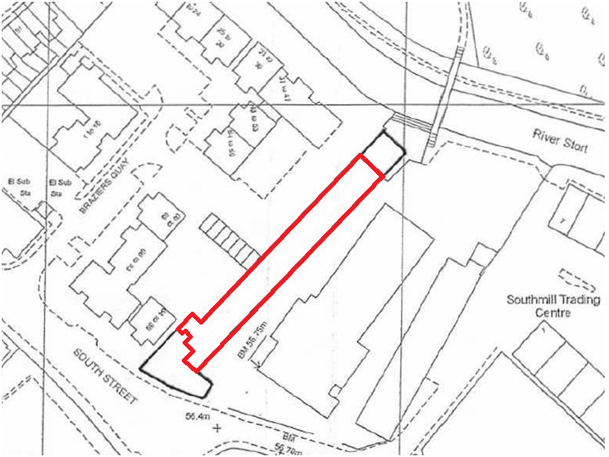
“Millars One” is one of three former Malting buildings within the larger Millars Complex which have been sympathetically converted to provide a vibrant mix of residential, leisure, office, restaurant and D1 facilities. There is a road that circulates the three buildings and a car park situated at the eastern edge of the complex adjacent to the River Stort.

The property is an extensive, largely rectangular building arranged over ground, first and second floor levels. The building has been subdived to accommodate four tenants to include a Restaurant, a hot food take-away, a Dance studio and a Gym. Due to the substantial nature, riverside location and regular footprint of the building, it may offer long-term flexibility for sub-division or conversion to a variety of uses.

The property currently benefits from a mixture of planning uses including A5 Hot Food Take-Away and D2 Gym. Planning permission was recently granted on “Millars One” for the conversion of the first floor, into six self-contained apartments. The proposed scheme will retain the commercial use on the ground floor, and the general appearance will be refurbished.

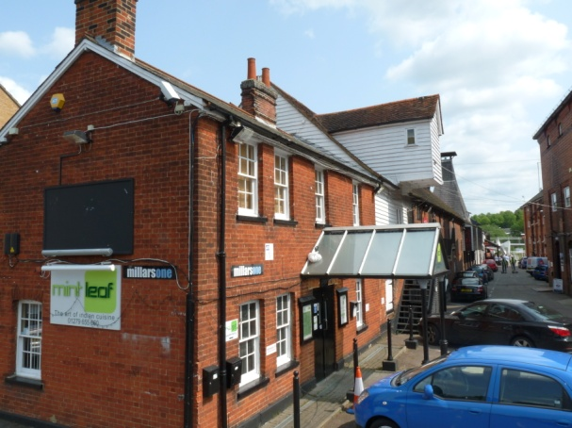 | 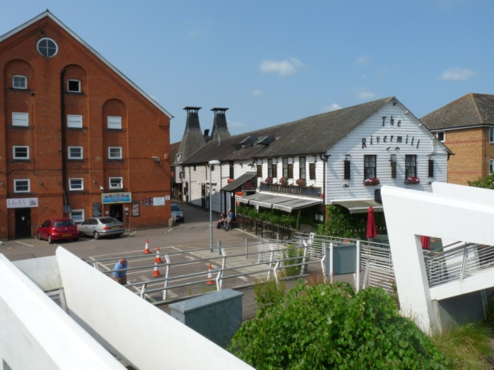 | 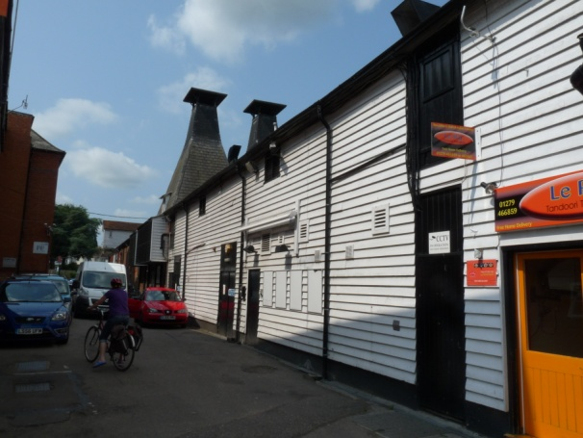 | 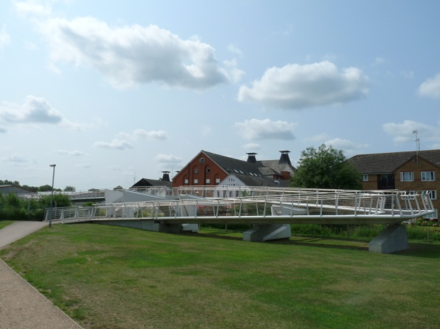

Residential Values

Flat | Description | Area  (approx Sq Ft) | Sale Price | Rental Per Annum
1 | 1 Bedroom + 1 Study | 587 | £260,000 | £13,800
2 | 1 Bedroom + 1 Study | 646 | £280,000 | £13,800
3 | 1 Bedroom + 1 Study | 685 | £320,000 | £13,800
4 | 1 Bedroom | 461 | £210,000 | £10,800
5 | 1 Bedroom + 1 Study | 605 | £270,000 | £13,800
6 | 1 Bedroom | 518 | £230,00 | £10,800
TOTAL |  | 3,502 | £1,570,000 | £76,800

Commercial Values.

Unit | Description | Area  (Approx. Sq. Ft) | Tenancy Details | Rental Value  (per annum exclusive)
1 | Gym | 3,428 | Vacant | £41,000
2 | Takeaway | 268 | 25 years from October 2010  5 Yearly Rent Reviews | £6,000
TOTAL |  | 3,696 |  | £47,000 / Annum

Planning

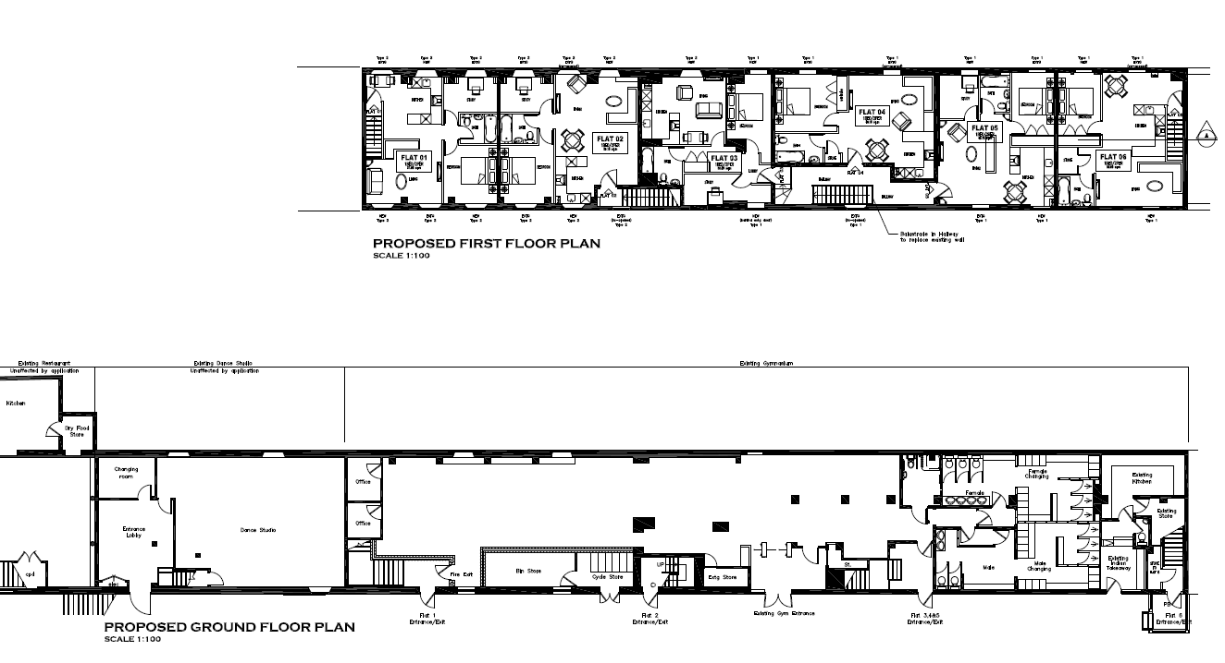

The Purchase

FURTHER INFORMATION
Viewing strictly by prior appointment with Levene Commercial:

Charles Wilkinson AssocRICS BSc Dip DEA
T: 020 8977 6885
E: charles@levene-commercial.com

Josh O’Rawe BA (Hons)
T: 020 8977 6885
E: charles@levene-commercial.com

Jubilee House,
Jubilee Close,
Hampton Wick,
KT1 4DG

T: 020 8977 6885
W: www.levenecommercial.com

TENURE
Freehold with the benefit of an existing tenancy.

VAT
We are advised that VAT will be applicable at the prevailing rate.

PRICE
Offers in the Region Of £2,200,000

F & C Commercial Ltd t/a Levene Commercial for themselves and for the vendor or lessors of this property whose agents they are given notice that: (i) the particulars are produced in good faith, are set out as a general guide only and do not constitute any part of a contract: (ii) no person in the employment of F & C Commercial Ltd t/a Levene Commercial, has any authority to make or give any representation or warranty in relation to this property Nov 2017

