Sordaria Meiosis and Crossing Over Lab Name _________________________
Objective: To determine the change in crossing-over frequency (map distance) under various experimental conditions for the fungus Sordaria fimicola.

Principle and background: Sordaria fimicola is a fungus of the phylum Ascomycota and is commonly found in the dung of herbivorous animals. Like many fungi, Sordaria sp. has a haploid/diploid life cycle. Normally this fungus exists as a haploid organism, (haploid means 1n) but occasionally when the mycelium from two individuals meet, a diploid zygote (diploid means 2n) is formed. The diploid zygote then undergoes meiosis to yield 8 haploid ascospores. These ascospores exist in a narrow pod called an ascus. Many asci will grow together forming a reproductive structure called a perithecium. The perithecium is a reproductive structure that is analogous to a mushroom in other taxa of fungi. Eventually these asci will burst, releasing the ascospores to start a new colony.
Figure 1: Sordaria sp. life cycle
What makes Sordaria sp. useful and unique is that certain aspects of meiosis can be directly investigated due to the unique formation of 8 haploid ascospores within an ascus. More specifically, the process of meiotic crossing-over (also referred to as homologous recombination or sometimes more broadly as synapsis) can be inferred from the order of ascospores in an ascus.
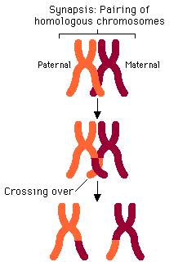
Crossing-over is a process that occurs when homologous genes from the paternally and maternally inherited chromosomes will swap genetic material. At the end of the process, each chromosome will consist of a patchwork of genes from both mother and father. Essentially, each chromosome will be “shuffled” so that entirely new gene combinations will be present on each chromosome. Fungi are generally genderless so the designation of maternal and paternal is really not quite accurate. However, the principle remains the same; when the mycelium from two different colonies meet, a diploid zygote is formed which undergoes crossing-over and meiosis to yield haploid ascospores.
In order to investigate crossing-over in Sordaria sp., we will need to conduct a cross between two mutant strains. The mutant strains we are using have different genes for spore color. More specifically, we will be using three spore-color mutants.
Figure 2: Crossing over results in new genetic combinations. Image: Pearson Education, 2010.
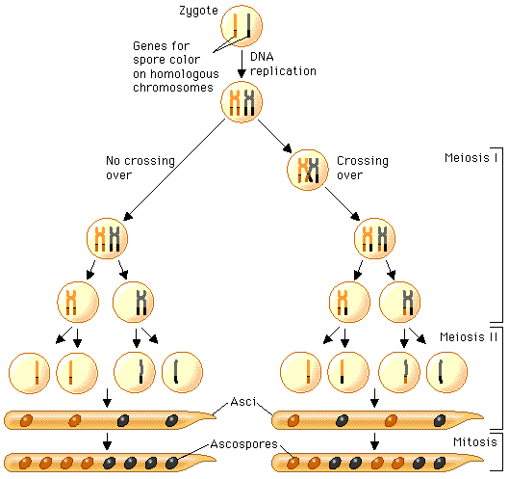
The spore color of the normal (wild type) Sordaria is black. This phenotype is due to the production of the pigment melanin and its deposition in the cell walls. Several different genes are involved in the control of the melanin biosynthetic pathway and each gene has two possible allelic forms. The gray spore gene has two allelic forms: the wild type allele (g⁺) and a mutant allele (g). The tan spore gene also has two forms: a wild type allele (t⁺), and a mutant allele (t). Normal black spores are produced only if both wild type alleles are present at the loci of both genes. Thus, black ascospores have the genotype (g⁺ t⁺). It is important to remember that spores are haploid and these designations are not quite the same as genotype designations when exploring Mendelian inheritance in diploid organisms. To be more specific, (g) and (t) are different genes in different locations on a chromosome. Those with the genotype (g t⁺), are gray, while (g⁺ t) are tan. Ascospores that are (g t) show a cumulative effect of the two mutations and are colorless. To observe crossing over in Sordaria sp., one must make hybrids between wild type and mutant strains of Sordaria sp. The arrangement of the spores directly reflects whether or not crossing over has occurred. The process of ascospore formation is outlined in figure 3 below.
As the figure to the right illustrates, the haploid mycelium of a gray and tan strain (it is the same process for any combination of mutants) meet to form a zygote. The chromosomes of the zygote then undergo DNA replication to generate sister chromatids. The sister chromatids combine during synapsis to produce a tetrad consisting of the two parental sister chromatids. It is during this stage that genes or chromosomal fragments will swap places. The newly recombined tetrads are then pulled apart during meiosis I to yield two diploid daughter cells each containing a recombined chromosome. Finally, the diploid daughter cells undergo meiosis II where four haploid daughter cells are formed each containing a recombined chromosome. These haploid daughter cells then undergo mitosis to produce the final 8 ascospores. As figure 3 shows, it is possible that no recombination took place at all. Figure 4 shows the possible ascospore color combinations if crossing-over does occur. It is important to remember that each pattern of ascospores represents a specific pattern of crossing-over.
Figure 3: The arrangement of ascospores corresponds directly with the process of crossing-over and chromosomal segregation. Image: Pearson Education, 2010.
Figure 4: There are four possible ascospore arrangements indicative of crossing -over events.
The pattern of crossing you observe and the frequency of each pattern will enable us to calculate the map distance for each gene. Map distance is essentially the percent of crossing-over that occurs for any particular gene. Map distance is also the theoretical distance between a centromere (the center of a chromosome) and a gene. Although this may seem confusing at first the concept that underlies the assumptions about map distance are really very simple. Essentially, the further a gene is away from the centromere the more likely it will cross-over. Therefore, genes that are close to the centromere do not cross-over very frequently. Genes that are near the ends of the chromosome will cross-over much more frequently. Genes that are in-between will show a crossing-over frequency that is in-between genes at the center or near the ends of a chromosome. Observations about the relationship between crossing-over frequency and map distance are repeatable and reliable. When we calculate the crossing-over frequency we are essentially determining the distance between the gene and the centromere. As the frequency of crossing-over increases, the distance between the centromere and a gene must also increase. If the measured frequency of crossing-over decreases, the distance between the gene and centromere also decreases. In this way, crossing-over frequency is really the same as map distance. However, map distance is not a true distance! It is only a relative measure and provides little physical information about where a gene’s location on a chromosome actually is.
Like many biological phenomena, crossing-over probably occurs for a valuable reason. It has been theorized that recombining genes in new combinations is possibly an adaptation to environmental stresses. In fact, one study found that samples of Sordaria fimicola from locations that differ in their hospitality (UV exposure, humidity, temperature) to this fungus differ markedly in their inherent recombination frequencies for various genes (Lamb et al., 1998). Other studies have found that changes in environmental conditions will alter the frequency of crossing-over (and of course, map distance too!)(Lamb, 1968).

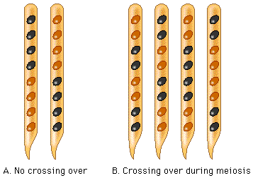
Figure 5: When no crossing-over has occurred the ratio is 4:4. Image from Pearson Education.
Mapping Genes on Chromosomes
By studying the frequency of crossing over, you can gather information that lets you draw a map of the relative location of genes on a chromosome. A map unit is a relative measure of the distance between two linked genes, or between a gene and the centromere. The greater the number of crossovers, the greater the map distance.
From the crossing over data you gather for Sordaria, you will be able to calculate the map distance between the gene for spore color and the centromere. To find the number of map units, you divide the percent of crossovers by 2.
Why divide by two? Each crossover produces two spores like the parents and two spores that are a result of the crossover. Thus, to determine the number of crossovers, you must divide the number of asci counted by two since only half the spores in each ascus result from crossing over.

Map units = recombinant frequency
2

Procedure
- Use the power point slides of Sordaria crosses.
- Observe all of the slides and count at least a total of 50 asci. Do not count the all black or all tan asci since these do not depict hybridization.
- Record the number of 4:4 asci (non-crossover) and the number of asci showing crossover in the data table on the next page.
- Calculate the % asci showing crossover and the gene to centromere distance (Map Units) and record this on the table on the next page.

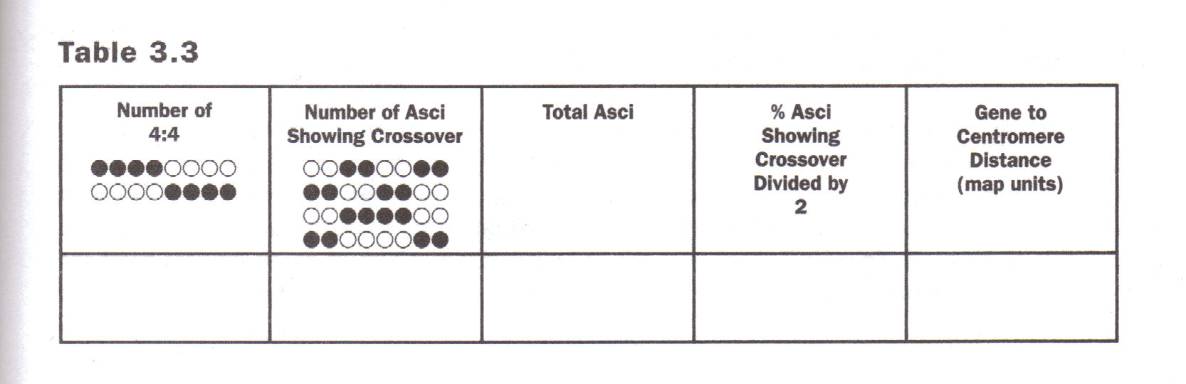

Write the average class data for Gene to Centromere Distance (Map Units) here: _______________
Evaluating Results
- Why did you divide the % asci showing crossover by 2 in order to get the gene to centromere distance?

- The published map distance between the spore color gene and the centromere is 26 map units. How did the class data compare with this distance?

- How can you account for any disparities between the class data and the published data?

- Illustrate what happened during meiosis to produce the results you found.

