REVIEW OF 2017 BALLARAT OPEN RACQUETBALL CHAMPIONSHIPS
SINGLES
Grade | Winner | Runner-Up
Men’s Open | Cam White | Steve Andrewartha
Women’s Open | Kristel Proctor | Sue Dunlop
A | Anthony Hain | Chris Rollauer
B | Matthew Bayley | Dave Whan
C | Blake Caspersz | Michael Barclay
D | Kevin Till | Nicola Baines
E | Angela Printz | Jackson Lander-Mitchell
F | Cooper Hawkins | Talia Tatham
Junior Girl’s | Ella Partington
Junior Boy’s | Lee Greenwood | Ricky McGinley

DOUBLES
Grade Winner s Runners-Up
Open Andrewartha/Wilcock Bosch/Rundell
A Bosnner/Skelton Hain/Proctor
B Phillips/Whan Baxter/Barclay
C Falconer/Cooper Caspersz/Harrison
D A. & B. Morgan C. & S. Landy
E Printz & Gunsser Tatham/Goulding

The highlights of the penultimate Victorian Racquetball Grand Prix Tournament Circuit event for the year, the Ballarat Open Championships were; Cam White extending his unbeaten record and claiming his third Ballarat Open in the past four years, Kristel Proctor’s annexing of the Women’s Open title, which now sees her heading up both the National and Victorian Circuits for that event, a 20% increase in entry numbers over the 2016 event, including nineteen Grand Prix debutants, which now takes the actual entry increase for the past two years to an amazing 55%.
SINGLES RESULTS
MEN’S OPEN
Prior to last year’s event, this title for the previous five years had been owned by Cam White (2011/14/15), and Garry Pedersen (2012/13), but in 2016 Dromana’s Steve Andrewartha prevailed, and since then his outstanding form has catapulted him into heading up the rankings for both the National and Victorian Grand Prix circuits for this event in 2017, with only one event in each circuit to be played for the year.

But for the 2017 event The King, who has an imposing record which includes 15 Australian and 15 Victorian Open titles, was back in town, so it was a great chance to gauge where Andrewartha stood with White in comparison to his tight three game semi final loss to him in 2015, if they both met up in the final climax, which is what eventually happened.

In their respective semi finals, Andrewartha came from a game down to overcome 2016 Ballarat Runner up Peter French, 18/21, 21/10, 21/14, with White overpowering fourth seeded Garry Pedersen, 21/7, 21/12.
There is no doubt that Andrewartha has had a most successful past eighteen months annexing seven National and Victorian GP titles, but in what was a high class finale, punctuated by many unbelievable long rallies, and containing an incredible range of shots and returns, it was White who once again took control at the critical stages and overcame a gallant Andrewartha, 21/13, 21/17.
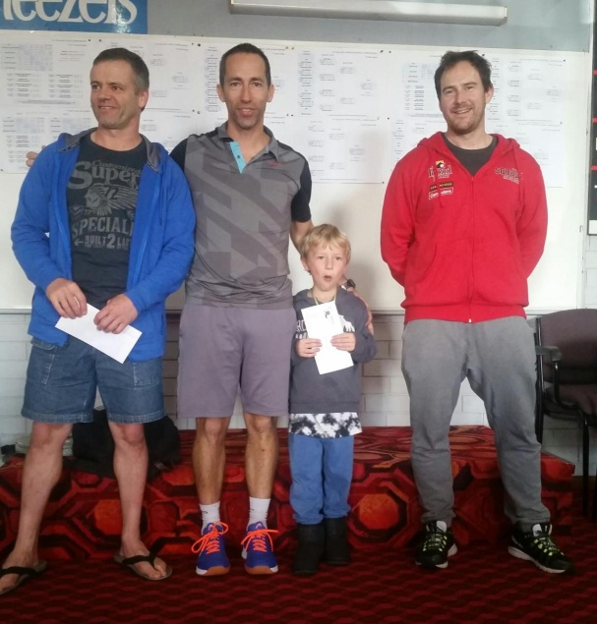
Steve Andrewartha, Cam White, Archer White & Russell McLean
Women’s Open
With the Queen of Racquetball, and 2016 Ballarat Open winner Sarah Fitz-Gerald confined to her castle this weekend, the top seed in the Women’s Open was current National GP Circuit leader Kristel Proctor, runner-up to Fitz-Gerald in this event last year & and this year’s Victorian Open, plus the winner of the recent Tasmanian Open.
So when the pointy end of this event was reached, it was another face off between Proctor and second seeded Sue Dunlop, who is currently in second place on the National GP Circuit ranking’s board. These two players have played out some incredible matches, but once again it was Proctor who seized early control which she never relinquished, taking it out 21/16, 21/11, which now takes her to the top of the Victorian GP rankings as well.
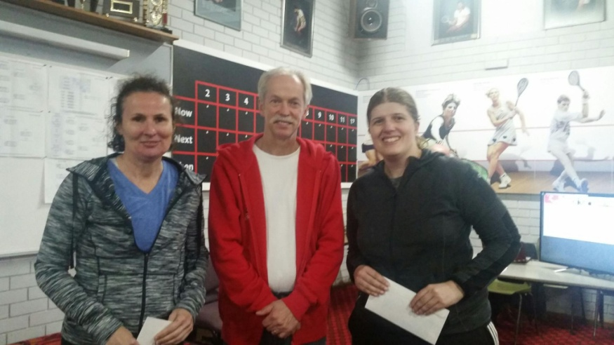
Sue Dunlop, David Rowe & Kristel Proctor
A GRADE:
Although top seeded Anthony Hain was a pronounced favourite, having won the recent Geelong and Victorian Open A Grade titles, the field contained several experienced players, including second seeded Chris Rollauer, the 2016 A Grade National & Victorian GP Champion.
The two top seeds did advance to the final stanza, but it was Hain who led throughout, displaying he was destined for higher places, outpointing Rollauer, 21/11, 21/7.
In their respective semi finals, Rollauer took out Mt. District’s third seeded Rob Hay, 21/10, 21/6, whilst Hain put paid to fifth seeded local hope Troy Anwyl, 21/13, 21/5.
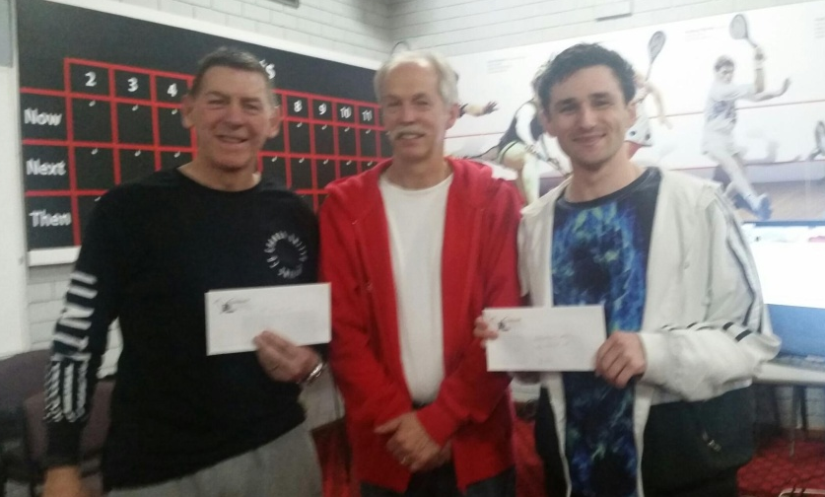
Chris Rollauer, David Rowe & Anthony Hain
B GRADE:
Rarely does South Australian stalwart and top seeded Dave Whan miss out reaching the pointy end of a B Grade event, and in 2016 he annexed the only two Victorian GP Circuit events he played in, the Victorian and Ballarat Opens, but recently ‘a new kid on the block’ appeared, Mulgrave’s second seeded Matthew Bayley who denied Whan successive Victorian Open B Grade crowns in July; would he do the same in the Ballarat event.
Whilst Whan, who has been using these racquetball tournaments as a key part of his fitness training for his assault on Mt. Everest in October, was cruising through the top half of the draw, Bayley was extended to three games by Wangaratta’s Paul Trinick, in the quarters, and then had to stave off a determined challenge from Ballarat’s sixth seeded James Hosking to make it to the final stanza.
The first game of the final was an enthralling contest with both players having their chances to capture the important first game before Bayley won the 40th point and taking the game 21/19. Although Whan hung in bravely, he could not break through the strong defences of Bayley in the second game finally succumbing 11/21, providing the ‘NEW KID’ with a Victorian GP Circuit running double.
Dave Whan, Paul Vear & Matthew Bayley
C GRADE:
One of the most improved players on the racquetball circuit over the past twelve months has definitely been Ballarat’s Blake Caspersz, who after finishing ‘down the track’ in the 2016 Geelong Classic C Grade event, he then earned himself the title of ‘Marathon Man’, after surviving four intense, action packed rounds, to capture the Ballarat C Grade title.
Since Caspersz returned to the circuits in June this year he has remained undefeated, along the way capturing the Geelong, Victorian and Tasmanian C Grade crowns and also heads up both the National and Victorian GP C Grade rankings.
When the judge called a halt to proceedings for this event, Caspersz had won his fourth successive event, plus a ‘back to back’ home event double, but not before coming back from a game down in the quarters against popular local Joy Nunn, to win 21/22, 21/11, 21/9, then holding on against the indefatigable Michael Barclay in a captivating final, 21/14, 22/21.
This event also saw the first appearance of Ballarat and Bendigo Centre Manager Russell McLean in a racquetball tournament, who performed very well before having to forfeit to Barclay whilst ahead in their semi final encounter.
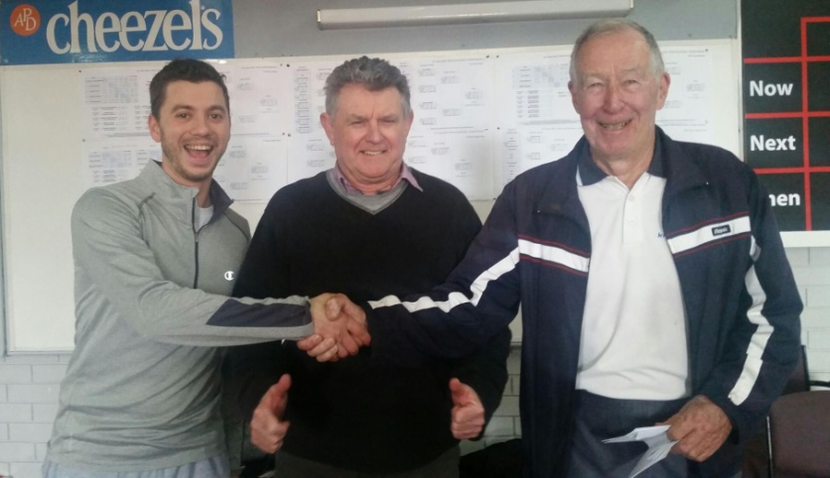
Blake Caspersz, Paul Vear & Michael Barclay
D GRADE:
Wodonga’s Baines’ family comprises five very talented racquetball and squash players, with the three siblings also representing Victoria at the current Australian Junior Squash Championships, and in this event all three females, Marion and her two daughters Nicola and Gabi were jousting for the booty.
In the end it was Nicola who had the bragging rights for the long drive home after finishing Runner-Up to Lakes Entrance’s Kevin Till who came from a game down to claim his first GP Circuit title, 19/21, 21/14, 21/14.
In their respective semi finals, Till accounted for current National & Victorian GP D Grade rankings leader Ben Bell, 21/16, 21/17, with Nicola wreaking revenge on Wangaratta’s Heather Williams in straight games for earlier disposing of her mother, 21/16 in their third game decider.
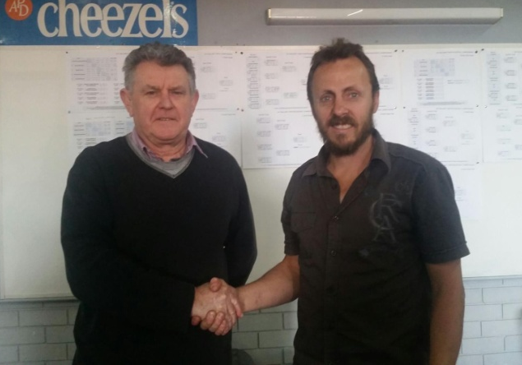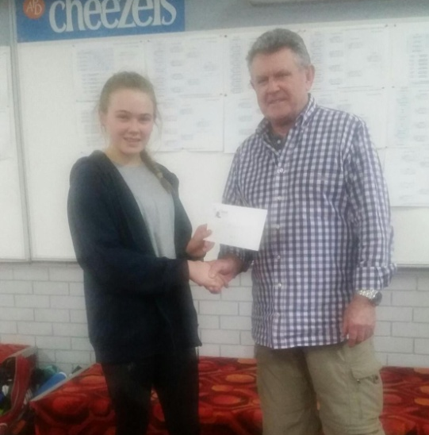
Paul Vear & Kevin Till Nicola Baines & Paul Vear
E Grade:
Following a couple of late scratchings the E Grade field was reduced to three, two exuberant youngsters, plus Lakes Entrance’s Angela Printz who had not played a GP singles event since the Lakes Classic in 2014.
In the end Printz finished on top, defeating Corio’s Jackson Lander-Mitchell, 21/18, 21/15, with local GP debutant Frederick England finishing in third place.
Paul Vear & Angela Printz Jackson Lander-Mitchell & Russell McLean
F Grade
This event comprised four females, including three GP debutants, plus Wangaratta’s Cooper Hawkins, who made his debut at the Victorian Open.
After Hawkins secured top spot in his pool, defeating Corio’s Tegan Goulding in the final round 21/17, 21/15, and Lakes Entrance’s Talia Tatham taking out the other pool over Jess Wilcock, 21/12, 21/14, Hawkins not only went on take the title, but he also had bragging rights over his father, Jason, who was unable to emulate his son’s feats in his B Grade event.
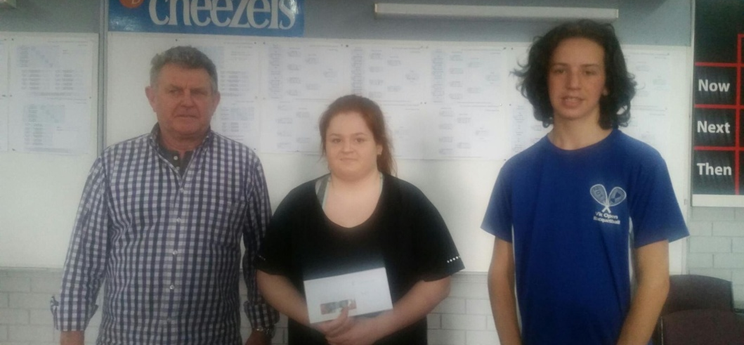
Paul Vear, Talia Tatham & Cooper Hawkins
Junior Girls/Boys Under 13’s
Corio’s Ella Partington took out the Junior Girl’s event, with Lee Greenwood defeating fellow local Ricky McGinley, 21/15, 21/18, to claim the Junior Boy’s title.

Ella Partington & Russell McLean Lee Greenwood, Russell McLean & Ricky McGinley

Author - Paul Vear

Photographers – Dawn & Ebony Harrison, and Cassie Landy

