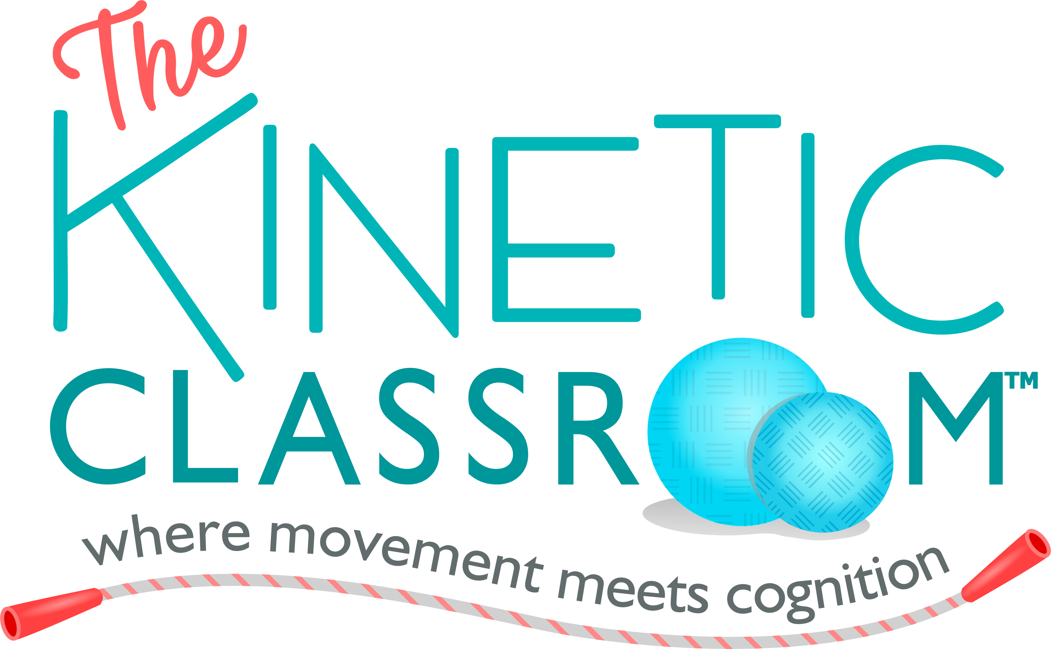

Welcome to the moveTHINK course on The Kinetic Classroom!
It is my joy to work with you to bring more cognitive-motor movement and executive function skill coaching strategies to your classroom, home or clinic.
Since 1985, I have enjoyed creating movement games and developing cognitive improvement strategies with children. After I earned my master’s degree in Physical Education from the University of Southern California in 1986 and my Doctorate in Psychology from Pepperdine in 1992, I used to bring a rolling sports travel bag to students’ homes full of polyspots, balls, bean bags and worksheets. At the time, we called that tool kit, The Kinetic Classroom.
It’s been my good fortune over the past 10 years to write about and teach the cognitive, behavioral, social-emotional and movement activities created with my colleagues, Wendy Young, Rebecca Comizio, Megan Garcia, and with the children with whom I have worked. We are excited so many educators, parents and clinicians around the world are interested in applying current neuroscience research in education.
I created The Kinetic Classroom after workshop participants asked to see more of the activities in video. Here you will find audio, video and written lessons from our books and cognitive-motor movement programs. I hope they bring you happiness and engage your own creativity as you use them, refine them and adapt them with your own students. We continue to develop cognitive-movement activities, graphics and video. We add them to the platform when we think they will be helpful to you. This moveTHINK course will run through December 2019. Then, we will review it, edit it or even make a new course, so please take the moveTHINK course by that date.

A few points about Teachable
Teachable is a platform on which you can take many courses once you have an account. When you sign-in, if the moveTHINK course does not open right away, look for the “My Courses” button and click there.
On the top right of every lesson there is a tab titled: “Complete and Continue” after you watch a lesson. Click on that when you complete a lesson, that way, when you leave and come back, you will be able to see on the progress bar, which videos you have already watched.
If you wish to jump around, you are invited to do so, by clicking on the course list on the left-hand side of your visual panel.
Professional Development Credit
When you complete the course, email me lynne@lynnekenney.com. I shall send you a brief quiz. You take the quiz, return it to me and I shall send you a certificate of completion for 5-hours of professional development.

In Closing
It is my honor to interact with colleagues in workshops, online and in person. I truly care about how this content helps you and the children with whom you work. So, please feel free to email me if you have ideas, questions or even wish to talk about your experiences applying the activities in your work or life lynne@lynnekenney.com.
If your school or organization would like a live workshop or webinar, email me and we can see if we can make that happen.
We have a very active online community so feel free to join us on Twitter and Facebook, where I share research and activities. We plan to get some live video up on Instagram as well in 2018-2019. Here is a link to our books on Amazon. Find all our social media links including youtube in one place right here.
Don’t forget to download the MindGarden at the end of the course to learn about many other wonderful authors, educators and resources. The research list I provide you is updated on occasion as well, yet it’s quite full now, so enjoy looking at the studies on which we base our work.
That’s it for now, enjoy the moveTHINK course on The Kinetic Classroom and let me know how it goes.
With Gratitude,

Lynne Kenney, PsyD
Pediatric Psychologist
www.lynnekenney.com

