How to Join Membership

Go to www.tennissa.co.za
Click on Open & Juniors or Seniors

Click on Join Today under Membership

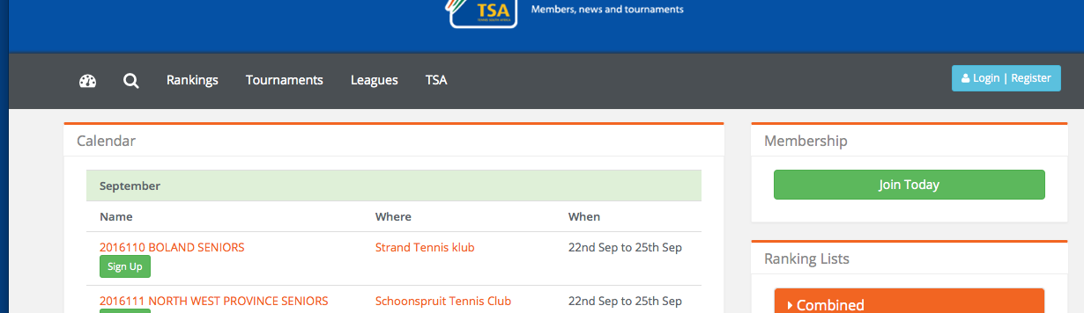

Fill in the I don't have an account on the right of screen if you are new to registering on SportyHQ

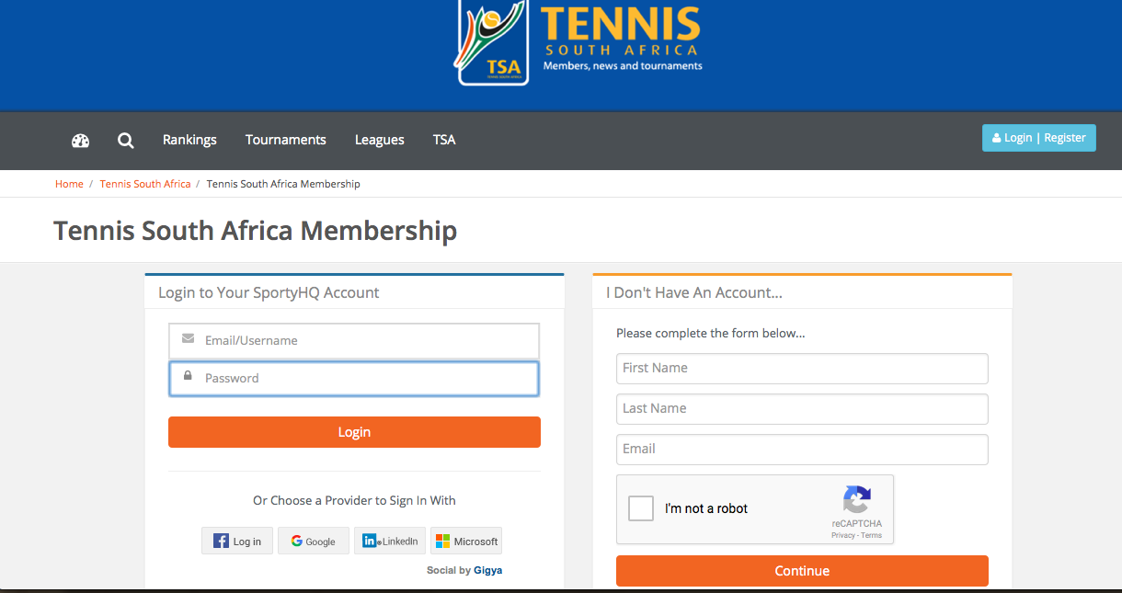

Check your email account

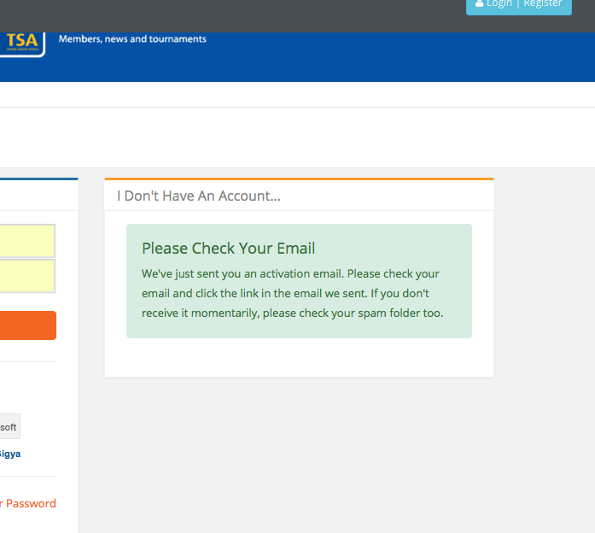

Click on link on email

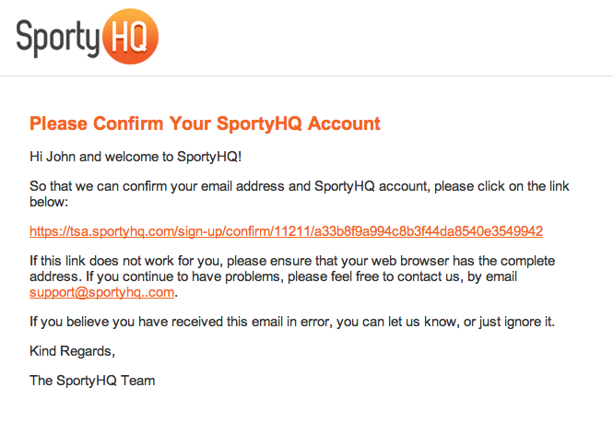

Complete your account setup filling in all fields

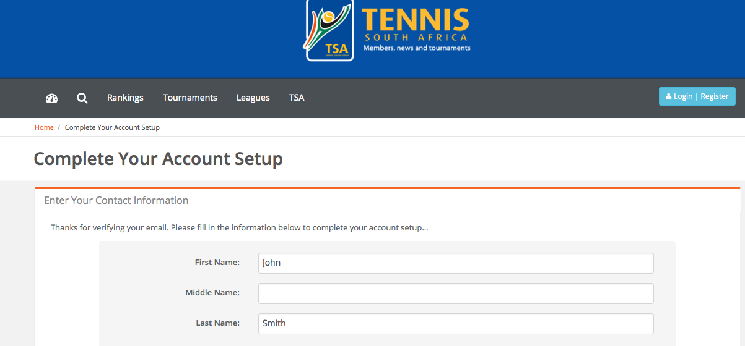

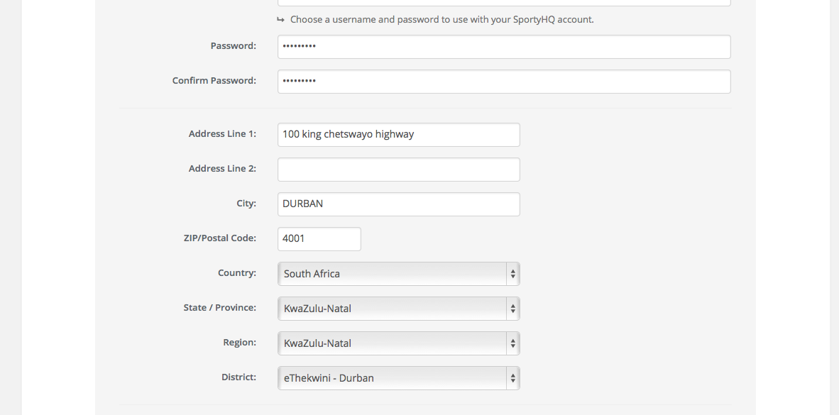

Click continue and finish filling in User details

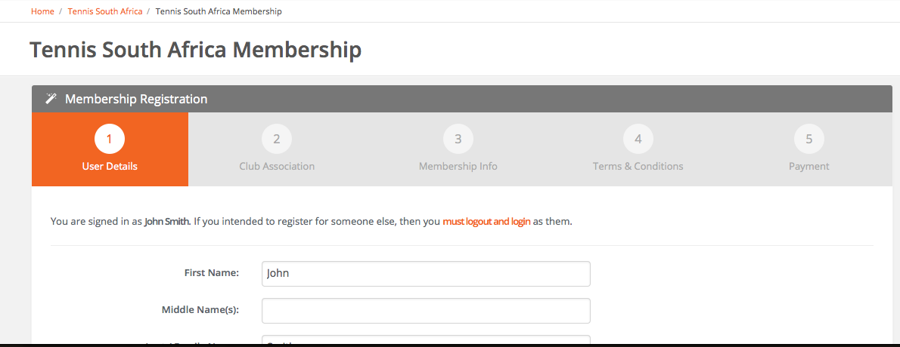

Fill in the Club, NOT school you are affiliated with

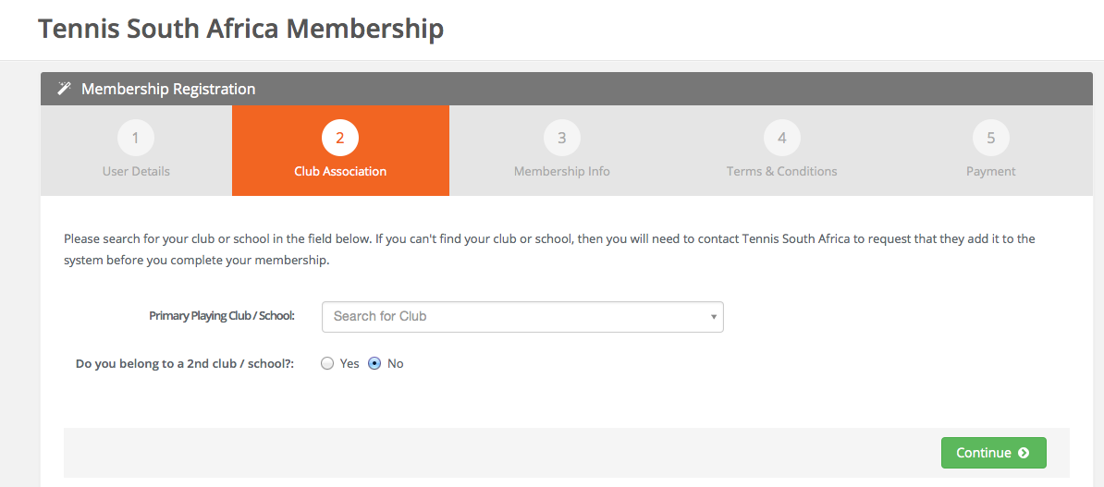

Choose the correct membership type in Tennis South Africa membership plan

Scroll to bottom and click on Continue

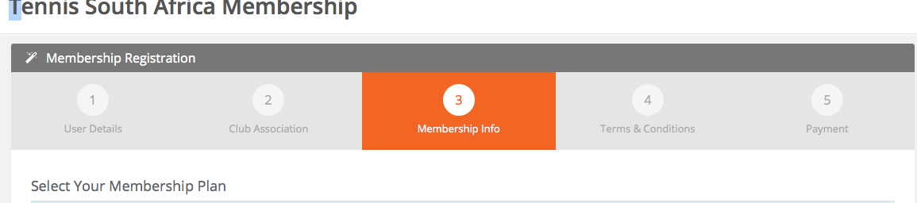

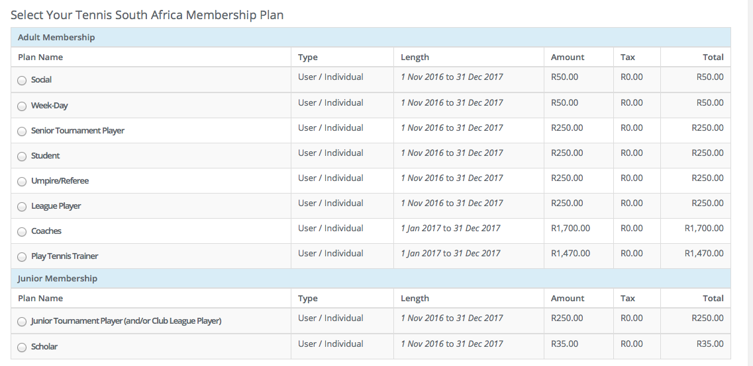

If you live in KZN then you will also have to pay the following membership fees.

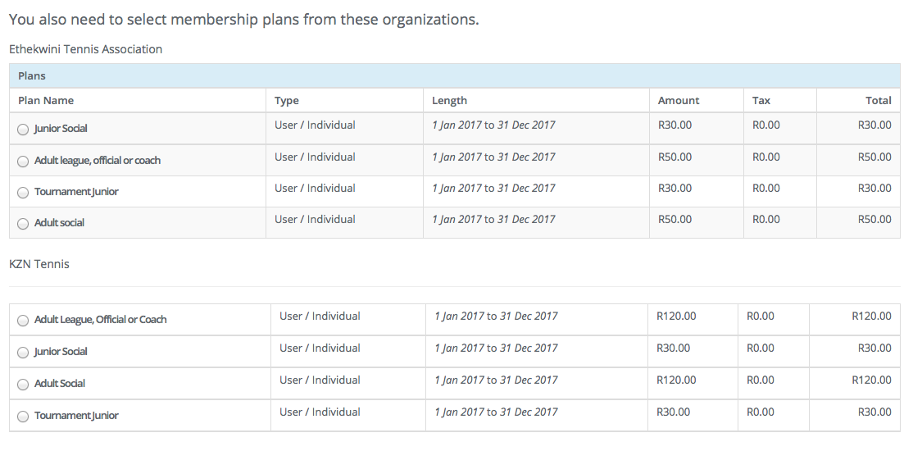

Membership fee descriptions

Adult membership

Social player – Player who plays tennis at a club, plays no tournaments or league
Coach – Professional coach
Week-day – Midweek social player
Student – Adult scholar
Senior tournament player – Tournament player playing in senior tournaments
League player – League player
Umpire/Referee
Play tennis trainer – Play and stay trainer

Junior membership

Scholar – School playing junior
Junior tournament player – Junior player playing in junior tournaments and club league

KZN Tennis Association membership

Junior or Adult members

Ethekwini Tennis Association (Durban)/ Uthungulu (Richards bay area)/ Ugu (South Coast) / Umgungungdlovu (PMB)

Click on I agree to the terms and conditions listed above

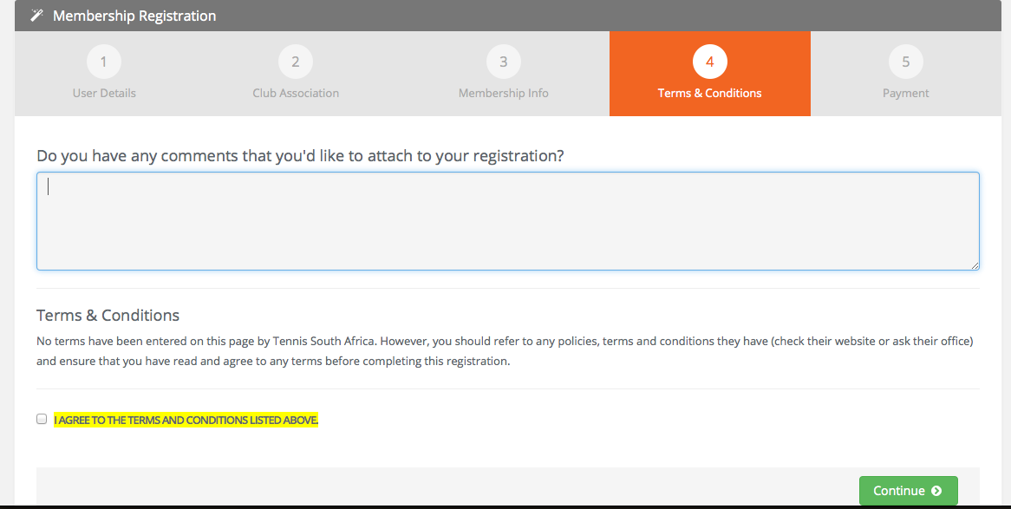

Continue to Payment screen

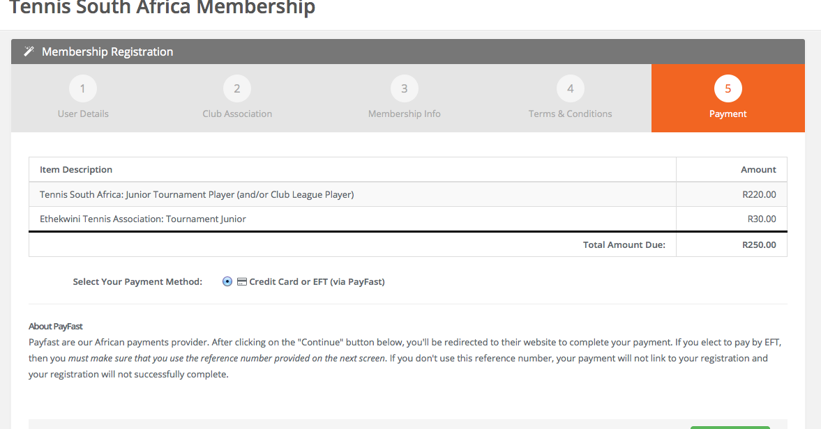

Continue to payfast screen and select your payment method.

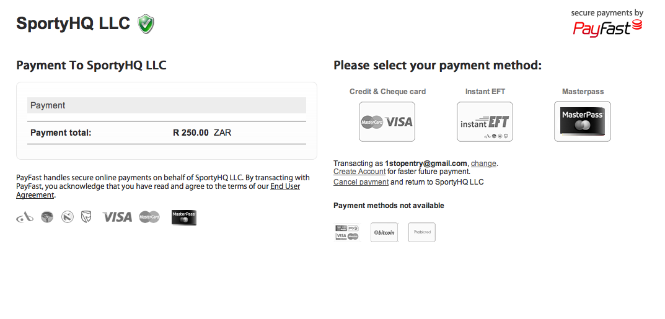

Credit and Cheque card payments

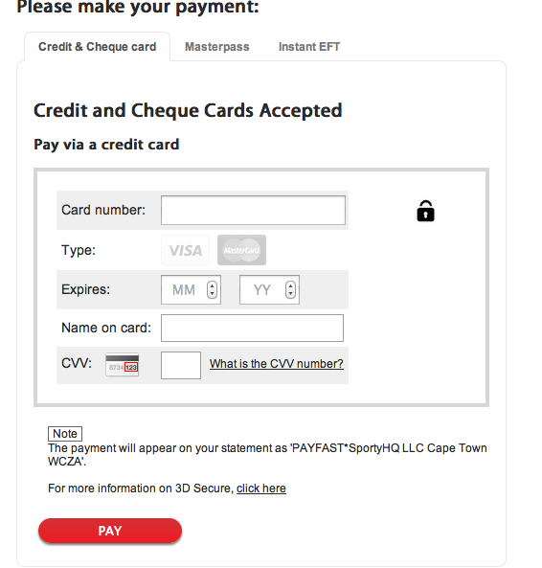

Masterpass payments

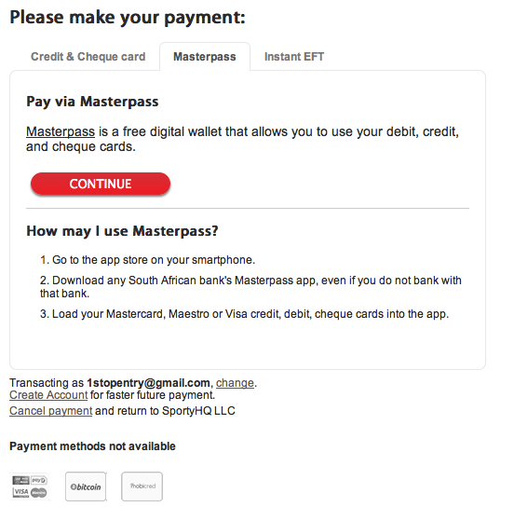

Instant EFT payments

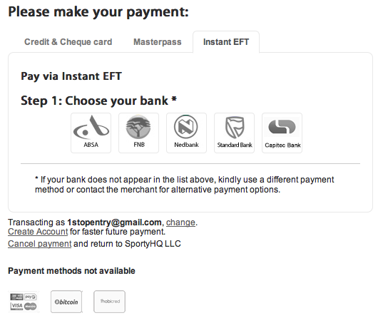

Select the bank you bank with by clicking on the bank icon
Under section 2 - Make an EFT payment via Absa (Your particular bank) click on log into you Absa(Your bank)online banking, this will open a new window and you will continue with online banking

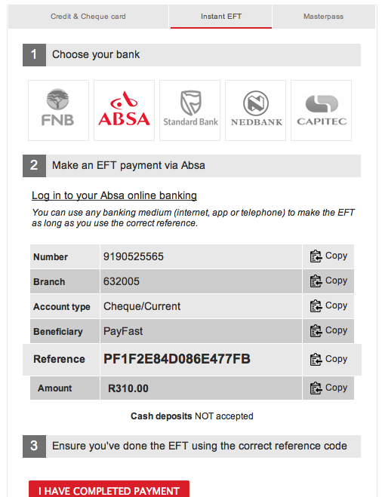

NB - Beneficiary Reference is

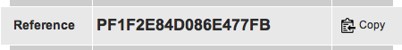

Once payment is complete this is a VERY IMPORTANT STEP

Go back to the payfast browser that is open

Click on I have completed payment

Payfast then searches for the reference number in their bank to the reference number you have put as your reference. Once matched payment will be complete.

Should the payment not go through please follow the following steps

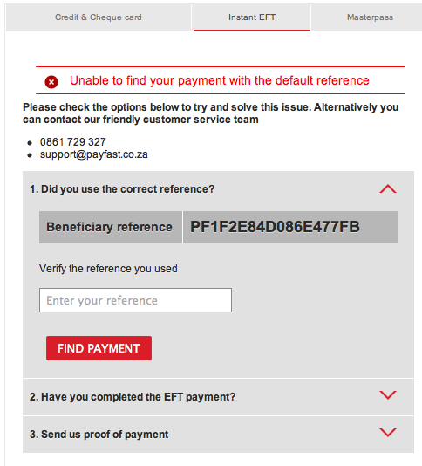

Check the reference number on your proof of payment to the beneficiary reference

If you have made a mistake then enter the reference number you have on your proof of payment in the verify the reference you used and click on Find Payment

If you are still having problems please can you click on Send us proof of payment.
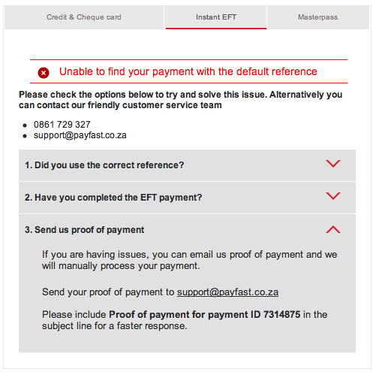

Send your proof of payment to support@payfast.co.za and payfast will get back to you. Please be sure to include your Proof of payment ID which is found at the bottom on the page.

