TO LET
(FLEXIBLE TERMS OFFERED)
OPEN STORAGE SITE
0.25 ACRE (approx.)

ALL MAINS SERVICES CONNECTED + 24 HOUR ACCESS

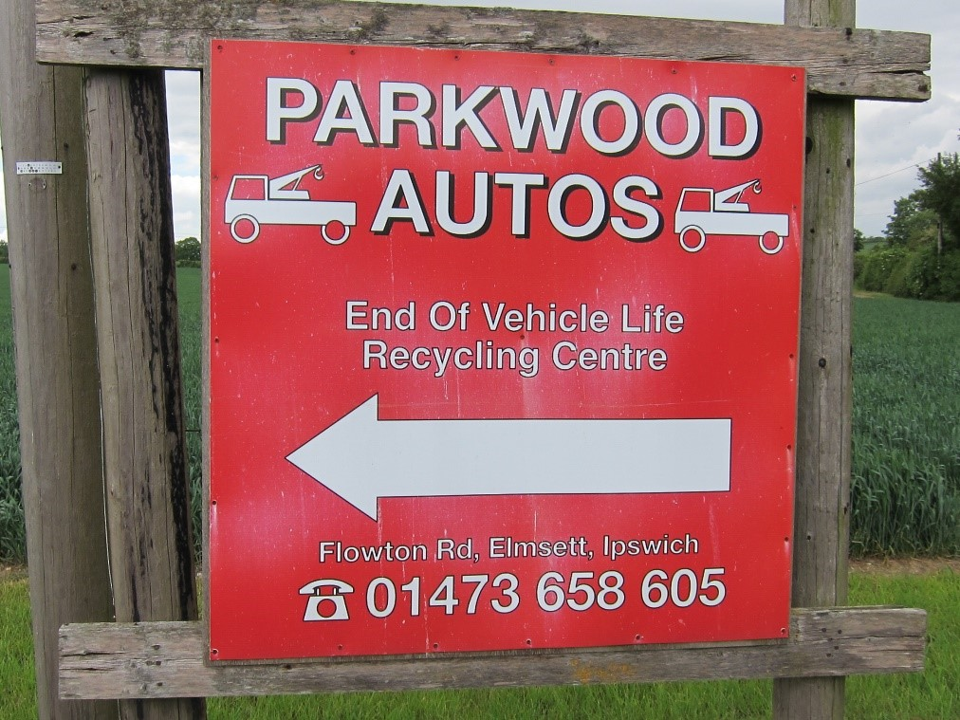

Parkwood Autos
Elmsett Park Recycling Site
Flowton Road
Elmsett Nr Ipswich
Suffolk IP7 6PF

LOCATION: The site is located within Elmsett Park Wood site approximately one mile north east of the village of Elmsett, approximately 8 miles from Ipswich, Suffolk. Access to the site is from Flowton Road via a private right of way surfaced with tarmacadam. Agricultural land lies on all sides beyond the edge of the Wood. The nearest residential property is Red House Farm, approximately 400 metres to the North East.

DESCRIPTION: The site comprises a broadly level and rectangular site of approximately 0.25 acre (subject to survey) and has operated as a motor salvage and waste metal recycling site for the past 20 years.

The available site may be suitable for Builders’ Yard or storage of up to 30 motor vehicles.

SITE ACCESS & The site is approached from Flowton Road via a right of way which is an
INFRASTRUCTURE: existing tarmacadam road and onto the freehold Title of the site (a Title Deed plan is available upon request)

Security for the site is maintained by a 2 metre high chain link and galvanised iron perimeter fence.

BUSINESS RATES: Payable by the Tenant and not included in the monthly Licence Fee

TERMS: The site is available to rent on flexible terms by Licence.

LICENCE FEE: £800.00 per calendar month

VAT: Value Added Tax is not payable

LEGAL COSTS: Each party to bear their own legal costs respectively

VIEWING: By prior appointment with lettings agents:-

Harris Commercial Surveyors
(01473 221222)
www.harriscommercial.com

SUBJECT TO CONTRACT.

